

User Manual

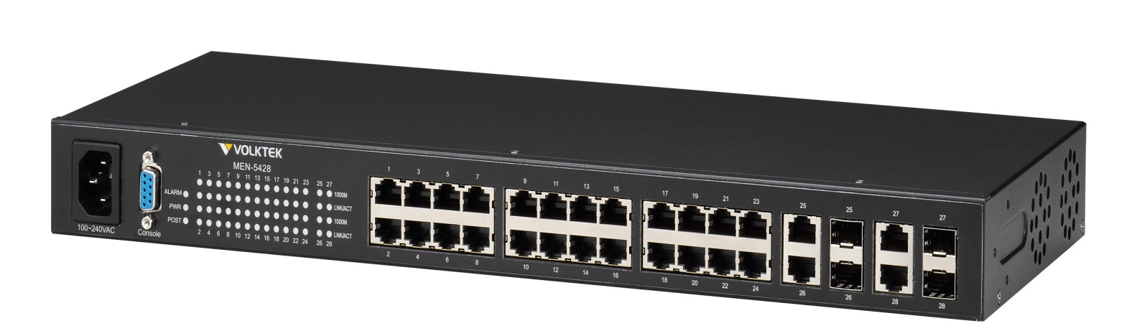
MEN-5428D
24 10/100/1000Base-T ports + 4 Gigabit combo slots
Managed Layer 2+ Access Switch

Version 2.0 30th July, 2018

COPYRIGHT
All rights reserved. No part of this publication may be reproduced, stored in a retrieval system, or transmitted in any form or by any means, whether electronic, mechanical, photo copying, recording or otherwise, without the prior written permission of the publisher.

FCC WARNING

This equipment has been tested and found to comply with the limits for a class A device, pursuant to part 15 of FCC rules. These limits are designed to provide reasonable protection against harmful interference in a commercial installation. This equipment generates uses and can radiate radio frequency energy and, if not installed and used in accordance with the instructions, may cause harmful interference to radio communication. Operation of this equipment in a residential area is likely to cause harmful interference, in which case, the user will be required to correct the interference at the user’s own expense.

CE

This is a Class A product. In a domestic environment, this product may cause radio interference in which case the user may be required to take adequate measures.
 | HOT& COLD WARNING
The Switch surface will getting very hot or cold depend on the operating environment. Please take special care when touch to the working switch.

Take special care to read and understand all the content in the warning boxes.

Take special care to read and understand all the content in the warning boxes.

Do not work on the system or connect or disconnect cables during periods of lightning activity.

Before working on equipment that is connected to power lines, remove jewelry (including rings, necklaces, and watches). Metal objects will heat up when connected to power and ground and can cause serious burns or weld the metal object to the terminals.

Do not stack the chassis on any other equipment. If the chassis falls, it can cause severe bodily injury and equipment damage.

An exposed wire lead from a DC-input power source can conduct harmful levels of electricity. Be sure that no exposed portion of the DC-input power source wire extends from the terminal block plug.

Ethernet cables must be shielded when used in a central office environment.

If a redundant power system (RPS) is not connected to the switch, install an RPS connector cover on the back of the switch.

Read the wall-mounting instructions carefully before beginning installation. Failure to use the correct hardware or to follow the correct procedures could result in a hazardous situation to people and damage to the system.

Before performing any of the following procedures, ensure that power is removed from the DC circuit.

Read the installation instructions before connecting the system to the power source.

To prevent bodily injury when mounting or servicing this unit in a rack, you must take special precautions to ensure that the system remains stable. The following guidelines are provided to ensure your safety:
- This unit should be mounted at the bottom of the rack if it is the only unit in the rack.
- When mounting this unit in a partially filled rack, load the rack from the bottom to the top with the heaviest component at the bottom of the rack.
- If the rack is provided with stabilizing devices, install the stabilizers before mounting or servicing the unit in the rack.

This unit might have more than one power supply connection. All connections must be removed to de-energize the unit.

Only trained and qualified personnel should be allowed to install, replace, or service this equipment.

When installing or replacing the unit, the ground connection must always be made first and disconnected last.

Voltages that present a shock hazard may exist on Power over Ethernet (PoE) circuits if interconnections are made using uninsulated exposed metal contacts, conductors, or terminals. Avoid using such interconnection methods, unless the exposed metal parts are located within a restricted access location and users and service people who are authorized within the restricted access location are made aware of the hazard. A restricted access area can be accessed only through the use of a special tool, lock and key or other means of security.
No user-serviceable parts inside. Do not open.

This equipment must be grounded. Never defeat the ground conductor or operate the equipment in the absence of a suitably installed ground conductor. Contact the appropriate electrical inspection authority or an electrician if you are uncertain that suitable grounding is available.

Table of Content
1. About this Guide 1
1.1. Welcome 1
1.2. Purpose 1
1.3. Terms/Usage 1
1.4. Features 2
1.5. Specifications 2
2. Hardware Description 5
2.1. Connectors 5
2.2. Installation 5
2.3. LED Indicators 7
3. Management options 9
3.1. Management via console port 9
3.2. Management by Telnet 10
3.3. How to enter the CLI? 10
3.4. CLI command concept 11
3.5. Management via Internet Browser Interface 12
3.6. System Information 12
3.6.1. CLI Configuration 12
3.6.2. Web Configuration 13
4. Basic Settings 15
4.1. General Settings 15
4.1.1. System 15
4.1.1.1. CLI Configuration 15
4.1.1.2. Web Configuration 17
4.1.2. Jumbo Frame 18
4.1.2.1. CLI Configuration 18
4.1.2.2. Web Configuration 19
4.1.3. SNTP 19
4.1.3.1. CLI Configuration 20
4.1.3.2. Web Configuration 22
4.1.4. Management Host 24
4.1.4.1. CLI Configuration 24
4.1.4.2. Web Configuration 24
4.2. MAC Management 25
4.2.1. CLI Configuration 26
4.2.2. Web Configuration 27
4.2.3. Refusal MAC settings (Black-hole MAC) 29
4.2.3.1. CLI Configuration 30
4.2.3.2. Web Configuration 30
4.3. Port Mirror 31
4.3.1. CLI Configuration 31
4.3.2. Web Configuration 33
4.4. Port Settings 34
4.4.1. CLI Configuration 36
4.4.2. Web Configuration 37
5. Advanced Settings 40
5.1. Bandwidth Control 40
5.1.1. QoS 40
5.1.1.1. CLI Configuration 45
5.1.1.2. Web Configuration 47
5.1.2. Rate Limitation 50
5.1.2.1. Storm Control 50
5.1.2.1.1. CLI Configuration 51
5.1.2.1.2. Web Configuration 52
5.1.2.2. Bandwidth Limitation 53
5.1.2.2.1. CLI Configuration 53
5.1.2.2.2. Web Configuration 54
5.2. DHCPv6 55
5.2.1. DHCPv6 Options 55
5.2.1.1. CLI Configurations 55
5.2.1.2. Web Configurations 55
5.2.2. DHCPv6 Relay 56
5.2.2.1. CLI Configurations 56
5.2.2.2. Web Configurations 56
5.3. IGMP Snooping 57
5.3.1. IGMP Snooping 57
5.3.1.1. CLI Configuration 59
5.3.1.2. Web Configuration 60
5.3.2. IGMP Filtering 63
5.3.2.1. CLI Configurations 64
5.3.2.2. Web Configurations 65
5.3.3. MVR 67
5.3.3.1. CLI Configuration 70
5.3.3.2. Web Configuration 71
5.3.4. Multicast Address 72
5.3.4.1. CLI Configuration 74
5.3.4.2. Web Configuration 74
5.3.5. Explicit Host Tracking 75
5.3.5.1. CLI Configurations 75
5.3.5.2. Web Configurations 76
5.4. VLAN 77
5.4.1. Port Isolation 77
5.4.1.1. CLI Configuration 78
5.4.1.2. Web Configuration 79
5.4.2. 802.1Q VLAN 80
5.4.2.1. CLI Configuration 82
5.4.2.2. Web Configuration 83
5.4.3. GARP/GVRP 87
5.4.3.1. CLI Configuration 88
5.4.3.2. Web Configuration 89
5.4.4. IP Subnet VLAN 92
5.4.4.1. CLI Configuration 92
5.4.4.2. Web Configuration 93
5.4.5. MAC-based VLAN 93
5.4.5.1. CLI Configuration 94
5.4.5.2. Web Configuration 94
5.4.6. Protocol-based VLAN 95
5.4.6.1. CLI Configuration 95
5.4.6.2. Web Configuration 96
5.4.7. Q-in-Q VLAN (VLAN Stacking) 96
5.4.7.1. CLI Configuration 102
5.4.7.2. Web Configuration 103
5.4.8. VLAN Translation 106
5.4.8.1. CLI Configuration 106
5.4.8.2. Web Configuration 107
5.5. DHCP Options 108
5.5.1. Option 66 and 67 108
5.5.1.1. CLI Configuration 109
5.5.1.2. Web Configuration 109
5.5.2. Option 82 110
5.5.2.1. CLI Configuration 112
5.5.2.2. Web Configuration 113
5.6. DHCP Relay 114
5.6.1. CLI Configuration 116
5.6.2. Web Configuration 116
5.7. Dual Homing 117
5.7.1. CLI Configuration 117
5.7.2. Web Configuration 118
5.8. EEE (Energy Efficient Ethernet) 119
5.8.1. Introduction 119
5.8.2. CLI Configuration 119
5.8.3. Web Configuration 120
5.9. ERPS 121
5.9.1. CLI Configuration 123
5.9.2. Web configuration 124
5.10. Link Aggregation 127
5.10.1. Static Trunk 127
5.10.1.1. CLI Configuration 128
5.10.1.2. Web Configuration 129
5.10.2. LACP 130
5.10.2.1. CLI Configuration 131
5.10.2.2. Web Configuration 131
5.11. Link Layer Discovery Protocol (LLDP) 135
5.11.1. CLI Configuration 136
5.11.2. Web Configuration 137
5.12. Loop Detection 139
5.12.1. CLI Configuration 140
5.12.2. Web Configuration 142
5.13. PPPoE IA 143
5.13.1. CLI Configuration 147
5.13.2. Web Configuration 149
5.14. Static Route 153
5.14.1. Introduction 153
5.14.2. CLI configuration 153
5.14.3. Web configuration 156
5.15. STP 157
5.15.1. STP/RSTP 157
5.15.1.1. CLI Configuration 161
5.15.1.2. Web Configuration 165
5.15.2. MSTP 170
5.15.2.1. Introduction 170
5.15.2.2. CLI Configurations 172
5.15.2.3. Web Configurations 174
5.16. UDLD 180
5.16.1. CLI Configurations 180
5.16.2. Web Configurations 182
5.17. Xpress-Ring 184
5.17.1. CLI Configuration 184
5.17.2. Web Configuration 185
6. Security 187
6.1. IP Source Guard 187
6.1.1. DHCP Snooping 187
6.1.1.1. CLI Configuration 190
6.1.1.2. Web Configuration 191
6.1.1.3. DHCP Server Screening 193
6.1.1.3.1. CLI Configuration 193
6.1.1.3.2. Web Configuration 194
6.1.2. Binding Table 194
6.1.2.1. CLI Configuration 195
6.1.2.2. Web Configuration 195
6.1.3. ARP Inspection 197
6.1.3.1. ARP Inspection 197
6.1.3.1.1. CLI Configuration 198
6.1.3.1.2. Web Configuration 199
6.1.3.2. Filter Table 200
6.1.3.3. CLI Configuration 200
6.1.3.4. Web Configuration 201
6.2. ACL 202
6.2.1. CLI Configuration 203
6.2.2. Web Configuration 205
6.3. 802.1x 207
6.3.1. CLI Configuration 210
6.3.2. Web Configuration 212
6.4. Port Security 216
6.4.1. Port Security 216
6.4.1.1. CLI Configuration 218
6.4.1.2. Web Configuration 219
6.4.2. Sticky 220
6.4.2.1. CLI Configurations 220
6.4.2.2. Web Configurations 222
6.5. Switch Lock 225
6.5.1. CLI Configurations 225
6.5.2. Web Configurations 226
6.6. TACACS+ 227
6.6.1. CLI Configuration 228
6.6.2. Web Configuration 230
7. Monitor 232
7.1. Alarm 232
7.1.1. CLI Configuration 232
7.1.2. Web Configuration 232
7.2. Hardware Information 232
7.2.1. CLI Configuration 232
7.2.2. Web Configuration 233
7.3. Port Statistics 233
7.3.1. CLI Configuration 233
7.3.2. Web Configuration 234
7.4. Port Utilization 235
7.4.1. CLI Configuration 235
7.4.2. Web Configuration 235
7.5. RMON Statistics 235
7.5.1. CLI Configuration 235
7.5.2. Web Configuration 236
7.6. SFP Information 236
7.6.1. CLI Configuration 236
7.6.2. Web Configuration 237
7.7. Traffic Monitor 237
7.7.1. CLI Configuration 238
7.7.2. Web Configuration 239
8. Management 241
8.1. SNMP 241
8.1.1. SNMP 241
8.1.1.1. CLI Configuration 242
8.1.1.2. Web Configuration 242
8.1.2. SNMP Trap 244
8.1.2.1. SNMP Trap Receiver 244
8.1.2.2. SNMP Trap Events 245
8.1.2.2.1. CLI Configurations 246
8.1.2.2.2. Web Configurations 247
8.1.2.3. SNMP Port Trap 247
8.1.2.3.1. CLI Configurations 247
8.1.2.3.2. Web Configurations 248
8.1.3. SNMPv3 248
8.1.3.1. CLI Configurations 248
8.1.3.2. Web Configurations 249
8.2. Auto Provision 253
8.2.1. CLI Configuration 254
8.2.2. Web Configuration 255
8.3. Mail Alarm 255
8.3.1. Reference 256
8.3.2. CLI Configuration 256
8.3.3. Web Configuration 257
8.4. Maintenance 258
8.4.1. Configuration 258
8.4.1.1. CLI Configuration 258
8.4.1.2. Web Configuration 259
8.4.2. Firmware 260
8.4.3. Reboot 260
8.4.4. Server Control 261
8.4.4.1. CLI Configuration 261
8.4.4.2. Web Configuration 261
8.5. System log 262
8.5.1. CLI Configuration 262
8.5.2. Web Configuration 263
8.6. User Account 264
8.6.1. CLI Configuration 264
8.6.2. Web Configuration 265
Customer support 266

- About this Guide

  - Welcome
The MEN-5428(D) is a high port density managed access switch designed to deliver Gigabit Ethernet speeds with exceptional performance for high density subscriber base with high ARPU. A variety of traffic-shaping QoS mechanisms and rich software features of the MEN-5428(D) increase overall efficiency and reliability of the network. Easy-to-use management and monitoring capabilities significantly reduces IT overhead by eliminating the need to manually configure policies on the switch, saving valuable time and effort, and avoids unnecessary OPEX.
The switch is equipped with 24 multi-rate (10/100/1000Mbps) copper and 4 Gigabit Combo ports to deliver multi-rate transmission speeds for enterprise and FTTx networks. Using its Fiber ports, the MEN-5428(D) quickly uplinks to the aggregation switches in the network to provide high bandwidth uplinks over variable distances. Thereby, service providers can take advantage of the switch’s high port density to extend their reach within metro areas and also offer high-speed connectivity to their subscribers.

  - Purpose
This guide discusses how to install and configure your Managed Layer 2+Access Switch.

  - Terms/Usage
In this guide, the term “Switch” (first letter upper case) refers to the MEN-5428(D) Switch, and “switch” (first letter lower case) refers to other switches.

  - Features
Network Function  LACP Support  Static Link Trunking  STP/RSTP/MSTP  MVR  GVRP/GARP  Loop Detection  VLAN Management  IGMP Snooping (v1/v2/3)  Dying Gasp  VLAN stacking (QinQ)  Link Layer Discovery Protocol  SFP DDMI Support  ERPS (G8032v2)  Xpress Ring  Network Management  RS-232c Local Console  Telnet, CLI  SNMP v1/v2c/v3  SNMP Trap  SNTP  Web-based  RMON Statistics  Port-based Mirroring  Firmware Upgradeable Configuration Port configuration, status, and statistics | Auto-provisioning  User Security  MAC-based Authentication  MAC Limitation  Private VLAN for port isolation  802.1x Support  ACL (L2/L3/L4)  DHCP Relay/option82  DHCP Snooping  DHCP Server Screening  ARP Inspection  Port AuthenticationTraffic Management and QoS  Bandwidth control  Traffic Control  Port-based VLAN  Tag-based VLAN  4K static VLAN  Rate Limitation  DSCP/Tos Support  8 Hardware Queues  SP/WRR  Storm Control  802.3x flow control  Port-based rate control

Specifications

IEEE Standards
IEEE 802.3 10Base-T
IEEE 802.3u 100Base-TX
IEEE 802.3ab 1000Base-T
IEEE 802.3z 1000Base-SX/LX/LHX
IEEE 802.3 Nway Auto-negotiation
IEEE 802.3ad Port Trunk with LACP
IEEE 802.3x Flow Control
IEEE 802.1d Spanning Tree Protocol
IEEE 802.1w Rapid Spanning Tree Protocol
IEEE 802.1s Multiple Spanning Tree Protocol
IEEE 802.1p CoS, Priority Protocol
IEEE 802.1q VLAN Tagging
IEEE 802.1ad Link Layer Discovery Protocol
IEEE 802.1x Port Authentication

Performance
Switching fabric 56Gbps
L2 forwarding 41.7Mpps
Throughput 14,880 pps to 10 Mbps ports
148,800 pps to 100 Mbps ports
1,488,000 pps to 1000 Mbps ports
Packet buffer size 8Mbit
MAC addresses 16k
Jumbo Frame 10k

Ports
10/100/1000Base-T (RJ45) 24
Gigabit Combo (10/100/1000 RJ45 or Gigabit SFP) 04
DB-9 console 01

Maximum Distances
RJ45 up to 100 m
SC/SFP up to 120 km
Console 15 m

Mechanical & Environmental
Operating temperature 0°C to 50°C
Storage temperature -20°C to 70°C
Operating humidity 10% to 90% RH
Storage humidity 5% to 95% RH

Power
Front access AC power 100-240V, 50~60Hz
DC Jack 15V DC (Not available on MEN-5428D)
12V DC battery back-up Not supported on MEN-5428D
-48V DC power input MEN-5428D only, via 4-pin terminal block
Power consumption 25W (without Battery)

Dimensions & Weight
Dimensions (WxHxD) 440 x 44 x 180mm
Weight 2.3 kg
19” rack-mountable

- Hardware Description

MEN-5428 Front Panel
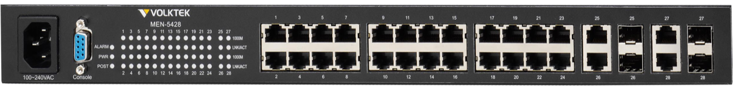
MEN-5428D Front Panel
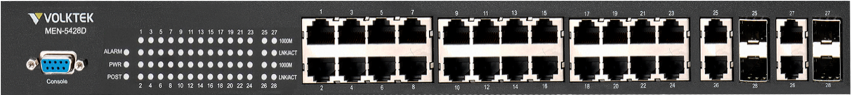

24 Copper ports (10/100/1000Mbps) +
4 Gigabit SFP slots or 4 RJ45 ports (10/100/1000Mbps)
  - Connectors
The Switch utilizes ports with copper and SFP fiber port connectors functioning under Ethernet/Fast Ethernet/Gigabit Ethernet standards.

10/100/1000Base-T Ports
The 10/100/1000Base-T ports support network speeds of 10Mbps, 100Mbps or 1000Mbps, and can operate in half- and full-duplex transfer modes. These ports also offer automatic MDI/MDI-X crossover detection that gives true “plug-n-play” capability – just plug the network cables into the ports and the ports will adjust according to the end-node devices. The following are recommended cabling for the RJ45 connectors: (1) 10 Mbps – Cat 3 or better; (2) 100 or 1000 Mbps – Cat 5 or better.

Gigabit Combo ports
There are four Gigabit Combo ports on the MEN-5428(D). Combo ports have both an RJ45 interface and an SFP slot, of which one can be in use at any one time. The RJ45 ports operate at 10/100/1000 Mbps, while the SFP ports are capable of operating at 1000 Mbps.

The Gigabit copper ports have the same number as its corresponding SFP slot. This means that once an SFP slot is connected, the correspondingly numbered RJ45 port (25, 26, 27 or 28) will not function.

  - Installation
The location chosen for installing the Switch may greatly affect its performance. When selecting a site, we recommend considering the following rules:
- Install the Switch in an appropriate place. See Technical Specifications for the acceptable temperature and humidity ranges.
- Install the Switch in a location that is not affected by strong electromagnetic field generators (such as motors), vibration, dust, and direct sunlight.
- Leave at least 10cm of space at the front and rear of the unit for ventilation.
- Affix the provided rubber pads to the bottom of the Switch to protect the case from scratching.

Desktop Installation
Follow the instructions listed below to install the Switch in a desktop location:
- Locate the Switch in a clean, flat and safe position that has convenient access to power.
- Affix the four self-adhesive rubber pads to the underside of the Switch.
- Apply 100~240V AC or 48V DC (MEN-5428D) power to the Switch (The green PWR LED on the front panel should light up).
- Connect cables from the network partner devices to the ports on the front panel (The green LNK LED on the upper right of the port should light).

This Switch can also be mounted on a vertical surface. Simply use the underside of the unit as a template to measure and mark out the position of the holes on to the surface where the unit is to be installed. Then use the two screws provided to mount the Switch firmly in place.

Warning: Because invisible laser radiation may be emitted from the aperture of the port when no cable is connected, avoid exposure to laser radiation and do not stare into open apertures.

Mounting on a Rack
Attach brackets to each side of the switch and place the brackets in the rack’s slots. Insert and tighten two screws to securely attach the bracket to the rack on each side.

Getting Connected
The Switch is capable of connecting up to 28network devices employing a combination of twisted-pair and fiber cabling paths at Ethernet, Fast Ethernet, or Gigabit Ethernet speeds.

Installing the SFP modules and Fiber Cable
- Slide the selected SFP module into the selected SFP slot (Make sure the SFP module is aligned correctly with the inside of the slot)
- Insert and slide the module into the SFP slot until it clicks into place
- Remove any rubber plugs that may be present in the SFP module’s mouth
- Align the fiber cable’s connector with the SFP module’s mouth and insert the connector
- Slide the connector in until a click is heard
- If you want to pull the connector out, first push down the release clip on top of the connector to release the connector from the SFP module.

To properly connect fiber cabling: Check that the fiber terminators are clean. You can clean the cable plugs by wiping them gently with a clean tissue or cotton ball moistened with a little ethanol. Dirty fiber terminators on fiber optic cables will impair the quality of the light transmitted through the cable and lead to degraded performance on the port.

Note: When inserting the cable, be sure the tab on the plug clicks into position to ensure that it is properly seated.

Check the corresponding port LED on the Switch to be sure that the connection is valid. (Refer to the LED chart).

Connecting Copper Cable
The RJ45 Ethernet ports fully support auto-sensing and auto-negotiation.
- Insert one end of a Category 3/4/5/5e (see recommendation above) type twistedpair cable into an available RJ45 port on the Switch and the other end into the port of the network node.
- Check the corresponding port LED on the Switch to ensure that the connection is valid. (Refer to LED chart)

Connecting the Console Port Cable
The console port (DB-9) provides the out-of-band management facility. Use null modem cable to connect the console port on the Switch and the other end intothe COM port of the computer.

Connecting to computers or a LAN
You can use Ethernet cables to connect computers directly to the Switch ports. You can also connect hubs/switches to the switch ports by Ethernet cables. You can use either crossover or straight-through Ethernet cables to connect computers, hubs, or switches.

Notice: Use a twisted-pair Category 5e Ethernet cable to connect the 10/100/1000Base-T port; otherwise the link speed will not be able to reach 1Gbps.

  - LED Indicators
This Switch is equipped with Unit LEDs to enable you to determine the status of the Switch, as well as Port LEDs to display what is happening in all your connections. They are as follows:
Unit LEDs
LED | Condition | Status
POWER | Illuminated | Power on
POWER | Off | Power off or fail
POST | Illuminated | System ready to use
POST | Blinking | Power on self-test
POST | Off | Power off or test fail
ALARM | Illuminated | Alarm for over threshold of system temperature or voltage
ALARM | Blinking | Alarm for loop detection
ALARM | Off | Switch is in normal condition
LNK/ACT (for 1~24th10/100/1000Mbps Copper ports) | Illuminated | Ethernet link-up
LNK/ACT (for 1~24th10/100/1000Mbps Copper ports) | Blinking | Receiving or transmitting data
LNK/ACT (for 1~24th10/100/1000Mbps Copper ports) | Off | Port disconnected or link failed
1000 | Illuminated | 1000Mbps
1000 | Off | 10/100Mbp
LNK/ACT  (for 25~28th ports) | Illuminated | Ethernet link-up
LNK/ACT  (for 25~28th ports) | Blinking | Receiving or transmitting data
LNK/ACT  (for 25~28th ports) | Off | Port disconnected or link failed
1000 | Illuminated | 1000Mbps
1000 | Off | 10/100Mbp

- Management options
This system may be managed out-of-band through the console port on the front panel or in-band by using Telnet. The user may also choose web-based management, accessible through a Web browser.

The management agent is based on SNMP (Simple Network Management Protocol). This SNMP agent permits the switch to be managed from any PC in the network by using in-band management software.

The switch gives you the flexibility to access and manage it by using any or all of the methods described. The administration console and web browser interfaces are embedded in the Switch software and can be used immediately after setup.

  - Management via console port
Prior to accessing the switch’s onboard agent via a network connection, you must first configure it with a valid IP address, subnet mask, and default gateway using an out of band connection or the BOOTP protocol.

After configuring the switch’s IP parameters, you can access the onboard configuration program from anywhere within the attached network or via the internet. The onboard configuration program can be accessed using Telnet from any computer attached to the network. It can also be managed from any computer using a Web browser.

Access the Switch via a terminal emulator (such as Hyper Terminal) attached to the console port. The console port is set at the factory with the following default COM port properties. Configure your own terminal to match the following:

Setting | Default Value
Terminal Emulation | VT100
Baud Rate | 38400
Parity | None
Data Bits | 8
Stop Bits | 1
Flow Control | None

Note: Ensure that the terminal or PC you are using to make this connection is configured to match the above settings. Otherwise the connection will not work.

Then press [ENTER] to open the login screen with the “Default Value” for Username and Password as “admin”.

  - Management by Telnet
Activate your workstation’s command prompt program and access your Switch via the Internet by typing in the correct IP address (factory default IP address is 192.168.0.254 - connect directly via console port to configure a unique IP address). Your command prompt program will allow use of the Telnet protocol.

- Connect your computer to one of the Ethernet ports.
- Open a Telnet session to the Switch’s IP address. If this is your first login, use the default values.

Setting | Default Value
IP Address | 192.168.0.254
Subnet Mask | 255.255.255.0
Default Gateway | 0.0.0.0
Management VLAN | 1
Default Username | admin
Default Password | admin

- Make sure your computer IP address is in the same subnet, unless you are accessing the Switch through one or more routers.

How to enter the CLI?
Press [Enter] key to enter the login command prompt when below message is displayed on the screen.
Please press Enter to activate this console

Input “admin” to enter the CLI mode when below message is displayed on the screen.
L2SWITCH login:

You can execute a few limited commands when CLI prompt is displayed as below.
L2SWITCH>

If you want to execute more powerful commands, you must enter the privileged mode.
Input command “enable”
L2SWITCH>enable

Input a valid username and password when below prompt are displayed.
user:admin
password:admin

L2SWITCH#

CLI command concept
Node | Command | Description
enable | show hostname | This command displays the system’s network name.
configure | reboot | This command reboots the system.
eth0 | ip addressA.B.C.D/M | This command configures a static IP and subnet mask for the system.
interface | show | This command displays the current port configurations.
acl | show | This command displays the current access control profile.
vlan | show | This command displays the current VLAN configurations.

The Node type:
- enable
Its command prompt is“L2SWITCH#”.
It means these commands can be executed in this command prompt.

- configure
Its command prompt is “L2SWITCH(config)#”.
It means these commands can be executed in this command prompt.
In Enable code, executing command “configure terminal” enter the configure node.
L2SWITCH#configure terminal

- eth0
Its command prompt is “L2SWITCH(config-if)#”.
It means these commands can be executed in this command prompt.
In Configure code, executing command “interface eth0” enter the eth0 interface node.
L2SWITCH(config)#interface eth0
L2SWITCH(config-if)#

- interface
Its command prompt is “L2SWITCH(config-if)#”.
It means these commands can be executed in this command prompt.
In Configure code, executing command “interface gigaethernet1/0/5” enter the interface port 5.
Or
In Configure code, executing command “interface fastethernet1/0/5” enter the interface port 5.
Note: depend on your port speed, gigaethernet1/0/5 for gigabit Ethernet ports and fastethernet1/0/5 for fast Ethernet ports.
L2SWITCH(config)#interface gigaethernet1/0/5
L2SWITCH(config-if)#

- vlan
Its command prompt is “L2SWITCH(config-vlan)#”.
It means these commands can be executed in this command prompt.
In Configure code, executing command “vlan 2” enter the vlan 2 node.
Note: where the “2” is the vlan ID.
L2SWITCH(config)#vlan 2
L2SWITCH(config-vlan)#

- acl
Its command prompt is “L2SWITCH(config-acl)#”.
It means these commands can be executed in this command prompt.
In Configure code, executing command “access-list test” enter the access-list test node.
Note: where the “test” is the profile name.
L2SWITCH(config)#access-list test
L2SWITCH(config-acl)#

  - Management via Internet Browser Interface
From a PC, open your Web browser, type the following in the Web address (or location) box:http://192.168.0.254 and then press <Enter>.
This is the factory default IP address for the switch. A login dialog is displayed, as shown in the figure:
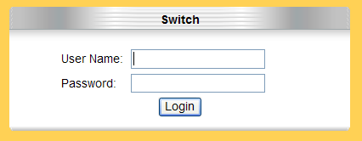

Enter your user name/password, and then click OK.
Use the defaults the first time you log into the program. You can change the password at any time through CLI interface.
Default:
User name: admin,
Password: admin.

  - System Information
The System Information window appears each time you log intothe program. Alternatively, this window can be accessed by clicking System Status > System Information

    - CLI Configuration
Node | Command | Description
enable | show hostname | This command displays the system’s network name.
enable | show interface eth0 | This command displays the current Eth0 configurations.
enable | show model | This command displays the system information.
enable | show running-config | This command displays the current operating configurations.
enable | show system-info | This command displays the system’s CPU loading and memory information.
enable | show uptime | This command displays the system up time.

    - Web Configuration
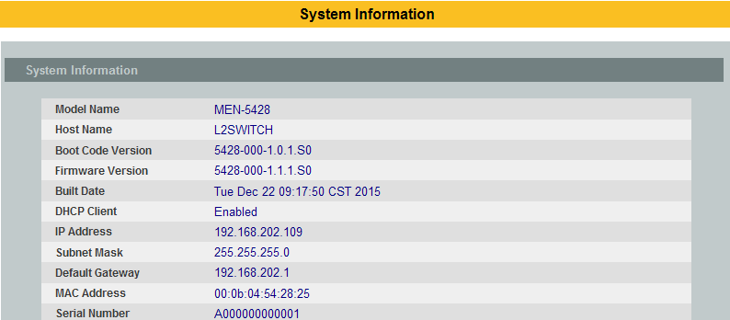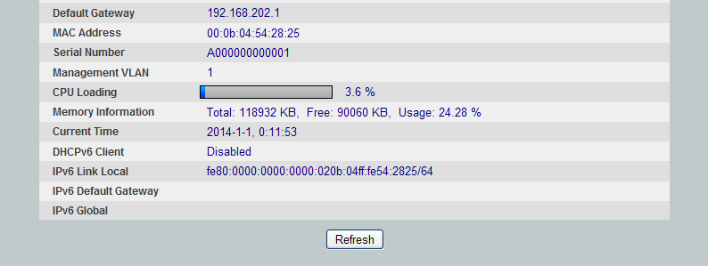

Parameter | Description
Model Name | This field displays the model name of the Switch.
Host name | This field displays the name of the Switch.
Boot Code Version | This field displays the boot code version.
Firmware Version | This field displays the firmware version.
Built Date | This field displays the built date of the firmware.
DHCP Client | This field displays whether the DHCP client is enabled on the Switch.
IP Address | This field indicates the IP address of the Switch.
Subnet Mask | This field indicates the subnet mask of the Switch.
Default Gateway | This field indicates the default gateway of the Switch.
MAC Address | This field displays the MAC (Media Access Control) address of the Switch.
Serial Number | The serial number assigned by manufacture for identification of the unit.
Management VLAN | This field displays the VLAN ID that is used for the Switch management purposes.
CPU Loading | This field displays the percentage of your Switch’s system load.
Memory Information | This field displays the total memory the Switch has and the memory which is currently available (Free) and occupied (Usage).
Current Time | This field displays current date (yyyy-mm-dd) and time (hh:mm:ss).
DHCPv6 Client | This field displays whether the DHCPv6 client is enabled on the Switch.
IPv6Link Local | This field displays the network address for IPv6.
IPv6 Default Gateway | This field displays the default gateway for IPv6.
IPv6 Global | This field displays the global network address for IPv6.
Refresh | Click this to update the information in this screen.

Basic Settings

General Settings

System
Management VLAN
To specify a VLAN group which can access the Switch.
- The valid VLAN range is from 1 to 4094.
- If you want to configure a management VLAN, the management VLAN should be created first and the management VLAN should have at least one member port.

Host Name
The hostname is same as the SNMP system name. Its length is up to 64 characters.
The first 16 characters of the hostname will be configured as the CLI prompt.

Default Settings
The default Hostname is L2SWITCH
The default DHCP client is disabled.
The default Static IP is 192.168.0.254
Subnet Mask is 255.255.255.0
Default Gateway is 0.0.0.0
Management VLAN is 1.

CLI Configuration
Node | Command | Description
enable | ping IPADDR [–c COUNT] | This command sends an echo request to the destination host. The –c parameter allow user to specific the packet count. The default count is 4.
enable | ping IPADDR [–s SIZE] | This command sends an echo request to the destination host. The –s parameter allow user to specific the packet size. Valid range: 0 ~ 1047 bytes.
enable | ping IPADDR [–c COUNT –s SIZE] | This command sends an echo request to the destination host. The –c parameter allow user to specific the packet count. The default count is 4. The –s parameter allow user to specific the packet size. Valid range: 0 ~ 1047 bytes.
enable | ping IPADDR [-s SIZE –c COUNT] | This command sends an echo request to the destination host. The –c parameter allow user to specific the packet count. The default count is 4. The –s parameter allow user to specific the packet size. Valid range: 0 ~ 1047 bytes.
configure | reboot | This command reboots the system.
configure | hostname STRINGS | This command sets the system's network name.
configure | interface eth0 | This command enters the eth0 interface node to configure the system IP.
configure | configure terminal | This command changes the mode to config mode.
configure | interface eth0 | This command changes the mode to eth0 mode.
eth0 | show | This command displays the eth0 configurations.
eth0 | ip addressA.B.C.D/M | This command configures a static IP and subnet mask for the system.
eth0 | ip address default-gateway A.B.C.D | This command configures the system default gateway.
eth0 | ip dhcp client (disable|enable|renew) | This command configures a DHCP client function for the system.  Disable: Use a static IP address on the switch.  Enable & Renew: Use DHCP client to get an IP address from DHCP server.
eth0 | management vlan VLANID | This command configures the management vlan.
eth0 | ip ipv6-addressAAAA:BBBB:CCCC:DDDD:EEEE:FFFF:GGGG:HHHH/M | This command configures a global scope of IPv6 address and subnet mask for the system.
eth0 | ip ipv6-addressdefault-gatewayAAAA:BBBB:CCCC:DDDD:EEEE:FFFF:GGGG:HHHH | This command configures a default gateway for the system.
eth0 | ip ipv6-dhcp client (disable|enable|renew) | This command configures a DHCPv6 client function for the system.  Disable: Use a static IP address on the switch.  Enable & Renew: Use DHCPv6 client to get an IP address from DHCPv6 server.

Web Configuration
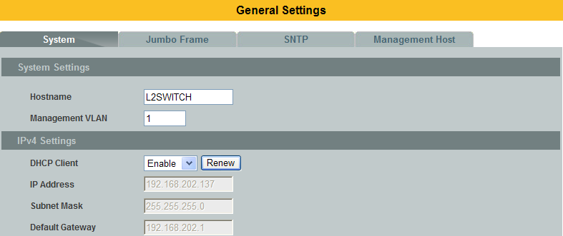
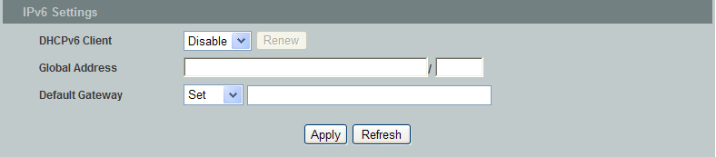

Parameter | Description
Hostname | Enter up to 64 alphanumeric characters for the name ofyour Switch. The hostname should be the combination of the digit or the alphabet or hyphens (-) or underscores (_).
Management VLAN | Enter a VLAN ID used for Switch management purposes.
IPv4 Settings
DHCP Client | Select Enable to allow the Switch to automatically get an IP address from a DHCP server. Click Renew to have the Switch re-get an IP address from the DHCP server.  Select Disable if you want to configure the Switch’s IP address manually.
IP Address | Configures an IPv4 address for your Switch in dotted decimal notation. For example, 192.168.0.254.
Subnet Mask | Enter the IP subnet mask of your Switch in dotted decimal notation for example 255.255.255.0.
Default Gateway | Enter the IP address of the default outgoing gateway in dotted decimal notation, for example 192.168.1.1.
IPv6 Settings
DHCPv6 Client | Select Enable to allow the Switch to automatically get an IP address from a DHCPv6 server. Click Renew to have the Switch re-get an IP address from the DHCP server.  Select Disable if you want to configure the Switch’s IP address manually.
IPv6 Settings
DHCPv6 Client | Select Enable to allow the Switch to automatically get an IP address from a DHCPv6 server. Click Renew to have the Switch re-get an IP address from the DHCP server.  Select Disable if you want to configure the Switch’s IP address manually.
Global Address | Configure a global IPv6 address for the Switch.
Default Gateway | Set – Set an IPv6 default gateway for the Switch.  Unset – Unset the IPv6 default gateway for the Switch.
Apply | Click this button to take effect the settings.
Refresh | Click this button to reset the fields to the last setting.

Jumbo Frame
Jumbo frames are Ethernet frames with a payload greater than 1500 bytes. Jumbo frames can enhance data transmission efficiency in a network. The bigger the frame size, the better the performance.

Notice:
- The jumbo frame settings will apply to all ports.
- If the size of a packet exceeds the jumbo frame size, the packet will be dropped.
- The available values are 1522,1536,1552,9010,9216,10240.

Default Setting: The default jumbo frame is 10240 bytes.

CLI Configuration
Node | Command | Description
enable | show jumboframe | This command displays the current jumbo frame settings.
configure | jumboframe(10240|1522|1536|1552|9010|9216) | This command configures the maximum number of bytes of frame size for all ports.
configure | interface IFNAME | This command enters the interface configure node.
interface | jumboframe(10240|1522|1536|1552|9010|9216) | This command configures the maximum number of bytes of frame size.
configure | interface range gigabitethernet1/0/PORTLISTS | This command enters the interface configure node.
if-range | jumboframe(10240|1522|1536|1552|9010|9216) | This command configures the maximum number of bytes of frame size.

Web Configuration
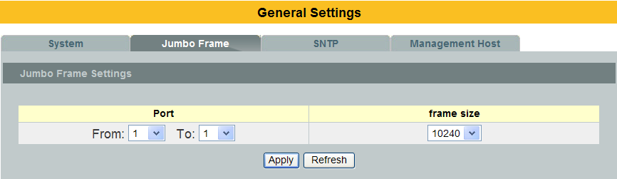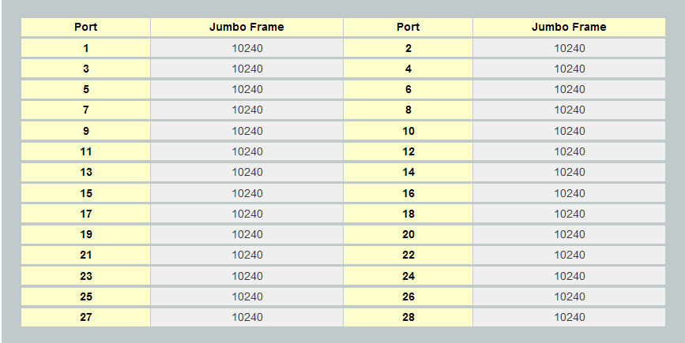

Parameter | Description
Port | This field specifies a port or a range of ports for configuration.
Frame Size | This field configures the maximum number of bytes of frame size for specified port(s).
Apply | Click this button to take effect the settings.
Refresh | Click this button to reset the fields to the last setting.

SNTP
The Network Time Protocol (NTP) is a protocol for synchronizing the clocks of computer systems over packet-switched, variable-latency data networks. A less complex implementation of NTP, using the same protocol but without requiring the storage of state over extended periods of time is known as the Simple Network Time Protocol (SNTP).NTP provides Coordinated Universal Time (UTC). No information about time zones or daylight saving time is transmitted; this information is outside its scope and must be obtained separately.

UDP Port: 123.

Daylight saving is a period from late spring to early fall when many countries set their clocks ahead of normal local time by one hour to give more daytime light in the evening.
Note:
- The SNTP server always replies the UTC current time.
- When the Switch receives the SNTP reply time, the Switch will adjust the time with the time zone configuration and then configure the time to the Switch.
- If the time server’s IP address is not configured, the Switch will not send any SNTP request packets.
- If no SNTP reply packets, the Switch will retry every 10 seconds forever.
- If the Switch has received SNTP reply, the Switch will re-get the time from NTP server every 24 hours.
- If the time zone and time NTP server have been changed, the Switch will repeat the query process.
- No default SNTP server.

Default Settings
Current Time:
-----------------------------------------------
Time: 0:3:51 (UTC)
Date: 1970-1-1

Time Server Configuration:
-----------------------------------------------
Time Zone : +00:00
IP Address : 0.0.0.0
Daylight Saving Time Configuration:
-----------------------------------------------
State : disabled
Start Date: None.
End Date : None.

CLI Configuration

Node | Command | Description
enable | show time | This command displays current time and time configurations.
configure | time HOUR:MINUTE:SECOND | Sets the current time on the Switch.  hour: 0-23  min: 0-59  sec: 0-59  Note: If you configure Daylight Saving Time after you configure the time, the Switchwill apply Daylight Saving Time.
configure | time date YEAR/MONTH/DAY | Sets the current date on the Switch.  year: 1970-  month: 1-12  day: 1-31
configure | time daylight-saving-time | This command enables the daylight saving time.
configure | time daylight-saving-time start-date(first|second|third|fourth|last)(Sunday|Monday|Tuesday|Wednesday|Thursday|Friday|Saturday) MONTH HOUR | This command sets the start time of the Daylight Saving Time.
configure | time daylight-saving-time end-date(first|second|third|fourth|last)(Sunday|Monday|Tuesday|Wednesday|Thursday|Friday|Saturday) MONTH HOUR | This command sets the end time of the Daylight Saving Time.
configure | no time daylight-saving-time | This command disables daylight saving on the Switch.
configure | time ntp-server (disable|enable) | This command disables / enables the NTP server state.
configure | time ntp-server IP_ADDRESS | This command sets the IP address of your time server.
configure | time ntp-serverdomain-name STRING | This command sets a domain name of your time server.
configure | time timezone STRING | Configures the time difference between UTC (formerlyknown as GMT) and your time zone.  Valid Range: -1200 ~ +1200.
Example:
L2SWITCH(config)#time ntp-server 192.5.41.41
L2SWITCH(config)#time timezone +0800
L2SWITCH(config)#time ntp-server enable
L2SWITCH(config)#time daylight-saving-time start-date first Monday 6 0
L2SWITCH(config)#time daylight-saving-time end-datelastSaturday10 0

Web Configuration
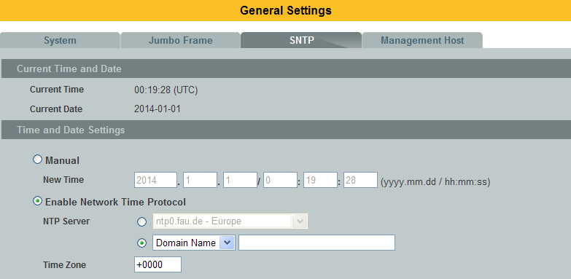
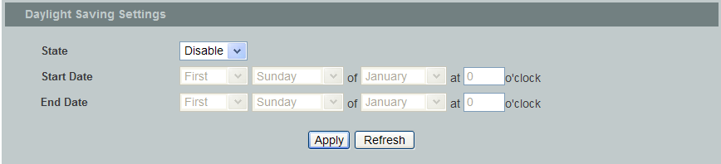

Parameter | Description
Current Time and Date
Current Time | This field displays the time you open / refresh this menu.
Current Date | This field displays the date you open / refresh this menu.
Time and Date Setting
Manual | Select this option if you want to enter the system date and time manually.
New Time | Enter the new date in year, month and day format and time in hour, minute and second format. The new date and time then appear in the Current Date and Current Time fields after you click Apply.
Enable  Network Time  Protocol | Select this option to use Network Time Protocol (NTP) for the time service.
NTP Server | Select a pre-designated time server or type the IP address or type the domain name of your timeserver. The Switch searches for the timeserver for up to 60 seconds.
Time Zone | Select the time difference between UTC (Universal Time Coordinated, formerly known as GMT, Greenwich Mean Time) and your time zone.
Daylight Saving Settings
State | Select Enable if you want to use Daylight Saving Time. Otherwise, select Disable to turn it off.
Start Date | Configure the day and time when Daylight Saving Time starts if you enabled Daylight Saving Time. The time is displayed in the 24 hour format. Here are a couple of examples:  Daylight Saving Time starts in most parts of the United States on the second Sunday of March. Each time zone in the United States starts using Daylight Saving Time at 2 A.M. local time. So in the United States you would select Second, Sunday, 3(March)and 2:00.  Daylight Saving Time starts in the European Union on the last Sunday of March. All of the time zones in the European Union start using Daylight Saving Time at the same moment (1 A.M. GMT or UTC). So in the European Union you would select Last, Sunday, 3(March)and the last field depends on your time zone. In Germany for instance, you would select 2:00 because Germany's time zone is one hour ahead of GMT or UTC (GMT+1).
End Date | Configure the day and time when Daylight Saving Time ends if you enabled Daylight Saving Time. The time field uses the 24 hour format.  Here are a couple of examples:  Daylight Saving Time ends in the United States on the last Sunday of October. Each time zone in the United States stops using Daylight Saving Time at 2 A.M. local time. So in the United States you would select First, Sunday, 11(November)and 2:00.  Daylight Saving Time ends in the European Union on the last Sunday of October. All of the time zones in the European Union stop using Daylight Saving Time at the same moment (1 A.M. GMT or UTC). So in the European Union you would select Last, Sunday, 10(October)and the last field depends on your time zone. In Germany for instance, you would select 2:00 because Germany's time zone is one hour ahead of GMT or UTC (GMT+1).
Apply | Click this button to take effect the settings.
Refresh | Click this button to reset the fields to the last setting.

Management Host
The feature limits the hosts which can manage the Switch. The default has no management host. That is, any hosts can manage the Switch via telnet or web browser. If user has configured one or more management host, the Switch can be managed by these hosts only. The feature allow user to configure management IP up to 3 entries.

Default Settings
This feature allows user to configure management host up to 3 entries.
The default is none, any host can manage the Switch via telnet or web browser.

CLI Configuration
Node | Command | Description
enable | show interface eth0 | The command displays the all of the interface eth0 configurations.
eth0 | Show | The command displays the all of the interface eth0 configurations.
eth0 | management host A.B.C.D | The command adds a management host address.
eth0 | no management host A.B.C.D | The command deletes a management host address.

Example:
L2SWITCH#configure terminal
L2SWITCH(config)#interface eth0
L2SWITCH(config-if)#management host 192.168.200.106

Web Configuration
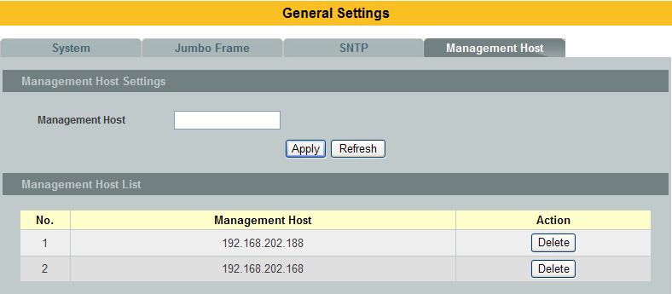

Parameter | Description
Management Host | This field configures the management host.
Apply | Click this button to take effect the settings.
Refresh | Click this button to begin configuring this screen afresh.
Management Host List
No. | This field displays a sequential number for each management host.
Management Host | This field displays the management host.
Action | Click the Delete button to remove the specified entry.

MAC Management
Dynamic Address:
The MAC addresses are learnt by the switch. When the switch receives frames, it will record the source MAC, the received port and the VLAN in the address table with an age time. When the age time is expired, the address entry will be removed from the address table.

Static Address:
The MAC addresses are configured by users. The static addresses will not be aged out by the switch. The static address can be removed by user only.
The maximum static address entry is up to 256.

The switch supports up to 16K address table. The static address and the dynamic address share the same table.

The MAC Table (a MAC table is also known as a filtering database) shows howframes are forwarded or filtered across the Switch’s ports. When a device (whichmay belong to a VLAN group) sends a packet which is forwarded to a port on theSwitch, the MAC address of the device is shown on the Switch’s MAC Table. It alsoshows whether the MAC address is dynamic (learned by the Switch) or static(manually entered).

The Switch uses the MAC Table to determine how to forward frames. See thefollowing figure.
- The Switch examines a received frame and learns the port from which this source MAC address came.
- The Switch checks to see if the frame's destination MAC address matches a source MAC address already learnt in the MAC Table.
  - If the Switch has already learnt the port for this MAC address, then it forwards the frame to that port.
  - If the Switch has not already learnt the port for this MAC address, then the frame is flooded to all ports. Too much port flooding leads to network congestion.
  - If the Switch has already learnt the port for this MAC address, but the destination port is the same as the port it came in on, then it filters the frame.

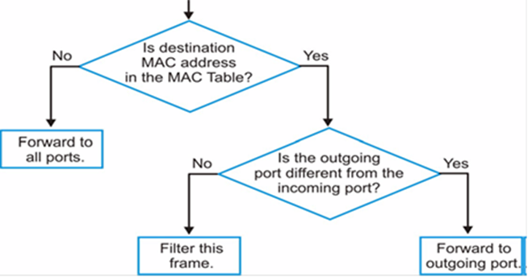

Figure: MAC Table Flowchart

Default Settings
- The default MAC address table age time is 300 seconds.
- The Maximum static address entry is 256.

CLI Configuration
Node | Command | Description
enable | show mac-address-table aging-time | This command displays the current MAC address table age time.
enable | show mac-address-table(static|dynamic) | This command displays the current static/dynamic unicast address entries.
enable | show mac-address-table mac MACADDR | This command displays information of a specific MAC.
enable | show mac-address-table port PORT_ID | This command displays the current unicast address entries learnt by the specific port.
configure | mac-address-table static MACADDR vlan VLANID port PORT_ID | This command configures a static unicast entry.
configure | no mac-address-table static MACADDR vlan VLANID | This command removes a static unicast entry from the address table.
configure | mac-address-table aging-time VALUE | This command configures the mac table aging time.
configure | clear mac address-table dynamic | This command clears the dynamic address entries.

The procedures to configure a static MAC address.
- To enter the configure node.
L2SWITCH#configure terminal
L2SWITCH(config)#

- To configure a static MAC address on port 1 of vlan 1.
L2SWITCH(config)#mac-address-table static 00:11:22:33:44:55 vlan 1 port 1

Web Configuration
Static MAC
A static Media Access Control (MAC) address is an address that has been manually entered in the MAC address table. Static MAC addresses do not age out. When you set up static MAC address rules, you are setting static MAC addresses for a port. This may reduce the need for broadcasting.

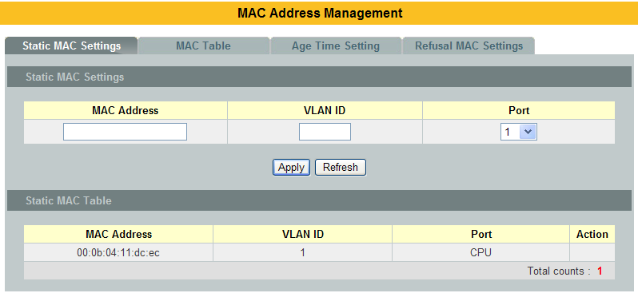

Parameter |  | Description
Static MAC Settings
MAC Address | Enter the MAC address of a computer or device that you want to add to theMAC address table.  Valid format is hh:hh:hh:hh:hh:hh.
VLAN ID | Enter the VLAN ID to apply to the computer or device.
Port | Enter the port number to which the computer or device is connected.
Apply | Click Apply to take effect the settings.
Refresh | Click this to update the information in the MAC table.
Static MAC Table
MAC Address | This field displays the MAC address of a manually entered MAC address entry.
VLAN ID | This field displays the VID of a manually entered MAC address entry.
Port | This field displays the port number of a manually entered MAC address entry. The MAC address with port CPU means the Switch’s MAC addresses itself.
Action | Click Delete to remove this manually entered MAC address entry from the MAC address table. You cannot delete the Switch’s MAC address from the static MAC address table.

MAC Table
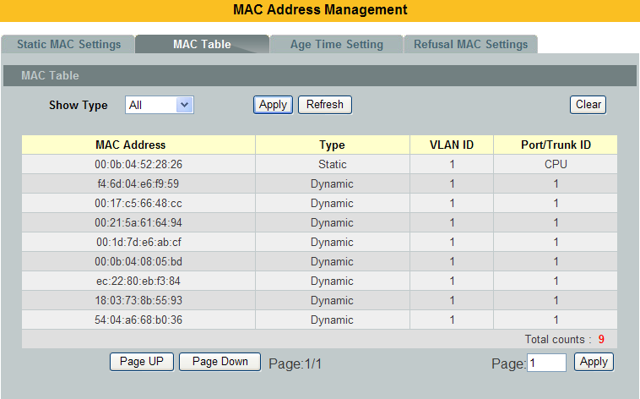

Parameter | Description
Show Type | Select the MAC type in the MAC table which you want to display.
Apply | Click this to display the information in the MAC table.
Refresh | Click this to update the information in the MAC table.
Clear | Click this to clear the entire dynamic MAC in the MAC table.
MAC Address | This field displays a MAC address.
Type | This field displays whether this entry was entered manually (Static) or whether it was learned by the Switch (Dynamic).
VLAN ID | This field displays the VLAN ID of the MAC address entry.
Port/Trunk ID | This field displays the port number (or the trunk ID) the MAC address entry is associated. It displays CPU if it is the entry for the Switch itself.  The CPU means that it is the Switch’s MAC.
Total Counts | This field displays the total entries in the MAC table.
Page Up | Click the button to display previous page of the MAC address.
Page Down | Click the button to display next page of the MAC address.
Page | The current page of the MAC address.  You also input the page ID and then click the Apply button to display the page of the MAC address.

Age Time Settings
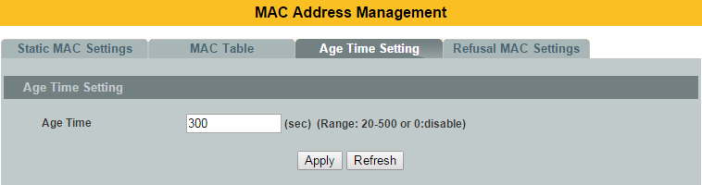

Parameter | Description
Age Time | Configure the age time, the valid range is from 20 to 500 seconds. The default value is 300 seconds.
Apply | Click Apply to take effect the settings.
Refresh | Click this to update the information in the MAC table.

Refusal MAC settings (Black-hole MAC)
This type of MAC address entries are configured manually. A switch discards the packets destined for or originated from the MAC addresses contained in black hole MAC address entries. Black hole entries are configured for filtering out frames with specific source or destination MAC addresses

Notice: User can configure up to 20 entries.

CLI Configuration
Node | Command | Description
enable | show mac-address-table refusal | This command displays the current refusal MAC address only.
configure | mac-address-table refusal MACADDR vlan VLANID | This command configures a refusal MAC on a specific VLAN.
configure | mac-address-table refusal MACADDR | This command configures a refusal MAC.

The procedures to configure a refusal MAC address.
- To enter the configure node.
L2SWITCH#configure terminal
L2SWITCH(config)#

- To configure a refusal MAC address for all ports and all vlans.
L2SWITCH(config)#mac-address-table refusal 00:11:22:33:44:55

- To configure a refusal MAC address for all ports on a specific vlan.
L2SWITCH(config)#mac-address-table refusal 00:11:22:33:44:55 vlan 1.

Web Configuration
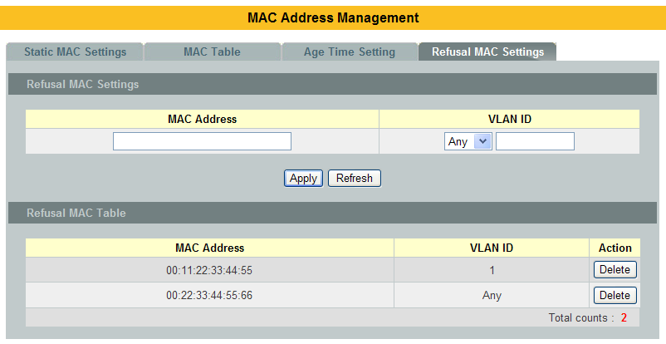

Parameter | Description
MAC Address | Enter the MAC address of a computer or device that you want to refusal.  Valid format is hh:hh:hh:hh:hh:hh.
VLAN ID | Enter the VLAN ID to apply to the computer or device.
Apply | Click Apply to take effect the settings.
Refresh | Click Refresh to begin configuring this screen afresh.
MAC Address | This field displays a MAC address.
VLAN ID | This field displays the VLAN ID of the MAC address entry.
Action | Click Delete to remove this manually entered MAC address entry from the refusal MAC address table.
Total Counts | This field displays the total entries in the refusal MAC table.

Port Mirror
Port-based Mirroring
The Port-Based Mirroring is used on a network switch to send a copy of network packets sent/received on one or a range of switch ports to a network monitoring connection on another switch port (Monitor-to Port). This is commonly used for network appliances that require monitoring of network traffic, such as an intrusion-detection system.
Port Mirroring, together with a network traffic analyzer, helps to monitor network traffic. Users can monitor the selected ports (Source Ports) for egress and/or ingress packets.

Source Mode:
Ingress : The received packets will be copied to the monitor port.
Egress : The transmitted packets will be copied to the monitor port.
Both : The received and transmitted packets will be copied to the monitor port.

Note:
- The monitor port cannot be a trunk member port.
- The monitor port cannot be ingress or egress port.
- If the Port Mirror function is enabled, the Monitor-to Port can receive mirrored packets only.
- If a port has been configured as a source port and then user configures the port as a destination port, the port will be removed from the source ports automatically.

Default Settings
Mirror Configurations:
State : Disable
Monitor port : 1
Ingress port(s) : None
Egress port(s) : None

CLI Configuration
Node | Command | Description
enable | show mirror | This command displays the current port mirroring configurations.
configure | mirror (disable|enable) | This command disables / enables the port mirroring on the switch.
configure | mirror destination port PORT_ID | This command specifies the monitor port for the port mirroring.
configure | mirror source ports PORT_LIST mode (both|ingress|egress) | This command adds a port or a range of ports as the source ports of the port mirroring.
configure | no mirror source ports PORT_LIST | This command removes a port or a range of ports from the source ports of the port mirroring.

The procedures to configure the port mirror.
- To enter the configure node.
L2SWITCH#configure terminal
L2SWITCH(config)#

- To enable the global mirror function.
L2SWITCH(config)#mirror enable

- To configure the monitor port to port 2.
L2SWITCH(config)#mirror destination port 2

- To configure the source ports which you want to check.
L2SWITCH(config)#mirror source ports 3-10 mode both

Web Configuration
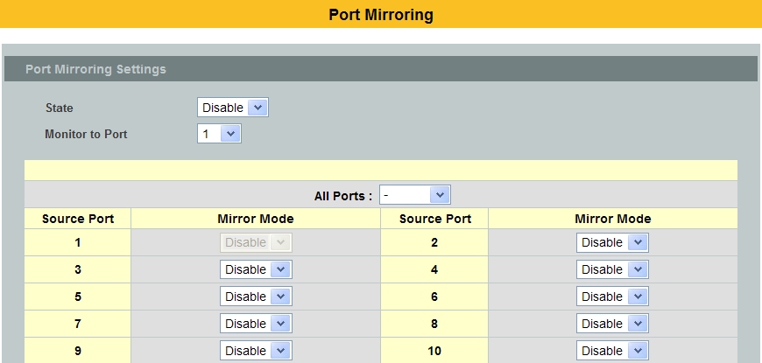
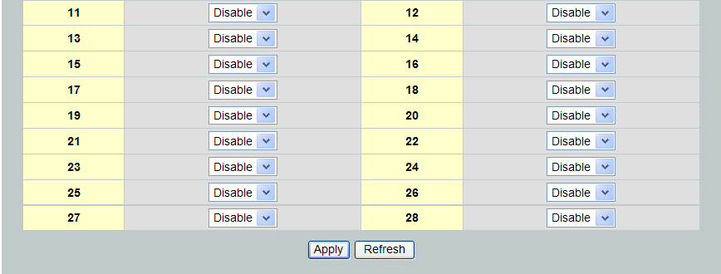

Parameter | Description
State | Select Enable to turn on port mirroring or select Disable to turn it off.
Monitor to Port | Select the port which connects to a network traffic analyzer.
All Ports | Settings in this field apply to all ports.  Use this field only if you want to make some settings the same for all ports.  Use this field first to set the common settings and then make adjustments on a port-by-port basis.
Source Port | This field displays the number of a port.
Mirror Mode | Select Ingress, Egress or Both to only copy the ingress (incoming), egress (outgoing) or both (incoming and outgoing) traffic from the specified source ports to the monitor port. Select Disable to not copy any traffic from the specified source ports to the monitor port.
Apply | Click Apply to take effect the settings.
Refresh | Click Refresh to begin configuring this screen afresh.

Port Settings
- Duplex mode
A duplex communication system is a system composed of two connected parties or devices that can communicate with one another in both directions.

Half Duplex:
A half-duplex system provides for communication in both directions, but only one direction at a time (not simultaneously). Typically, once a party begins receiving a signal, it must wait for the transmitter to stop transmitting, before replying.
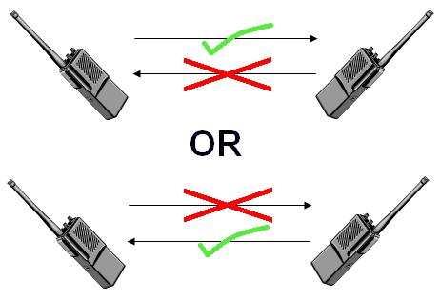

Full Duplex:
A full-duplex, or sometimes double-duplex system, allows communication in both directions, and, unlike half-duplex, allows this to happen simultaneously. Land-line telephone networks are full-duplex, since they allow both callers to speak and be heard at the same time.


- Loopback Test
A loopback test is a test in which a signal in sent from a communications device and returned (looped back) to it as a way to determine whether the device is working right or as a way to pin down a failing node in a network. One type of loopback test is performed using a special plug, called a wrap plug, that is inserted in a port on a communications device. The effect of a wrap plug is to cause transmitted (output) data to be returned as received (input) data, simulating a complete communications circuit using a single computer.

- Auto MDI-MDIX
Auto-MDIX (automatic medium-dependent interface crossover) is a computer networking technology that automatically detects the required cable connection type (straight-through or crossover) and configures the connection appropriately, thereby removing the need for crossover cables to interconnect switches or connecting PCs peer-to-peer. When it is enabled, either type of cable can be used and the interface automatically corrects any incorrect cabling. For Auto-MDIX to operate correctly, the speed on the interface and duplex setting must be set to "auto". Auto-MDIX was developed by HP engineers Dan Dove and Bruce Melvin.

The original "HP Auto-MDIX" invention was spawned one day when Bruce was looking for a cross-over cable in the lab. His efforts were being hampered and out of frustration he asked Dan "Can't you invent a way so I don't need these “cross-over cables” His inspiration led Dan to develop the method which utilizes a pseudo-random number generator to decide whether or not a network port will attach its transmitter, or its receiver to each of the twisted pairs used to Auto-Negotiate the link.

Subsequently, Dan went on to promote Auto-MDIX within the IEEE-802.3ab (1000BASE-T) standard and also develop patented algorithms for "Forced Mode Auto-MDIX" which allows a link to be automatically established even if the port does not auto-negotiate.

- Auto Negotiation
Auto (auto-negotiation) allows one port to negotiate with a peer port automatically to obtain the connection speed and duplex mode that both ends support. When auto-negotiation is turned on, a port on the Switch negotiates with the peer automatically to determine the connection speed and duplex mode.

If the peer port does not support auto-negotiation or turns off this feature, the Switch determines the connection speed by detecting the signal on the cable and using half-duplex mode. When the Switch’s auto-negotiation is turned off, a port uses the pre-configured speed and duplex mode when making a connection, thus requiring you to make sure that the settings of the peer port are the same in order to connect.
- Flow Control
A concentration of traffic on a port decreases port bandwidth and overflows buffer memory causing packet discards and frame losses. Flow Control is used toregulate transmission of signals to match the bandwidth of the receiving port.
The Switch uses IEEE802.3x flow control in full duplex mode and backpressureflow control in half duplex mode.

IEEE802.3x flow control is used in full duplex mode to send a pause signal to thesending port, causing it to temporarily stop sending signals when the receivingport memory buffers fill.

Back Pressure flow control is typically used in half duplex mode to send a"collision" signal to the sending port (mimicking a state of packet collision)causing the sending port to temporarily stop sending signals and resend later.

Note: 1000 Base-T doesn’t support force mode.

Cable Test.
This feature determines the quality of the cables, shorts, and cable impedance mismatch, bad connectors, termination mismatch, and bad magnetics. The feature can work on the copper Ethernet cable only.

Default Settings
- The default port Speed & Duplex is auto for all ports.
- The default port Flow Control is Off for all ports.

CLI Configuration
Node | Command | Description
enable | show interface IFNAME | This command displays the current port configurations.
configure | interface IFNAME | This command enters the interface configure node.
interface | show | This command displays the current port configurations.
interface | loopback (none| mac) | This command tests the loopback mode of operation for the specific port.
interface | flowcontrol (off | on) | This command disables / enables the flow control for the port.
interface | speed (auto|10-full||10-half| 100-full|100-half|1000-full) | This command configures the speed and duplex for the port.
interface | shutdown | This command disables the specific port.
interface | no shutdown | This command enables the specific port.
interface | description STRINGs | This command configures a description for the specific port.
interface | no description | This command configures the default port description.
interface | cable-test start | This command starts to diagnostics the Ethernet cable.
interface | clean cable-test result | This command cleans the test result of the Ethernet cable test.
interface | show cable-test result | This command displays the test result of the Ethernet cable test.
configure | interface range gigabitethernet1/0/PORTLISTS | This command enters the interface configure node.
if-range | description STRINGs | This command configures a description for the specific ports.
if-range | no description | This command configures the default port description for the specific ports.
if-range | shutdown | This command disables the specific ports.
if-range | no shutdown | This command enables the specific ports.
if-range | speed (auto|10-full||10-half| 100-full|100-half|1000-full) | This command configures the speed and duplex for the port.

Web Configuration
General Settings:
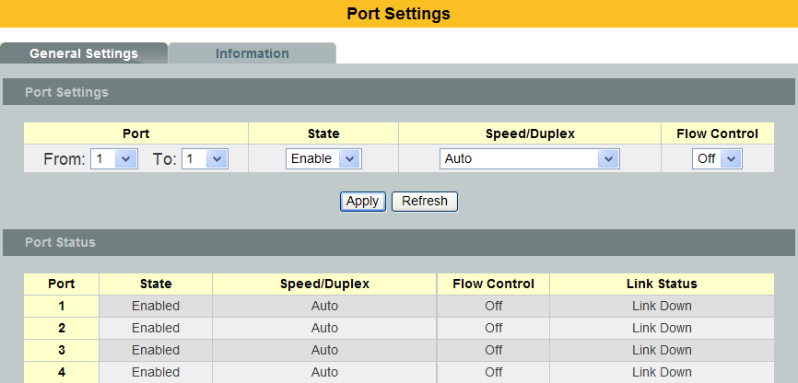
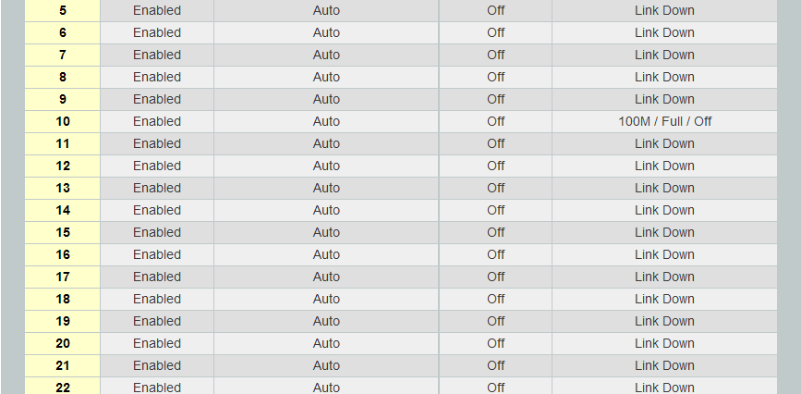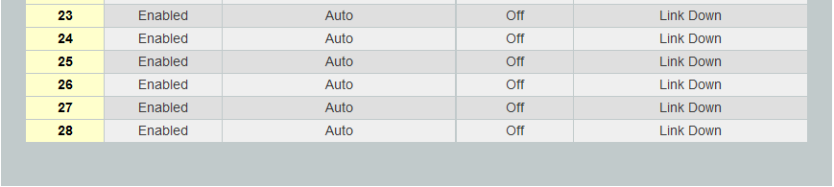

Parameter | Description
Port | Select a port or a range ports you want to configure on this screen.
State | Select Enable to activate the port or Disable to deactivate the port.
Speed/Duplex | Select the speed and duplex mode of the port. The choices are:  • Auto  • 10 Mbps / Full Duplex  • 10 Mbps / Half Duplex  • 100 Mbps / Full Duplex  • 100 Mbps / Half Duplex  • 1000 Mbps / Full Duplex
Flow Control | Select On to enable access to buffering resources for the port thus ensuring lossless operation across network switches. Otherwise, select Off to disable it.
Apply | Click Apply to take effect the settings.
Refresh | Click Refresh to begin configuring this screen afresh.
Port | This field displays the port number.
State | This field displays whether the port is enabled or disabled.
Speed/Duplex | This field displays the speed either 10M, 100Mor 1000Mand the duplex mode Full or Half.
Flow Control | This field displays whether the port’s flow control is On or Off.
Link Status | This field displays the link status of the port. If the port is up, it displays the port’s speed, duplex and flow control setting. Otherwise, it displays Link Down if the port is disabled or not connected to any device.

Information:
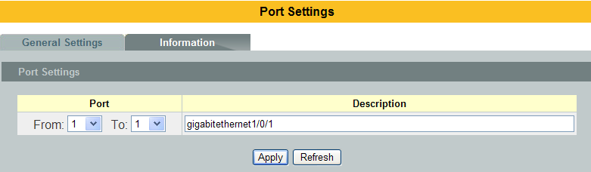
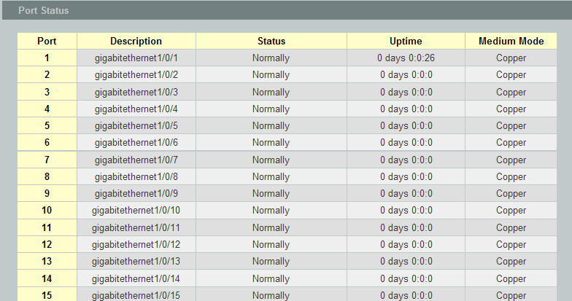
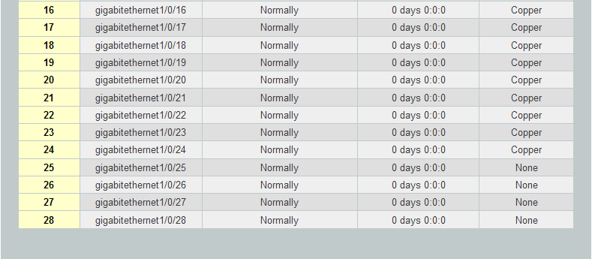

Parameter | Description
Port | Select a port or a range ports you want to configure on this screen.
Description | Configures a meaningful name for the port(s).
Port Status
Port | This field displays the port number.
Description | The meaningful name for the port.
Status | The field displays the detail port status if the port is blocked by some protocol.
Uptime | The sustained time from last link up.
Medium Mode | The current working medium mode, copper or fiber, for the port.

Advanced Settings

Bandwidth Control

QoS
Each egress port can support up to 8 transmit queues. Each egress transmit queue contains a list specifying the packet transmission order. Every incoming frame is forwarded to one of the 8 egress transmit queues of the assigned egress port, based on its priority. The egress port transmits packets from each of the 8 transmit queues according to a configurable scheduling algorithm, which can be a combination of Strict Priority (SP) and/or Weighted Round Robin (WRR).

Typically, networks operate on a best-effort delivery basis, which means that all traffic has equal priority and an equal chance of being delivered in a timely manner. When congestion occurs, all traffic has an equal chance of being dropped.

When you configure the QoS feature, you can select specific network traffic, prioritize it according to its relative importance, and use congestion-management and congestion-avoidance techniques to give preferential treatment. Implementing QoS in your network makes network performance more predictable and bandwidth utilization more effective.

The Switch supports 802.1p priority queuing. The Switch has 8 priority queues. These priority queues are numbered from 7 (Class 7) — the highest priority queue — to 0 (Class 0) — the lowest priority queue.
The eight priority tags specified in IEEE 802.1p (p0 to p7) are mapped to the Switch’s priority queues as follows:

Priority : 0 1 2 3 4 5 6 7
Queue : 2 0 1 3 4 5 6 7

Priority scheduling is implemented by the priority queues stated above. The Switch will empty the four hardware priority queues in order, beginning with the highest priority queue, 7, to the lowest priority queue, 0. Each hardware queue will transmit all of the packets in its buffer before permitting the next lower priority to transmit its packets. When the lowest hardware priority queue has finished transmitting all of its packets, the highest hardware priority queue will begin transmitting any packets it may have received.

QoS Enhancement
You can configure the Switch to prioritize traffic even if the incoming packets are not marked with IEEE 802.1p priority tags or change the existing priority tags based on the criteria you select. The Switch allows you to choose one of the following methods for assigning priority to incoming packets on the Switch:

- 802.1p Tag Priority - Assign priority to packets based on the packet’s 802.1p tagged priority.
- Port Based QoS - Assign priority to packets based on the incoming port on the Switch.
- DSCP Based QoS - Assign priority to packets based on their Differentiated Services Code Points (DSCPs).

Note: Advanced QoS methods only affect the internal priority queue mapping for the Switch. The Switch does not modify the IEEE 802.1p value for the egress frames. You can choose one of these ways to alter the way incoming packets are prioritized or you can choose not to use any QoS enhancement setting on the Switch.

802.1p Priority
When using 802.1p priority mechanism, the packet is examined for the presence of a valid 802.1p priority tag. If the tag is present, the packet is assigned to a programmable egress queue based on the value of the tagged priority. The tagged priority can be designated to any of the available queues.

Ethernet Packet:
6 | 6 | 2 | 42-1496 | 4
DA | SA | Type / Length | Data | FCS

6 | 6 | 4 | 2 | 42-1496 | 4
DA | SA | 802.1Q Tag | Type / Length | Data | FCS

802.1Q Tag:
2 bytes | 2 bytes
Tag Protocol Identifier (TPID) | Tag Control Information (TCI)
16 bits | 3 bits | 1 bit | 12 bits
TPID (0x8100) | Priority | CFI | VID

- Tag Protocol Identifier (TPID): a 16-bit field set to a value of 0x8100 in order to identify the frame as an IEEE 802.1Q-tagged frame.
- Tag Control Information (TCI)
  - Priority Code Point (PCP): a 3-bit field which refers to the IEEE 802.1p priority. It indicates the frame priority level from 0 (lowest) to 7 (highest), which can be used to prioritize different classes of traffic (voice, video, data, etc).
  - Canonical Format Indicator (CFI): a 1-bit field. If the value of this field is 1, the MAC address is in non-canonical format. If the value is 0, the MAC address is in canonical format. It is always set to zero for Ethernet switches. CFI is used for compatibility between Ethernet and Token Ring networks. If a frame received at an Ethernet port has a CFI set to 1, then that frame should not be bridged to an untagged port.
  - VLAN Identifier (VID): a 12-bit field specifying the VLAN to which the frame belongs. A value of 0 means that the frame doesn't belong to any VLAN; in this case the 802.1Q tag specifies only a priority and is referred to as a priority tag. A value of hex 0xFFF is reserved for implementation use. All other values may be used as VLAN identifiers, allowing up to 4094 VLANs. On bridges, VLAN 1 is often reserved for management.
Priority Levels:
PCP: Priority Code Point.
PCP | Network Priority | Traffic Characteristics
1 | 0 (lowest) | Background
0 | 1 | Best Effort
2 | 2 | Excellent Effort
3 | 3 | Critical Applications
4 | 4 | Video, <100 ms latency
5 | 5 | Video, < 10 ms latency
6 | 6 | Internetwork Control
7 | 7 (highest) | Network Control

DiffServ (DSCP)
Differentiated Services or DiffServ is a computer networking architecture that specifies a simple, scalable and coarse-grained mechanism for classifying, managing network traffic and providing Quality of Service (QoS) guarantees on modern IP networks. DiffServ can, for example, be used to provide low-latency, guaranteed service (GS) to critical network traffic such as voice or video while providing simple best-effort traffic guarantees to non-critical services such as web traffic or file transfers.

Differentiated Services Code Point (DSCP) is a 6-bit field in the header of IP packets for packet classification purposes. DSCP replaces the outdated IP precedence, a 3-bit field in the Type of Service byte of the IP header originally used to classify and prioritize types of traffic.

When using the DiffServ priority mechanism, the packet is classified based on the DSCP field in the IP header. If the tag is present, the packet is assigned to a programmable egress queue based on the value of the tagged priority. The tagged priority can be designated to any of the available queues.

Version | IHL | Type of Service | Total Length
Identification |  |  | Flags | Fragment Offset
Time to Live |  | Protocol | Header Checksum
Source Address
Destination Address
Options |  |  |  |  | Padding
Example Internet Datagram Header

IP Header Type of Service: 8 bits

The Type of Service provides an indication of the abstract parameters of the quality of service desired. These parameters are to be used to guide the selection of the actual service parameters when transmitting a datagram through a particular network. Several networks offer service precedence, which somehow treats high precedence traffic as more important than other traffic (generally by accepting only traffic above a certain precedence at time of high load). The major choice is a three way tradeoff between low-delay, high-reliability, and high-throughput.

Bits 0-2: Precedence.
Bit 3: 0 = Normal Delay, 1 = Low Delay.
Bits 4: 0 = Normal Throughput, 1 = High Throughput.
Bits 5: 0 = Normal Reliability, 1 = High Reliability.
Bit 6-7: Reserved for Future Use.

0 1 2 3 4 5 6 7
+-----+-----+-----+-----+-----+-----+-----+-----+
| PRECEDENCE | D | T | R | 0 | 0 |
+-----+-----+-----+-----+-----+-----+-----+-----+

Precedence
111 - Network Control
110 - Internetwork Control
101 - CRITIC/ECP
100 - Flash Override
011 - Flash
010 - Immediate
001 - Priority
000 - Routine

The use of the Delay, Throughput, and Reliability indications may increase the cost (in some sense) of the service. In many networks better performance for one of these parameters is coupled with worse performance on another. Except for very unusual cases at most two of these three indications should be set.

The type of service is used to specify the treatment of the datagram during its transmission through the internet system. Example mappings of the internet type of service to the actual service provided on networks such as AUTODIN II, ARPANET, SATNET, and PRNET is given in "Service Mappings".

The Network Control precedence designation is intended to be used within a network only. The actual use and control of that designation is up to each network. The Internetwork Control designation is intended for use by gateway control originators only.

If the actual use of these precedence designations is of concern toa particular network, it is the responsibility of that network to control the access to, and use of, those precedence designations.

DSCP Priority DSCP Priority DSCP Priority
0 0 1 0 2 0
. . .
60 0 61 0 62 0
63 0
Example:
IP Header
DSCP=50 45 C8 . . .

Queuing Algorithms
Queuing algorithms allow switches to maintain separate queues for packets fromeach individual source or flow and prevent a source from monopolizing thebandwidth.

- Strict-Priority (SPQ)
The packets on the high priority queue are always service firstly.

- Weighted round robin (WRR)
Round Robin scheduling services queues on a rotating basis and is activated only when a port has more traffic than it can handle. A queue is given an amount of bandwidth irrespective of the incoming traffic on that port. This queue then moves to the back of the list. The next queue is given an equal amount of bandwidth, and then moves to the end of the list; and so on, depending on the number of queues being used. This works in a looping fashion until a queue is empty.

Weighted Round Robin (WRR) scheduling uses the same algorithm as round robin scheduling, but services queues based on their priority and queue weight (the number you configure in the queue Weight field) rather than a fixed amount of bandwidth. WRR is activated only when a port has more traffic than it can handle. Queues with larger weights get more service than queues with smaller weights. This queuing mechanism is highly efficient in that it divides any available bandwidth across the different traffic queues and returns to queues that have not yet emptied.

Default Settings
Qos mode : High First (SPQ)
The mapping of the Priority to Queue are:
PRIO 0 ==> COSQ 2
PRIO 1 ==> COSQ 0
PRIO 2 ==> COSQ 1
PRIO 3 ==> COSQ 3
PRIO 4 ==> COSQ 4
PRIO 5 ==> COSQ 5
PRIO 6 ==> COSQ 6
PRIO 7 ==> COSQ 7

The DiffServ is disabled on the switch.

DSCP Priority DSCP Priority DSCP Priority DSCP Priority
---- -------- ---- -------- ---- -------- ---- --------
00 0 01 0 02 0 03 0
04 0 05 0 06 0 07 0
08 0 09 0 10 0 11 0
12 0 13 0 14 0 15 0
16 0 17 0 18 0 19 0
20 0 21 0 22 0 23 0
24 0 25 0 26 0 27 0
28 0 29 0 30 0 31 0
32 0 33 0 34 0 35 0
36 0 37 0 38 0 39 0
40 0 41 0 42 0 43 0
44 0 45 0 46 0 47 0
48 0 49 0 50 0 51 0
52 0 53 0 54 0 55 0
56 0 57 0 58 0 59 0
60 0 61 0 62 0 63 0

Note: If the DiffServ is disabled, the 802.1p tag priority will be used.

CLI Configuration
Node | Command | Description
enable | show queue cos-map | This command displays the current 802.1p priority mapping to the service queue.
enable | show qos mode | This command displays the current QoS scheduling mode of IEEE 802.1p.
configure | queue cos-map PRIORITYQUEUE_ID | This command configures the 802.1p priority mapping to the service queue.
configure | no queue cos-map | This command configures the 802.1p priority mapping to the service queue to default.
configure | qos mode high-first | This command configures the QoS scheduling mode to high_first, each hardware queue will transmit all of the packets in its buffer before permitting the next lower priority to transmit its packets.
configure | qos mode wrr-queue weights VALUE VALUE VALUE VALUE | This command configures the QoS scheduling mode to Weighted Round Robin.
interface | default-priority | This command allows the user to specify a default priority handling of untagged packets received by the Switch. The priority value entered with this command will be used to determine which of the hardware priority queues the packet is forwarded to. Default: 0.
interface | no default-priority | This command configures the default priority for the specific port to default (0).
enable | show diffserv | This command displays DiffServ configurations.
configure | diffserv (disable|enable) | This command disables / enables the DiffServ function.
configure | diffserv dscp VALUE priority VALUE | This command sets the DSCP-to-IEEE 802.1q mappings.

Web Configuration
Port Priority
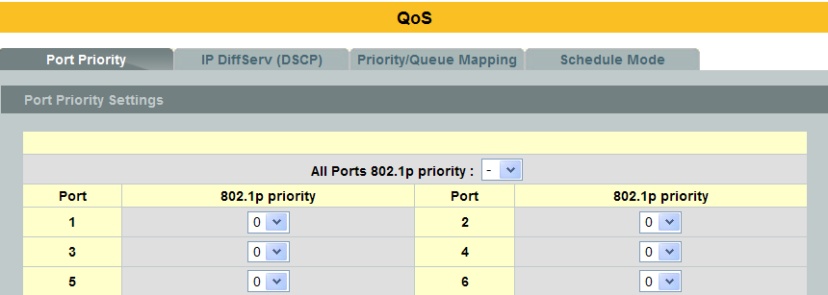
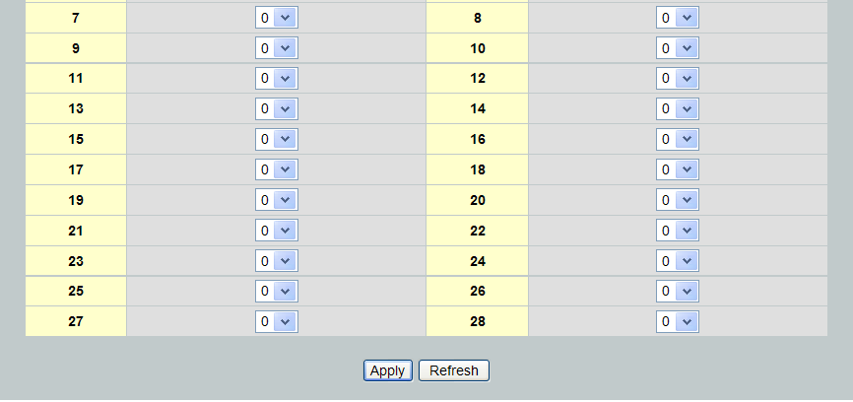

Parameter | Description
All Ports 802.1p  priority | Use this field to set a priority for all ports. The value indicates packet priority and is added to the priority tag field of incoming packets. The values range from 0 (lowest priority) to 7 (highest priority).
Port | This field displays the number of a port.
802.1p Priority | Select a priority for packets received by the port. Only packets without a802.1p priority tagged will be applied the priority you set here.
Apply | Click Apply to take effect the settings.
Refresh | Click Refresh to begin configuring this screen afresh.

IP DiffServ (DSCP)
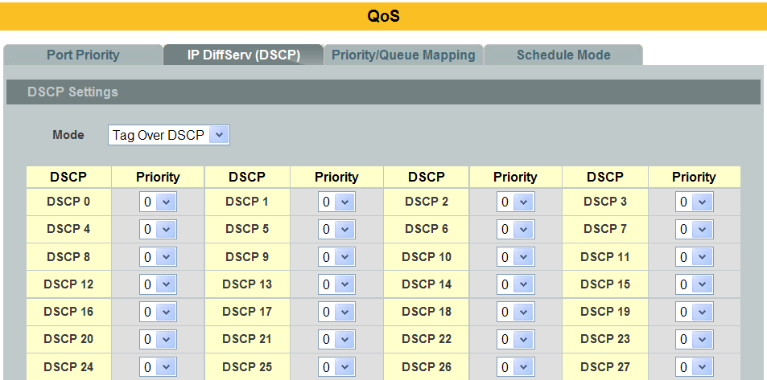
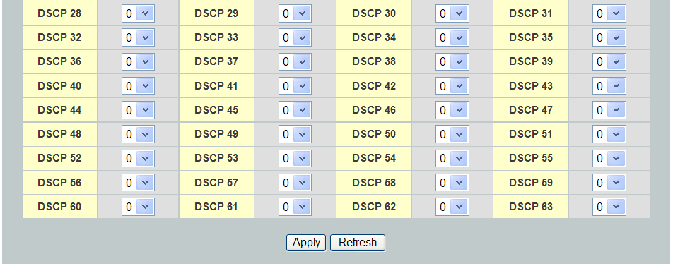

Parameter | Description
Mode | “Tag Over DSCP” or “DSCP Over Tag”.“Tag Over DSCP” means the 802.1p tag has higher priority than DSCP.
Priority | This field displays each priority level. The values range from 0 (lowest priority) to 7 (highest priority).
Apply | Click Apply to take effect the settings.
Refresh | Click Refresh to begin configuring this screen afresh.

Priority/Queue Mapping
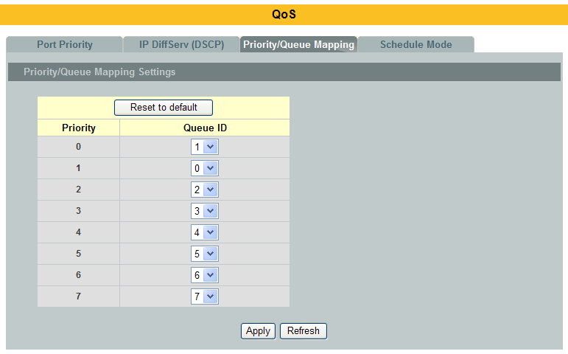

Parameter | Description
Reset to Default | Click this button to reset the priority to queue mappings to the defaults.
Priority | This field displays each priority level. The values range from 0 (lowest priority) to 7 (highest priority).
Queue ID | Select the number of a queue for packets with the priority level.
Apply | Click Apply to take effect the settings.
Refresh | Click Refresh to begin configuring this screen afresh.

Schedule Mode
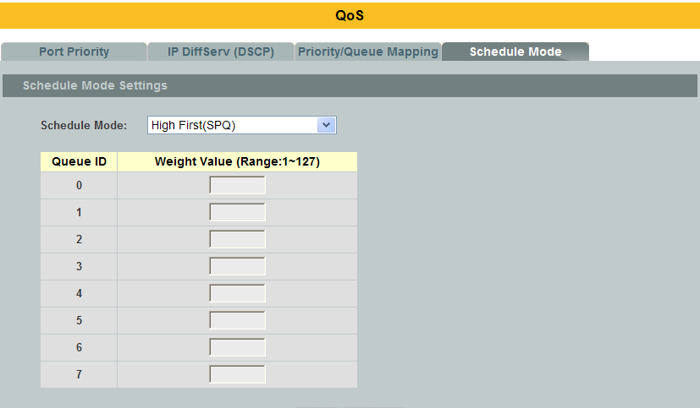

Parameter | Description
Schedule Mode | Select Strict Priority (SP) or Weighted Round Robin (WRR).  Note: Queue weights can only be changed when Weighted Round Robin is selected.  Weighted Round Robin scheduling services queues on a rotating basis based on their queue weight (the number you configure in the queue Weight field). Queues with larger weights get more service than queues with smaller weights.
Queue ID | This field indicates which Queue (0 to 3) you are configuring. Queue 0 has the lowest priority and Queue 3 the highest priority.
Weight Value | You can only configure the queue weights when Weighted Round Robin is selected. Bandwidth is divided across the different traffic queues according to their weights.
Apply | Click Apply to take effect the settings.
Refresh | Click Refresh to begin configuring this screen afresh.

Rate Limitation

Storm Control
A broadcast storm means that your network is overwhelmed with constant broadcast or multicast traffic. Broadcast storms can eventually lead to a complete loss of network connectivity as the packets proliferate.

Storm Control protects the Switch bandwidth from flooding packets, including broadcast packets, multicast packets, and destination lookup failure (DLF). The Rate is a threshold that limits the total number of the selected type of packets. For example, if the broadcast and multicast options are selected, the total amount of packets per second for those two types will not exceed the limit value.

Broadcast storm control limits the number of broadcast, multicast and unknown unicast (also referred to as Destination Lookup Failure or DLF) packets the Switch receives per second on the ports. When the maximum number of allowable broadcast, multicast and unknown unicast packets is reached per second, the subsequent packets are discarded. Enable this feature to reduce broadcast, multicast and unknown unicast packets in your network.

Storm Control unit : 652 pps.

Default Settings
Broadcast Storm Control : 652 pps.
Multicast Storm Control : None.
DLF Storm Control : 652 pps.

CLI Configuration
Node | Command | Description
enable | show storm-control | This command displays the current storm control configurations.
configure | storm-control rate RATE_LIMIT type (bcast | mcast | DLF | bcast+mcast | bcast+DLF | mcast+DLF | bcast+mcast+DLF) ports PORTLISTS | This command enables the bandwidth limit for broadcast or multicast or DLF packets and set the limitation.
configure | no storm-controltype (bcast | mcast | DLF | bcast+mcast | bcast+DLF | mcast+DLF | bcast+mcast+DLF) ports PORTLISTS | This command disables the bandwidth limit for broadcast or multicast or DLF packets.

Example:
L2SWITCH#configure terminal
L2SWITCH(config)#storm-control rate 1 type bcast ports 1-6
L2SWITCH(config)#storm-control rate 1 type mcast ports 1-6
L2SWITCH(config)#storm-control rate 1 type DLF ports 1-6

Web Configuration
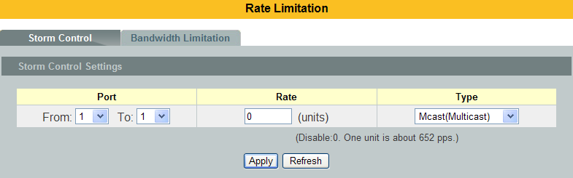
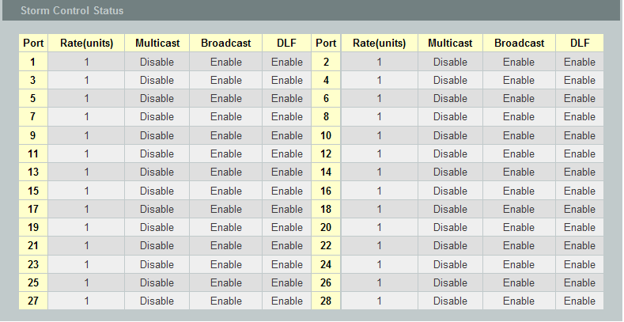

Parameter | Description
Port | Select the port number for which you want to configure storm control settings.
Rate | Select the number of packets (of the type specified in the Type field) per second the Switch can receive per second.
Type | Select Broadcast - to specify a limit for the amount of broadcast packets received per second.  Multicast - to specify a limit for the amount of multicast packets received per second.  DLF - to specify a limit for the amount of DLF packets received per second.
Apply | Click Apply to take effect the settings.
Refresh | Click Refresh to begin configuring this screen afresh.

Bandwidth Limitation
The rate limitation is used to control the rate of traffic sent or received on a network interface.

Rate Limitation unit: Mbps.

Default Setting: All ports’ Ingress and Egress rate limitation are disabled.

CLI Configuration
Node | Command | Description
enable | show bandwidth-limit | This command displays the current rate control configurations.
configure | bandwidth-limit egress RATE_LIMIT ports PORTLISTS | This command enables the bandwidth limit for outgoing packets and set the limitation.
configure | no bandwidth-limit egress ports PORTLISTS | This command disables the bandwidth limit for outgoing packets.
configure | bandwidth-limit ingress RATE_LIMIT ports PORTLISTS | This command enables the bandwidth limit for incoming packets and set the limitation.
configure | no bandwidth-limit ingress ports PORTLISTS | This command disables the bandwidth limit for incoming packets.

Example:
L2SWITCH#configure terminal
L2SWITCH(config)#bandwidth-limit egress 1 ports 1-6
L2SWITCH(config)#bandwidth-limit ingress 1 ports 1-6

Web Configuration
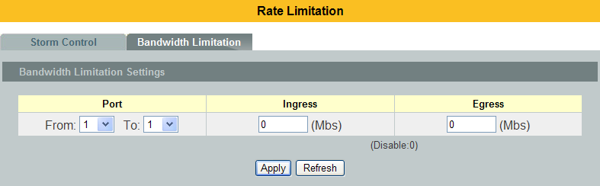
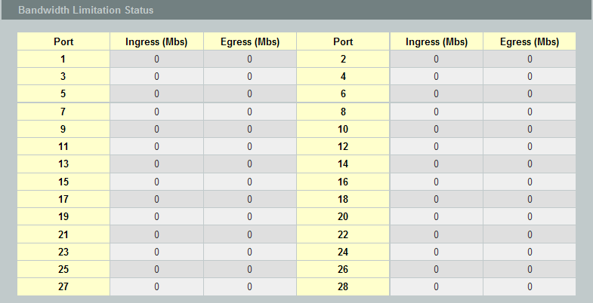

Parameter | Description
Port | Selects a port that you want to configure.
Ingress | Configures the rate limitation for the ingress packets.
Egress | Configures the rate limitation for the egress packets.
Apply | Click Apply to take effect the settings.
Refresh | Click Refresh to begin configuring this screen afresh.

DHCPv6
    - DHCPv6 Options
      - CLI Configurations
Node | Command | Description
enable | show ipv6 dhcp-options | This command displays the IPv6 DHCP option configurations.
configure | ipv6 dhcp-options option_18(disable|enable) | This command enables/disables the IPv6 DHCP option 18.
configure | ipv6 dhcp-options option_37 | This command enables/disables the IPv6 DHCP option 37.

      - Web Configurations
Option 18
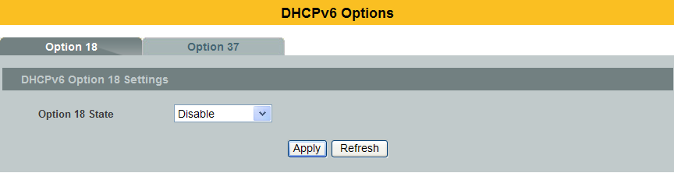

Parameter | Description
Option 18 State | The field enables / disables the option 18.

Option 37
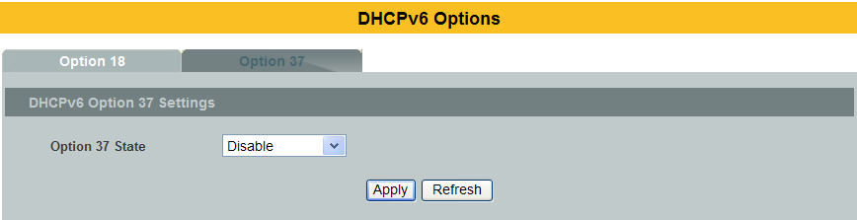

Parameter | Description
Option 37 State | The field enables / disables the option 37.

    - DHCPv6 Relay
      - CLI Configurations
Node | Command | Description
enable | show ipv6 dhcp relay | This command displays the IPv6 DHCP Relay configurations.
configure | ipv6 dhcp relay (enable|disable) | This command enables/disables the IPv6 DHCP Relay.
configure | ipv6 dhcp relay hops_count_limit<1-32> | This command configures hop count limitation for IPv6 DHCP Relay.
configure | ipv6 dhcp relay vlanSTRINGS | This command enables the IPv6 DHCP Relay in a vlan or a range of vlan.
configure | no ipv6 dhcp relay vlanSTRINGS | This command disables the IPv6 DHCP Relay in a vlan or a range of vlan.

      - Web Configurations
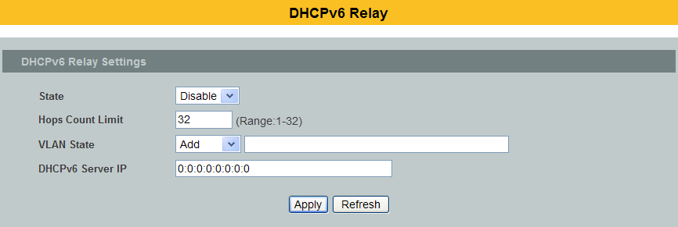
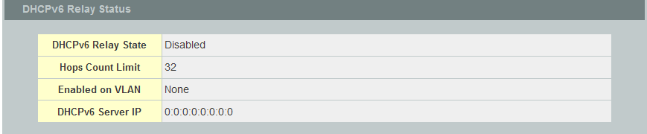

Parameter | Description
State | The field enables / disables the Ipv6 DHCP Relay.
Hops Count Limit | The field configures the hops count limit for the IPv6 DHCP Relay.
VLAN State | The field enables / disables the Ipv6 DHCP Relay in a vlan or a range of vlans.
DHCPv6 Server IP | The field configures the DHCPv6 server’s IP.

IGMP Snooping

IGMP Snooping
The IGMP snooping is for multicast traffic. The Switch can passively snoop on IGMP packets transferred between IP multicast routers/switches and IP multicast hosts to learn the IP multicast group membership. IGMP snooping allows the Switch to learn multicast groups without you having to manually configure them.

The Switch can passively snoop on IGMP packets transferred between IP multicastrouters/switches and IP multicast hosts to learn the IP multicast groupmembership. It checks IGMP packets passing through it, picks out the groupregistration information, and configures multicasting accordingly. IGMP snoopingallows the Switch to learn multicast groups without you having to manuallyconfigure them.
The Switch forwards multicast traffic destined for multicast groups (that it haslearned from IGMP snooping or that you have manually configured) to ports thatare members of that group. IGMP snooping generates no additional networktraffic, allowing you to significantly reduce multicast traffic passing through yourSwitch.
The Switch can perform IGMP snooping on up to 4094 VLANs. You can configurethe Switch to automatically learn multicast group membership of any VLANs. TheSwitch then performs IGMP snooping on the first VLANs that send IGMP packets.

This is referred to as auto mode. Alternatively, you can specify the VLANs thatIGMP snooping should be performed on. This is referred to as fixed mode. In fixedmode the Switch does not learn multicast group membership of any VLANs otherthan those explicitly added as an IGMP snooping VLAN.

Immediate Leave
When you enable IGMP Immediate-Leave processing, the switch immediately removes a port when it detects an IGMP version 2 leave message on that port. You should use the Immediate-Leave feature only when there is a single receiver present on every port in the VLAN. (Immediate Leave is only supported on IGMP Version 2 hosts).

The switch uses IGMP snooping Immediate Leave to remove from the forwarding table an interface that sends a leave message without the switch sending group-specific queries to the interface. The VLAN interface is pruned from the multicast tree for the multicast group specified in the original leave message. Immediate Leave ensures optimal bandwidth management for all hosts on a switched network, even when multiple multicast groups are simultaneously in use.

Fast Leave
The switch allow user to configure a delay time. When the delay time is expired, the switch removes the interface from the multicast group.

Last Member Query Interval
Last Member Query Interval: The Last Member Query Interval is the Max ResponseTime inserted into Group-Specific Queries sent in response to Leave Group messages, and is also the amount of time between Group-Specific Query messages.

Without Immediate Leave, when the switch receives an IGMP leave message from a subscriber on a receiver port, it sends out an IGMP specific query on that port and waits for IGMP group membership reports. If no reports are received in a configured time period, the receiver port is removed from multicast group membership.

IGMP Querier
There is normally only oneQuerier per physical network. All multicast routers start up as a Querier on each attached network. If a multicast router hears aQuery message from a router with a lower IP address, it MUST become aNon-Querier on that network. If a router has not heard a Querymessage from another router for [Other Querier Present Interval], it resumes the role of Querier. Routers periodically [Query Interval]send a General Query on each attached network for which this routeris the Querier, to solicit membership information. On startup, a router SHOULD send [Startup Query Count] General Queries spaced closely together [Startup Query Interval] in order to quickly and reliably determine membership information. A General Query is addressed to the all-systems multicast group (224.0.0.1), has a Group Address field of 0, and has a Max Response Time of [Query Response Interval].

Port IGMP Querier Mode
- Auto:
The Switch uses the port as an IGMP query port if the port receives IGMP query packets.

- Fixed:
The Switch always treats the port(s) as IGMP query port(s). This is for when connecting an IGMP multicast server to the port(s).
The Switch always forwards the client’s report/leave packets to the port.
Normally, the port is connected to an IGMP server.

- Edge:
The Switch does not use the port as an IGMP query port.
The IGMP query packets received by this port will be dropped.
Normally, the port is connected to an IGMP client.
Note: The Switch will forward the IGMP join and leave packets to the query port.

Configurations:
Users can enable / disable the IGMP Snooping on the Switch. Users also can enable / disable the IGMP Snooping on a specific VLAN. If the IGMP Snooping on the Switch is disabled, the IGMP Snooping is disabled on all VLANs even some of the VLAN IGMP Snooping are enabled.

Default Settings
- If received packets are not received after 400 seconds, all multicast entries will be deleted.
- The default global IGMP snooping state is disabled.
- The default VLAN IGMP snooping state is disabled for all VLANs.
- The unknown multicast packets will be dropped.
- The default port Immediate Leave state is disabled for all ports.
- The default port Querier Mode state is auto for all ports.
- The IGMP snooping Report Suppression is disabled.

Notices: There are a global state and per VLAN states.
- When the global state is disabled, the IGMP Snooping on the Switch is disabled even per VLAN states are enabled.
- When the global state is enabled, user must enable per VLAN states to enable the IGMP Snooping on the specific VLAN.

CLI Configuration

Node | Command | Description
enable | show igmp-snooping | This command displays the current IGMP snooping configurations.
enable | show igmp-snooping counters | This command displays the current IGMP snooping counters.
enable | show igmp-snooping querier | This command displays the current IGMP Queriers.
enable | show multicast | This command displays the multicast group in IP format.
configure | clear igmp-snooping counters | This command clears all of the IGMP snooping counters.
configure | igmp-snooping (disable | enable) | This command disables / enables the IGMP snooping on the switch.
configure | igmp-snooping vlan VLANID | This command enables the IGMP snooping function on aVLAN or range of VLANs.
configure | no igmp-snooping vlan VLANID | This command disables the IGMP snooping function on aVLAN or range of VLANs.
configure | igmp-snooping unknown-multicast(drop|flooding) | This command configures the process for unknown multicast packets when the IGMP snooping function is enabled.  drop: Drop all of the unknown multicast packets.
configure | igmp-snooping report-suppression (disable|enable) | This command disables / enables the IGMP snooping report suppression function on the switch.
configure | clear igmp-snooping counters | This command clears the IGMP snooping counters.
configure | clear igmp-snooping counters (port|vlan) | This command clears the IGMP snooping counters for port or vlan.
interface | igmp-querier-mode (auto|fixed|edge) | This command specifies whether or not and under what conditions theport(s) is (are) IGMP query port(s). The Switch forwardsIGMP join or leave packets to an IGMP query port, treatingthe port as being connected to an IGMP multicast router (orserver). You must enable IGMP snooping as well. (Default: auto)
interface | igmp-immediate-leave | This command enables the IGMP Snooping immediate leave function for the specific port.
interface | no igmp-immediate-leave | This command disables the IGMP Snooping immediate leave function for the specific port.
interface | igmp-snooping group-limit VALUE | This command configures the maximum groups for the specific port.
interface | no igmp-snooping group-limit | This command removes the limitation of the maximum groups for the specific port.
configure | interface range gigabitethernet1/0/PORTLISTS | This command enters the interface configure node.
if-range | igmp-immediate-leave | This command enables the IGMP Snooping immediate leave function for the specific ports.
if-range | no igmp-immediate-leave | This command disables the IGMP Snooping immediate leave function for the specific ports.
if-range | igmp-snooping group-limit VALUE | This command configures the maximum groups for the specific ports.
if-range | no igmp-snooping group-limit | This command removes the limitation of the maximum groups for the specific ports.
if-range | igmp-querier-mode (auto|fixed|edge) | This command specifies whether or not and under what conditions theports is (are) IGMP query port(s). The Switch forwardsIGMP join or leave packets to an IGMP query port, treatingthe port as being connected to an IGMP multicast router (orserver). You must enable IGMP snooping as well. (Default: auto)

Example:
L2SWITCH(config)#igmp-snooping enable
L2SWITCH(config)#igmp-snooping vlan 1
L2SWITCH(config)#igmp-snooping querier enable
L2SWITCH(config)#igmp-snooping querier vlan 1
L2SWITCH(config)#interface 1/0/1
L2SWITCH(config-if)#igmp-immediate-leave
L2SWITCH(config-if)#igmp-querier-mode fixed
L2SWITCH(config-if)#igmp-snooping group-limit 20

Web Configuration
General Settings
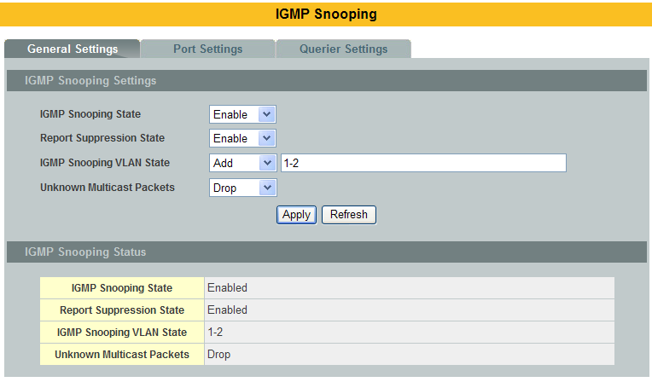

Parameter | Description
IGMP Snooping State | Select Enable to activate IGMP Snooping to forward group multicasttraffic only to ports that are members of that group. Select Disable todeactivate the feature.
Report Suppression State | Select Enable/Disableto activate/deactivate IGMP Snooping report suppression function.
IGMP Snooping VLAN State | Select Add and enter VLANs upon which the Switch is to perform IGMPsnooping. The valid range of VLAN IDs is between 1 and 4094. Use acomma (,) or hyphen (-) to specify more than one VLANs. SelectDelete and enter VLANs on which to have the Switch not perform IGMPsnooping.
Unknown Multicast Packets | Specify the action to perform when the Switch receives an unknownmulticast frame. Select Drop to discard the frame(s). Select Floodingto send the frame(s) to all ports.
Apply | Click Apply to configure the settings.
Refresh | Click this to reset the fields to the last setting.
IGMP Snooping State | This field displays whether IGMP snooping is globally enabled ordisabled.
Report Suppression State | This field displays whether IGMP snooping report suppression is enabled ordisabled.
IGMP Snooping VLANState | This field displays VLANs on which the Switch is to perform IGMPsnooping. None displays if you have not enabled IGMP snooping on anyport yet.
Unknown  Multicast  Packets | This field displays whether the Switch is set to discard or flood unknownmulticast packets.

Port Settings
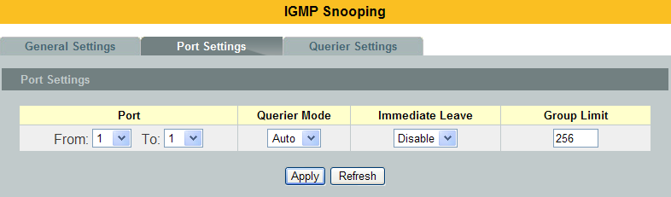
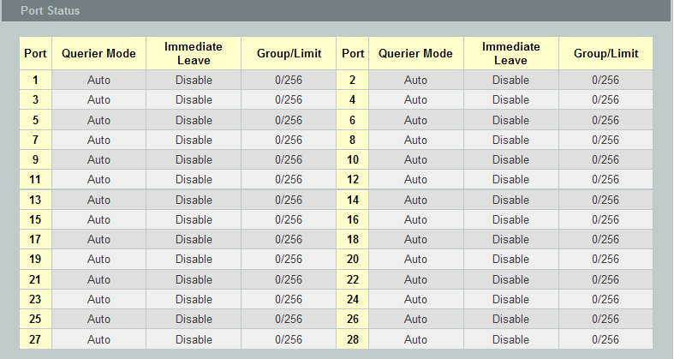

Parameter | Description
Querier Mode | Select the desired setting, Auto, Fixed, or Edge. Auto means the Switch uses the port as an IGMP query port if the port receives IGMP query packets. Fixed means the Switch always treats the port(s) as IGMP query port(s). This is for when connecting an IGMP multicast server to the port(s). Edge means the Switch does not use the port as an IGMP query port. In this case, the Switch does not keep a record of an IGMP router being connected to this port and the Switch does not forward IGMP join or leave packets to this port.
Immediate  Leave | Select individual ports on which to enable immediate leave.
Group Limit | Configures the maximum group for the port or a range of ports.
Apply | Click Apply to apply the settings.
Refresh | Click this to reset the fields.
Port | The port ID.
Querier Mode | The Querier mode setting for the specific port.
Immediate Leave | The Immediate Leave setting for the specific port.
Group Counts | The current joining group count and the maximum group count.

Querier Settings
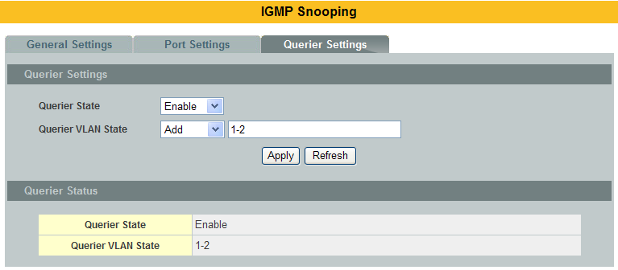

Parameter | Description
Querier State | This field configures the global Querier state.
Querier VLAN State | This field enables the Querier state in a vlan or a range of vlan.
Apply | Click Apply to apply the settings.
Refresh | Click this to reset the fields to the last setting.
Querier State | This filed indicates the current global Querier status.
Querier VLAN State | This field indicates the Querier status in vlan.

IGMP Filtering
The IGMP Snooping Filter allows users to configure one or some of range or multicast address to drop or to forward them.

      - CLI Configurations
Node | Command | Description
enable | show igmp-snooping filtering | This command displays the IGMP snooping filtering configurations.
configure | igmp-snooping filtering (enable|disable) | This command enables/disables the IGMP snooping filtering profiles on the Switch.
configure | igmp-snooping filtering profile | This command enters the IGMP snooping filtering profiles configuration node.
configure | no igmp-snooping filtering all | This command removes all of the IGMP snooping filtering profiles from the Switch.
configure | no igmp-snooping filtering STRINGS | This command removes the IGMP snooping filtering profiles by name from the Switch.
config-igmp | Group GROUP_ID start-address START-ADDR end-address END-ADDR | This command configures the group configurations, including group index and start multicast address and end multicast address.
config-igmp | type (deny|permit) | This command configures the type of deny or permit for the group.
config-igmp | no group GROUP-ID | This command removes the group configurations.
config-igmp | no group all | This command removes all of the group configurations.
config-igmp | type (deny|permit) | This command configures the type of deny or permit for the group.
interface | igmp-snooping filtering profile STRING | This command enables the IGMP snooping filtering profiles on the specific port.
interface | no igmp-snooping filtering profile STRINGS | This command disables the IGMP snooping filtering profiles on the specific port.
configure | interface range gigabitethernet1/0/PORTLISTS | This command enters the interface configure node.
if-config | igmp-snooping filtering profile STRING | This command enables the IGMP snooping filtering profiles on the range of ports.
if-config | no igmp-snooping filtering profile STRINGS | This command disables the IGMP snooping filtering profiles on the range of ports.

      - Web Configurations
General Settings:
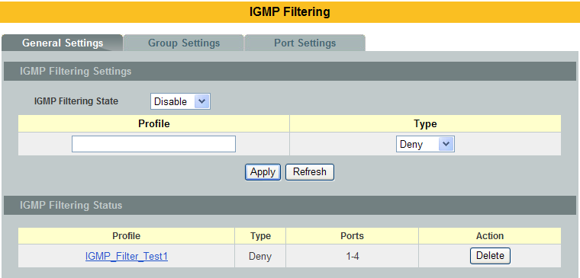

Parameter | Description
IGMP Filtering State | This field configures the global IGMP Filtering state.
Profile | This field creates the IGMP Filtering profile.
Type | The field configures the type of action for the profile.
Apply | Click Apply to apply the settings.
Refresh | Click this to reset the fields to the last setting.
IGMP Filtering Status
Profile | The profile name.
Type | The type of action.
Ports | The field indicates the ports that the IGMP Filtering profile is activated.
Action | Click the “Delete” button to delete the profile.

Group Settings:
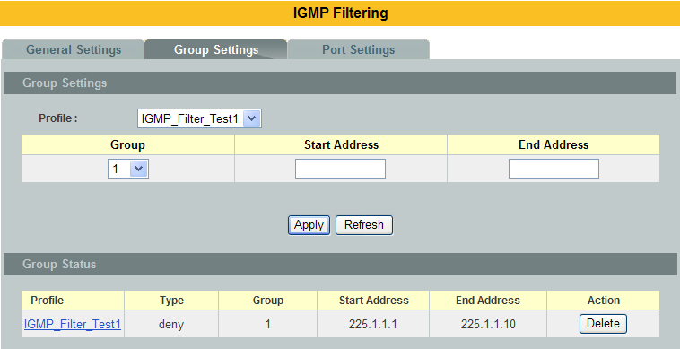

Parameter | Description
Profile | This field selects the profile which you want to configure the group.
Group | This field selects the group index.
Start Address | The field configures the first multicast address of the group.
End Address | The field configures the last multicast address of the group.
Apply | Click Apply to apply the settings.
Refresh | Click this to reset the fields to the last setting.

Port Settings:
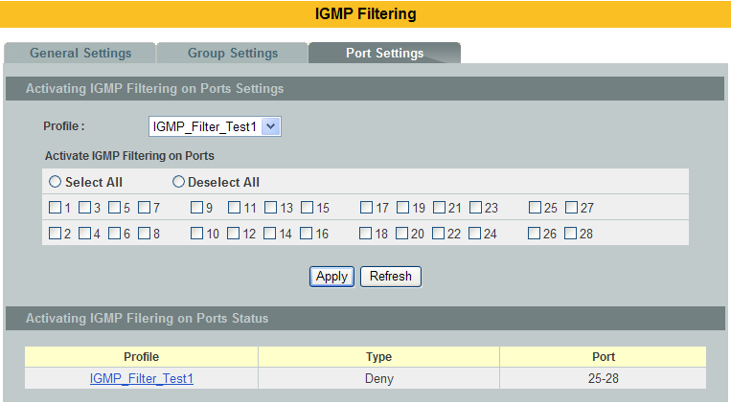

Parameter | Description
Profile | This field selects the profile which you want to activate on the ports.
Activate IGMP Filtering on Ports | Selects the ports which you want to activate the IGMP Filtering profile.
Apply | Click Apply to apply the settings.
Refresh | Click this to reset the fields to the last setting.

MVR
MVR refers to Multicast VLAN Registration that enables a media server totransmit multicast stream in a single multicast VLAN while clients receivingmulticast VLAN stream can reside in different VLANs. Clients in differentVLANs intend to join or leave the multicast group simply by sending the IGMPJoin/leave message to a receiver port. The receiver port belonging to one ofthe multicast groups can receive multicast stream from media server. Without support of MVR, the Multicast stream from media server andsubscriber must reside in the same VLAN.

- Source ports : The Stream source ports.
- Receiver ports : The Client ports.
- Tagged ports : Configure the tagged ports for source ports or receiver ports.

MVR Mode

- Dynamic Mode:
If we select the dynamic mode in MVR setting, IGMP report messagetransmitted from the receiver port will be forwarded to a multicast routerthrough its source port. Multicast router knows which multicast groups exist onwhich interface dynamically.

- Compatible mode:
If we select the dynamic mode in MVR setting, IGMP report messagetransmitted from the receiver port will not be transmitted to a multicast router.

Multicast router must be statically configured.

Operation Mode

- Join Operation:
A subscriber sends an IGMP report message to the switch to join theappropriate multicast. The next depends on whether the IGMP reportmatches the switch configured multicast MAC address. If it matches,the switch CPU modifies the hardware address table to include thisreceiver port and VLAN as a forwarding destination of MVLAN.
- Leave Operation:
Subscriber sends an IGMP leave message to the switch to leave themulticast. The switch CPU sends an IGMP group-specific querythrough the receiver port VLAN. If there is another subscriber in theVLAN, subscriber must respond within the max response time. Ifthere is no subscriber, the switch would eliminate this receiver port.

- Immediate Leave Operation:
Subscriber sends an IGMP leave message to the switch to leave themulticast. Subscribers do not need to wait for the switch CPU to sendan IGMP group-specific query through the receiver port VLAN. Theswitch will immediately eliminate this receiver port.

Figure-1:
MOD Without MVR
Switch
MoD Server
Receiver Ports

VLAN1 VLAN2 VLAN3 VLAN4 VLAN5 VLAN6

Figure-2:

MOD Support MVR
Switch supports MVR
MoD Server
Receiver Ports

VLAN1 VLAN2 VLAN3 VLAN4 VLAN5 VLAN6

Default Settings
There is no MVR vlan.
Default configuration for a new MVR:
MVR VLAN Information
VLAN ID : 2
Name : MVR2
Active : Enabled
Mode : Dynamic
Source Port(s) : None
Receiver Port(s) : None
Tagged Port(s) : None

The Switch allows user to create up to 250 groups.
The Switch allows user to create up to 16 MVRs.

Notices
- IGMP snooping and MVR can be independently enabled.
- IGMP snooping and MVR use the same IGMP timers.
- MVR can recognize IGMPv3 reports.
- About the IGMPv3 report, switch doesn’t treat those group records with the following group record types as membership reports. Those group record types are MODE_IS_INCLUDE, CHANGE_TO_INCLUDE_MODE, ALLOW_NEW_SOURCES and BLOCK_OLD_SOURCES.
- Don’t use the group address X.0.0.1 for your multicast stream. It is because the system detects and records the 224.0.0.1 for dynamic querier port. The group address X.0.0.1 may conflict with 224.0.0.1.
- Because the lower 23 bits of the 28-bit multicast IP address are mapped into the 23 bits of available Ethernet address space. When you configure group address, the Switch compare the lower 23 bits only.
- CLI command “group 1 start-address 224.1.1.1 6”, it creates 6 groups. That is, one IP, one group.
- The MVR name should be the combination of the digit or the alphabet.
- The group name should be the combination of the digit or the alphabet.

      - CLI Configuration
Node | Command | Description
enable | show mvr | This command displays the current MVR configurations.
enable | show mvr vlan VLANID | This command displays the current MVR configurations of the specific VLAN.
enable | show igmp-snooping | This command displays the current IGMP snooping configurations.
configure | mvr VLANID | This command configures the MVR configurations for the specific VLAN.
configure | no mvr VLANID | This command disables the MVR configurations for the specific VLAN.
MVR | group NAME | This command configures a group configuration for the MVR.
MVR | no group NAME | This command removes the group configurations from the MVR.
MVR | inactive | This command disables the MVR settings.
MVR | no inactive | This command enables the MVR settings.
MVR | mode (dynamic|compatible) | This command configures the mode for the MVR.  - Dynamic : Sends IGMP report to all MVR source ports in the multicast VLAN.  - Compatible : Sets the Switch not to send IGMP report.
MVR | name STRING | This command configures the name for the MVR.
MVR | no name | This command configures the default name for the MVR.
MVR | receiver-port PORTLIST | This command sets the receiver port(s). Normally the source ports are connected to the streaming client.
MVR | no receiver-port PORTLIST | This command removesa port or range of ports from the receiver port(s).
MVR | source-port PORTLIST | This command sets the source port(s). Normally the source ports are connected to the streaming server.
MVR | no source-port PORTLIST | This command removesa port or range of ports from the source port(s).
MVR | tagged PORTLIST | This command sets the tagged port(s). Same as the VLAN tagged port.
MVR | no tagged PORTLIST | This command removesa port or range of ports from the tagged port(s).
MVR | priority-override (disable|enable) | This command enables/disables the multicast priority override.

      - Web Configuration
MVR Settings
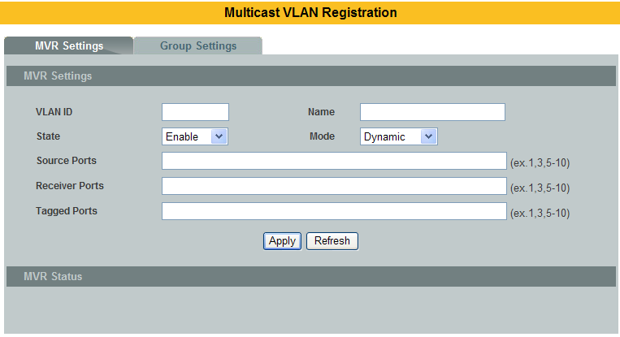
Parameter | Description
VLAN ID | Configures a VLAN.
NAME | Configures a name for the MVR.
Priority Override | Enable / Disable for the priority override.
State | Enables / Disables the MVR.
Mode | Configures the mode for the MVR.
802.1p Priority | The priority for these multicast group packets.
Source Ports | Configures the source port(s) for the MVR. Normally the source ports are connected to the streaming server.
Receive Ports | Configures the receive port(s) for the MVR. Normally the source ports are connected to the streaming client
Tagged Ports | Configures the tagged port(s) for the MVR. Same as the VLAN tagged port.

Group Settings
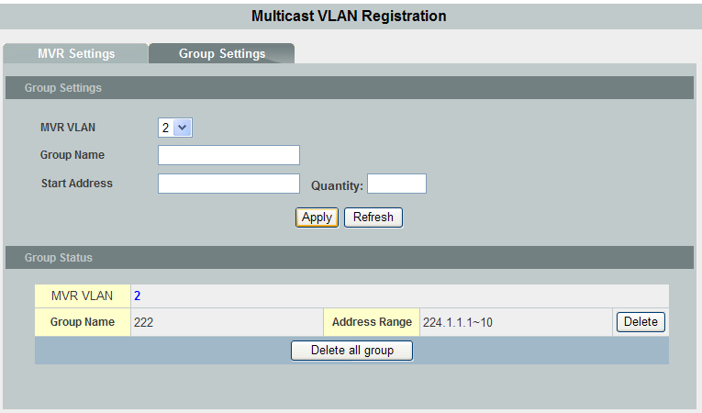

Parameter | Description
MVR VLAN | Select a MVR VLAN.
Group Name | Configures the group name.
Start Address | Configures the multicast start address.
Quantity | Configures the quantity of the multicast address.

Multicast Address
A multicast address is associated with a group of interested receivers. According to RFC 3171, addresses 224.0.0.0 to 239.255.255.255, the former Class D addresses, are designated as multicast addresses in IPv4.

The IANA owns the OUI MAC address 01:00:5e, therefore multicast packets are delivered by using the Ethernet MAC address range 01:00:5e:00:00:00 - 01:00:5e:7f:ff:ff. This is 23 bits of available address space.

The first octet (01) includes the broadcast/multicast bit. The lower 23 bits of the 28-bit multicast IP address are mapped into the 23 bits of available Ethernet address space. This means that there is ambiguity in delivering packets. If two hosts on the same subnet each subscribe to a different multicast group whose address differs only in the first 5 bits, Ethernet packets for both multicast groups will be delivered to both hosts, requiring the network software in the hosts to discard the unrequired packets.

Class | AddressRange | Supports
Class A | 1.0.0.1 to 126.255.255.254 | Supports 16 million hosts on each of 127 networks.
Class B | 128.1.0.1 to 191.255.255.254 | Supports 65,000 hosts on each of 16,000 networks.
Class C | 192.0.1.1 to 223.255.254.254 | Supports 254 hosts on each of 2 million networks.
Class D | 224.0.0.0 to 239.255.255.255 | Reserved for multicast groups.
Class E | 240.0.0.0 to 254.255.255.254 | Reserved for future use, or Research and Development Purposes.
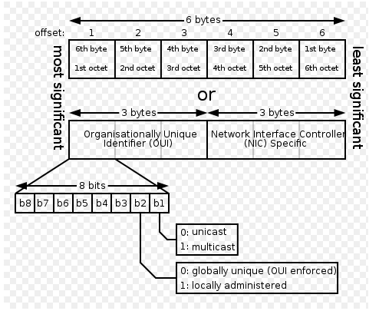
IP multicast address | Description
224.0.0.0 | Base address (reserved)
224.0.0.1 | The All Hosts multicast group that contains all systems on the same network segment
224.0.0.2 | The All Routers multicast group that contains all routers on the same network segment
224.0.0.5 | The Open Shortest Path First (OSPF) AllSPFRouters address. Used to send Hello packets to all OSPF routers on a network segment
224.0.0.6 | The OSPF AllDRouters address. Used to send OSPF routing information to OSPF designated routers on a network segment
224.0.0.9 | The RIP version 2 group address. Used to send routing information using the RIP protocol to all RIP v2-aware routers on a network segment
224.0.0.10 | EIGRP group address. Used to send EIGRP routing information to all EIGRP routers on a network segment
224.0.0.13 | PIM Version 2 (Protocol Independent Multicast)
224.0.0.18 | Virtual Router Redundancy Protocol
224.0.0.19 - 21 | IS-IS over IP
224.0.0.22 | IGMP Version 3 (Internet Group Management Protocol)
224.0.0.102 | Hot Standby Router Protocol Version 2
224.0.0.251 | Multicast DNS address
224.0.0.252 | Link-local Multicast Name Resolution address
224.0.1.1 | Network Time Protocol address
224.0.1.39 | Cisco Auto-RP-Announce address
224.0.1.40 | Cisco Auto-RP-Discovery address
224.0.1.41 | H.323 Gatekeeper discovery address

CLI Configuration
Node | Command | Description
enable | show mac-address-table multicast | This command displays the current static/dynamic multicast address entries.
enable | show mac-address-table multicast vlan VLANID | This command displays the current static/dynamic multicast address entries with a specific vlan.
configure | mac-address-table multicast MACADDR vlan VLANID ports PORTLIST | This command configures a static multicast entry.
configure | no mac-address-table multicast MACADDR | This command removes a static multicast entry from the address table.

Web Configuration
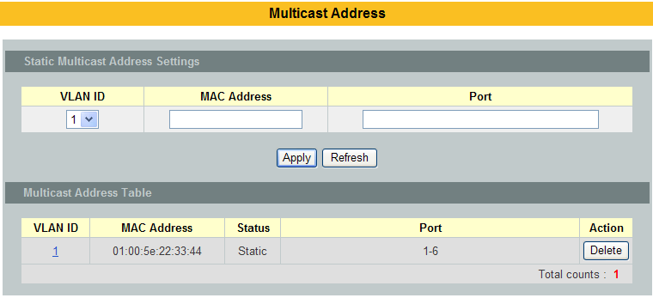

Parameter | Description
VLAN ID | Configures the VLAN that you want to configure.
MAC Address | Configures the multicast MAC which will not be aged out.  Valid format is hh:hh:hh:hh:hh:hh.
Port | Configures the member port for the multicast address.
Apply | Click Apply to save your changes back to the Switch.
Refresh | Click Refresh to begin configuring this screen afresh.

Explicit Host Tracking
This capability enables the Switch to track each individualhost that is joined to a particular group or channel and to achieve minimal leave latencies when hosts leave amulticast group or channel.

Notice:
  - Before configuring the ip igmp explicit-tracking command, IGMP must be enabled.
  - When explicit host tracking is enabled, the router uses more memory than if explicit tracking is disabled because the router must store the membership state of all hosts on the interface.

CLI Configurations
Node | Command | Description
enable | show ip multicast | This command shows the IGMP snooping membership information.
enable | show igmp-snooping membership | This command shows the IGMP snooping host membership information.
config | igmp-snoopingexplicit-tracking | This command enables the IGMP snooping explicit host tracking on the Switch.
config | no igmp-snoopingexplicit-tracking | This command disables the IGMP snooping explicit host tracking on the Switch.

Web Configurations
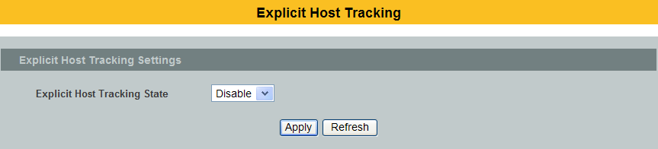
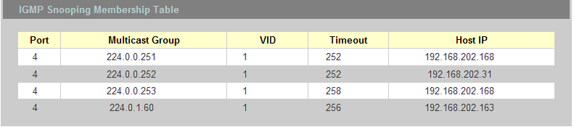

Parameter | Description
Explicit Tracking state | The filed enables/disables the IGMP Snooping explicit host tracking state on the Switch.
IGMP Snooping Membership Table
Index | This field indicates the index of the entry.
Port | This field indicates the port of the entry.
Multicast Group | This field indicates the multicast address of the entry.
VID | This field indicates the vlan of the entry.
Timeout | This field indicates the remaining time in the table of the entry.
Host IP | This field indicates the host IP which joins the multicast group.

VLAN

Port Isolation
The port isolation is a port-based virtual LAN feature. It partitions the switching ports into virtual private domains designated on a perport basis. Data switching outside of the port’s private domain is not allowed. It will ignore the packets’ tag VLAN information.

This feature is a per port setting to configure the egress port(s) for the specific port to forward its received packets. If the CPU port (port 0) is not an egress port for a specific port, the host connected to the specific port cannot manage the Switch.

If you wish to allow two subscriber ports totalk to each other, you must define the egress port for both ports.CPU refers to the Switch management port. By default it forms a VLANwith all Ethernet ports. If it does not form a VLAN with a particular portthen the Switch cannot be managed from that port.

Example:
If you want to allow port-1 and port-3 to talk to each other, you must configure as below:
L2SWITCH(config)#interface 1/0/1
L2SWITCH(config-if)#port-isolation ports 3
L2SWITCH(config-if)#exit
; Allow the port-1 to send its ingress packets to port-3.

L2SWITCH(config)#interface 1/0/3
L2SWITCH(config-if)#port-isolation ports 1
L2SWITCH(config-if)#exit
; Allow the port-3to send its ingress packets to port-1

Default Settings
(Port-0=CPU).
Egress Port Egress Port
1 2 1 2
Port 01234567890123456789012345678 Port 01234567890123456789012345678
---- ----------------------------- ---- -----------------------------
1 VVVVVVVVVVVVVVVVVVVVVVVVVVVVV 2 VVVVVVVVVVVVVVVVVVVVVVVVVVVVV
3 VVVVVVVVVVVVVVVVVVVVVVVVVVVVV 4 VVVVVVVVVVVVVVVVVVVVVVVVVVVVV
5 VVVVVVVVVVVVVVVVVVVVVVVVVVVVV 6 VVVVVVVVVVVVVVVVVVVVVVVVVVVVV
7 VVVVVVVVVVVVVVVVVVVVVVVVVVVVV 8 VVVVVVVVVVVVVVVVVVVVVVVVVVVVV
9 VVVVVVVVVVVVVVVVVVVVVVVVVVVVV 10 VVVVVVVVVVVVVVVVVVVVVVVVVVVVV
11 VVVVVVVVVVVVVVVVVVVVVVVVVVVVV 12 VVVVVVVVVVVVVVVVVVVVVVVVVVVVV
13 VVVVVVVVVVVVVVVVVVVVVVVVVVVVV 14 VVVVVVVVVVVVVVVVVVVVVVVVVVVVV
15 VVVVVVVVVVVVVVVVVVVVVVVVVVVVV 16 VVVVVVVVVVVVVVVVVVVVVVVVVVVVV
17 VVVVVVVVVVVVVVVVVVVVVVVVVVVVV 18 VVVVVVVVVVVVVVVVVVVVVVVVVVVVV
19 VVVVVVVVVVVVVVVVVVVVVVVVVVVVV 20 VVVVVVVVVVVVVVVVVVVVVVVVVVVVV
21 VVVVVVVVVVVVVVVVVVVVVVVVVVVVV 22 VVVVVVVVVVVVVVVVVVVVVVVVVVVVV
23 VVVVVVVVVVVVVVVVVVVVVVVVVVVVV 24 VVVVVVVVVVVVVVVVVVVVVVVVVVVVV
25 VVVVVVVVVVVVVVVVVVVVVVVVVVVVV 26 VVVVVVVVVVVVVVVVVVVVVVVVVVVVV
27 VVVVVVVVVVVVVVVVVVVVVVVVVVVVV 28 VVVVVVVVVVVVVVVVVVVVVVVVVVVVV

CLI Configuration
Node | Command | Description
enable | show port-isolation | This command displays the current port isolation configurations.  “V” indicates the port’s packets can be sent to that port.  “-” indicates the port’s packets cannot be sent to that port.
interface | port-isolation ports PORTLISTS | This command configures a port or a range of ports to egress traffic from the specific port.
interface | no port-isolation | This command configures all ports to egress traffic from the specific port.

Web Configuration
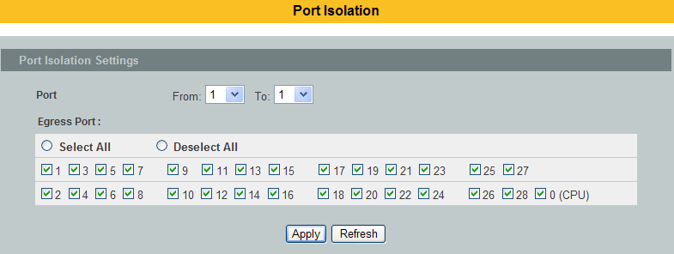
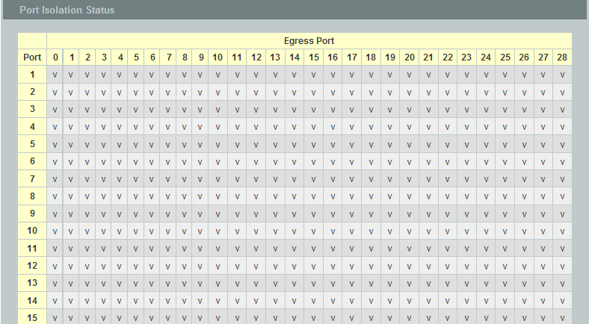
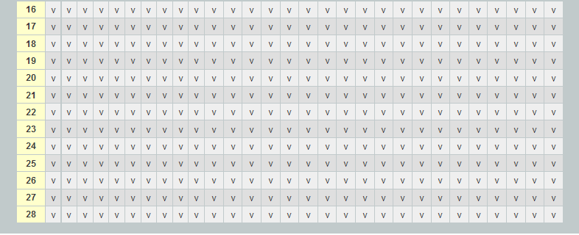

Parameter | Description
Port | Select a port number to configure its port isolation settings.  Select All Ports to configure the port isolation settings for all ports on the Switch.
EgressPort | An egress port is an outgoing port, that is, a port through which a datapacket leaves.  Selecting a port as an outgoing port means it will communicate with theport currently being configured.
Select All/  Deselect All | Click Select All to mark all ports as egress ports and permit traffic.  Click Deselect All to unmark all ports and isolate them.  Deselecting all ports means the port being configured cannot communicate with any other port.
Apply | Click Apply to configure the settings.
Refresh | Click this to reset the fields to the last setting.
Port  Isolation  Status | “V” indicates the port’s packets can be sent to that port.  “-” indicates the port’s packets cannot be sent to that port.

802.1Q VLAN
A virtual LAN, commonly known as a VLAN, is a group of hosts with a common set of requirements that communicate as if they were attached to the Broadcast domain, regardless of their physical location. A VLAN has the same attributes as a physical LAN, but it allows for end stations to be grouped together even if they are not located on the same network switch. Network reconfiguration can be done through software instead of physically relocating devices.

VID- VLAN ID is the identification of the VLAN, which is basically used by the standard 802.1Q. It has 12 bits and allow the identification of 4096 (2^12) VLANs. Of the 4096 possible VIDs, a VID of 0 is used to identify priority frames and value 4095 (FFF) is reserved, so the maximum possible VLAN configurations are 4,094.

A tagged VLAN uses an explicit tag (VLAN ID) in the MAC header to identify theVLAN membership of a frame across bridges - they are not confined to the switchon which they were created. The VLANs can be created statically by hand ordynamically through GVRP. The VLAN ID associates a frame with a specific VLANand provides the information that switches need to process the frame across thenetwork. A tagged frame is four bytes longer than an untagged frame andcontains two bytes of TPID (Tag Protocol Identifier, residing within the type/lengthfield of the Ethernet frame) and two bytes of TCI (Tag Control Information, startsafter the source address field of the Ethernet frame).

The CFI (Canonical Format Indicator) is a single-bit flag, always set to zero forEthernet switches. If a frame received at an Ethernet port has a CFI set to 1, thenthat frame should not be forwarded as it is to an untagged port. The remainingtwelve bits define the VLAN ID, giving a possible maximum number of 4,096VLANs. Note that user priority and VLAN ID are independent of each other. Aframe with VID (VLAN Identifier) of null (0) is called a priority frame, meaning thatonly the priority level is significant and the default VID of the ingress port is givenas the VID of the frame. Of the 4096 possible VIDs, a VID of 0 is used to identifypriority frames and value 4095 (FFF) is reserved, so the maximum possible VLANconfigurations are 4,094.

TPID | User Priority | CFI | VLAN ID
2 bytes | 3 bits | 1 bit | 12 bits

- Forwarding Tagged and Untagged Frames
Each port on the Switch is capable of passing tagged or untagged frames. Toforward a frame from an 802.1Q VLAN-aware switch to an 802.1Q VLAN-unawareswitch, the Switch first decides where to forward the frame and then strips off theVLAN tag. To forward a frame from an 802.1Q VLAN-unaware switch to an 802.1QVLAN-aware switch, the Switch first decides where to forward the frame, and theninserts a VLAN tag reflecting the ingress port's default VID. The default PVID isVLAN 1 for all ports, but this can be changed.

A broadcast frame (or a multicast frame for a multicast group that is known by thesystem) is duplicated only on ports that are members of the VID (except theingress port itself), thus confining the broadcast to a specific domain.
- 802.1Q Port base VLAN
With port-based VLAN membership, the port is assigned to a specific VLAN independent of the user or system attached to the port. This means all users attached to the port should be members of the same VLAN. The network administrator typically performs the VLAN assignment. The port configuration is static and cannot be automatically changed to another VLAN without manual reconfiguration.
As with other VLAN approaches, the packets forwarded using this method do not leak into other VLAN domains on the network. After a port has been assigned to a VLAN, the port cannot send to or receive from devices in another VLAN without the intervention of a Layer 3 device.

The device that is attached to the port likely has no understanding that a VLAN exists. The device simply knows that it is a member of a subnet and that the device should be able to talk to all other members of the subnet by simply sending information to the cable segment. The switch is responsible for identifying that the information came from a specific VLAN and for ensuring that the information gets to all other members of the VLAN. The switch is further responsible for ensuring that ports in a different VLAN do not receive the information.

This approach is quite simple, fast, and easy to manage in that there are no complex lookup tables required for VLAN segmentation. If port-to-VLAN association is done with an application-specific integrated circuit (ASIC), the performance is very good. An ASIC allows the port-to-VLAN mapping to be done at the hardware level.

Default Settings
  - The default PVID is 1 for all ports.
  - The default Acceptable Frame is All for all ports.
  - All ports join in the VLAN 1.

Notice: The maximum VLAN group is 4094

CLI Configuration
Node | Command | Description
enable | show vlan VLANID | This command displays the VLAN configurations.
configure | vlan <1~4094> | This command enables a VLAN and enters the VLAN node.
configure | no vlan <1~4094> | This command deletes a VLAN.
vlan | show | This command displays the current VLAN configurations.
vlan | name STRING | This command assigns a name for the specific VLAN.  The VLAN name should be the combination of the digit or the alphabet or hyphens (-) or underscores (_).  The maximum length of the name is 16 characters.
vlan | no name | This command configures the vlan name to default.  Note: The default vlan name is “VLAN”+vlan_ID, VLAN1, VLAN2,…
vlan | add PORTLISTS | This command adds a port or a range of ports to the vlan.
vlan | fixed PORTLISTS | This command assignsports for permanent member of the vlan.
vlan | no fixed PORTLISTS | This command removes all fixed member from the vlan.
vlan | taggedPORTLISTS | This command assignsports for tagged member of the VLAN group. The ports should be one/some of the permanent members of the vlan.
vlan | no tagged PORTLISTS | This command removes all tagged member from the vlan.
vlan | untaggedPORTLISTS | This command assignsports for untagged member of the VLAN group. The ports should be one/some of the permanent members of the vlan.
vlan | no untagged PORTLISTS | This command removes all untagged member from the vlan.
interface | acceptable frame type (all|tagged|untagged) | This command configures the acceptable frame type.  all - acceptable all frame types.  tagged - acceptable tagged frame only.  untagged– acceptable untagged frame only.
interface | pvid VLANID | This command configures a VLAN ID for the port default VLAN ID.
interface | no pvid | This command configures 1 for the port default VLAN ID.
configure | interface range (gigabitethernet1/0/) PORTLISTS | This command enters the interface configure node.
if-range | pvid VLANID | This command configures a VLAN ID for the port default VLAN ID.
if-range | no pvid | This command configures 1 for the port default VLAN ID.
configure | vlan range STRINGS | This command configures a range of vlans.
configure | no vlan range STRINGS | This command removes a range of vlans.
vlan-range | add PORTLISTS | This command adds a port or a range of ports to the vlans.
vlan-range | fixed PORTLISTS | This command assignsports for permanent member of the VLAN group.
vlan-range | no fixed PORTLISTS | This command removes all fixed member from the vlans.
vlan-range | taggedPORTLISTS | This command assignsports for tagged member of the VLAN group. The ports should be one/some of the permanent members of the vlans.
vlan-range | no tagged PORTLISTS | This command removes all tagged member from the vlans.
vlan-range | untaggedPORTLISTS | This command assignsports for untagged member of the VLAN group. The ports should be one/some of the permanent members of the vlans.
vlan-range | no untagged PORTLISTS | This command removes all untagged member from the vlans.

Example:
L2SWITCH#configure terminal
L2SWITCH(config)#vlan 2
L2SWITCH(config-vlan)#fixed 1-6
L2SWITCH(config-vlan)#tagged 1-3

Web Configuration
VLAN Settings
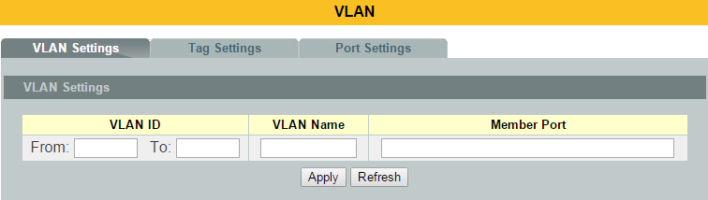

Parameter | Description
VLAN ID | Enter the VLAN ID for this entry; the valid range is between 1 and 4094.
VLAN Name | Enter a descriptive name for the VLAN for identification purposes. The VLAN name should be the combination of the digit or the alphabet or hyphens (-) or underscores (_).  The maximum length of the name is 16 characters.
MemberPort | Enter the port numbers you want the Switch to assign to the VLAN as members. You can designate multiple port numbers individually by using a comma (,) and by range with a hyphen (-).
Apply | Click Apply to save your changes back to the Switch.
Refresh | Click Refresh to begin configuring this screen afresh.
VLAN List
VLAN ID | This field displays the index number of the VLAN entry. Click the number to modify the VLAN.
VLAN Name | This field displays the name of the VLAN.
VLAN Status | This field displays the status of the VLAN. Static or Dynamic (802.1QVLAN).
MemberPort | This field displays which ports have been assigned as members of theVLAN. This will display None if no ports have been assigned.
Action | Click Delete to remove the VLAN. The VLAN 1 cannot be deleted.

Tag Settings
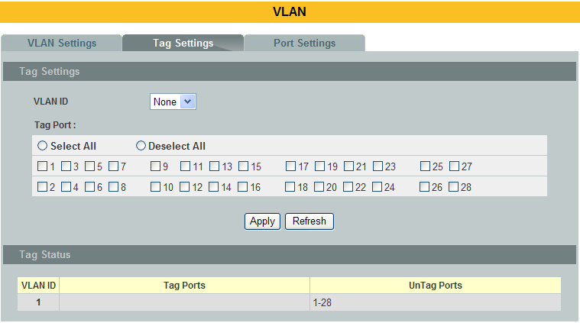

Parameter | Description
VLAN ID | Select a VLAN ID to configure its port tagging settings.
TagPort | Selecting a port which is a member of the selected VLAN ID will make it a tag port. This means the port will tag all outgoing frames transmitted with the VLAN ID.
Select All | Click Select All to mark all member ports as tag ports.
Deselect All | Click Deselect All to mark all member ports as untag ports.
Apply | Click Apply to save your changes back to the Switch.
Refresh | Click Refresh to begin configuring this screen afresh.
Tag Status
VLAN ID | This field displays the VLAN ID.
Tag Ports | This field displays the ports that have been assigned as tag ports.
Untag Ports | This field displays the ports that have been assigned as untag ports.

Port Settings
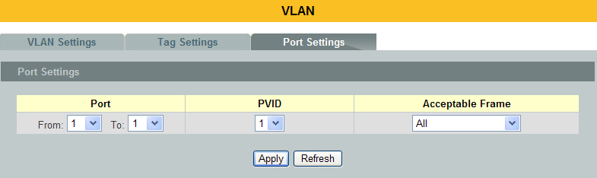
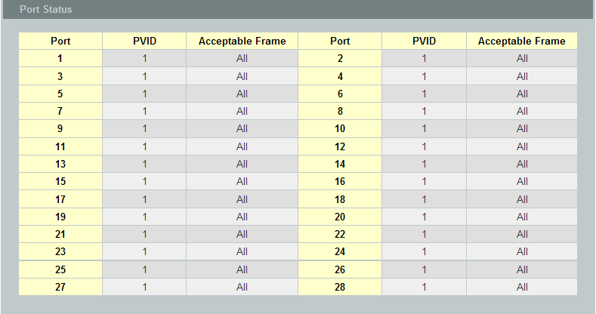

Parameter | Description
Port | Select a port number to configure from the drop-down box.  Select All to configure all ports at the same time.
PVID | Select a PVID (Port VLAN ID number) from the drop-down box.
Acceptable Frame | Specify the type of frames allowed on a port. Choices are All, VLANUntagged Only or VLAN Tagged Only.  Select All from the drop-down list box to accept all untagged or taggedframes on this port. This is the default setting.  Select VLAN Tagged Only to accept only tagged frames on this port. Alluntagged frames will be dropped.  Select VLAN Untagged Only to accept only untagged frames on this port.All tagged frames will be dropped.
Apply | Click Apply to save your changes back to the Switch.
Refresh | Click Refresh to begin configuring this screen afresh.
Port Status
Port | This field displays the port number.
PVID | This field displays the Port VLAN ID number.
Acceptable Frame | This field displays the type of frames allowed on the port. This will eitherdisplay All or VLANTagged Only or VLAN Untagged Only.

GARP/GVRP
GARP and GVRP are industry-standard protocols that are described in IEEE 802.1p.
GVRP is a GARP application that provides 802.1Q-compliant VLAN pruning and dynamic VLANcreation on 802.1Q trunk ports.
With GVRP, the switch can exchange VLAN configuration information with other GVRP switches,prune unnecessary broadcast and unknown unicast traffic, and dynamically create and manage VLANson switches that are connected through 802.1Q trunk ports.

GVRP makes use of GID and GIP, which provide the common state machine descriptions and the common information propagation mechanisms defined for use in GARP-based applications. GVRP runs only on 802.1Q trunk links. GVRP prunes trunk links so that only active VLANs will be sent across trunk connections. GVRP expects to hear join messages from the switches before it will add a VLAN to the trunk. GVRP updates and hold timers can be altered. GVRP ports run in various modes to control how they will prune VLANs. GVRP can be configured to dynamically add and manage VLANS to the VLAN database for trunking purposes.

In other words, GVRP allows the propagation of VLAN information from device to device. With GVRP, a single switch is manually configured with all the desired VLANs for the network, and all other switches on the network learn those VLANs dynamically. An endnode can be plugged into any switch and be connected to that endnode's desired VLAN. For endnodes to make use of GVRP, they need GVRP-aware Network Interface Cards (NICs). The GVRP-aware NIC is configured with the desired VLAN or VLANs, then connected to a GVRP-enabled switch. The NIC communicates with the switch, and VLAN connectivity is established between the NIC and switch.

Registration Mode:
- Normal : The normal registration mode allows dynamic creation (if dynamic VLAN creation is enabled), registration, and deregistration of VLANs on the trunk port. Normal mode is the default.

- Forbidden: The forbidden registration mode deregisters all VLANs (exceptVLAN 1) and prevents any further VLAN creation or registration on the trunk port.

- Fixed : The fixed registration mode allows manual creation and registration of VLANs, prevents VLAN deregistration, and registers all known VLANs on other ports on the trunk port. (Same as the static VLAN)

GVRP Timer:
Join Timer : Specifies the maximum number of milliseconds the interface waits before sending VLAN advertisements.

Leave Timer : Specifies the number of milliseconds an interface waits after receiving a leave message before the interface leaves the VLAN specified in the message.

Leaveall Timer: Specifies the interval in milliseconds at which Leave All messages are sent on interfaces. Leave All messages help to maintain current GVRP VLAN membership information in the network.

The value for leave must be greater than three times the join value (leave >= join * 3). The value for leaveall must be greater than the value for leave (leaveall>leave).

Default Settings
The default port Join Time is 20 for all ports.
The default port Leave Time is 60 for all ports.
The default port Leaveall Time is 1000 for all ports.
The default port Hold Time is 10 for all ports.

      - CLI Configuration
Node | Command | Description
enable | show gvrp configuration | This command displays the GVRP configurations.
enable | show gvrp statistics | This command displays the GVRP configurations on a port or all ports.
enable | show garp timer | This command displays the timers for the GARP.
configure | gvrp (disable | enable) | This command disables / enables the GVRP on the switch.
configure | no gvrp configuration | This command set GVRP configuration to its defaults.
interface | gvrp (disable | enable) | This command disables / enables the GVRP on the specific port.
interface | gvrp registration (normal|forbidden) | This command configures the registration mode for the GVRP on the specific port.
interface | no gvrp configuration | This command set GVRP configuration to its defaults for the specific port.
interface | garp join-time VALUE leave-time VALUE leaveall-time VALUE | This command configures the join time / leaves time / leave all time for the GARP on the specific port.
interface | no garp time | This command configures the join time / leaves time / leaves all time to default for the GARP on the specific port.

      - Web Configuration
GVRP Settings
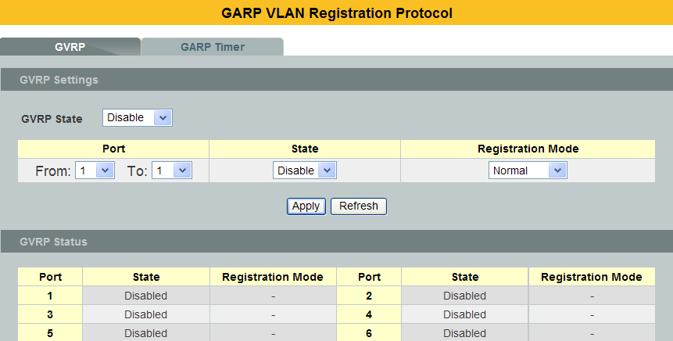
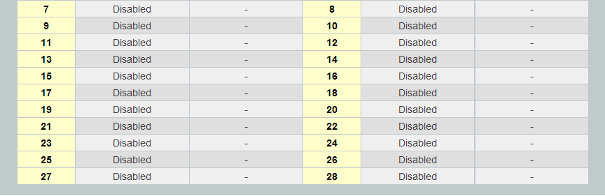

Parameter | Description
GVRPState | Select Enable to activate GVRPfunction to exchange VLAN configuration information with other GVRP switches. Select Disable todeactivate the feature.
Port | Select the port that you want to configure the GVRP settings.
State | Select Enable to activate the port GVRPfunction. Select Disable todeactivate the port GVRP function.
Registration Mode | Select Normal to allows dynamic creation (if dynamic VLAN creation is enabled), registration, and deregistration of VLANs on the trunk port.  Select Forbidden to deregister all VLANs (exceptVLAN 1) and prevents any further VLAN creation or registration on the trunk port.

GARP Timer
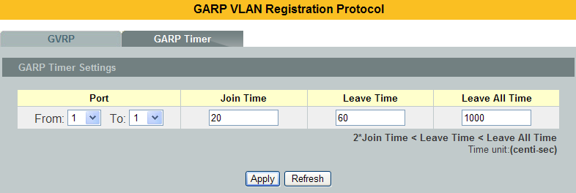
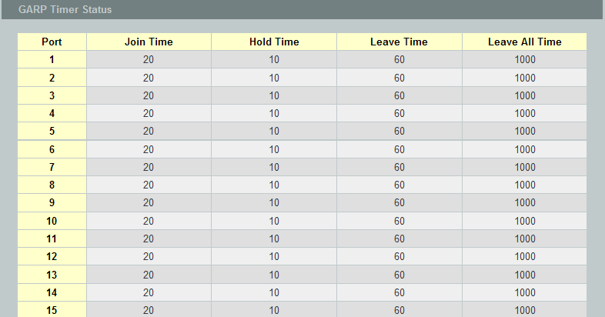
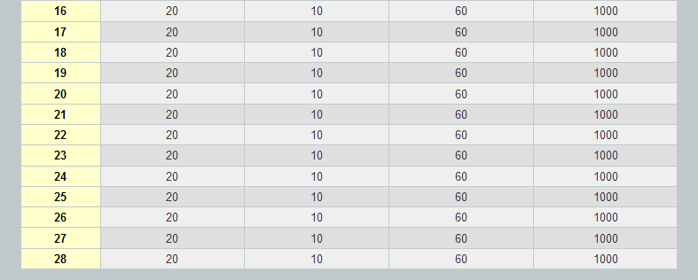

Parameter | Description
Join Time | Specifies the maximum number of milliseconds the interface waits before sending VLAN advertisements.
Leave Time | Specifies the number of milliseconds an interface waits after receiving a leave message before the interface leaves the VLAN specified in the message.
Leaveall Time | Specifies the interval in milliseconds at which Leave All messages are sent on interfaces. Leave All messages help to maintain current GVRP VLAN membership information in the network.

IP Subnet VLAN
IP subnet based VLANs enables the user to categorize the group of traffics into logical VLANs based on the source IP addresses and the subnet masks of packets. After receiving an untagged packet from a port, the switchchecks its source IP address and the IP subnet from where itis came from. After the checking has done, the switch forwards the packet in the corresponding VLAN. If no IP subnet classification can be made, the packet is followed to the normal VLAN classification methods of the switch. The significantbenefit of using subnet based VLANs is that the priority can be divided and integrated based on which VLAN the traffic belongs to.

Notices: The 802.1Q port base VLAN should be created first in order for the packet to be switched.

CLI Configuration
Node | Command | Description
enable | show ip-subnet-vlan | This command displays the all of the IP subnet vlan configurations.
configure | ip-subnet-vlan ip IPADDR mask IPADDR vlan VALUE priority VALUE | This command creates an IP subnet vlan entry with the IP address, subnet mask, vlan and priority.
configure | no ip-subnet-vlan ip IPADDR | This command deletes an IP subnet vlan entry.
configure | no ip-subnet-vlanall | This command deletes all of the IP subnet vlan entries.

Example:
- If you want to let hosts group 192.168.203.xxx to vlan 2 with priority 3. You can configure as below:

L2SWITCH(config)#ip-subnet-vlan ip 192.168.203.1 mask 255.255.255.0 vlan 2 priority 3
Success!

- Display current IP subnet vlan configurations:
L2SWITCH#show ip-subnet-vlan

IP Address Subnet Mask VLAN Priority
----------------- ----------------- --------- --------
192.168.203.1 255.255.255.0 2 3

Total Entries: 1

Web Configuration

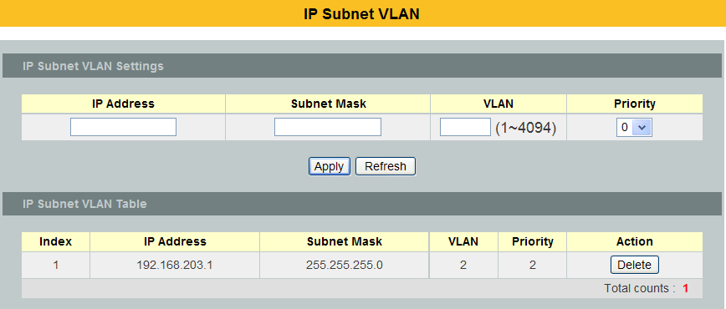

Parameter | Description
IP Address | Configures the IP address.
Subnet Mask | Configures the IP subnet mask.
VLAN | Configures the VALN.
Priority | Configures the priority.
IP Subnet VLAN Table
Index | The index of the entry.
IP Address | The IP address of the entry.
Subnet Mask | The mask address of the entry.
VLAN | The VLAN of the entry.
Priority | The priority of the entry.
Action | Clicks the Delete button to delete this entry.
Total Counts | It dictates the total entry of the IP subnet VLAN.

MAC-based VLAN

The MAC base VLAN allows users to create VLAN with MAC address. The MAC address can be the leading three or more bytes of the MAC address.

For example, 00:01:02 or 00:03:04:05 or 00:01:02:03:04:05.

When the Switch receives packets, it will compare MAC-based VLAN configures. If the SA is matched the MAC-based VLAN configures, the Switch replace the VLAN with user configured and them forward them.

For example:
Configurations: 00:01:02, VLAN=23, Priority=2.
The packets with SA=00:01:02:xx:xx:xx will be forwarded to VLAN 22 member ports.

Notices: The 802.1Q port base VLAN should be created first.

      - CLI Configuration
Node | Command | Description
enable | show mac-vlan | This command displays the all of the mac-vlan configurations.
configure | mac-vlan STRINGS vlan VLANID priority <0-7> | This command creates a mac-vlan entry with the leading three or more bytes of mac address and the VLAN and the priority.
configure | no mac-vlan entry STRINGS | This command deletes a mac-vlan entry.
configure | no mac-vlanall | This command deletes all of the mac-vlan entries.

Where the STRINGS is the leading three bytes or more bytes of the mac address.
For example:
00:01:02
00:01:02:03
00:01:02:03:04
00:01:02:03:04:05

Example:
L2SWITCH(config)#vlan 22
L2SWITCH(config-vlan)#fixed 1-10
L2SWITCH(config-vlan)#exit
L2SWITCH(config)#mac-vlan 00:01:02:03:04vlan 22 priority 1

      - Web Configuration
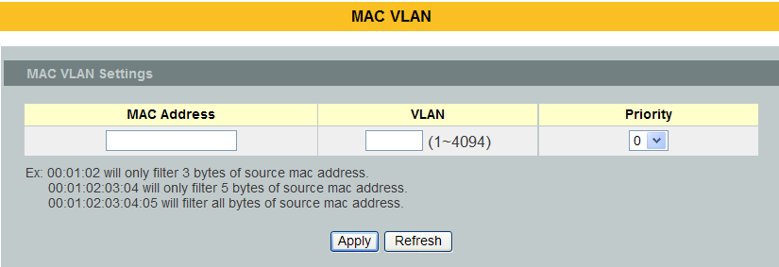
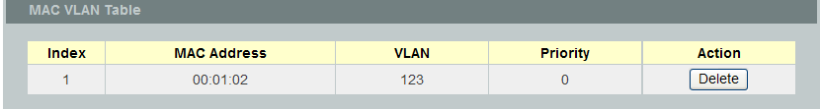

Parameter | Description
MAC Address | Configures the leading three or more bytes of the MAC address.
VLAN | Configures the VLAN.
Priority | Configures the 802.1Q priority.
Action | Click the “Delete” button to delete the protocol VLAN profile.

Protocol-based VLAN
The Protocol based VLAN allows users to create VLAN with packet frame type. The packet frame type can be one of the three frame types: EthernetII, NonLLC-SNAP and LLC-SNAP. If configuring the EthernetII frame type, the configuration will be more detail with the Ethernet type.

When the user configures the protocol VLAN as LLC-SNAP, VLAN:22, ports list: 1-3.

If the Switch receives packets with LLC-SNAP frame type from port 1 to 3, the packets’ VLAN will be replaced with VLAN 22 and be forwarded to VLAN 22 member ports.

Notices: The 802.1Q port base VLAN should be created first.

      - CLI Configuration
Node | Command | Description
enable | show protocol-vlan | This command displays the all of the protocol-vlan configurations.
configure | protocol-vlan frame-typeethernetIIether-type STRINGS vlan VLANID ports PORTLISTS | This command creates a protocol-vlan entry with ethernetII frame type.
configure | protocol-vlan frame-typenonLLC-SNAP vlan VLANID ports PORTLISTS | This command creates a protocol-vlan entry with nonLLC-SNAP frame type.
configure | protocol-vlan frame-typeLLC-SNAP vlan VLANID ports PORTLISTS | This command creates a protocol-vlan entry with LLC-SNAP frame type.
configure | no protocol-vlan frame-type ethernetII ether-type STRINGS vlan VLANID | This command deletes a protocol-vlan entry with ethernetII frame type.
configure | no protocol-vlan frame-type nonLLC-SNAP vlan VLANID | This command deletes a protocol-vlan entry with nonLLC-SNAP frame type and vlan.
configure | no protocol-vlan frame-type LLC-SNAP vlan VLANID | This command deletes a protocol-vlan entry with LLC-SNAP frame type and vlan.
configure | no protocol-vlan all | This command deletes all of the protocol-vlan entries.

Example:
L2SWITCH(config)#protocol-vlan frame-type LLC-SNAP vlan 12 ports 1-2
L2SWITCH(config)#protocol-vlan frame-type nonLLC-SNAP vlan 13 ports 3-4
L2SWITCH(config)#protocol-vlan frame-type ethernetII ether-type 0800 vlan 14 ports 1-2

      - Web Configuration
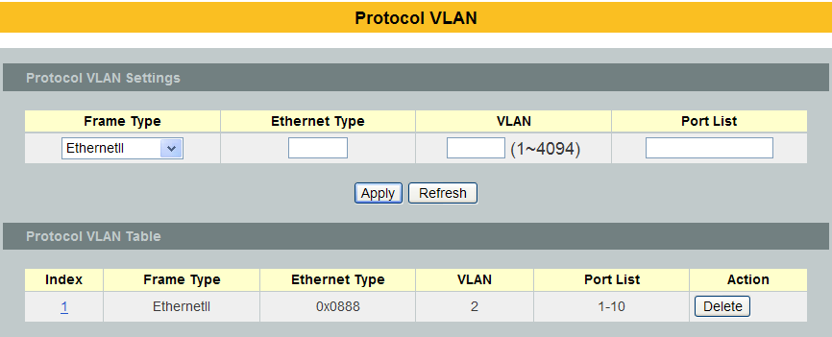

Parameter | Description
Frame Type | Select one of three frame types, “EthernetIU” and “NonLLC-SNAP” and “LLC-SNAP”.
Ethernet type | Input the Ethernet type for the EthernetII frame type.
VLAN | Configure the VLAN ID.
Port List | Configure the member ports.
Action | Click the “Delete” button to delete the protocol VLAN profile.

Q-in-Q VLAN (VLAN Stacking)
Q-in-Q tunneling is also known as VLAN stacking. Both of them use 802.1q double tagging technology. Q-in-Q is required by ISPs (Internet Service Provider) that require Transparent LAN services (TLS), and the service provider has their own set of VLAN, independent of customer VLANs. Typically, each service provider VLAN interconnects a group of sites belonging to a customer. However, a service provider VLAN could also be shared by a set of customers sharing the same end points and quality of service requirements of the VLAN. Double tagging is considered to be a relatively simpler way of implementing transparent LAN. This is accomplished by encapsulating Ethernet Frame. A second or outer VLAN tag is inserted in Ethernet frames sent over the ingress PE (Provider Edge). This VLAN tag corresponds to the VLAN of the Service Provider (SP). When the frame reaches the destination PE, the SP VLAN is stripped off. The DA of the encapsulated frame and the VLAN ID are used to take further L2 decisions, similar to an Ethernet frame arriving from a physical Ethernet port. The SP VLAN tag determines the VPLS (Virtual Private LAN Service) membership. Double tagging aggregates multiple VLANs within another VLAN and provides a private, dedicated Ethernet connection between customers to reach their subnet transparently across multiple networks. Thus service providers can create their own VLANs without interfering with customer VLANs by using double tagging. This allows them to connect customers to ISPs and ASPs (Application Service Provider).

The ports that are connected to the service provider VLANs are called tunnel ports, and the ports that are connected to the customer VLANs are called access (subscriber/customer) ports. When a port is configured as tunnel port, all the outgoing packets on this port will be sent out with SPVLAN (SPVID and 1p priority) tag. The incoming packet can have two tags (SPVLAN + CVLAN), one tag (SPVLAN or CVLAN), or no tag. In all cases, the packet is sent out with a SPVLAN tag. When a port is configured as an access port, the incoming traffic can have only a CVLAN (CVID and 1p priority) tag or no tag. Hence, all the packets that are being sent out of access ports will be untagged or single tagged (CVLAN). When a port is configured as a normal port, it will ignore the frames with double tagging.

Double Tagging Format
A VLAN tag (service provider VLAN stacking or customer IEEE 802.1Q) consists of the following three fields.

TPID | Priority | VID
TPID (Tag Protocol Identifier) is a standard Ethernet type code identifying the frame and indicates that whether the frame carries IEEE 802.1Q tag information. The value of this field is 0x8100 as defined in IEEE 802.1Q. Other vendors may use a different value, such as 0x9100.

Tunnel TPID is the VLAN stacking tag type the Switch adds to the outgoing frames sent through a Tunnel Port of the service provider's edge devices

Priority refers to the IEEE 802.1p standard that allows the service provider to prioritize traffic based on the class of service (CoS) the customer has paid for. "0" is the lowest priority level and "7" is the highest.

VID is the VLAN ID. SP VID is the VID for the second or outer (service provider’s) VLAN tag. CVID is the VID for the first or inner (Customer’s) VLAN tag.

The frame formats for an untagged Ethernet frame; a single-tagged 802.1Q frame (customer)and a “double-tagged” 802.1Q frame (service provider) are shown as following.

untagged frame | DA | SA | Len or Etype | Data | FCS
single-tagged frame | DA | SA | TPID | P | VID | Len or Etype | Data | FCS
double-tagged frame | DA | SA | Tunnel TPID | P | VID | TPID | P | VID | Len or Etype | Data | FCS

DA: Destination Address
SA: Source Address
Tunnel TPID: Tag Protocol Identifier added on a tunnel port
P: 802.1p priority
VID: VLAN ID
Len or Etype: Length or Ethernet frame type
Data: Frame data
FCS: Frame Check Sequence

VLAN Stacking Port Roles
Each port can have three VLAN stacking “roles”, Normal, Access Port and Tunnel Port.
- Select Normal for “regular” (non-VLAN stacking) IEEE 802.1Q frame switching.
- Select Access Port for ingress ports on the service provider's edge devices. The incoming frame is treated as "untagged", so a second VLAN tag (outer VLAN tag) can be added.
- Select Tunnel Port for egress ports at the edge of the service provider's network. All VLANs belonging to a customer can be aggregated into a single service provider's VLAN (using the outer VLAN tag defined by SP VID).

Note: In order to have the double tagged frames switching correctly, user has to configure a service provider’s VLAN (SPVLAN) on the Q-in-Q switch. Then, the double tagged frames can be switched according to the SP VID. The SPVLAN should include all the related Tunnel and Access ports. Also, user has to configure the Tunnel posts as tagged ports and the Access ports as untagged ports.

Port-based Q-in-Q
Q-in-Q encapsulation is to convert a single tagged 802.1Q packet into a double tagged Q-in-Q packet. The Q-in-Q encapsulation can be based on port or traffic. Port-based Q-in-Q is to encapsulate all the packets incoming to a port with the same SPVID outer tag. The mode is more inflexible.

In the following example figure, both Xand Yare Service Provider’s Network (SPN)customers with VPN tunnels between their head offices and branch offices respectively. Bothhave an identical VLAN tag for their VLAN group. The service provider can separate thesetwo VLANs within its network by adding tag 100to distinguish customer Xand tag 200todistinguish customer Yat edge device A and then stripping those tags at edge device B as thedata frames leave the network.
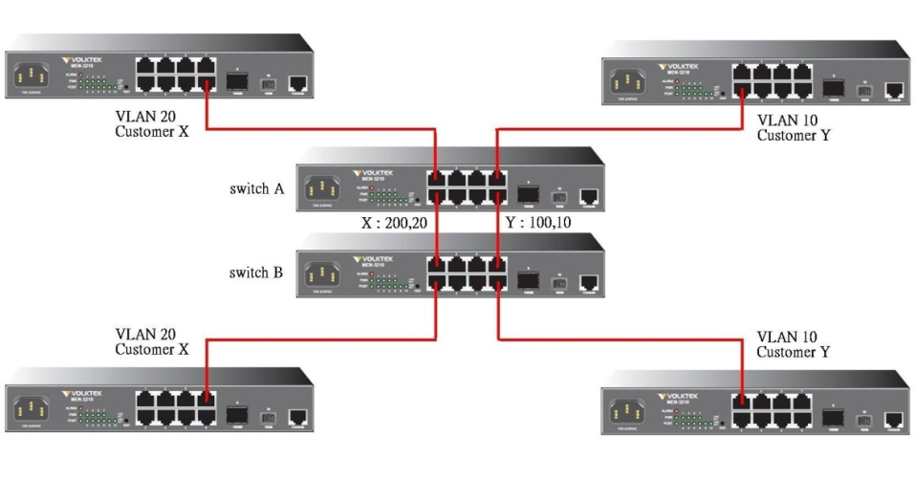
This example shows how to configure switch A with ports 1 on the Switch to tag incoming frames withthe service provider’s VID of 200 (ports are connected to customer X network) and configure port 7 to service providr’s VID of 100 (ports are connected to customer Y network).This examplealso shows how to set the priority for port 1 to 3 and port 7 to 4.

L2SWITCH(config)# vlan-stacking port-based
L2SWITCH(config)# vlan-stacking tpid-table index 2 value 88a8
L2SWITCH(config)# vlan 10
L2SWITCH(config-vlan)# fixed 7,8
L2SWITCH(config-vlan)# tagged 7
L2SWITCH(config-vlan)# exit
L2SWITCH(config)# vlan 100
L2SWITCH(config-vlan)# fixed 7,8
L2SWITCH(config-vlan)# tagged 8
L2SWITCH(config-vlan)# exit
L2SWITCH(config)# vlan 20
L2SWITCH(config-vlan)# fixed 1,2
L2SWITCH(config-vlan)# tagged 1
L2SWITCH(config-vlan)# exit
L2SWITCH(config)# vlan 200
L2SWITCH(config-vlan)# fixed 1,2
L2SWITCH(config-vlan)# tagged 2
L2SWITCH(config-vlan)# exit
L2SWITCH(config)# interface gigaethernet1/0/1
L2SWITCH(config-if)# vlan-stacking port-based role access
L2SWITCH(config-if)# vlan-stacking spvid 200
L2SWITCH(config-if)# vlan-stacking priority 3
L2SWITCH(config)# interface gigaethernet1/0/2
L2SWITCH(config-if)# vlan-stacking port-based role tunnel
L2SWITCH(config-if)# vlan-stacking tunnel-tpid index 2
L2SWITCH(config)# interface gigaethernet1/0/7
L2SWITCH(config-if)# vlan-stacking port-based role access
L2SWITCH(config-if)# vlan-stacking spvid 100
L2SWITCH(config-if)# vlan-stacking priority 4
L2SWITCH(config)# interface gigaethernet1/0/8
L2SWITCH(config-if)# vlan-stacking port-based role tunnel
L2SWITCH(config-if)# vlan-stacking tunnel-tpid index 2
L2SWITCH(config-if)# exit
L2SWITCH(config)# exit
L2SWITCH# show vlan-stacking
L2SWITCH# show vlan-stacking tpid-table
L2SWITCH# show vlan-stacking portbased-qinq

Selective Q-in-Q
The traffic based Q-in-Q is also called Selective Q-in-Q. Selective Q-in-Q allows the Switch to add different outer VLAN tags to theincoming frames received on one port according to their inner VLAN tags. In the Selective Q-in-Q mode, switch performs traffic classification for the traffic incoming to a port based on the VLAN ID. When a user uses different VLAN IDs for different services, traffic can be classified according to the VLAN ID. For example, the VLAN ID 100 for surfing on the internet by PC.The VLAN ID 200 of IPTV.The VLAN ID 300 of VIP customers. After receiving user data, the switch labels the traffic of surfing on the Internet by PC with 500 as a SPVID outer tag, IPTV with 600, and VIP customers with 700.
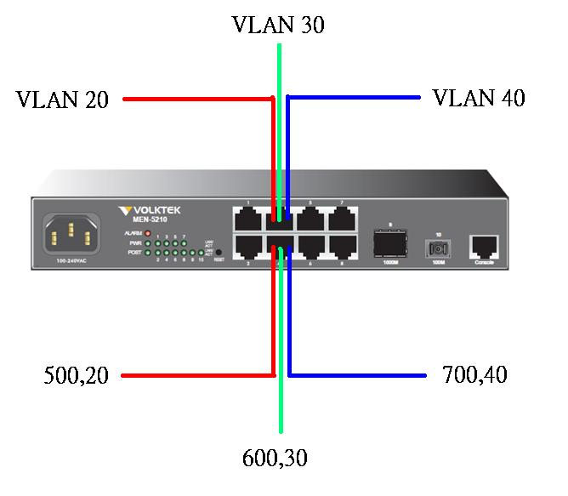
This following example shows how to configure ports 3 on the Switch to tag incoming frames withthe different service provider’s VID and priority.

L2SWITCH(config)# vlan-stacking selective
L2SWITCH(config)# vlan-stacking tpid-table index 6 value 9100
L2SWITCH(config)# vlan 20
L2SWITCH(config-vlan)# fixed 3,4
L2SWITCH(config-vlan)# tagged 3
L2SWITCH(config-vlan)# exit
L2SWITCH(config)# vlan 30
L2SWITCH(config-vlan)# fixed 3,4
L2SWITCH(config-vlan)# tagged 3
L2SWITCH(config-vlan)# exit
L2SWITCH(config)# vlan 40
L2SWITCH(config-vlan)# fixed 3,4
L2SWITCH(config-vlan)# tagged 3
L2SWITCH(config-vlan)# exit
L2SWITCH(config)# vlan 500
L2SWITCH(config-vlan)# fixed 3,4
L2SWITCH(config-vlan)# tagged 4
L2SWITCH(config-vlan)# exit
L2SWITCH(config)# vlan 600
L2SWITCH(config-vlan)# fixed 3,4
L2SWITCH(config-vlan)# tagged 4
L2SWITCH(config-vlan)# exit
L2SWITCH(config)# vlan 700
L2SWITCH(config-vlan)# fixed 3,4
L2SWITCH(config-vlan)# tagged 4
L2SWITCH(config-vlan)# exit
L2SWITCH(config)# vlan-stacking selective-qinq rule1
L2SWITCH(config-qinq)# cvids 20
L2SWITCH(config-qinq)# priority 2
L2SWITCH(config-qinq)# spvid 500
L2SWITCH(config-qinq)# access-ports 3
L2SWITCH(config-qinq)# tunnel-ports 4
L2SWITCH(config-qinq)# active
L2SWITCH(config-qinq)# show
L2SWITCH(config-qinq)# exit
L2SWITCH(config)# vlan-stacking selective-qinq rule2
L2SWITCH(config-qinq)# cvids 30
L2SWITCH(config-qinq)# priority 5
L2SWITCH(config-qinq)# spvid 600
L2SWITCH(config-qinq)# access-ports 3
L2SWITCH(config-qinq)# tunnel-ports 4
L2SWITCH(config-qinq)# active
L2SWITCH(config-qinq)# show
L2SWITCH(config-qinq)# exit
L2SWITCH(config)# vlan-stacking selective-qinq rule3
L2SWITCH(config-qinq)# cvids 40
L2SWITCH(config-qinq)# priority 7
L2SWITCH(config-qinq)# spvid 700
L2SWITCH(config-qinq)# access-ports 3
L2SWITCH(config-qinq)# tunnel-ports 4
L2SWITCH(config-qinq)# active
L2SWITCH(config-qinq)# show
L2SWITCH(config-qinq)# exit
L2SWITCH(config)# interface 1/0/4
L2SWITCH(config-if)# vlan-stacking tunnel-tpid index 6
L2SWITCH(config-if)# exit
L2SWITCH(config)# exit
L2SWITCH# show vlan-stacking
L2SWITCH# show vlan-stacking tpid-table
L2SWITCH# show vlan-stacking selective-qinq

Default Setting: VLAN Stacking is disabled.

CLI Configuration
Node | Command | Description
enable | show vlan-stacking | This command displays the current vlan-stacking type.
enable | show vlan-stacking selective-qinq | This command displays the selective Q-in-Q configurations.
enable | show vlan-stacking portbased-qinq | This command displays the port-based q-in-Q configurations.
enable | show vlan-stacking tpid-inform | This command displays the TPID configurations.
configure | vlan-stacking (disable|port-based|selective) | This command disables the vlan stacking or enables the vlan-stacking with port-based or selective on the switch.
configure | vlan-stacking selective-qinq STRINGS | This command creates a selective Q-in-Q profile with the name.
configure | no vlan-stacking selective-qinq STRINGS | This command removes the selective Q-in-Q profile with the name.
configure | vlan-stacking tpid-table index<2-6> value STRINGS | This command configures TPID table.
interface | vlan-stacking port-based priority <0~7> | This command sets the priority in port based Q-in-Q.
interface | vlan-stacking port-based role (tunnel|access|normal) | This command sets VLAN stacking port role.
interface | vlan-stacking port-based spvid <1~4096> | This command sets the service provider’s VID of the specified port.
interface | vlan-stacking tunnel-tpid index<1-6> | This command sets TPID for a Q-in-Q tunnel port.
configure | interface range gigabitethernet1/0/PORTLISTS | This command enters the interface configure node.
if-range | vlan-stacking port-based priority <0~7> | This command sets the priority in port based Q-in-Q.
if-range | vlan-stacking port-based role (tunnel|access|normal) | This command sets VLAN stacking port role.
if-range | vlan-stacking port-based spvid <1~4096> | This command sets the service provider’s VID of the specified port.
if-range | vlan-stacking tunnel-tpid index<1-6> | This command sets TPID for a Q-in-Q tunnel port.
qinq | active | This command enables the selective Q-in-Q profile.
qinq | Inactive | This command disables the selective Q-in-Q profile.
qinq | cvid VLANID | This command specifies the customer’s VLAN range on the incoming packets.
qinq | spvid VLANID | This command sets the service provider’s VLAN ID for outgoing packets in selective Q-in-Q.
qinq | priority <0-7> | This command sets priority in selective Q-in-Q.
qinq | access-portsPORTLISTS | This command specifies the access ports to apply the rule.
qinq | tunnel-ports PORTLISTS | This command specifies the tunnel ports to apply the rule.
qinq | End | The command exits the CLI Q-in-Q node and enters the CLI enable node.
qinq | Exit | The command exits the CLI Q-in-Q node and enter the CLI configure node.
qinq | Show | The command shows the current selective Q-in-Q profile configurations.

Web Configuration
VLAN Stacking
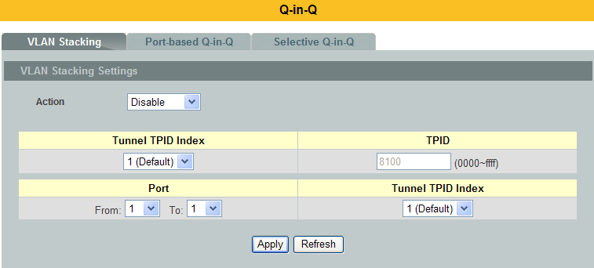
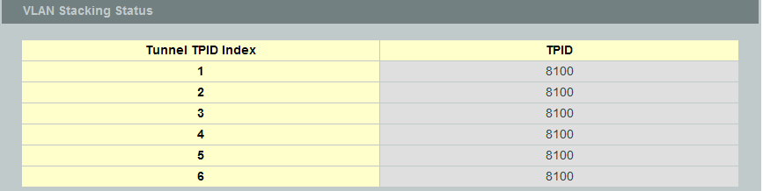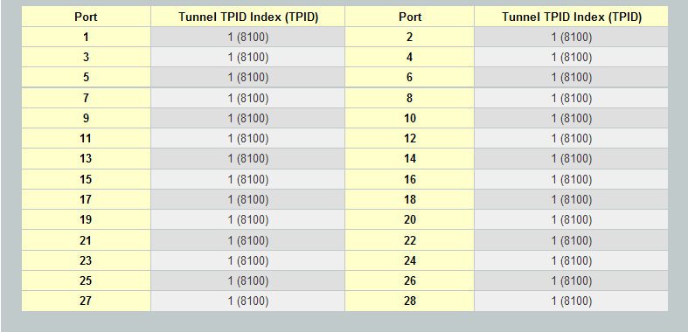

Parameter | Description
Action | Select one of the three modes, Disable or Port-Based or Selectivefor the VLAN stacking.
Configures the TPID Table: The TPID table has 6 entries.
Tunnel TPID Index | Selects the table index.
TPID | Configures the TPID.
Configures the Port TPID:
Port | Selects a port or a range of ports which you want to configure.
Tunnel TPID Index | Configures the index of the TPID Table for the specific ports.

Port-Based Q-in-Q
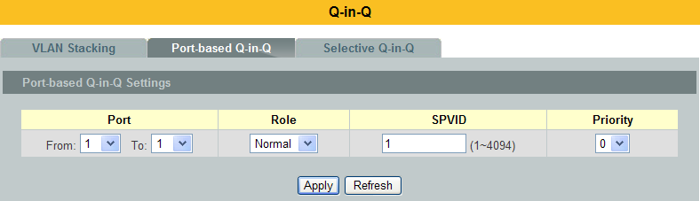
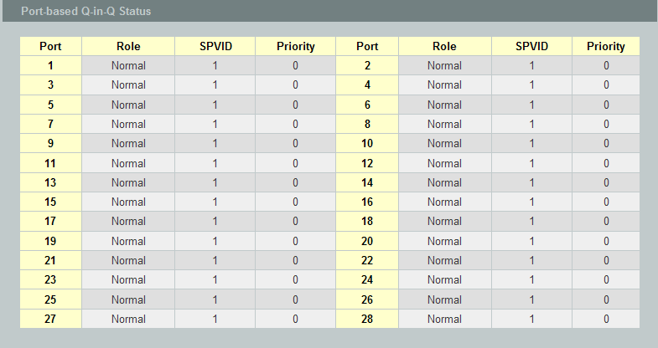

Parameter | Description
Port | Selects a port or a range of ports which you want to configure.
Role | Selects one of the three roles, Normal and Access and Tunnel, for the specific ports.
SPVID | Configures the service provider’s VLAN.
Priority | Configures the priority for the specific ports.

Selective Q-in-Q
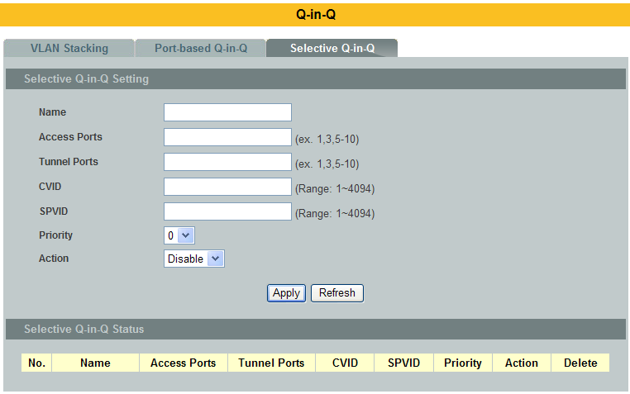

Parameter | Description
Name | Configures the selective Q-in-Q profile name.
Access Ports | Configures a port or a range of ports for the access ports.
Tunnel Ports | Configures a port or a range of ports for the tunnel ports.
CVID | Configures a customer’s VLAN.
SPVID | Configures a service provider’s VLAN.
Priority | Configures an 802.1Q priority for the profile.
Action | Enables / Disables the profile.

VLAN Translation
      - CLI Configuration
Node | Command | Description
enable | show vlan-translation | This command displays the vlan translation configuration.
configure | vlan-translation egressold-vlan VLANID new-vlan VLANID priority <0-7> | This command configures the egress vlan translation configuration for all ports.
configure | vlan-translation ingress port PORT_ID old-vlan VLANID new-vlan VLANID priority <0-7> | This command configures the vlan translation configuration by port.
configure | no vlan-translation port PORT_ID old-vlan VLANID | This command resets the vlan translation configuration by port.
configure | no vlan-translation all | This command resets all of the vlan translation configurations, including egress and ingress configurations.
configure | no vlan-translation egress all | This command resets all of the egress vlan translation configurations.
configure | no vlan-translation egress old-vlan VLAN-ID | This command resets specific egress vlan translation configurations.
configure | no vlan-translation ingress port PORT_ID old_vlan VLAN_ID | This command resets specific ingress vlan translation configurations.

      - Web Configuration
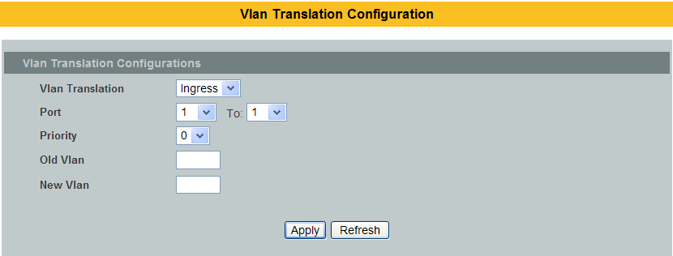
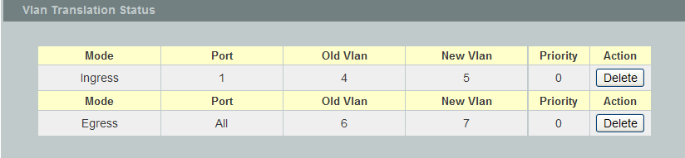

Parameter | Description
Vlan Translation | Select “Ingress” or “Egress” which you want to create the type of vlan translation.
Port | Selects a port or a range of ports for the vlan translation rule.
Priority | Configures a new priority for the vlan translation rule.
Old Vlan | Configures the vlan for the old vlan in the vlan translation rule.
New Vlan | Configures the vlan for the new vlan in the vlan translation rule.
Vlan Translation Status
Mode | The mode of the vlan translation rule.
Port | The port of the vlan translation rule.
Old Vlan | The old vlan of the vlan translation rule.
New Vlan | The new vlan of the vlan translation rule.
Priority | The priority of the vlan translation rule.
Action | Clicks the “Delete” button to delete this vlan translation rule.

DHCP Options

Option 66 and 67
The Dynamic Host Configuration Protocol(DHCP) is used by device for requesting Internet Protocol parameters, such as an IP address from a network server. The protocol operates based on the client-server model.

When the Switch connects to a network, its DHCP client software in the operating system sends a broadcast query requesting necessary information. Any DHCP server on the network may service the request. The DHCP server manages a pool of IP addresses and information about client configuration parameters such as default gateway, domain name, the name servers, and time servers, and “DHCP option 66 and 67”.

DHCP option 66 is used to identify a TFTP server when the “TFTP server name” fieldin the DHCP header has been used for DHCP options.DHCP option 67 is used to identify a TFTP server when the “file name” fieldin the DHCP header has been used for DHCP options. If DHCP server supply“DHCP option 66 and 67” then the user can set it. When the switch connects to a network, the switch will get DHCP option 66 and 67’s information from DHCP sever. The user can put the configure file on the TFTP server. The Switch will download configure file from TFTP server automatically and it will take effect the configuration file immediately.

The procedures to use the DHCP option 66 and 67:
Configurations:
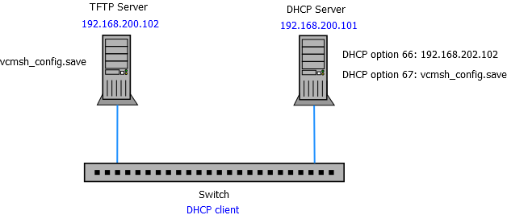

- Set DHCP option 66 and 67’s information on the DHCP server as below:
  - DHCP option 66: 192.168.202.102
  - DHCP option 67: vcmsh_config.save
- Put configuration file “vcmsh_config.save” in TFTP server.
- Enable DHCP option 66 and 67 on the Switch.
- Enable DHCP client on the Switch.
- When the Switch gets an IP from DHCP server, the DHCP server also gives the option 66’s and 67’s information to the Switch.
- When the Switch gets the option 66 and 67 information, it downloads the configuration file from TFTP server automatically.
- The Switch will take effect the configuration file immediately.
- If the configuration file has an auto-back command, the Switch backups the current system configuration to the TFTP server automatically.

Notice: The auto-backup command should be the last command in the configuration file.

      - CLI Configuration

Node | Command | Description
enable | show dhcp-options | This command displays the configurations and status for the DHCP option 66 and 67.
configure | dhcp-options option_66_67 (disable | enable) | This command disables / enables the DHCP option 66 and 67 on the Switch.
configure | dhcp-options option_66_67 auto-backup | This command uploads the current configurations to TFTP server. The file name is vcmsh_config_MODEL-NAME_MAC if you didn’t specify a filename for it.
configure | dhcp-options option_66_67 auto-backupfile FILENAME | This command configures a filename for the auto-backup function.
      - Web Configuration
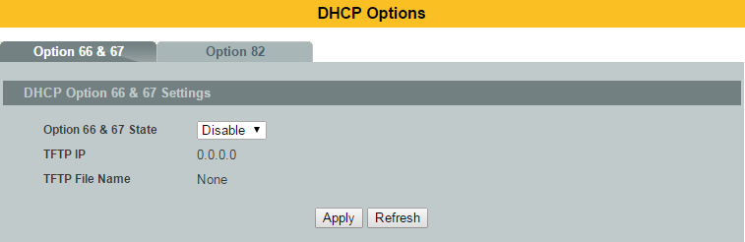

Parameter | Description
State | Select this option to enable / disable the DHCP option 66 and 67 on the Switch.
TFTP IP | The TFTP server’s IP address gotten from the DHCP option 66.
TFTP File Name | The configuration filename gotten from the DHCP option 67.
Apply | Click Apply to save your changes to the Switch.
Refresh | Click Refresh to begin configuring this screen afresh.

    - Option 82
DHCP Option 82 is the “DHCP Relay Agent Information Option”. Option 82 was designed to allow a DHCP Relay Agent to insert circuit specific information into a request that is being forwarded to a DHCP server. Specifically the option works by setting two sub-options: Circuit ID and Remote ID.

The DHCP option 82 is working on the DHCP snooping or/and DHCP relay.
The switch will monitor the DHCP packets and append some information as below to the DHCPDISCOVER and DHCPREQUEST packets. The switch will remove the DHCP Option 82 from the DHCPOFFER and DHCPACK packets. The DHCP server will assign IP domain to the client dependent on these information.

The maximum length of the information is 32 characters.

In residential, metropolitan Ethernet-access environments, DHCP can centrally manage the IP address assignments for a large number of subscribers. When the DHCP option-82 feature is enabled on the switch, a subscriber device is identified by the switch port through which it connects to the network (in addition to its MAC address). Multiple hosts on the subscriber LAN can be connected to the same port on the access switch and are uniquely identified.

When you enable the DHCP snooping information option 82 on the switch, this sequence of events occurs:
- The host (DHCP client) generates a DHCP request and broadcasts it on the network.
- When the switch receives the DHCP request, it adds the option-82 information in the packet. The option-82 information contains the switch MAC address (the remote-ID suboption) and the port identifier, vlan-mod-port, from which the packet is received (the circuit-ID suboption).
- If the IP address of the relay agent is configured, the switch adds the IP address in the DHCP packet.
- The switch forwards the DHCP request that includes the option-82 field to the DHCP server.
- The DHCP server receives the packet. If the server is option-82 capable, it can use the remote ID, the circuit ID, or both to assign IP addresses and implement policies, such as restricting the number of IP addresses that can be assigned to a single remote ID or circuit ID. Then the DHCP server echoes the option-82 field in the DHCP reply.
- The DHCP server unicasts the reply to the switch if the request was relayed to the server by the switch. When the client and server are on the same subnet, the server broadcasts the reply. The switch verifies that it originally inserted the option-82 data by inspecting the remote ID and possibly the circuit ID fields. The switch removes the option-82 field and forwards the packet to the switch port that connects to the DHCP client that sent the DHCP request.

Option Frame Format:
Code | Len | Agent Information Field
82 | N | i1 | i2 | i3 | i4 | . . . | iN
The Agent Information field consists of asequence of SubOpt/Length/Value tuples for each sub-option, encodedin the following manner:

Sub-Option | Len | Sub-Option Value
1 | N | s1 | s2 | s3 | s4 | . . . | sN

DHCP Agent Sub-Option Description
Sub-option Code
--------------- ----------------------
1 Agent Circuit ID Sub-option
2 Agent Remote ID Sub-option

Circuit ID Sub-option Format:
Suboption Type | Length | Information
0x01 |  | Circuit Form

Remote ID Suboption Frame Format:
Suboption Type | Length | Type | Length | MAC Address
0x02 | 8 | 0 | 6 | 6

Circuit Form:
The circuit form is a flexible architecture. It allows user to combine any information or the system configurations into the circuit sub-option.
The Circuit Form is a string format. And its maximum length is 100 characters.
The keyword, %SPACE, will be replaced with a space character.
The other keywords get system configurations from the system and then replace the keyword and its leading code in the Circuit form. Eventually, the content of the circuit form is part of the payload on the DHCP option 82 packet.

Rules:
- The keyword must have a leading code ‘%’. For example: %HOSTNAME.
- If there are any characters following the keywords, you must add ‘+’ between the keyword and character. For example: %HOSTNAME+/.
- If there are any characters before the keyword, you must add ‘+’ between the character and the keyword. For example: Test+%HOSTNAME.

Keyword:
HOSTNAME - Add the system name into the Circuit sub-option..
SPACE - Add a space character.
SVLAN - Add the service provider VLAN ID into the Circuit sub-option.
If the service provider VLAN is not defined, the system will return
PVLAN.
CVLAN - Add the customer VLAN ID into the Circuit sub-option.
If the CVLAN is not defined, the system return 0.
PORT - Add the transmit port ID into the Circuit sub-option.
FRAME - Add the frame ID into the Circuit sub-option.
The frame ID is configured with the CLI command, “dhcp-options option82 circuit_frame VALUE”. Or GUI Circuit Frame.
SHELF - Add the shelf ID into the Circuit sub-option.
The shelf ID is configured with the CLI command, “dhcp-options option82 circuit_shelf VALUE”. Or GUI Circuit Shelf.
SLOT - Add the slot ID into the Circuit sub-option.
The slot ID is configured with the CLI command, “dhcp-options option82 circuit_slot VALUE”. Or GUI Circuit Slot.

For Example:
HOSTNAME=L2SWITCH.
SVLAN=44.
CVLAN=32.
Circuit Form=RD+%SPACE+Department+%SPACE+%HOSTNAME+%SPACE+%PORT+_+%SVLAN+.+%CVLAN
The circuit sub-option result is: RD Department L2SWITCH 1_44.32

Default setting
DHCP Option 82 state : disabled.
Circuit Frame : 1.
Circuit Shelf : 0.
Circuit Slot : 0.
Circuit ID String: %HOSTNAME+%SPACE+eth/+%FRAME+/+%SHELF+/+%SLOT+:+%PORT+_+%SVLAN+:+%CVLAN
Remote ID String: %HOSTNAME+%SPACE+eth/+%FRAME+/+%SHELF+/+%SLOT+:+%PORT+_+%SVLAN+:+%CVLAN

      - CLI Configuration
Node | Command | Description
enable | show dhcp-options | This command displays the DHCP options configurations.
configure | dhcp-options option82 (disable | enable) | This command disables / enables the DHCP option 82on the Switch.
configure | dhcp-options option82 circuit_id | This command configures the information of the circuit ID sub-option.
configure | dhcp-options option82 remote_id | This command configures the information of the remote ID sub-option.
configure | dhcp-options option82 circuit_frame VALUE | This command configures the frame ID for the circuit sub-option.
configure | dhcp-options option82 circuit_shelf VALUE | This command configures the shelf ID for the circuit sub-option.
configure | dhcp-options option82 circuit_slot VALUE | This command configures the slot ID for the circuit sub-option.

      - Web Configuration
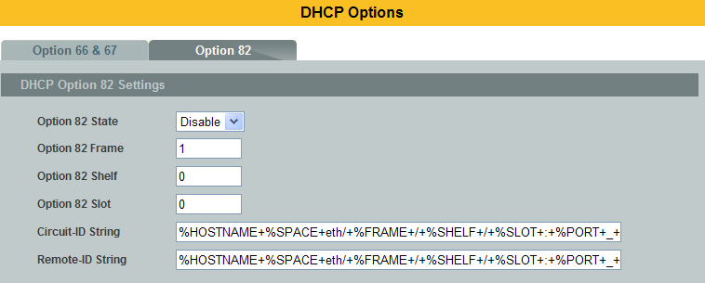
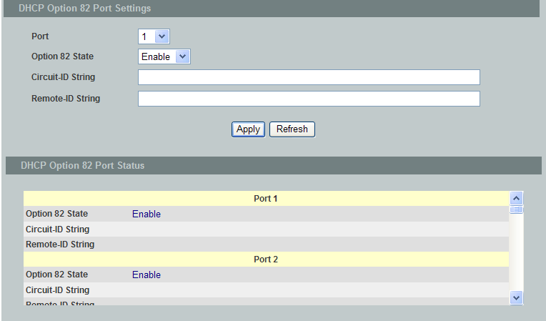

Parameter | Description
State | Select this option to enable / disable the DHCP option 82 on the Switch.
Circuit Frame | The frame ID for the circuit sub-option.
Circuit Shelf | The shelf ID for the circuit sub-option.
Circuit Slot | The slot ID for the circuit sub-option.
Circuit-ID String | The String of the circuit ID sub-option information.
Remote-ID String | The String of the remote ID sub-option information.
Apply | Click Apply to save your changes to the Switch.
Refresh | Click Refresh to begin configuring this screen afresh.
DHCP Option 82 Port Settings
Port | The port ID.
Circuit-ID String | The String of the circuit ID sub-option information for the specific port.
Remote-ID String | The String of the remote ID sub-option information for the specific port.
DHCP Option 82 Port Status
 | The field displays all of the ports’ configurations.

DHCP Relay
Because the DHCPDISCOVER message is a broadcast message, and broadcasts only cross other segments when they are explicitly routed, you might have to configure a DHCP Relay Agent on the router interface so that all DHCPDISCOVER messages can be forwarded to your DHCP server. Alternatively, you can configure the router to forward DHCP messages and BOOTP message. In a routed network, you would need DHCP Relay Agents if you plan to implement only one DHCP server.

The DHCP Relay that either a host or an IP router that listens for DHCP client messages being broadcast on a subnet and then forwards those DHCP messages directly to a configured DHCP server. The DHCP server sends DHCP response messages directly back to the DHCP relay agent, which then forwards them to the DHCP client. The DHCP administrator uses DHCP relay agents to centralize DHCP servers, avoiding the need for a DHCP server on each subnet.

Most of the time in small networks DHCP uses broadcasts however there are some circumstances where unicast addresses will be used. When a networks have a single DHCP server that provides IP addresses for multiple subnets. A router for such a subnet receives the DHCP broadcasts, converts them to unicast (with a destination MAC/IP address of the configured DHCP server, source MAC/IP of the router itself). The field identified as the GIADDR in the main DHCP page is populated with the IP address of the interface on the router it received the DHCP request on. The DHCP server uses the GIADDR field to identify the subnet the device and select an IP address from the correct pool. The DHCP server then sends the DHCP OFFER back to the router via unicast which then converts it back to a broadcast and out to the correct subnet containing the device requesting an address.

Configurations:
Users can enable / disable the DHCP Relay on the Switch. Users also can enable / disable the DHCP Relay on a specific VLAN. If the DHCP Relay on the Switch is disabled, the DHCP Relay is disabled on all VLANs even some of the VLAN DHCP Relay are enabled.

Applications
- Application-1 (Over a Router)
The DHCP cleint-1 and DHCP client-2 are located in different IP segments. But they allocate IP address from the same DHCP server.

DHCP Client-1 Switch Router Switch DHCP Client-2

DHCP Server

- Application-2 (Local in different VLANs)
The DHCP cleint-1 and DHCP client-2 are located in different VLAN. But they allocate IP address from the same DHCP server.

Switch DHCP Relay agent
8
7
1
2
3
4
6
5
Server client client client client client client client

VLAN 1: port 1, 2 (Management VLAN)
VLAN 2: port 3, 4
VLAN 3: port 5, 6
VLAN 4: port 7, 8

DHCP Server Port 1.
DHCP Client Port 2, 3, 4, 5, 6, 7, 8.

Result: Hosts connected to port 2,3,4,5,6,7,8 can get IP from DHCP server.
Note: The DHCP Server must connect to the management VLAN member ports.
The DHCP Relay in management VLAN should be enabled.

Default Settings
The default global DHCP relay state is disabled.
The default VLAN DHCP relay state is disabled for all VLANs.
The default DHCP server is 0.0.0.0

    - CLI Configuration
Node | Command | Description
enable | show dhcp relay | This command displays the current configurations for the DHCP relay.
configure | dhcp relay (disable | enable) | This command disables / enables the DHCP relay on the switch.
configure | dhcp relay vlan VLAN_RANGE | This command enables the DHCP relay function on a VLAN or a range of VLANs.
configure | no dhcp relay vlan VLAN_RANGE | This command disables the DHCP relay function on a VLAN or a range of VLANs.
configure | dhcp helper-addressIP_ADDRESS | This command configures the DHCP server’s IP address.
configure | no dhcp helper-address | This command removes the DHCP server’s IP address.
Example:
L2SWITCH#configure terminal
L2SWITCH(config)# interface eth0
L2SWITCH(config-if)# ip address 172.20.1.101/24
L2SWITCH(config-if)# ip address default-gateway 172.20.1.1
L2SWITCH(config)#dhcp relay enable
L2SWITCH(config)# dhcp relay vlan 1
L2SWITCH(config)# dhcp helper-address 172.20.1.1

    - Web Configuration
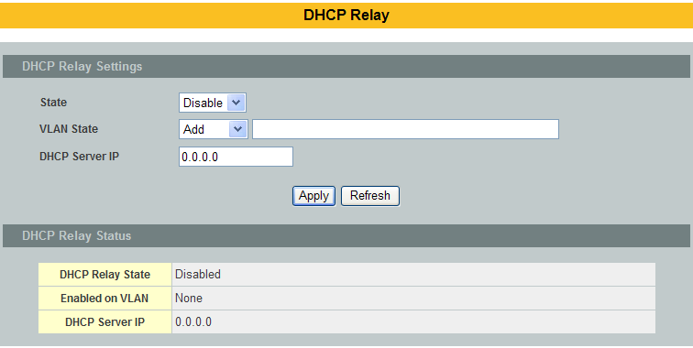

Parameter | Description
State | Enables/ disables the DHCP relay for the Switch.
VLANState | Enables / disables the DHCP relay on the specific VLAN(s).
DHCP Server IP | Configures the DHCP server’s IP address.

Dual Homing
Dual Homing is a network topology in which a device is connected to the network by way of two independent access points (points of attachment). One access point is the primary connection, and the other is a standby connection that is activated in the event of a failure of the primary connection.

How Dual-Homing Works?
Assume the primary connection and secondary connections are connected to Internet by different way. For example, primary connection is connected to a physical network but secondary connection is connected to a wireless network. When enable dual homing feature, device will default connect to Internet by primary connectionand secondary connectionwill be shutdown. If the port or all ports of primary connection link-down, then device will replace primary connection by secondary connection to connect to Internet. At this situation, if secondary connection is also link-down, device will do nothing. Secondary connection only works as primary connection disconnecting.

Default Settings
Dual-Homing Configurations:
State : Disable.
Primary Channel : -
Secondary Channel : -
-----------------------------------------------------
Detail Status:
Primary Channel Status : -
Secondary Channel Status : -

Notices: If the channel is a single port, then the port cannot add into any trunk group.

    - CLI Configuration
Node | Command | Description
enable | show dual-homing | This command displays the dual-homing information.
configure | dual-homing (disable | enable) | This command disables / enables the dual-homing function for the system.
configure | dual-homing primary-channel(port|trunk) VALUE | This command sets the dual-homing primary channel for the system. The channel can be a single port or a trunk group.
configure | no dual-homing primary-channel | This command removes the dual-homing primary channel for the system.
configure | dual-homing secondary-channel (port|trunk) VALUE | This command sets the dual-homing secondary channel for the system. The channel can be a single port or a trunk group.
configure | no dual-homing secondary-channel | This command removes the dual-homing secondary channel for the system.

Example:
L2SWITCH(config)# link-aggregation 1 ports 5-6
L2SWITCH(config)# link-aggregation 1 enable
L2SWITCH(config)# dual-homing primary-channel port 2
L2SWITCH(config)# dual-homing secondary -channeltrunk 1
L2SWITCH(config)# dual-homing enable

    - Web Configuration
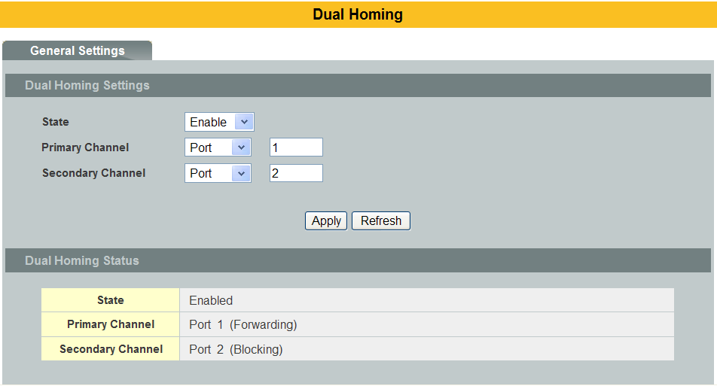

Parameter | Description
State | Enables/ disables the Dual-Homing for the Switch.
Primary channel | Configures the primary channel. The channel can be single port or a trunk group.
Secondary channel | Configures the secondary channel. The channel can be single port or a trunk group.

EEE (Energy Efficient Ethernet)

Introduction
The Energy Efficient Ethernet (EEE) is an IEEE 802.3az standard that is designed to reduce power consumption in Ethernet networks during idle periods.

EEE can be enabled on devices that support low power idle (LPI) mode. Such devices can save power by entering LPI mode during periods of low utilization. In LPI mode, systems on both ends of the link can save power by shutting down certain services. EEE provides the protocol needed to transition into and out of LPI mode in a way that is transparent to upper layer protocols and applications.

Notice: This feature is for Ethernet copper ports only.

Default Settings
All ports’ EEE states are disabled.

CLI Configuration
Node | Command | Description
enable | show interface [IFNAME] | This command displays the current port configurations.
interface | power efficient-ethernet auto | The command enables EEE on the specified interface. When EEE is enabled, the device advertises and auto negotiates EEE to its link partner.
interface | no power efficient-ethernet auto | The command disables EEE on the specified interface.

Example:
L2SWITCH#configure terminal
L2SWITCH(config-if)#interface gigabitethernet1/0/1
L2SWITCH(config-if)#power efficient-ethernet auto
L2SWITCH(config-if)#no power efficient-ethernet auto

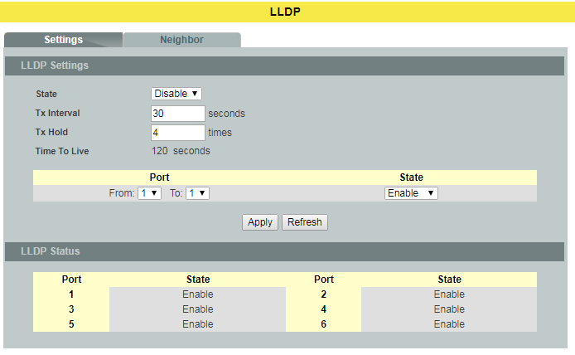

Web Configuration
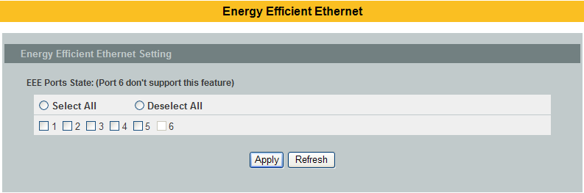

Parameter | Description
EEEPortState | Click a port to enable IEEE 802.3az Energy Efficient Ethernet on that port.
Select All | Click this to enable IEEE 802.3az Energy Efficient Ethernet across all ports.
Deselect All | Click this to disable IEEE 802.3az Energy Efficient Ethernet across all ports.
Apply | Click Apply to configure the settings.
Refresh | Click this to reset the fields to the last setting.

ERPS
The ITU-T G.8032 Ethernet Ring Protection Switching feature implements protection switching mechanismsfor Ethernet layer ring topologies. This feature uses the G.8032 Ethernet Ring Protection (ERP) protocol,defined in ITU-T G.8032, to provide protection for Ethernet traffic in a ring topology, while ensuring thatno loops are within the ring at the Ethernet layer. The loops are prevented by blocking traffic on either apredetermined link or a failed link.

The Ethernet ring protection functionality includes the following:
- Loop avoidance
- The use of learning, forwarding, and Filtering Database (FDB) mechanisms

Loop avoidance in an Ethernet ring is achieved by guaranteeing that, at any time, traffic may flowon all but one of the ring links. This particular link is called the ring protection link (RPL) andunder normal conditions this ring link is blocked, i.e., not used for service traffic. One designatedEthernet ring node, the RPL owner node, is responsible to block traffic at one end of the RPL.Under an Ethernet ring failure condition, the RPL owner node is responsible for unblocking its endof the RPL, unless the RPL has failed, allowing the RPL to be used for traffic. The other Ethernetring node adjacent to the RPL, the RPL neighbor node, may also participate in blocking orunblocking its end of the RPL.

The Ethernet rings could support a multi-ring/ladder network that consists of conjoined Ethernetrings by one or more interconnection points. The protection switching mechanisms and protocoldefined in this Recommendation shall be applicable for a multi-ring/ladder network, if the followingprinciples are adhered to:
- R-APS channels are not shared across Ethernet ring interconnections;
- on each ring port, each traffic channel and each R-APS channel are controlled (e.g., forblocking or flushing) by the Ethernet ring protection control process (ERP control process)of only one Ethernet ring;
- Each major ring or sub-ring must have its own RPL.

In an Ethernet ring, without congestion, with all Ethernet ring nodes in the idle state (i.e., nodetected failure, no active automatic or external command and receiving only "NR, RB" R-APSmessages), with less than 1200 km of ring fiber circumference and fewer than 16 Ethernet ringnodes, the switch completion time (transfer time as defined in [ITU-T G.808.1]) for a failure on aring link shall be less than 50 ms.

The ring protection architecture relies on the existence of an APS protocol to coordinate ringprotection actions around an Ethernet ring.

The Switch supports up to six rings.

Guard timer -- All ERNs use a guard timer. The guard timer prevents the possibility of forming a closed loop and prevents ERNs from applying outdated R-APS messages. The guard timer activates when an ERN receives information about a local switching request, such as after a switch fail (SF), manual switch (MS), or forced switch (FS). When this timer expires, the ERN begins to apply actions from the R-APS it receives. This timer cannot be manually stopped.

Wait to restore (WTR) timer -- The RPL owner uses the WTR timer. The WTR timer applies to the revertive mode to prevent frequent triggering of the protection switching due to port flapping or intermittent signal failure defects. When this timer expires, the RPL owner sends a R-APS (NR, RB) through the ring.

Wait to Block (WTB) timers -- This wait-to-block timer is activated on the RPL owner. The RPL owner uses WTB timers before initiating an RPL block and then reverting to the idle state after operator-initiated commands, such as for FS or MS conditions, are entered. Because multiple FS commands are allowed to co-exist in a ring, the WTB timer ensures that the clearing of a single FS command does not trigger the re-blocking of the RPL. The WTB timer is defined to be 5 seconds longer than the guard timer, which is enough time to allow a reporting ERN to transmit two R-APS messages and allow the ring to identify the latent condition.When clearing a MS command, the WTB timer prevents the formation of a closed loop due to the RPL owner node applying an outdated remote MS request during the recovery process.
Hold-off timer -- Each ERN uses a hold-off timer to delay reporting a port failure. When the timer expires, the ERN checks the port status. If the issue still exists, the failure is reported. If the issue does not exist, nothing is reported.

ERPS revertive and non-revertiveswitching
ERPS considers revertive and non-revertiveoperation. In revertive operation, after thecondition(s) causing a switch has cleared, thetraffic channel is restored to the workingtransport entity, i.e. blocked on the RPL. In thecase of clearing of a defect, the trafficchannelreverts after the expiry of a WTR timer, which isused to avoid toggling protection states in caseof intermittent defects. In non-revertive operation,the trafficchannel continues to use theRPL, if it is not failed, after a switch conditionhas cleared.

Control VLAN:
The pure ERPS control packets domain only, no other packets are transmitted in this vlan to guarantee no delay for the ERPS. So when you configure a Control VLAN for a ring, the vlan should be a new one. The ERPS will create this control vlan and its member ports automatically. The member port should have the Left and Right ports only.

In ERPS, the control packets and data packets are separated in different vlans.
The control packets are transmitted in a vlan which is called the Control VLAN.

Instance:
For ERPS version 2, the instance is a profile specifies a control vlan and a data vlan or multiple data vlans for the ERPS. In ERPS, it can separate the control packets and data packets in different vlans. The control packets is in the Control VLAN and the data packets can be in one or multiple data vlan. And then user can assign an instance to an ERPS ring easily.

In ERPS version 1, if a port is blocked by ERPS, all packets are blocked.
In ERPS version 2, if a port is blocked by a ring of ERPS, only the packets belong to the vlans in the instance are blocked.

Notice:
Control VLAN and Instance:
In CLI or Web configurations, there are the Control VLAN and the Instance settings.
If the Control VLAN is configured for a ring and you want to configure an instance for the ring. The control vlan of the instance must be same as the Control VLAN; otherwise, you will get an error. If you still want to use this instance, you can change the Control VLAN to same as the control vlan of the instance first. And then configures the instance.

    - CLI Configuration
Node | Command | Description
Enable | show erps | This command displays the ERPS configurations.
Enable | show erps instance | This command displays the ERPS instance configurations.
Enable | show erps instance INSTANCE_ID | This command displays the specific ERPS instance configurations.
Configure | erps enable | This command enables the global ERPS on the Switch.
Configure | no erps enable | This command disables the global ERPS on the Switch.
Configure | erps ring-id VALUE | This command creates an ERPS ring and itsID and enter ERPS node.
Configure | erps instance | This command enters the instance configure node.
Configure | no erps ring-id VALUE | This command creates an ERPS ring and enter ERPS node to configure detail ring configurations.
erps-ring | show | This command displays the configurations of the ring.
erps-ring | control-vlan | This command configures a control-vlan for the ERPS ring.
erps-ring | guard-timer | This command configures the Guard Timer for the ERPS ring. (default:500ms)
erps-ring | holdoff-timer | This command configures theHold-off Timer for the ERPS ring. (default:0ms)
erps-ring | left-port PORTID type [owner|neighbor|normal] | This command configures theleft port and type for the ERPS ring.
erps-ring | mel VALUE | This command configures a Control MEL for the ERPS ring.
erps-ring | name STRING | This command configures a name for the ERPS ring.
erps-ring | revertive | This command configures therevertive mode for the ERPS ring.
erps-ring | no revertive | This command configures thenon-revertive mode for the ERPS ring.
erps-ring | right-port PORTID type [owner|neighbor|normal] | This command configures theright port and type for the ERPS ring.
erps-ring | ring enable | This command enables thering.
erps-ring | no ring enable | This command disables the ring.
erps-ring | version | This command configures a version for the ERPS ring.
erps-ring | wtr-timer | This command configures theWTR Timer for the ERPS ring. (default: 5 minutes)
config-erps-inst | instance INSTANCE_ID control-vlan VLAN_ID data-vlan VLAN_ID | This command configures a new instance and specifies its control vlan and data vlan.
config-erps-inst | no instance INSTANCE_ID | This command removes an instance.
config-erps-inst | show | This command displays all of the instance configurations.

    - Web configuration
Ring Settings:
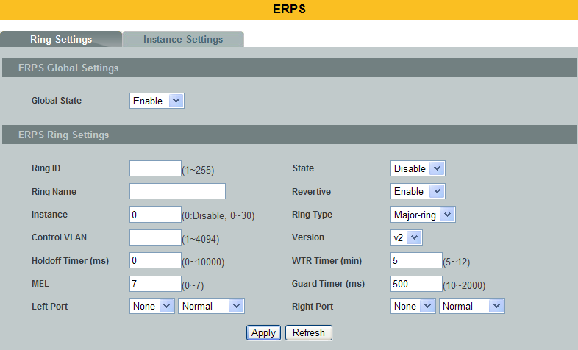
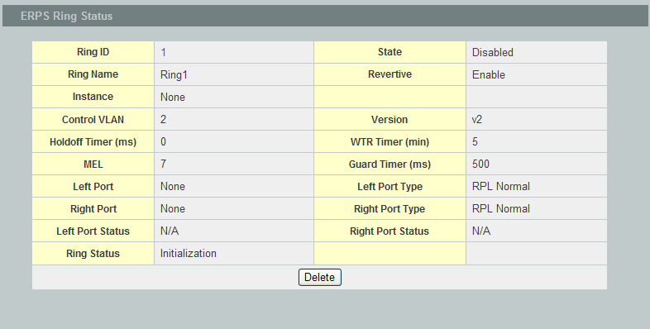

Parameter | Description
Global State | Enables / disables the global ERPS state.
Ring ID | Configures the ring ID. The Valid value is from 1 to 255.
State | Enables/ disables the ring state.
Ring Name | Configures the ring name.(Up to 32 characters)
Revertive | Enables / disables the revertive mode.
Instance | Configures the instance for the ring. The Valid value is from 0 to 30. 0-Disable means the ERPS is running in version 1. The control VLAN of the instance should be same as below Control VLAN.
Control VLAN | Configures the Control VLAN which is the ERPS control packets domain for the ring.
Version | Configures the version for the ring.
Hold-off Timer | Configures the Hold-off time for the ring. The Valid value is from 0 to 10000 (ms).
WTR Timer | Configures the WTR time for the ring. The Valid value is from 5 to 12 (min).
MEL | Configures the Control MEL for the ring. The Valid value is from 0 to 7. The default is 7.
Guard Timer | Configures the Guard time for the ring. The Valid value is from 10 to 2000 (ms).
Left Port | Configures the left port and its type for the ring. The valid port type is one of Owner, Neighbor or Normal.
Right Port | Configures the right port and its type for the ring. The valid port type is one of Owner, Neighbor or Normal.
ERPS Status
Ring ID | The ring ID.
Ring Name | The ring name.
State | The ring state.
Revertive | The ring revertive mode.
Control VLAN | The ring Control VLAN.
Version | The protocol version on the ring.
Holdoff Timer | The Hold-off time.
WTR Timer | The WTR time.
MEL | The Control MEL.
Guard Timer | The Guard time.
Left Port | The left port.
Left Port Type | The left port type.
Right Port | The right port.
Right Port Type | The right port type.
WTB Timer | The WTB time.
Ring Status | The current ring status.
Left Port Status | The current left port status.
Right Port Status | The current right port status.

Instance Settings:
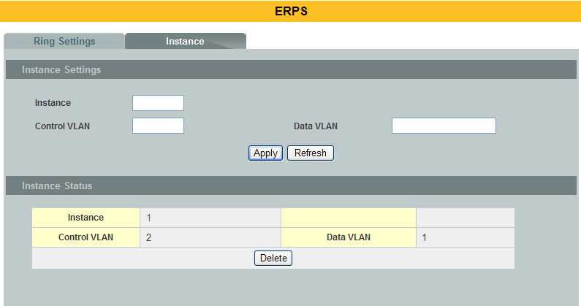

Parameter | Description
Instance Settings
Instance | Configures the instance ID. The valid value is from 1 to 31.
Control VLAN | Configures the control vlan for the instance. The valid value is from 1 to 4094.
Data VLAN | Configures the data vlan for the instance. The valid value is from 1 to 4094. It can be one or multiple vlans.
Instance Status
Instance | The instance ID.
Control VLAN | The control vlan of the instance.
Data VLAN | The data vlan of the instance.

Link Aggregation

Static Trunk
Link Aggregation (Trunking) is the grouping of physical ports into one logicalhigher-capacity link. You may want to trunk ports if for example, it is cheaper touse multiple lower-speed links than to under-utilize a high-speed, but more costly,single-port link.

However, the more ports you aggregate then the fewer available ports you have. Atrunk group is one logical link containing multiple ports.The Switch supports both static and dynamic link aggregation.

Note: In a properly planned network, it is recommended to implement static linkaggregation only. This ensures increased network stability and control over thetrunk groups on your Switch.

Default Settings
- The default group Link Aggregation state is disabled for all groups.
- The default group Link Aggregation load balance is source MAC and destination MAC for all groups.
- Maximum link aggregation group : 8.
- Maximum port in link aggregation group : 8.

CLI Configuration
Node | Command | Description
enable | show link-aggregation | The command displays the current trunk configurations.
configure | link-aggregation[GROUP_ID] (disable | enable) | The command disables / enables the trunk on the specific trunk group.
configure | link-aggregation[GROUP_ID] interface PORTLISTS | The command adds ports to a specific trunk group.
configure | no link-aggregation[GROUP_ID] interface PORTLISTS | The commands delete ports from a specific trunk group.
configure | link-aggregationGROUP_ID load-balance (mac|ip) | The commands configurations the load balance algorithm for the link aggregation.

Example:
L2SWITCH#configure terminal
L2SWITCH(config)#link-aggregation 1 enable
L2SWITCH(config)#link-aggregation 1 ports 1-4

Web Configuration
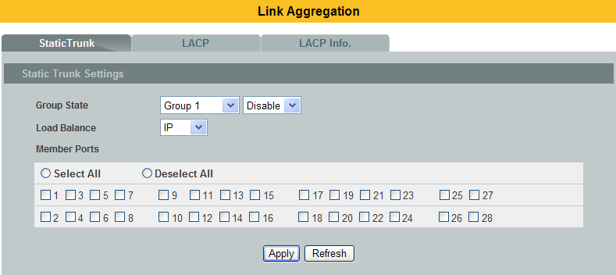
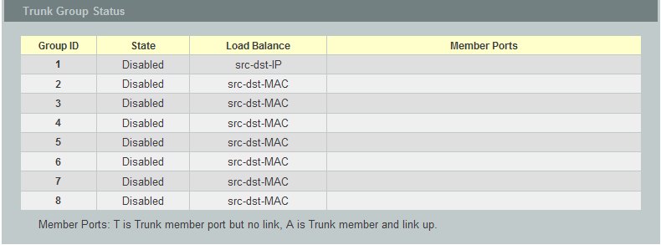

Parameter | Description
Group State | Select the group ID to use for this trunk group, that is, one logical linkcontaining multiple ports.  Select Enable to use this static trunk group.
Load Balance | Configures the load balance algorithm for the specific trunk group.
Member Ports | Select the ports to be added to the static trunk group.
Apply | Click Apply to configure the settings.
Refresh | Click this to reset the fields to the last setting.
Trunk Group Status
Group ID | This field displays the group ID to identify a trunk group, that is, one logical link containing multiple ports.
State | This field displays if the trunk group is enabled or disabled.
Load Balance | This field displays the load balance policy for the trunk group.
Member Ports | This field displays the assigned ports that comprise the static trunk group.

LACP
The Switch adheres to the IEEE 802.3ad standard for static and dynamic (LACP)port trunking.The IEEE 802.3ad standard describes the Link Aggregation Control Protocol(LACP) for dynamically creating and managing trunk groups.When you enable LACP link aggregation on a port, the port can automaticallynegotiate with the ports at the remote end of a link to establish trunk groups.

LACP also allows port redundancy, that is, if an operational port fails, then one ofthe “standby” ports become operational without user intervention. Please notethat:
- You must connect all ports point-to-point to the same Ethernet switch andconfigure the ports for LACP trunking.
- LACP only works on full-duplex links.
- All ports in the same trunk group must have the same media type, speed,and duplex mode and flow control settings.
- Configure trunk groups or LACP before you connect the Ethernet switch to avoidcausing network topology loops.

System Priority:
The switch with the lowest system priority (and lowest port number if system priority is the same) becomes the LACP “server”. The LACP “server” controls the operation of LACP setup. Enter a number to set the priority of an active port using Link Aggregation Control Protocol (LACP). The smaller number the higher priority level.

System ID:
The LACP system ID is the combination of the LACP system priority value and the MAC address of the router.

Administrative Key:
The administrative key defines the ability of a port to aggregate with other ports. A port's ability to aggregate with other ports is determined by these factors:
- Port physical characteristics, such as data rate, duplex capability, and point-to-point or shared medium.
- Configuration restrictions that you establish.

Port Priority:
The port priority determines which ports should be put in standby mode when there is a hardware limitation that prevents all compatible ports from aggregating.

Default Settings
- The default System Priority is 32768.
- The default group LACP state is disabled for all groups.

CLI Configuration
Node | Command | Description
enable | show trunk | This command displays the current trunk configurations.
enable | show lacp counters [GROUP_ID] | This command displays the LACP counters for the specific group or all groups.
enable | show lacp internal [GROUP_ID] | This command displays the LACP internal information for the specific group or all groups.
enable | show lacp neighbor [GROUP_ID] | This command displays the LACP neighbor’s information for the specific group or all groups.
enable | show lacp port_priority | This command c displays the port priority for the LACP.
enable | show lacp sys_id | This command displays the actor’s and partner’s system ID.
configure | Lacp (disable | enable) | This command disables / enables the LACP on the switch.
configure | Lacp GROUP_ID (disable | enable) | This command disables / enables the LACP on the specific trunk group.
configure | clear lacp counters [PORT_ID] | This command clears the LACP statistics for the specific port or all ports.
configure | lacp system-priority<1-65535> | This command configures the system priority for the LACP. Note: The default value is 32768.
configure | no lacp system-priority | This command configures the default for the system priority for the LACP.
interface | lacp port_priority <1-65535> | This command configures the priority for the specific port.  Note: The default value is 32768.
interface | no lacp port_priority | This command configures the default for the priority for the specific port.
configure | interface range gigabitethernet1/0/PORTLISTS | This command enters the interface configure node.
if-range | lacp port_priority <1-65535> | This command configures the priority for the specific ports.  Note: The default value is 32768.
if-range | no lacp port_priority | This command configures the default for the priority for the specific ports.

Web Configuration
LACP Settings
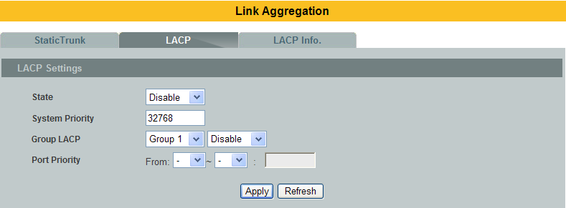
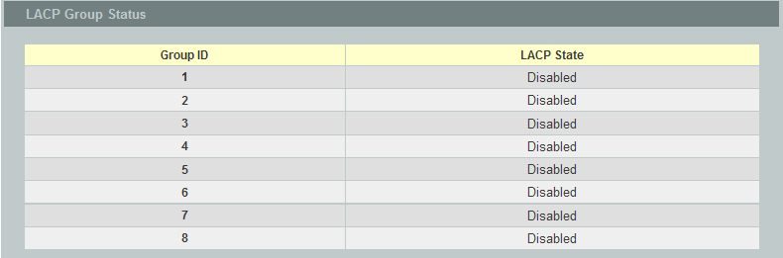
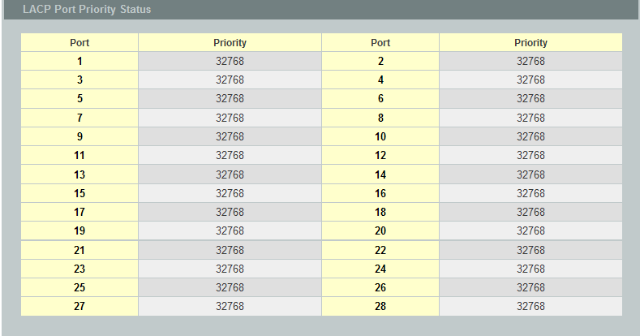

Parameter | Description
State | Select Enable from the drop down box to enable Link Aggregation Control Protocol (LACP).  Select Disable to not use LACP.
System Priority | LACP system priority is a number between 1 and 65,535. The switch with the lowest system priority (and lowest port number if system priority is the same) becomes the LACP “server”. The LACP “server” controls the operation of LACP setup. Enter a number to set the priority of an active port using Link Aggregation Control Protocol (LACP). The smaller the number, the higher the priority level.
Group LACP | Select a trunk group ID and then select whether to Enable or DisableGroup Link Aggregation Control Protocol for that trunk group.
Port Priority | Select a port or a range of ports to configure its (their) LACP priority.
Apply | Click Apply to configure the settings.
Refresh | Click this to reset the fields to the last setting.
LACP Group Status
Group ID | The field identifies the LACP group ID.
LACPState | This field displays if the group has LACP enabled.
LACP Port Priority Status
Port | The field identifies the port ID.
Priority | The field identifies the port’s LACP priority.

LACP Info.
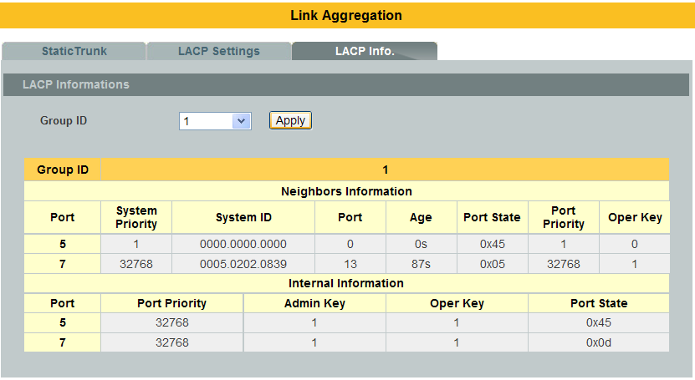

Parameter | Description
Group ID | Select a LACP group that you want to view.
Neighbors Information
Port | The LACP member port ID.
System Priority | LACP system priority is used to determine link aggregation group (LAG) membership, and to identify this device to other switches during LAG negotiations. (Range: 0-65535; Default: 32768)
System ID | The neighbor Switch’s system ID.
Port | The direct connected port Id of the neighbor Switch.
Age | The available time period of the neighbor Switch LACP information.
Port State | The direct connected port’s state of the neighbor Switch.
Port Priority | The direct connected port’s priority of the neighbor Switch.
Oper Key | The Oper key of the neighbor Switch.
Internal Information
Port | The LACP member port ID.
Port Priority | The port priority of the LACP member port.
Admin Key | The Admin key of the LACP member port.
Oper Key | The Oper key of the LACP member port.
Port State | The port state of the LACP member port.

  - Link Layer Discovery Protocol (LLDP)
The Link Layer Discovery Protocol (LLDP) specified in this standard allows stations attached to an IEEE802® LAN to advertise, to other stations attached to the same IEEE 802 LAN, the major capabilitiesprovided by the system incorporating that station, the management address or addresses of the entity orentities that provide management of those capabilities, and the identification of the station’s point ofattachment to the IEEE 802 LAN required by those management entity or entities.

The information distributed via this protocol is stored by its recipients in a standard ManagementInformation Base (MIB), making it possible for the information to be accessed by a Network ManagementSystem (NMS) using a management protocol such as the Simple Network Management Protocol (SNMP).

Default Settings
The LLDP on the Switch is disabled.

Tx Interval : 30 seconds.
Tx Hold : 4 times.
Time To Live : 120 seconds.

Port Status Port Status
---- ------- ---- -------
1 Enable 2 Enable
3 Enable 4 Enable
5 Enable 6 Enable
7 Enable 8 Enable
9 Enable 10 Enable
11 Enable12 Enable
13 Enable14 Enable
15 Enable16 Enable
17 Enable18 Enable
19 Enable20 Enable
21 Enable22 Enable
23 Enable24 Enable
25 Enable26 Enable
27 Enable28 Enable

    - CLI Configuration
Node | Command | Description
enable | show lldp | This command displays the LLDP configurations.
enable | show lldp neighbor | This command displays all of the ports’ neighbor information.
configure | lldp (disable|enable) | This command globally enables / disables the LLDP function on the Switch.
configure | lldp tx-interval | This command configures the interval to transmit the LLDP packets.
configure | lldp tx-hold | This command configures the tx-hold time which determines the TTL of the Switch’s message. (TTL=tx-hold * tx-interval)
interface | lldp-agent (disable|enable|rx-only|tx-only) | This command configures the LLDP agent function.  disable– Disable the LLDP on the specific port.  enable– Transmit and Receive the LLDP packet on the specific port.  tx-only – Transmit the LLDP packet on the specific port only.  rx-only – Receive the LLDP packet on the specific port.
configure | interface range gigabitethernet1/0/PORTLISTS | This command enters the interface configure node.
if-range | lldp-agent (disable|enable|rx-only|tx-only) | This command configures the LLDP agent function.  disable– Disable the LLDP on the specific port.  enable– Transmit and Receive the LLDP packet on the specific port.  tx-only – Transmit the LLDP packet on the specific port only.  rx-only – Receive the LLDP packet on the specific port.

    - Web Configuration
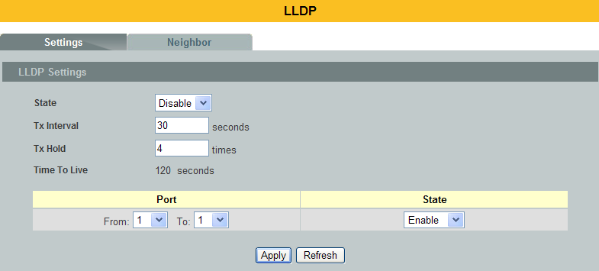
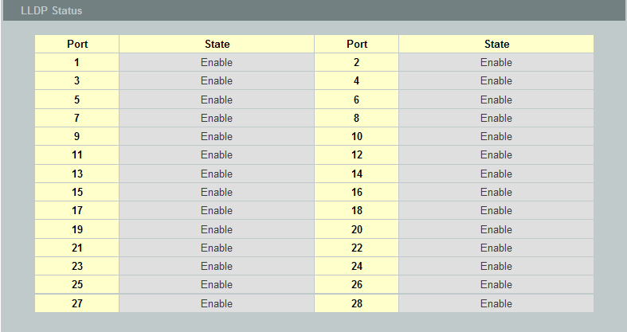

Parameter | Description
State | Globally enables / disables the LLDP on the Switch.
Tx Interval | Configures the interval to transmit the LLDP packets.
Tx Hold | Configures the tx-hold time which determines the TTL of the Switch’s message. (TTL=tx-hold * tx-interval)
Time To Live | The hold time for the Switch’s information.
Port | The port range which you want to configure.
State | Enables / disables the LLDP on these ports.
LLDP Status
Port | The Port ID.
State | The LLDP state for the specific port.

LLDP Neighbor
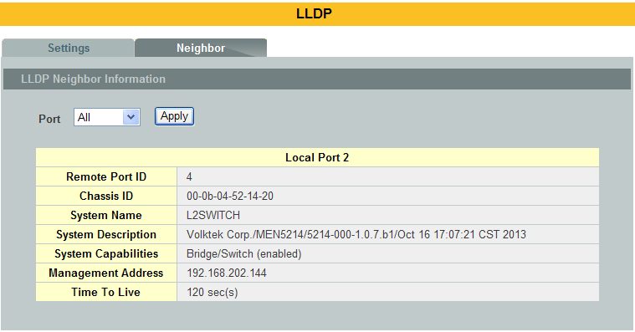

Parameter | Description
Port | Select the port(s) which you want to display the port’s neighbor information.
Local Port | The local port ID.
Remote Port ID | The connected port ID.
Chassis ID | The neighbor’s chassis ID.
System Name | The neighbor’s system name.
System Description | The neighbor’s system description.
System Capabilities | The neighbor’s capability.
Management Address | The neighbor’s management address.
Time To Live | The hold time for the neighbor’s information.

Loop Detection
Loop detection is designed to handle loop problems on the edge of your network. Thiscan occur when a port is connected to a Switch that is in a loop state. Loop stateoccurs as a result of human error. It happens when two ports on a switch areconnected with the same cable. When a switch in loop state sends out broadcastmessages the messages loop back to the switch and are re-broadcast again andagain causing a broadcast storm.

The difference between the Loop Detection and STP:

Loop Detection STP

The loop detection function sends probe packets periodically to detect if the port connect to a network in loop state. The Switch shuts down a port if the Switch detects that probe packets loop back to the same port of the Switch.

Loop Recovery:
When the loop detection is enabled, the Switch will send one probe packets everytwo secondsandthen listen this packet.If it receives the packetat the same port, the Switch will disable this port. After the time period, recovery time, the Switch will enable this port and do loop detection again.

The Switch generates syslog, internal log messages as well as SNMP traps when it shuts down a port via the loop detection feature.

For the access Switch, it may not enable the STP function.To guarantee the network topology is loop free, the Loop detection function also need detect below scenario.

Default Settings
The default global Loop-Detection state is disabled.
The default Loop Detection Destination MAC is 00:0b:04:AA:AA:AB
The default Port Loop-Detection state is disabled for all ports.
The default Port Loop-Detection status is unblocked for all ports.
The loop detection on the Switch is disabled.
Loop Detection Destination MAC=00:0b:04:aa:aa:ab

Recovery Recovery
Port State Status State Time Port State Status State Time
------------ ------- -------- ---- ---- -------- ------- -------- ----
1 Disabled Normal Enabled 1 2 Disabled Normal Enabled 1
3 Disabled Normal Enabled 1 4 Disabled Normal Enabled 1
5 Disabled Normal Enabled 1 6 Disabled Normal Enabled 1
7 Disabled Normal Enabled 18 Disabled Normal Enabled 1
9 Disabled Normal Enabled 110 Disabled Normal Enabled 1
11 Disabled Normal Enabled 1 12 Disabled Normal Enabled 1
13 Disabled Normal Enabled 1 14 Disabled Normal Enabled 1
15 Disabled Normal Enabled 1 16 Disabled Normal Enabled 1
17 Disabled Normal Enabled 1 18 Disabled Normal Enabled 1
19 Disabled Normal Enabled 1 20 Disabled Normal Enabled 1
21 Disabled Normal Enabled 1 22 Disabled Normal Enabled 1
23 Disabled Normal Enabled 1 24 Disabled Normal Enabled 1
25 Disabled Normal Enabled 1 26 Disabled Normal Enabled 1
27 Disabled Normal Enabled 1 28 Disabled Normal Enabled 1

CLI Configuration
Node | Command | Description
enable | show loop-detection | This command displays the current loop detection configurations.
configure | loop-detection (disable | enable) | This command disables / enables the loop detection on the switch.
configure | loop-detection address MACADDR | This command configures the destination MAC for the loop detection special packets.
configure | no loop-detection address | This command configures the destination MAC to default (00:0b:04:AA:AA:AB).
interface | loop-detection (disable | enable) | This command disables / enables the loop detection on the port.
interface | no shutdown | This command enables the port. It can unblock port blocked by loop detection.
interface | loop-detection recovery (disable | enable) | This command enables / disables the recovery function on the port.
interface | loop-detection recovery time VALUE | This command configures the recovery period time.
configure | interface range gigabitethernet1/0/PORTLISTS | This command enters the interface configure node.
if-range | loop-detection (disable | enable) | This command disables / enables the loop detection on the ports.
if-range | loop-detection recovery (disable | enable) | This command enables / disables the recovery function on the port.
if-range | loop-detection recovery time VALUE | This command configures the recovery period time.

Example:
L2SWITCH(config)#loop-detection enable
L2SWITCH(config)#interface 1/0/1
L2SWITCH(config-if)#loop-detection enable

Web Configuration
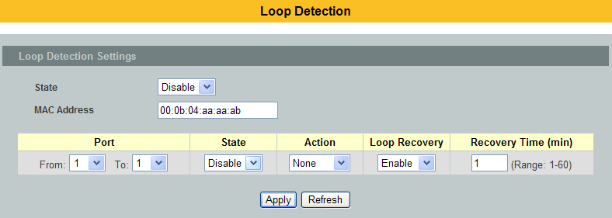
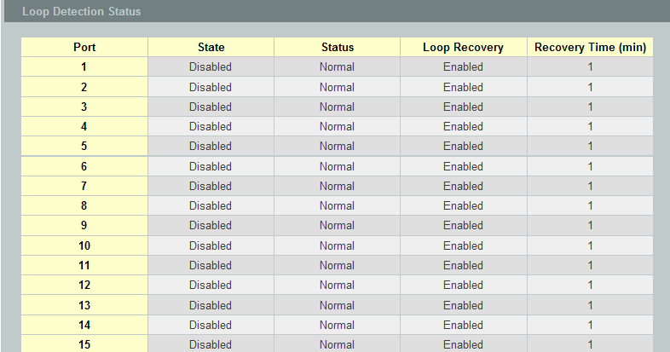
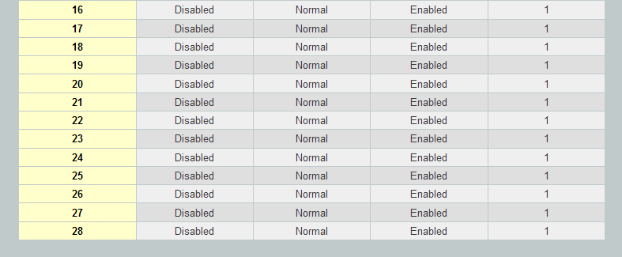

Parameter | Description
State | Select this option to enable loop guard on the Switch.
MAC Address | Enter the destination MAC address the probe packets will be sent to. If the port receives these same packets the port will be shut down.
Port | Select a port on which to configure loop guard protection.
State | Select Enable to use the loop guard feature on the Switch.
Loop Recovery | Select Enable to reactivate the port automatically after the designated recovery time has passed.
Recovery Time | Specify the recovery time in minutes that the Switch will wait beforereactivating the port. This can be between 1 to 60 minutes.
Apply | Click Apply to save your changes to the Switch.
Refresh | Click Refresh to begin configuring this screen afresh.
Loop Guard Status
Port | This field displays a port number.
State | This field displays if the loop guard feature is enabled.
Status | This field displays if the port is blocked.
Loop Recovery | This field displays if the loop recovery feature is enabled.
Recovery  Time (min) | This field displays the recovery time for the loop recovery feature.

PPPoE IA
PPPoEIntermediate Agent(PPPoEIA)isplacedbetween asubscriberandBRAStohelptheserviceproviderBRAS distinguishbetweenendhostsconnectedoverEthernettoan accessswitch.Ontheaccessswitch,PPPoEIAenablesSubscriberLineIdentificationbyappropriatelytaggingEthernetframesofdifferentusers.(Thetag containsspecificinformationlike whichsubscriberisconnectedtotheswitchandVLAN.)PPPoEIAactsasminisecurityfirewallbetweenhost andBRASbyinterceptingallPPPoE ActiveDiscovery(PAD) messagesonaper-portper-vlanbasis.Itprovidesspecificsecurityfeature suchasverifyingtheintercepted PADmessagefromuntrustedport,insertingandremovingVSA Tags(vendor-specifictag)intoandfromPADmessages.

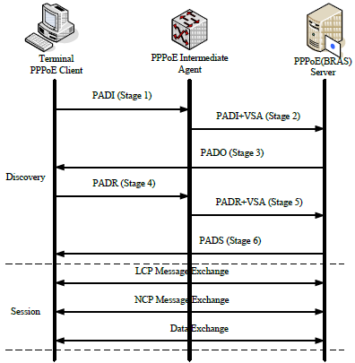

PPPoE Discovery Stage
- ThePPPoE clientbroadcastsaPADIpacketthat contains informationabouttheservicetypeitrequests.
- PPPoEIA interceptsPPPoEdiscoveryframesfromtheclientandinsertsauniquelineidentifier(circuit-id/remote-id) usingthePPPoEVendor-Specifictag(0x0105)toPADI(PPPoEActiveDiscoveryInitiation)packets.The PPPoEIAforwardsthesepacketstothe PPPoEserver aftertheinsertion.
- AfterreceivingaPADIpacket that itcan serve, aPPPoE serverreplieswitha PADO packet. Thedestination addressofthe PADO packetistheunicast packet ofthe hostthat sentthePADI.
- Dependingonthenetworktopology,sincethePADIwasbroadcast,thePPPoE clientmayreceivePADOpacketssentbymultiplePPPoEservers.AmongthesePPPoEservers,thePPPoEclientselectstheonewhosePADO packet arrivedtheearliestandunicastsaPADRpackettothePPPoE server.
- Dependingonthenetworktopology,sincethePADIwasbroadcast,thePPPoE clientmayreceivePADOpacketssentbymultiplePPPoEservers.AmongthesePPPoEservers,thePPPoEclientselectstheonewhosePADO packet arrivedtheearliestandunicastsaPADRpackettothePPPoE server.
- PPPoEIA interceptsPPPoEdiscoveryframesfromtheclientandinsertsauniquelineidentifier(circuit-id/remote-id) usingthePPPoEVendor-Specifictag(0x0105)toPADR(PPPoEActiveDiscoveryRequest)packets.ThePPPoEIAforwardsthesepacketstothe PPPoEserver aftertheinsertion.
- ThePPPoE server generates aunique session ID for thesessionandsendsthesessionIDtothePPPoEclientthrough a PADSpacket.Ifnoerror occurs,thesessionwill thusbeestablishedandPPPoEmoves ontotheSession stage.

PPPoE Intermediate Agent Tag Format
If the PPPoE Intermediate Agent is enabled, the Switch adds a vendor-specific tag to PADI (PPPoEActive Discovery Initialization) and PADR (PPPoE Active Discovery Request) packets from PPPoEclients. This tag is defined in RFC 2516 and has the following format for this feature.

Table 1 PPPoE Intermediate Agent Vendor-specific Tag Format
The Tag_Type is 0x0105 for vendor-specific tags, as defined in RFC 2516. The Tag_Len indicates thelength of Value, #1 and #2. The Value is the 32-bit number 0x00000DE9, which stands for the “ADSLForum” IANA entry. #1 and #2 are PPPoE intermediate agent sub-options, which contain additionalinformation about the PPPoE client.

Sub-Option Format
There are two types of sub-option: “Agent Circuit ID Sub-option” and “Agent Remote ID Suboption”.They have the following formats.

Table 2PPPoE IA Circuit ID Sub-option Format: User-defined String

SubOpt Length Value

Table 3PPPoE IA Remote ID Sub-option Format

SubOpt Length Value
The 0x01 in the first field identifies this as an Agent Circuit ID sub-option and 0x02 identifies this as anAgent Remote ID sub-option. The next field specifies the length of the field. The Switch takes theCircuit ID string you manually configure for a VLAN on a port as the highest priority and the CircuitID string for a port as the second priority. In addition, the Switch puts the PPPoE client’s MACaddress into the Agent Remote ID Sub-option if you do not specify any user-defined string.

Flexible Circuit ID Syntax with Identifier String and Variables
If you do not configure a Circuit ID string for a VLAN on a specific port or for a specific port, theSwitch adds the user-defined identifier string and variables into the Agent Circuit ID Sub-option.The system variables can be the host name of the access node (Switch), the port number of the PPPoE client and/or theVLAN ID on the PPPoE packet.

Table 4PPPoE IA System Variable
SYSTEM VARIABLE | DESCRIPTION
%HOSTNAME | Host name of access node(Switch)
%SPACE | Space key(ASCII 0x20)
%PORT | Port number of the client
%SVLAN | Service provider VLAN ID
%CVLAN | Client VLAN ID

PS. %SVLAN equal to %CVLAN

Users can freely combined circuit ID, using the '+' symbol to links system variables and identifier strings, in order to meet specific requirements.

EX: CLI Command

pppoe intermediate-agent format-type user-defined %HOSTNAME+%SPACE+atm+%SPACE+/0/0/+%PORT+:+%CVLAN

Table 5: PPPoE IA Circuit ID Sub-option Format: User-defined String and Variables

SubOpt Length Value

WT-101 Default Circuit ID Syntax
If you do not configure a Circuit ID string for a specific VLAN on a port or for a specific port, and no set the flexible Circuit ID syntax in the Switch, the Switchautomatically generates a Circuit ID string according to the default Circuit ID syntax which isdefined in the DSL Forum Working Text (WT)-101. The default access node identifier is the hostname of the PPPoE intermediate agent and the eth indicates “Ethernet”, and the slot id is 0.

SubOpt Length Value
Port State
Every port is either a trusted port or an untrusted port for the PPPoE intermediate agent. Thissetting is independent of the trusted/untrusted setting for DHCP snooping. Youcan also specify the agent sub-options (circuit ID and remote ID) that the Switch adds to PADI andPADR packets from PPPoE clients.

Trusted ports are connected to PPPoE servers.

- If a PADO (PPPoE Active Discovery Offer), PADS (PPPoE Active Discovery Session-confirmation),or PADT (PPPoE Active Discovery Terminate) packet is sent from a PPPoE server and received ona trusted port, the Switch forwards it to all other ports.

- If a PADI or PADR packet is sent from a PPPoE client but received on a trusted port, the Switchforwards it to other trusted port(s).

Note: The Switch will drop all PPPoE discovery packets if you enable the PPPoE
intermediate agent and there are no trusted ports.

- The trusted ports can keep/replace/strip vendor-tag of PADO and PADS packet.
- Keep: means that the PPPoE agent will keep original vendor-tag in the PADO/PADS packet.
- Replace: means that the PPPoE agent will replace the vendor-tag in the PADO/PADS packet with its own vendor-tag.
- Strip: means that the PPPoE agent will strip the vendor-tag in the PADO/PADS packet(Default).

Untrusted ports are connected to subscribers.

- If a PADI, PADR, or PADT packet is sent from a PPPoE client and received on an untrusted port,the Switch adds a vendor-specific tag to the packet and then forwards it to the trusted port(s).

- The Switch discards PADO and PADS packets which are sent from a PPPoE server but received onan untrusted port.

    - CLI Configuration
Node | Command | Description
enable | show pppoe intermediate-agent configuration | This command displays the current configurations for the PPPoE IA.
enable | show pppoe intermediate-agent statistics | This command displays the current statistics for the PPPoE IA.
enable | show pppoe intermediate-agent statistics by-vlan <VLAN-list> | This command displays the current statistics by specific VLANs for the PPPoE IA.
configure | clear pppoe intermediate-agent statistics | This command clears the statistics for the PPPoE IA.
configure | clear pppoe intermediate-agent statistics by-vlan <VLAN-list> | This command clears the statistics by specific VLANs for the PPPoE IA.
configure | pppoe intermediate-agent <enable|disable> | This command disables / enables the PPPoE IA on the switch.
configure | pppoe intermediate-agent format-type user-defined <user-defined-string> | This command configures the user defined circuit ID string for the PPPoE IA.
configure | pppoe intermediate-agent vlan <VLAN-list> | This command enablesthe PPPoE IAoneither(a)aspecificVLAN,(b)acomma separatedlistlike"x,y,"or (c)arangelike "x-y".
configure | pppoe intermediate-agent circuit-id-vlan <VLAN-list> | This command enablesthe PPPoE IAcircuit-idoneither (a)aspecificVLAN, (b)a commaseparatedlist like"x,y,"or (c)arange like"x-y".
configure | pppoe intermediate-agent remote-id-vlan <VLAN-list> | This command enables thePPPoE IAremote-idoneither (a)aspecificVLAN, (b)a commaseparatedlist like"x,y,"or (c)arange like"x-y".
configure | no pppoe intermediate-agent format-type user-defined | This no command removes the user defined circuit ID for the PPPoE IA.
configure | no pppoe intermediate-agent vlan | This no command disablesPPPoE IA on all VLANs.
configure | no pppoe intermediate-agent vlan <VLAN-list> | This no command disables thePPPoE IA on specific VLANs.
configure | no pppoe intermediate-agent circuit-id-vlan | This no command disables the PPPoE IAcircuit-idon all VLANs.
configure | no pppoe intermediate-agent circuit-id-vlan <VLAN-list> | This no command disables thePPPoE IAcircuit-idon specific VLANs.
configure | no pppoe intermediate-agent remote-id-vlan | This no command disables thePPPoE IAremote-idon all VLANs.
configure | no pppoe intermediate-agent remote-id-vlan <VLAN-list> | This no command disables thePPPoE IAremote-idon specific VLANs.
interface | pppoe intermediate-agent <enable|disable> | This command disables / enables the PPPoE IA on specific interface for the PPPoE IA.
interface | pppoe intermediate-agent trust | This command setsaphysical interfaceastrusted port.
interface | pppoe intermediate-agent format-type <circuit-id|remote-id><id-string> | This command sets circuit ID or remote ID string on specific interface for the PPPoE IA.
interface | pppoe intermediate-agent vendor-tag <keep|replace|strip> | This command is used to set the retransmitting policy of the specific interface for the PADO/PADS packet.  Default:Keep
interface | pppoe intermediate-agent vlan <VLAN-list> | This command enables thePPPoE IA on specific VLANs of interface.
interface | no pppoe intermediate-agent trust | This command setsaphysical interfaceas untrusted port.
interface | no pppoe intermediate-agent format-type <circuit-id|remote-id> | This command removes circuit ID or remote ID string on specific interface for the PPPoE IA
interface | no pppoe intermediate-agent vendor-tag | The command sets the retransmitting policy of the specific interface as “keep”.
interface | no pppoe intermediate-agent vlan | This command disables thePPPoE IA on all VLANs.
interface | no pppoe intermediate-agent vlan <VLAN-list> | This command disables thePPPoE IA on specific VLANs of interface.
if-pppoe-vlan | pppoe intermediate-agent format-type <circuit-id|remote-id><id-string> | This command sets circuit ID or remote ID string on specific VLANs of interface for the PPPoE IA.
if-pppoe-vlan | no pppoe intermediate-agent format-type <circuit-id|remote-id> | This command removes circuit ID or remote ID string on specific VLANs of interface for the PPPoE IA.

Example:
L2SWITCH(config)#pppoe intermediate-agent enable
L2SWITCH(config)#pppoe intermediate-agent vlan 1-100,200,300
L2SWITCH(config)#pppoe intermediate-agent circuit-id-vlan 1-100,200,300
L2SWITCH(config)#pppoe intermediate-agent remote-id-vlan 1-100,200,300
L2SWITCH(config)#pppoe intermediate-agent format-type user-defined %HOSTNAME+%SPACE+atm+%SPACE+/0/0/+%PORT+:+%CVLAN
L2SWITCH(config)#interface 1/0/1
L2SWITCH(config-if)#pppoe intermediate-agent enable
L2SWITCH(config-if)#interface 1/0/8
L2SWITCH(config-if)#pppoe intermediate-agent enable
L2SWITCH(config-if)#pppoe intermediate-agent trust
L2SWITCH(config-if)#pppoe intermediate-agent vlan 1
L2SWITCH(if-pppoe-vlan)#

    - Web Configuration
Global Configuration
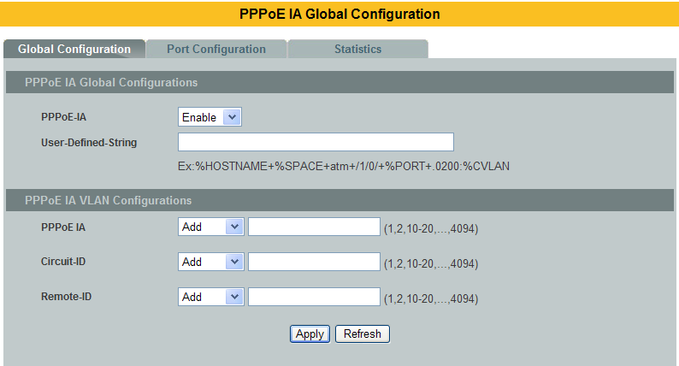

Parameter | Description
PPPoE-IA | Selects Enable to activate the PPPoE-IA or Disable to deactivate the PPPoE-IA.
User-Defined-String | User defined circuit ID string for the PPPoE IA.
PPPoE IA VLAN | Selects Add to increase the PPPoE-IA Vlan or Remove to delete the PPPoE-IA Vlan.
Circuit-ID VLAN | Selects Add to increase the Circuit-ID Vlan or Remove to delete the Circuit-ID Vlan.
Remote-ID VLAN | Selects Add to increase the Remote-ID Vlan or Remove to delete the Remote-ID Vlan.
Apply | Click Apply to take effect the settings.
Refresh | Click Refresh to begin configuring this screen afresh.

Port Configuration:
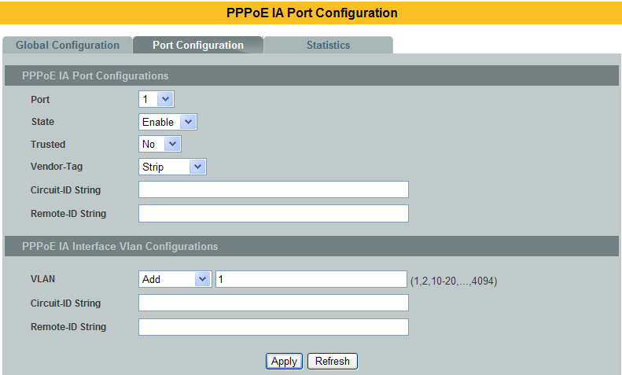
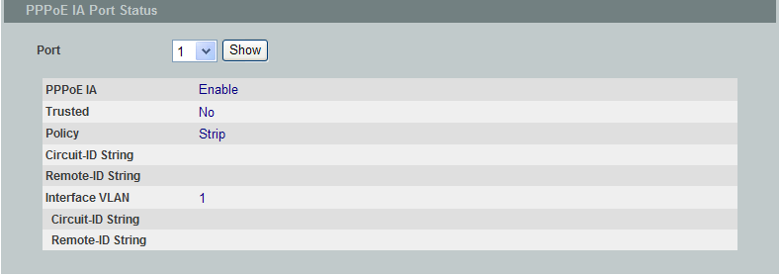

Parameter | Description
Port Number | Selects a port number you want to configure on this screen
State | Selects Enable to activate the port or Disable to deactivate the port
Trusted | Selects yes to sets a physical interface as trusted port
Vendor-Tag | Set the retransmitting policy of the specific interface for the PADO/PADS  packet<keep|replace|strip>.Default:Keep
Circuit-ID String | User defined circuit ID string onspecific interface for the PPPoE IA
Remote ID String | User defined remote ID string onspecific interface for the PPPoE IA
Interface VLAN | Selects Add to increase the interface Vlan or Remove to delete the interface Vlan
Circuit-ID String | User defined circuit ID string on specific interface vlan for the PPPoE IA
Remote-ID String | User defined remote ID string on specific interface vlan for the PPPoE IA
Apply | Click Apply to take effect the settings.
Refresh | Click Refresh to begin configuring this screen afresh.
Port | Selects a port number you want to display its configurations.
Show | Show the configurations of the port.

Statistics:
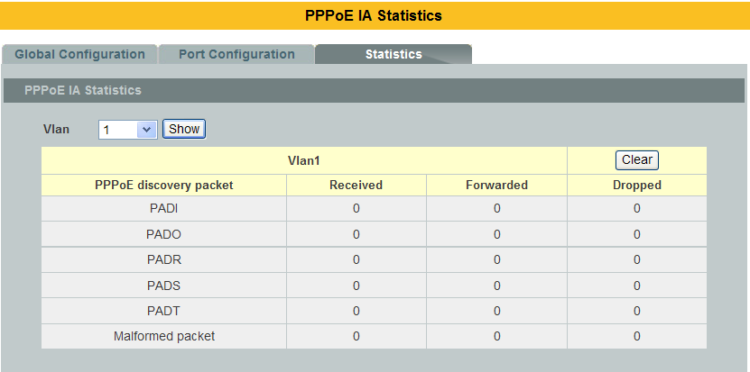

Parameter | Description
VLAN | Displays the current statistics of the vlan for the PPPoE IA.
PPPoE discovery packet | PPPoE packet type
Received | Total received packet
Forwarded | Total forwarded packet
Dropped | Total dropped packet
Show | Show the statistics of the vlan.
Clear | Clear the statistics of the vlan.

  - Static Route

Introduction
Static routes, which define explicit paths between two routers, cannot be automatically updated; youmust manually reconfigure static routes when network changes occur. Static routes use less bandwidththan dynamic routes. No CPU cycles are used to calculate and analyze routing updates.

IP forwarding
IP forwarding provides on end to end delivery of IP packet between hosts with help of routers. Routing database plays import role in forwarding the packets. Routers populate its routing database either by manual configurations or by using dynamic routing protocols.
IP forwarding works as router as well as Inter VLAN routing with trunk stick.
Manual routing configurations are called as Static routes. Static routes are permanent routes; we can delete those routes with manual configurations only.

Whenever an IP packet received by a router then it fetches destination IP address and it will do the lookup in routing table to find the longest prefix match route. Packet is forwarded on the assigned next-hop in the route.

    - CLI configuration
Node | Command | Description
enable | show ip forwarding status | This command displays the current configuration of the ip forwarding status.
enable | show ip routes(all|ipv4|ipv6) | This command displays the configurations of IPv4 orIPv6 or both routes from routing table.
enable | show ip arp(all|ipv4|ipv6) | This command displays dynamic and static IPv4 orIPv6or both ARP entries in ARP table.
enable | show ip hosts(all|ipv4|ipv6) | This command displays assigned IPv4 or IPv6 or both addresses for interfaces in router.
configure | ip forwarding enable | This command enables layer 3 IPv4 and IPv6 forwarding/routing globally.
configure | no ip forwarding enable | This command disables layer 3 IPv4 and IPv6 forwarding/routing globally.  This will delete all assigned IP addresses and static routes from interfaces.
configure | ip arp proxy enable | This command enables route to act as an ARP proxy globally; It will be useful in InterVLAN routing.
configure | no ip arp proxy enable | This command disables route to act as an ARP proxy.
configure | ipv4 arp <IPv4_ADDR><MAC_ADDR> | This command allows adding static IPv4 ARP entry in ARP table.
configure | ip6 arp <IPv6_ADDR><MAC_ADDR> | This command allows adding static IPv6 ARP entry in ARP table.
configure | no ipv4 arp <IPv4_ADDR><MAC_ADDR> | This command deletes a static IPv4 ARP entry from ARP table.
configure | no ipv6 arp <IPv6_ADDR><MAC_ADDR> | This command deletes a static IPv6 ARP entry from ARP table.
configure | interface vlan <1-4094> | This command enters the L3 interface node.
L3 interface | ipv4 address A.B.C.D/M | This command assigns a specified IPv4 interface route to the interface.  We can assign multiple IPv4 interface route to a single interface with different IP segment.  If this configuration is a first IP assigning to the interface then automatically interface is enabled for routing.
L3 interface | ipv6 address <IPv6_ADDR>/M | This command assigns a specified IPv6 interface route to the interface.  We can assign only one IPv6 interface route for an interface vlan.  If this configuration is a first IP assigning to the interface then it automatically enables the interface with routing.
L3 interface | no ipv4 address A.B.C.D/M | This command deletes a specified IPv4 interface route from the interface vlan.  This command deletes all dependent static routes on the specified IPv4 interface route.  If there is no assigned IP addresses for the specified interface after deleting then it will automatically disables routing in interface.
L3 interface | no ipv4 address <IPv6_ADDR>/M | This command deletes a specified IPv6 interface route from the interface.  This command deletes all dependent static routes on the specified IPv6 interface route.  If there is no assigned IP addresses for the specified interface after deleting then it will automatically disables routing in interface vlan.
L3 interface | ipv4 route A.B.C.D/M A.B.C.D | This command configures anIPv4 static route onto the specified interface vlan.
L3 interface | ipv6 route <IPv6_ADDR>/M <IPv6_ADDR> | This command configures anIPv6 static route onto the specified interface vlan.
L3 interface | no ipv4 routeA.B.C.D/M A.B.C.D | This command deletes a specified IPv4 static route from an interface vlan.
L3 interface | no ipv6 route<IPv6_ADDR>/M <IPv6_ADDR> | This command deletes a specified IPv6 static route from an interface vlan.

Example:
- IP Forwarding Enable: This command is used to enable ip forwarding (routing).
L2SWITCH(config)#ip forwarding enable

- IP Forwarding Disable: This command is used to disable ip forwarding.
L2SWITCH(config)#no ip forwarding enable

- ARP proxy enable: This command is used to enable ARP proxy.
L2SWITCH(config)#ip arp proxy enable

- ARP proxy disable: This command is used to disable ARP proxy.
L2SWITCH(config)#no ip arp proxy enable

- Add a static IPv4/IPv6 ARP entry: This command is used to add a static IPv4/IPv6 ARP entries.
L2SWITCH(config)#ipv4 arp 192.168.20.1 00:11:22:33:44:55
L2SWITCH(config)#ipv6 arp 1234:ab::ccdd 00:11:22:33:44:55

- Deletes a static IPv4/IPv6 ARP entry: This command is used to delete static IPv4/IPv6 ARP entries
L2SWITCH(config)#no ipv4 arp 192.168.20.1 00:11:22:33:44:55
L2SWITCH(config)#no ipv6 arp 1234:ab::ccdd 00:11:22:33:44:55

- Assigning aIPv4/IPv6 interface router: This command is used to add an IPv4/IPv6 interface route to a interface vlan.
L2SWITCH(config)#interface vlan 1
L2SWITCH(config-if-vlan-l3)#
L2SWITCH(config-if-vlan-l3)#ipv4 address 192.168.20.1/24
L2SWITCH(config-if-vlan-l3)#ipv6 address 1234:ab::ccdd/120

- Deleting IPv4/IPv6 address: This command is used to delete an IPv4/IPv6 interface route from a interface vlan.
L2SWITCH(config-if-vlan-l3)#no ipv4 address 192.168.20.1/24
L2SWITCH(config-if-vlan-l3)#no ipv6 address 1234:ab::ccdd/120

- Adding static IPv4/IPv6 route: This command is used to add an IPv4/IPv6 static route to a interface vlan.
L2SWITCH(config-if-vlan-l3)#ipv4 address 192.168.20.1/24 192.168.20.1
L2SWITCH(config-if-vlan-l3)#ipv6 address 1234:ab::ccdd/1201234:ab::ccdd

- Deleting static IPv4/IPv6 route: This command is used to delete an IPv4/IPv6 static route form an interface vlan.
L2SWITCH(config-if-vlan-l3)#no ipv4 address 192.168.20.1/24 192.168.20.1
L2SWITCH(config-if-vlan-l3)#no ipv6 address 1234:ab::ccdd/1201234:ab::ccdd

Web configuration
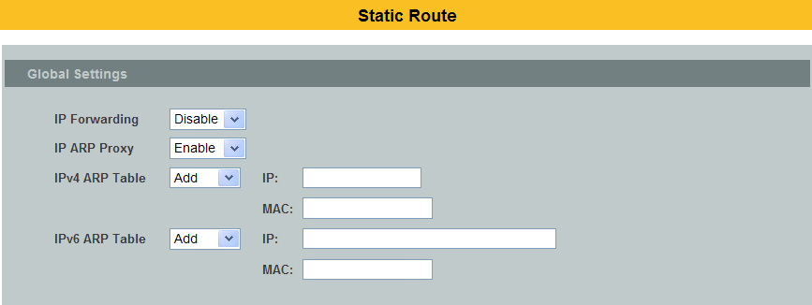
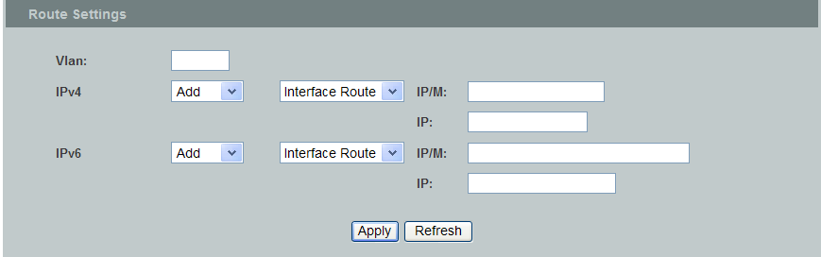
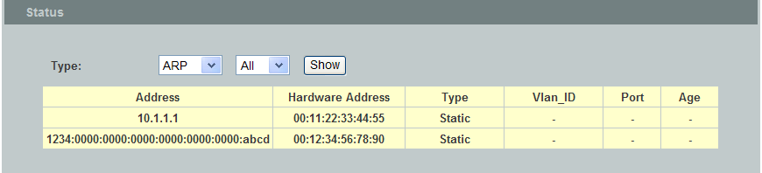
Parameter | Description
Global Settings
IP Forwarding | Enables / disables the IP forwarding globally.
IP ARP Proxy | Enables / disables the route to act as an ARP proxy globally.
IPv4 ARP Table | Adds a static IPv4 ARP entry in the ARP table.  / Deletes a static IPv4 ARP entry fromthe ARP table.
IP: | The IP address for the entry.
MAC: | The MAC address for the entry.
IPv6 ARP Table | Adds a static IPv6 ARP entry in the ARP table.  / Deletes a static IPv6 ARP entry fromthe ARP table.
IP: | The IP address for the entry.
MAC: | The MAC address for the entry.
Route Settings
Vlan | Specifics an interface vlan.
IPv4 | Adds an IPv4 Interface Route / Static Route onto the interface vlan. / Deletes an IPv4 Interface Route / Static Route from the interface vlan.  Selects the route type, Interface Route or Static Route.
IP/M: | The IP address and the netmask for the entry.
IP: | The static route address for the Static Route type only.
IPv6 | Adds an IPv6 Interface Route / Static Route onto the interface vlan. / Deletes an IPv6 Interface Route / Static Route from the interface vlan.  Selects the route type, Interface Route or Static Route.
IP/M: | The IP address and the netmask for the entry.
IP: | The static route address for the Static Route type only.
Status | Shows the ARP table / Host table / Route configurations.

STP

STP/RSTP
(R)STP detects and breaks network loops and provides backup links betweenswitches, bridges or routers. It allows a Switch to interact with other (R)STPcompliantswitches in your network to ensure that only one path exists betweenany two stations on the network.

The Switch supports Spanning Tree Protocol (STP) and Rapid Spanning TreeProtocol (RSTP) as defined in the following standards.
- IEEE 802.1D Spanning Tree Protocol
- IEEE 802.1w Rapid Spanning Tree Protocol

The Switch uses IEEE 802.1w RSTP (Rapid Spanning Tree Protocol) that allowsfaster convergence of the spanning tree than STP (while also being backwardscompatible with STP-only aware bridges). In RSTP, topology change information isdirectly propagated throughout the network from the device that generates thetopology change. In STP, a longer delay is required as the device that causes atopology change first notifies the root bridge and then the root bridge notifies thenetwork. Both RSTP and STP flush unwanted learned addresses from the filteringdatabase.

In STP, the port states are Blocking, Listening, Learning, Forwarding.
In RSTP, the port states are Discarding, Learning, and Forwarding.

Note: In this document, “STP” refers to both STP and RSTP.

STP Terminology
- The root bridge is the base of the spanning tree.
- Path cost is the cost of transmitting a frame onto a LAN through that port. Therecommended cost is assigned according to the speed of the link to which a port isattached. The slower the media, the higher the cost.

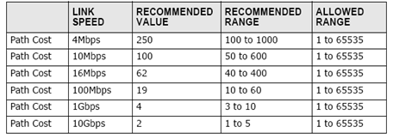

- On each bridge, the bridge communicates with the root through the root port. Theroot port is the port on this Switch with the lowest path cost to the root (the rootpath cost). If there is no root port, then this Switch has been accepted as the rootbridge of the spanning tree network.
- For each LAN segment, a designated bridge is selected. This bridge has the lowestcost to the root among the bridges connected to the LAN.
Forward Time (Forward Delay):
This is the maximum time (in seconds) the Switch will wait beforechanging states. This delay is required because every switch mustreceive information about topology changes before it starts to forwardframes. In addition, each port needs time to listen for conflictinginformation that would make it return to a blocking state; otherwise,temporary data loops might result. The allowed range is 4 to 30seconds.

Max Age:
This is the maximum time (in seconds) the Switch can wait withoutreceiving a BPDU before attempting to reconfigure. All Switch ports(except for designated ports) should receive BPDUs at regular intervals.Any port that age out STP information (provided in the last BPDU)becomes the designated port for the attached LAN. If it is a root port, anew root port is selected from among the Switch ports attached to thenetwork. The allowed range is 6 to 40 seconds.

Hello Time:
This is the time interval in seconds between BPDU (Bridge Protocol DataUnits) configuration message generations by the root switch. Theallowed range is 1 to 10 seconds.

PathCost:
Path cost is the cost of transmitting a frame on to a LAN through thatport. It is recommended to assign this value according to the speed ofthe bridge. The slower the media, the higher the cost.

How STP Works?
After a bridge determines the lowest cost-spanning tree with STP, it enables theroot port and the ports that are the designated ports for connected LANs, anddisables all other ports that participate in STP. Network packets are therefore onlyforwarded between enabled ports, eliminating any possible network loops.

STP-aware switches exchange Bridge Protocol Data Units (BPDUs) periodically, When the bridged LAN topology changes, a new spanning tree is constructed.Once a stable network topology has been established, all bridges listen for HelloBPDUs (Bridge Protocol Data Units) transmitted from the root bridge. If a bridgedoes not get a Hello BPDU after a predefined interval (Max Age), the bridgeassumes that the link to the root bridge is down. This bridge then initiatesnegotiations with other bridges to reconfigure the network to re-establish a validnetwork topology.

802.1D STP
The Spanning Tree Protocol (STP) is a link layer network protocol that ensures a loop-free topology for any bridged LAN. It is based on an algorithm invented by Radia Perlman while working for Digital Equipment Corporation. In the OSI model for computer networking, STP falls under the OSI layer-2. Spanning tree allows a network design to include spare (redundant) links to provide automatic backup paths if an active link fails, without the danger of bridge loops, or the need for manual enabling/disabling of these backup links. Bridge loops must be avoided because they result in flooding the network.

The Spanning Tree Protocol (STP) is defined in the IEEEStandard802.1D. As the name suggests, it creates a spanning tree within a mesh network of connected layer-2 bridges (typically Ethernet switches), and disables those links that are not part of the tree, leaving a single active path between any two network nodes.

STP switch port states:
- Blocking - A port that would cause a switching loop, no user data is sent or received but it may go into forwarding mode if the other links in use were to fail and the spanning tree algorithm determines the port may transition to the forwarding state. BPDU data is still received in blocking state.
- Listening - The switch processes BPDUs and awaits possible new information that would cause it to return to the blocking state.
- Learning - While the port does not yet forward frames (packets) it does learn source addresses from frames received and adds them to the filtering database (switching database)
- Forwarding - A port receiving and sending data, normal operation. STP still monitors incoming BPDUs that would indicate it should return to the blocking state to prevent a loop.
- Disabled - Not strictly part of STP, a network administrator can manually disable a port

802.1w RSTP

In 1998, the IEEE with document 802.1w introduced an evolution of the Spanning Tree Protocol: Rapid Spanning Tree Protocol (RSTP), which provides for faster spanning tree convergence after a topology change. Standard IEEE 802.1D-2004 now incorporates RSTP and obsoletes STP. While STP can take 30 to 50 seconds to respond to a topology change, RSTP is typically able to respond to changes within a second.

RSTP bridge port roles:
- Root - A forwarding port that is the best port from nonroot-bridge to Rootbridge
- Designated - A forwarding port for every LAN segment
- Alternate - An alternate path to the root bridge. This path is different than using the root port.
- Backup - A backup/redundant path to a segment where another bridge port already connects.
- Disabled - Not strictly part of STP, a network administrator can manually disable a port

Edge Port:
They are attached to a LAN that has no other bridges attached. These edge ports transition directly to the forwarding state. RSTP still continues to monitor the port for BPDUs in case a bridge is connected. RSTP can also be configured to automatically detect edge ports. As soon as the bridge detects a BPDU coming to an edge port, the port becomes a non-edge port.

Forward Delay:
The range is from 4 to 30 seconds. This is the maximum time (in seconds) the root device will wait before changing states (i.e., listening to learning to forwarding).

Transmission Limit:
This is used to configure the minimum interval between the transmissions of consecutive RSTP BPDUs. This function can only be enabled in RSTP mode. The range is from 1 to 10 seconds.

Hello Time:
Set the time at which the root switch transmits a configuration message. The range is from 1 to 10 seconds.

Bridge priority:
Bridge priority is used in selecting the root device, root port, anddesignated port. The device with the highest priority becomes theSTA root device. However, if all devices have the same priority, thedevice with the lowest MAC address will become the root device.

Port Priority:
Set the port priority in the switch. Low numeric value indicates a high priority. A port with lower priority is more likely to be blocked by STP if a network loop is detected. The valid value is from 0 to 240.

Path Cost:
The valid value is from 1 to 200000000. Higher cost paths are more likely to be blocked by STP if a network loop is detected.

BPDU Guard
This is a per port setting. If the port is enabled in BPDU guard and receive any BPDU, the port will be set to disable to avoid the error environments. User must enable the port by manual.

BPDU Filter
It is a feature to filter sending or receiving BPDUs on a switchport. If the port receives any BPDUs, the BPDUs will be dropped.

Notice: If both of the BPDU filter and BPDU guard are enabled, the BPDU filter has the high priority.
Root Guard
The Root Guard feature forces an interface to become a designated port to prevent surrounding switches from becoming a root switch. In other words, Root Guard provides a way to enforce the root bridge placement in the network. The Root Guard feature prevents a Designated Port from becoming a Root Port. If a port on which the Root Guard feature receives a superior BPDU, it moves the port into a root-inconsistent state (effectively equal to a listening state), thus maintaining the current Root Bridge status. The port can be moved to forwarding state if no superior BPDU received by this port for three hello times.
Default Settings
- STP/RSTP : disabled.
- STP/RSTP mode : RSTP.
- Forward Time : 15 seconds.
- Hello Time : 2 seconds.
- Maximum Age : 20 seconds.
- System Priority : 32768.
- Transmission Limit : 3 seconds.
- Per port STP state : enabled.
- Per port Priority : 128.
- Per port Edge port : disabled.
- Per port BPDU filter : disabled.
- Per port BPDU guard : disabled.
- Per port BPDU Root guard: disabled.
- Per port Path Cost : depend on port link speed.
Example: Bandwidth ->STPPort Cost Value
10 Mbps -> 100
100 Mbps-> 19
1 Gbps -> 4
10 Gbps -> 2

CLI Configuration
Node | Command | Description
enable | show spanning-tree active | This command displays the spanning tree information for only active port(s)
enable | show spanning-treeblockedports | This command displays the spanning tree information for only blocked port(s)
enable | show spanning-tree port detail PORT_ID | This command displays the spanning tree information for the interface port.
enable | show spanning-treestatistics PORT_ID | This command displays the spanning tree information for the interface port.
enable | show spanning-tree summary | This command displays the summary of port states and configurations
enable | clear spanning-tree counters | This command clears spanning-tree statistics for all ports.
enable | clear spanning-tree counters PORT_ID | This command clears spanning-tree statistics for a specific port.
configure | spanning-tree (disable | enable) | This command disables / enables the spanning tree function for the system.
configure | spanning-treealgorithm-timerforward-time TIME max-age TIME hello-time TIME | This command configures the bridge times(forward-delay,max-age,hello-time).
configure | no spanning-tree algorithm-timer | This command configures the default values for forward-time &max-age&hello-time.
configure | spanning-treeforward-time<4-30> | This command configures the bridge forward delay time(sec).
configure | no spanning-tree forward-time | This command configures the default values for forward-time.
configure | spanning-tree hello-time <1-10> | This command configures the bridge hello time(sec).
configure | no spanning-tree hello-time | This command configures the default values for hello-time.
configure | spanning-tree max-age <6-40> | This command configures the bridge message max-age time(sec).
configure | no spanning-tree max-age | This command configures the default values for max-age time.
configure | spanning-tree mode (rstp|stp) | This command configures the spanning mode.
configure | spanning-treepathcost method (short|long) | This command configures the pathcost method.
configure | spanning-treepriority<0-61440> | This command configures the priority for the system.
configure | no spanning-tree priority | This command configures the default values for the system priority.
interface | spanning-tree(disable|enable) | This command configures enables/disables the STP function for the specific port.
interface | spanning-treebpdufilter(disable|enable) | This command configures enables/disables the bpdufilter function for the specific port.
interface | spanning-treebpduguard(disable|enable) | This command configures enables/disables the bpduguard function for the specific port.
interface | spanning-tree rootguard (disable|enable) | This command enables/disables the BPDU Root guard port setting for the specific port.
interface | spanning-treeedge-port(disable|enable) | This command enables/disables the edge port setting for the specific port.
interface | spanning-tree cost VALUE | This command configures the cost for the specific port.  Cost range:  16-bit based value range 1-65535,  32-bit based value range 1-200000000.
interface | no spanning-tree cost | This command configures the path cost to default for the specific port.
interface | spanning-treeport-priority<0-240> | This command configures the port priority for the specific port.  Default: 128.
interface | no spanning-tree port-priority | This command configures the port priority to default for the specific port.
configure | interface range gigabitethernet1/0/PORTLISTS | This command enters the interface configure node.
if-range | spanning-tree(disable|enable) | This command configures enables/disables the STP function for the specific port.
if-range | spanning-treebpdufilter(disable|enable) | This command configures enables/disables the bpdufilter function for the specific port.
if-range | spanning-treebpduguard(disable|enable) | This command configures enables/disables the bpduguard function for the specific port.
if-range | spanning-tree rootguard (disable|enable) | This command enables/disables the BPDU Root guard port setting for the specific port.
if-range | spanning-treeedge-port(disable|enable) | This command enables/disables the edge port setting for the specific port.
if-range | spanning-tree cost VALUE | This command configures the cost for the specific port.  Cost range:  16-bit based value range 1-65535,  32-bit based value range 1-200000000.
if-range | no spanning-tree cost | This command configures the path cost to default for the specific port.
if-range | spanning-treeport-priority<0-240> | This command configures the port priority for the specific port.  Default: 128.
if-range | no spanning-tree port-priority | This command configures the port priority to default for the specific port.

Web Configuration
General Settings
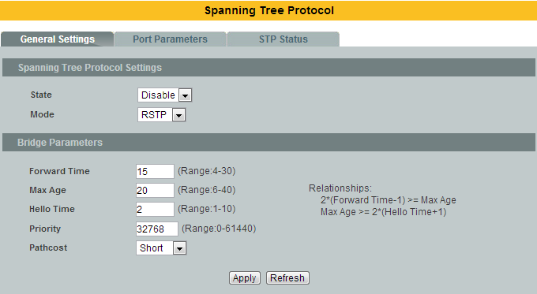

Parameter | Description
State | Select Enabled to use Spanning Tree Protocol (STP) or Rapid Spanning Tree Protocol (RSTP).
Mode | Select to use either Spanning Tree Protocol (STP) or Rapid SpanningTree Protocol (RSTP).
Forward Time | This is the maximum time (in seconds) the Switch will wait beforechanging states. This delay is required because every switch mustreceive information about topology changes before it starts to forwardframes. In addition, each port needs time to listen for conflictinginformation that would make it return to a blocking state; otherwise,temporary data loops might result. The allowed range is 4 to 30seconds.
Max Age | This is the maximum time (in seconds) the Switch can wait withoutreceiving a BPDU before attempting to reconfigure. All Switch ports(except for designated ports) should receive BPDUs at regular intervals.  Any port that age out STP information (provided in the last BPDU)becomes the designated port for the attached LAN. If it is a root port, anew root port is selected from among the Switch ports attached to thenetwork. The allowed range is 6 to 40 seconds.
Hello Time | This is the time interval in seconds between BPDU (Bridge Protocol DataUnits) configuration message generations by the root switch. Theallowed range is 1 to 10 seconds.
Priority | Priority is used in determining the root switch, root port and designatedport. The switch with the highest priority (lowest numeric value)becomes the STP root switch. If all switches have the same priority, theswitch with the lowest MAC address will then become the root switch.  Enter a value from 0~61440.  The lower the numeric value you assign, the higher the priority for thisbridge.  Priority determines the root bridge, which in turn determines the RootHello Time, Root Maximum Age and Root Forwarding Delay.
Pathcost | Path cost is the cost of transmitting a frame on to a LAN through thatport. It is recommended to assign this value according to the speed ofthe bridge. The slower the media, the higher the cost.

Port Parameters
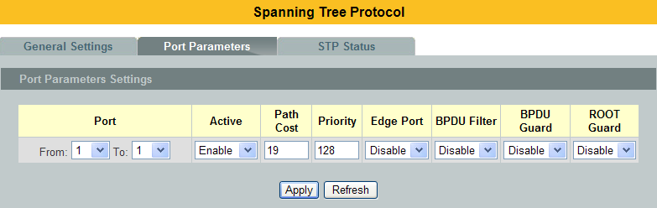
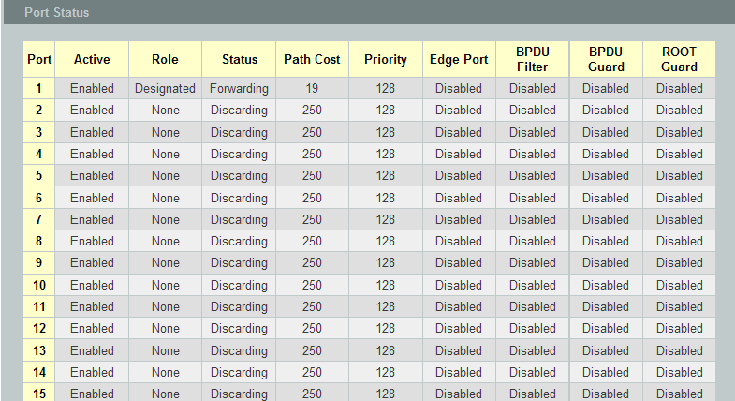
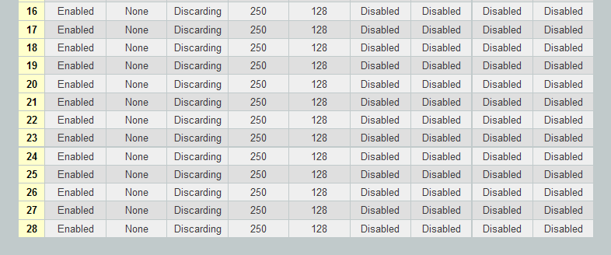

Parameter | Description
Port | Selects a port that you want to configure.
Active | Enables/Disables the spanning tree function for the specific port.
Path Cost | Configures the path cost for the specific port.
Priority | Configures the priority for the specific port.
EdgePort | Configures the port type for the specific port. Edge or Non-Edge.
BPDU Filter | Enables/Disables the BPDU filter function for the specific port.
BPDU Guard | Enables/Disables the BPDU guard function for the specific port.
ROOT Guard | Enables/Disables the BPDU root guard function for the specific port.
Port Status
Active | The state of the STP function.
Role | The port role. Should be one of the Alternated / Designated / Root / Backup / None.
Status | The port’s status. Should be one of the Discarding / Blocking / Listening / Learning / Forwarding / Disabled.
Path Cost | The port’s path cost.
Priority | The port’s priority.
Edge Port | The state of the edge function.
BPDU Filter | The states of the BPDU filter function.
BPDU Guard | The states of the BPDU guard function.
ROOT Guard | The state of the BPDU Root guard function.

STP Status
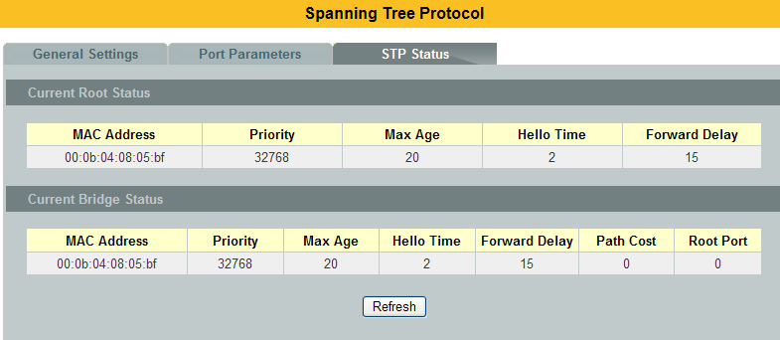

Parameter |  | Description
Current Root Status
MAC address | This is the MAC address of the root bridge.
Priority | Root refers to the base of the spanning tree (the root bridge). This field displays the root bridge’s priority. This Switch may also be the root bridge.
MAX Age | This is the maximum time (in seconds) the Switch can wait without receiving a configuration message before attempting to reconfigure.
Hello Time | This is the time interval (in seconds) at which the root switch transmits a configuration message. The root bridge determines Hello Time, Max Age and Forwarding Delay.
Forward Delay | This is the time (in seconds) the root switch will wait before changing states.
CurrentBridge Status
MAC address | This is the MAC address of the current bridge.
Priority | Priority is used in determining the root switch, root port and designated port. The switch with the highest priority (lowest numeric value) becomes the STP root switch. If all switches have the same priority, the switch with the lowest MAC address will then become the root switch.  Priority determines the root bridge, which in turn determines the Root Hello Time, Root Maximum Age and Root Forwarding Delay.
MAX Age | This is the maximum time (in seconds) the Switch can wait without receiving a BPDU before attempting to reconfigure. All Switch ports (except for designated ports) should receive BPDUs at regular intervals.  Any port that age out STP information (provided in the last BPDU) becomes the designated port for the attached LAN. If it is a root port, a new root port is selected from among the Switch ports attached to the network.
Hello Time | This is the time interval in seconds between BPDU (Bridge Protocol Data Units) configuration message generations by the root switch.
Forward Delay | This is the maximum time (in seconds) the Switch will wait before changing states. This delay is required because every switch must receive information about topology changes before it starts to forward frames. In addition, each port needs time to listen for conflicting information that would make it return to a blocking state; otherwise, temporary data loops might result.
Path Cost | Path cost is the cost of transmitting a frame on to a LAN through that port. It is recommended to assign this value according to the speed of the bridge. The slower the media, the higher the cost.
Root Cost | This is the number of the port on the Switch through which this Switch must communicate with the root of the Spanning Tree.

MSTP

Introduction
MSTP (IEEE 802.1S Multiple STP), which uses RSTP for rapid convergence, enables VLANs to be grouped into a spanning-treeinstance, with each instance having a spanning-tree topology independent of other spanning-treeinstances. This architecture provides multiple forwarding paths for data traffic, enables load balancing,and reduces the number of spanning-tree instances required to support a large number of VLANs.

Multiple Spanning-Tree Regions:
For switches to participate in multiple spanning-tree (MST) instances, you must consistently configurethe switches with the same MST configuration information. A collection of interconnected switches thathave the same MST configuration comprises an MST region.The MST configuration determines to which MST region each switch belongs. The configurationincludes the name of the region, the revision number, and the MST instance-to-VLAN assignment map.You configure the switch for a region by using the spanning-tree mst configuration globalconfiguration command, after which the switch enters the MST configuration mode. From this mode,you can map VLANs to an MST instance by using the instance MST configuration command, specifythe region name by using the name MST configuration command, and set the revision number by usingthe revision MST configuration command.

A region can have one member or multiple members with the same MST configuration; each membermust be capable of processing RSTP BPDUs. There is no limit to the number of MST regions in anetwork, but each region can support up to 16 spanning-tree instances. You can assign a VLAN to onlyone spanning-tree instance at a time.

Boundary Ports
A boundary port is a port that connects an MST region to a single spanning-tree region running RSTP,or to a single spanning-tree region running 802.1D, or to another MST region with a different MSTconfiguration. A boundary port also connects to a LAN, the designated switch of which is either a singlespanning-tree switch or a switch with a different MST configuration.

At the boundary, the roles of the MST ports do not matter, and their state is forced to be the same as theIST port state (MST ports at the boundary are in the forwarding state only when the IST port isforwarding). An IST port at the boundary can have any port role except a backup port role.

On a shared boundary link, the MST ports wait in the blocking state for the forward-delay time to expirebefore transitioning to the learning state. The MST ports wait another forward-delay time beforetransitioning to the forwarding state.
- If the boundary port is on a point-to-point link and it is the IST root port, the MST ports transition to the forwarding state as soon as the IST port transitions to the forwarding state.
- If the IST port is a designated port on a point-to-point link and if the IST port transitions to the forwarding state because of an agreement received from its peer port, the MST ports also immediately transition to the forwarding state.
- If a boundary port transitions to the forwarding state in an IST instance, it is forwarding in all MST instances, and a topology change is triggered. If a boundary port with the IST root or designated port role receives a topology change notice external to the MST cloud, the MSTP switch triggers a topology change in the IST instance and in all the MST instances active on that port.

Interoperability with 802.1D STP:
A switch running MSTP supports a built-in protocol migration mechanism that enables it to interoperatewith legacy 802.1D switches. If this switch receives a legacy 802.1D configuration BPDU (a BPDU withthe protocol version set to 0), it sends only 802.1D BPDUs on that port. An MSTP switch can also detectthat a port is at the boundary of a region when it receives a legacy BPDU, an MSTP BPDU (version 3)associated with a different region, or an RSTP BPDU (version 2).

However, the switch does not automatically revert to the MSTP mode if it no longer receives 802.1DBPDUs because it cannot determine whether the legacy switch has been removed from the link unlessthe legacy switch is the designated switch. Also, a switch might continue to assign a boundary role to aport when the switch to which this switch is connected has joined the region. To restart the protocolmigration process (force the renegotiation with neighboring switches), you can use the clearspanning-tree detected-protocols privileged EXEC command.

If all the legacy switches on the link are RSTP switches, they can process MSTP BPDUs as if they areRSTP BPDUs. Therefore, MSTP switches send either a version 0 configuration and TCN BPDUs orversion 3 MSTP BPDUs on a boundary port. A boundary port connects to a LAN, the designated switchof which is either a single spanning-tree switch or a switch with a different MST configuration.

      - CLI Configurations
Node | Command | Description
enable | show spanning-tree mstconfiguration | This command displays the MSTP configurations.
enable | show spanning-tree mstinstance | This command displays all of the instance configurations of the MSTP.
enable | show spanning-tree mstinstance <0-63> | This command displays specific instance configurations of the MSTP.
enable | show spanning-tree mstinstance <0-63>interface IFNAME | This command displays specific instance configurations on an interface of the MSTP.
enable | show spanning-tree mstinterface IFNAME | This command displays the configurations on an interface of the MSTP.
enable | show spanning-tree mstroot | This command displays the root bridge configurations.
configure | spanning-tree(disable|enable) | This command enables / disables the spanning tree.
configure | spanning-tree mode mst | This command configures the mode of the spanning tree. (one of the three modesSTP/RSTP/MSTP.)
configure | spanning-tree mst forward-time | This command configures the forward time for the MSTP.
configure | no spanning-tree mst forward-time | This command resets the forward time for the MSTP.  The default forward delay time is 15 seconds.
configure | spanning-tree mst hello-time | This command configures the hello time for the MSTP.
configure | no spanning-tree mst hello-time | This command resets the hello time for the MSTP.  The default hello time is 2 seconds.
configure | spanning-tree mst max-age | This command configures the maximum age time for the MSTP.
configure | no spanning-tree mst max-age | This command resets the maximum age time for the MSTP.  The default maximum age time is 20 seconds.
configure | spanning-tree mst max-hops | This command configures the maximum hop count.
configure | no spanning-tree mst max-hops | This command resets the maximum hop count.  The default maximum hop count is 20.
configure | spanning-tree mst instance STRING priority <0-61440> | This command resets the maximum hop count.  The default maximum hop count is 20.
configure | no spanning-tree mst instance STRING priority | This command resets the priority for the specific instance.
interface | spanning-tree mst instance STRING cost <1-200000000> | This command configures a cost on the specific port for the MSTP.
interface | no spanning-tree mst instance STRING cost | This command resets the cost on the specific port for the MSTP.
interface | spanning-tree mst instance STRING port-priority <0-240> | This command configures a priority on the specific port for the MSTP.
interface | no spanning-tree mst instance STRING port-priority | This command resets the priority on the specific port for the MSTP.
configure | spanning-tree mst configuration | This command enters the MSTP configure node.
configure | no spanning-tree mst configuration | This command resets all of configurations for the MSTP.
mst | apply | This command applies configurations to current instant.
mst | instance | This command configures the instance and vlan map.
mst | name | This command configures a region name for the MSTP.
mst | no name | This command reset the region name for the MSTP.
mst | revision | This command configures the revision for the MSTP.
mst | no revision | This command resets the revision for the MSTP.
mst | show (current|pending) | This command shows the MSTP configures.  Current – the working configurations.  Pending – the not applied configurations.

Specifying the MST Region Configuration and Enabling MSTP
For two or more switches to be in the same MST region, they must have the same VLAN-to-instancemapping, the same configuration revision number, and the same name.A region can have one member or multiple members with the same MST configuration; each membermust be capable of processing RSTP BPDUs. There is no limit to the number of MST regions in anetwork, but each region can support up to 16 spanning-tree instances. You can assign a VLAN to onlyone spanning-tree instance at a time.

L2SWITCH(config)#spanning-tree mst configuration
L2SWITCH(config-mst)#name MSTP
L2SWITCH(config-mst)#revision 1
L2SWITCH(config-mst)#instance 1 vlan 1-10

      - Web Configurations
General Settings:
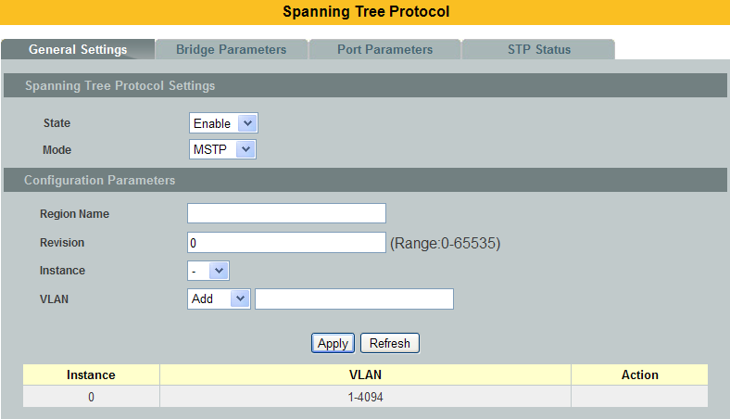

Parameter | Description
State | Select Enabled to use Spanning Tree Protocol (STP) or Rapid Spanning Tree Protocol (RSTP) or Multiple Spanning Tree Protocol (MSTP).
Mode | Selectsthe Spanning Tree running mode.  STP -Spanning Tree Protocol.  RSTP - Rapid SpanningTree Protocol.  MSTP - Multiple Spanning Tree Protocol.
Configuration Parameters
Region Name | Configures the region name for the Switch.
Revision | Configures the revision for the Switch.
Instance | Selects an instance which you want to configure.
VLAN | Select one or more vlans which will join the instance.  Note: the vlan will be removed from instance 0 automatically.
Instance and vlan map table
Instance | The instance.
VLAN | The vlan in the instance.
Action | Click Delete button to delete this instance.

Bridge Parameters:
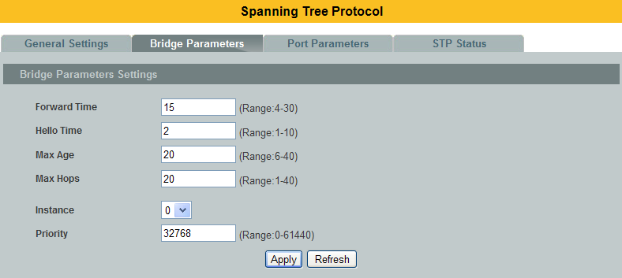
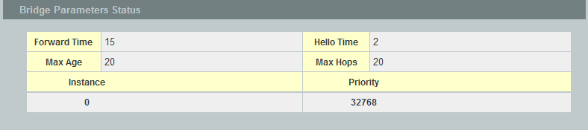

Parameter | Description
Forward Time | This is the maximum time (in seconds) the Switch will wait beforechanging states. This delay is required because every switch mustreceive information about topology changes before it starts to forwardframes. In addition, each port needs time to listen for conflictinginformation that would make it return to a blocking state; otherwise,temporary data loops might result. The allowed range is 4 to 30seconds.
Hello Time | This is the time interval in seconds between BPDU (Bridge Protocol DataUnits) configuration message generations by the root switch. Theallowed range is 1 to 10 seconds.
Max Age | This is the maximum time (in seconds) the Switch can wait withoutreceiving a BPDU before attempting to reconfigure. All Switch ports(except for designated ports) should receive BPDUs at regular intervals.  Any port that age out STP information (provided in the last BPDU)becomes the designated port for the attached LAN. If it is a root port, anew root port is selected from among the Switch ports attached to thenetwork. The allowed range is 6 to 40 seconds.
Max Hops
Instance | Selects an instance which you want to configure.
Priority | Configures the priority for the instance.  Priority is used in determining the root switch, root port and designatedport. The switch with the highest priority (lowest numeric value)becomes the STP root switch. If all switches have the same priority, theswitch with the lowest MAC address will then become the root switch.  Enter a value from 0~61440.  The lower the numeric value you assign, the higher the priority for thisbridge.  Priority determines the root bridge, which in turn determines the RootHello Time, Root Maximum Age and Root Forwarding Delay.

Port Parameters:
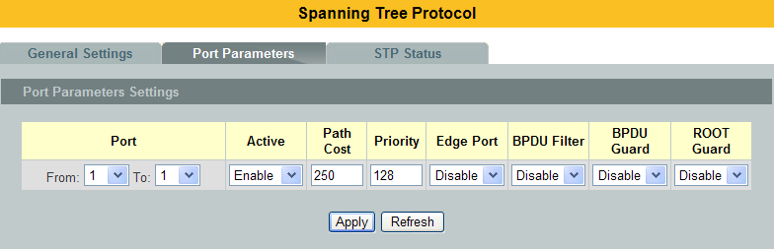
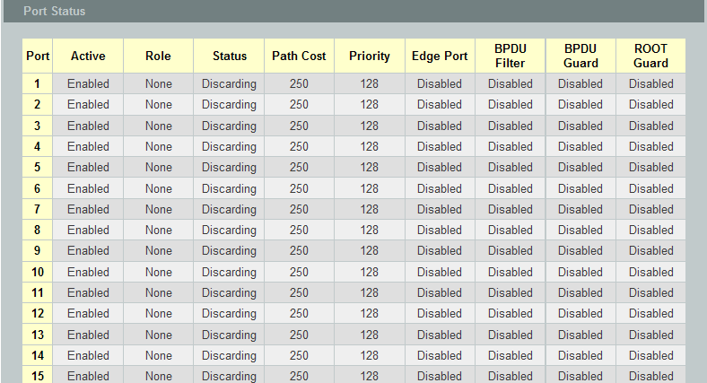
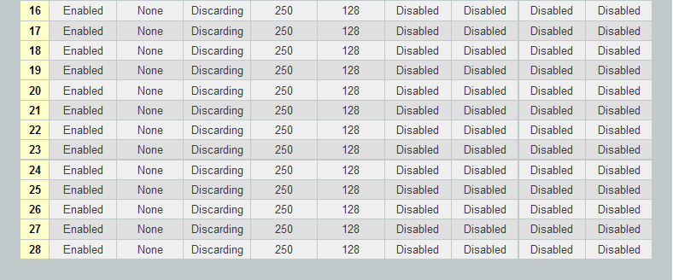

Parameter | Description
Instance | Selects a instance that you want to configure.
Port | Selects a port or a range of ports that you want to configure.
Path Cost | Configures the path cost for the specific port.
Priority | Configures the priority for the specific port.
Port | Selects a port or a range of ports that you want to configure.
Active | Enables/Disables the spanning tree function for the specific port.
Edge Port | Configures the port type for the specific port. Edge or Non-Edge.
BPDU Filter | Enables/Disables the BPDU filter function for the specific port.
BPDU Guard | Enables/Disables the BPDU guard function for the specific port.
ROOT Guard | Enables/Disables the BPDU root guard function for the specific port.
Port Status
Active | The state of the STP function.
Role | The port role. Should be one of the Alternated / Designated / Root / Backup / None.
Status | The port’s status. Should be one of the Discarding / Blocking / Listening / Learning / Forwarding / Disabled.
Path Cost | The port’s path cost.
Priority | The port’s priority.
Edge Port | The state of the edge function.
BPDU Filter | The state of the BPDU filters function.
BPDU Guard | The state of the BPDU guards function.
ROOT Guard | The state of the BPDU Root guard function.

STP Status:
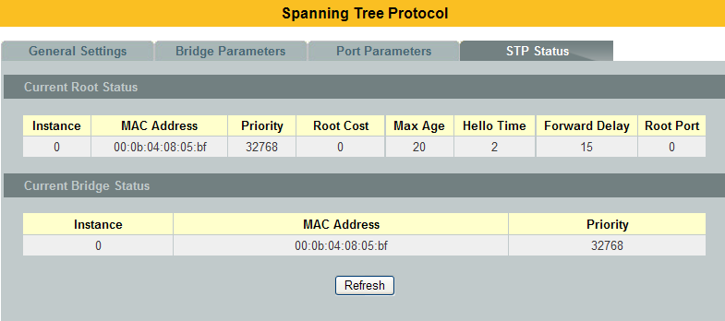

Parameter | Description
Current Root Status
Instance | The Instance ID.
MAC address | This is the MAC address of the root bridge.
Priority | Root refers to the base of the spanning tree (the root bridge). This field displays the root bridge’s priority. This Switch may also be the root bridge.
Root Cost | This is the path cost to the root bridge.
MAX Age | This is the maximum time (in seconds) the Switch can wait without receiving a configuration message before attempting to reconfigure.
Hello Time | This is the time interval (in seconds) at which the root switch transmits a configuration message. The root bridge determines Hello Time, Max Age and Forwarding Delay.
Forward Delay | This is the time (in seconds) the root switch will wait before changing states.
Root Port | This is the port to the root bridge.
Current Bridge Status
Instance | This is the MAC address of the current bridge.
MAC address | This is the MAC address of the bridge.
Priority | This is the priority of the Switch.

  - UDLD

The UDLD (Unidirectional Link Detection) protocol is used to detect and/or disable unidirectional connections before they create dangerous situations such as Spanning Tree loops or other protocol malfunctions.

The UDLD protocol was implemented to help correct certain assumptions made by other protocols and in particular to help the STP to function properly so as to avoid the creation of dangerous Layer 2 loops.

UDLD is meant to be a Layer 2 detection protocol that works on top of existing Layer 1 detection mechanisms defined by the IEEE standards.

Network systems typically check for miss wiring or unidirectional problems at the physical layer. The physical layer defines the actual physical components such as connectors and cables. So, physical layer only checks for open lines or port malfunctions and would not detect a miss wired systems.

But, UDLD performs mutual neighbor identification; in addition, it performs neighbor acknowledgement on top of the Logical Link Control (LLC) layer and thus is able to discover logical one-way miscommunication between neighbors even when either one of PHY layer mechanisms has deemed the transmission medium bidirectional.

Notice:
The port blocked by UDLD can be recovered automatically or you can execute the CLI command, “no shutdown”, in interface node. You can configure the recovery interval with CLI command, “errdisable recovery interval VALUE”.
    - CLI Configurations
Node | Command | Description
enable | show udld status | This command displays the UDLD global settings.
enable | show udld interface | This command displays the ports’ settings.
enable | show udld neighbor | This command displays the port’s neighbor information.
configure | udld enable | This command enables the global UDLD state.
configure | no udld enable | This command disables the global UDLD state.
configure | udld message interval-time VALUE | This command configures the interval time of sending .
configure | udld message interval-time reset | This command configures the interval time to default value. (7 seconds)
configure | errdisable recovery interval VALUE | This command configures the recovery interval time if ports is blocked by UDLD. (Default is 0, no recovery time, valid value is 30 ~ 86400 seconds.)
interface | no shutdown | This command enables the specific ports.
interface | udld port enable | This command enables the udld state for the specific port.
interface | no udld port enable | This command disables the udld state for the specific port.
interface | udld port aggressive | This command configures the udld mode to aggressive mode for the specific port.
interface | no udld port aggressive | This command configures the udld mode to normal mode for the specific port.

Default Configurations
1. Message interval time is set to 7
2. Port configuration of UDLD is enabled on all ports.

Case 1: To configure UDLD on port 1 only then disable udld port configuration on all interfaces except port 1 and enable global UDLD.
L2SWITCH#configure terminal
L2SWITCH(config)# interface <id> //All interfaces one by one except port 1
L2SWITCH(config-if)# no udld port enable
L2SWITCH(config-if)# exit
L2SWITCH(config)# udld enable

Case 2: To configure UDLD on all ports
L2SWITCH#configure terminal
L2SWITCH(config)# udld enable

Case 3: To disable UDLD on all ports
L2SWITCH#configure terminal
L2SWITCH(config)# no udld enable

Case 4: To disable UDLD on a specific port; example port 1
L2SWITCH#configure terminal
L2SWITCH(config)# interface <port_1>
L2SWITCH(config-if)# no udld port enable

Case 5: To enable aggressive mode on a specific port; example port 1
L2SWITCH#configure terminal
L2SWITCH(config)# interface <port_1>
L2SWITCH(config-if)# udld port aggressive

Case 6: To disable aggressive mode on a specific port; example port 1
L2SWITCH#configure terminal
L2SWITCH(config)# interface <port_1>
L2SWITCH(config-if)# no udld port aggressive

    - Web Configurations
Port Settings:
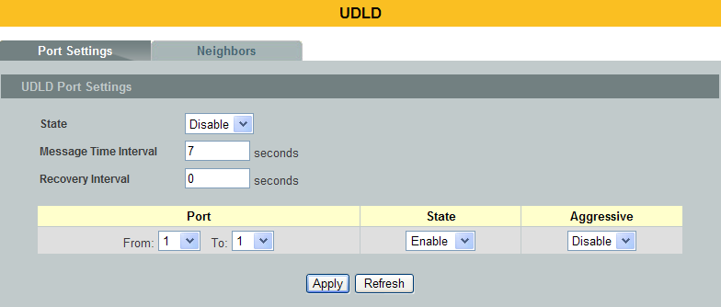
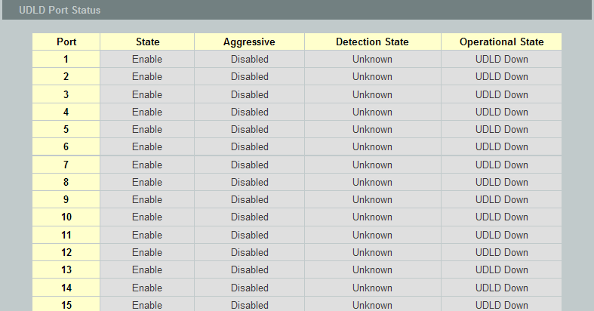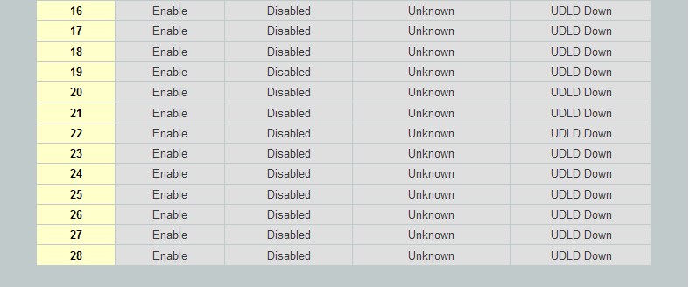

Parameter | Description
State | Selects Enable or Disable to enable or disable the global UDLD state.
Message Interval Time | Configures the message interval time.
Port | Selects a port or a range of ports to be configured.
State | Selects the port state for above selection.
Aggressive | Selects enable to let the port working in Aggressive mode. Selects disable to let the port working in Normal mode.
UDLD Port Status
State | Display the current UDLD port state for the specific port.
Aggressive | Display the current Aggressive state for the specific port.
Bidirectional State | Display the current detection state.
Operational State | Display the current operational state.

Neighbors:
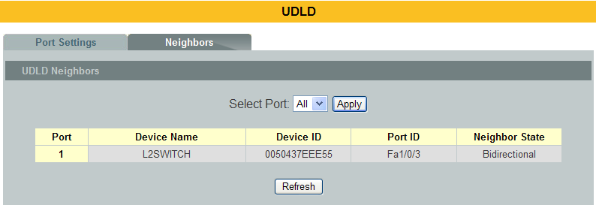

Parameter | Description
Select Port | Selects Enable or Disable to enable or disable the global UDLD state.
Port | The local port number.
Device Name | The device name of the neighbor Switch.
Device ID | The device ID of the neighbor Switch.
Port ID | The port number of the neighbor Switch connected to this port.
Neighbor State | The operational state of the neighbor Switch.

  - Xpress-Ring
The Xpress-Ring is a fast-acting, self-healing ring recovery technology that enables networks to recover from link failure within 10ms.

Fast Link Recovery and Ring Redundancy are important features for increasing the reliability of non-stop systems.

If the network is planned correctly with an arbiter Switch and ring ports, the network will recover from any segment failure within a very short time.

There are two roles (Forwarder and Arbiter) of the Switch in the Xpress-Ring. There is one and only one Switch is the Arbiter Switch and the others are the forwarder Switch.

One of the ring ports of the Arbiter Switch will be set to blocking state. When one of the ring connection is broken, the blocked port will be set to forwarding state.

Default Settings
Xpress-Ring Configurations:
The global Xpress Ring state is :Disabled.
Ring 1: State : Disabled.
Destination MAC : 01:80:c2:ff:ff:f0.
Role : Forwarder.
Primary Port : None.
Secondary Port : None.
Ring 2: State : Disabled.
Destination MAC : 01:80:c2:ff:ff:f1.
Role : Forwarder.
Primary Port : None.
Secondary Port : None.

    - CLI Configuration
Node | Command | Description
enable | show xpress-ring | This command displays the current Xpress-Ring configurations.
configure | xpress-ring(disable|enable) | This command enables/disables the Xpress-Ring on the Switch.
configure | xpress-ring ring (RING1|RING2) state (disable|enable) | This command enables/disables the ring on the Switch.
configure | xpress-ring ring (RING1|RING2) last-byte-destination-mac VALUE | This command configures the last byte of the destination MAC for the ring on the Switch.
configure | xpress-ring ring (RING1|RING2) role (forwarder|arbiter) | This command configures the role (forwarder/arbiter) for the ring on the Switch.
configure | xpress-ring ring (RING1|RING2) primary-port PORTID | This command configures the primary port for the ring on the Switch.  Notice: If the global xpress ring is disabled or ring state is disabled, you can input 0 to reset the primary port.
configure | xpress-ring ring (RING1|RING2) secondary-port PORTID | This command configures the secondary port for the ring on the Switch.  Notice: If the global xpress ring is disabled or ring state is disabled, you can input 0 to reset the primary port.

    - Web Configuration
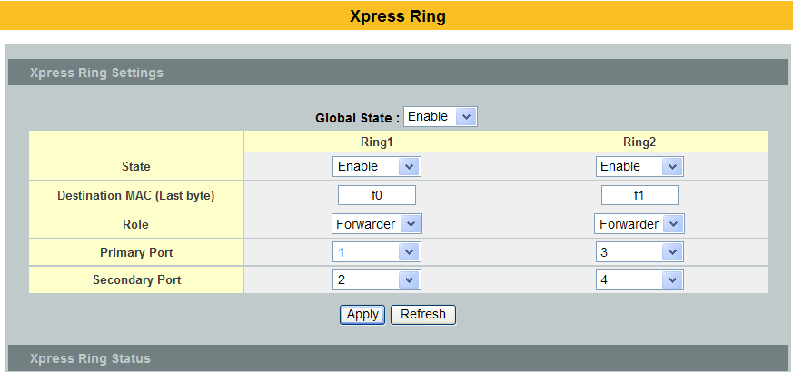
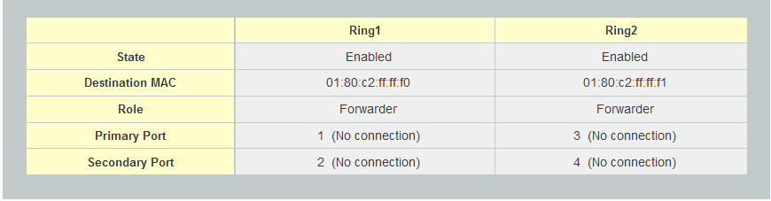

Parameter | Description
Current Root Status
Global State | Enables/Disable the global Xpress ring function.
State | Enables / Disables the ring state.
Destination MAC(Last byte) | Configures the last byte of the destination MAC for the ring.
Role | Configures the role for the ring.
Primary Port | Configures the primary port for the ring.
Secondary Port | Configure the secondary port for the ring.
Xpress Ring Status
State | The current state of the ring.
Destination MAC | The destination MAC for the ring.
Role | The current role of the ring.
Primary Port | The current primary port and its status.
Secondary Port | The current secondary port and its status.

Notices
- An Xpress Ring can have one Arbiter only.
- A Switch can join one or two Xpress Ring.
- Every Switch can be a Forwarder or Arbiter in an Xpress Ring.
- The two adjacent Xpress Rings should not use a same destination multicast MAC.
- If you want to enable the STP(RSTP) and Xpress Ring on a Switch, you should disable the STP (RSTP) on the Xpress Ring’s member ports.
- If you want to enable the Loop Detection and Xpress Ring on a Switch, you should disable the Loop Detection on the Xpress Ring’s member ports.
- If you want to enable the Broadcast Storm and Xpress Ring on a Switch, you should disable the Broadcast Storm on the Xpress Ring’s member ports.

Security

IP Source Guard
IP Source Guard is a security feature that restricts IP traffic on untrusted Layer 2 ports by filtering traffic based on the DHCP snooping binding database or manually configured IP source bindings. This feature helps prevent IP spoofing attacks when a host tries to spoof and use the IP address of another host. Any IP traffic coming into the interface with a source IP address other than that assigned (via DHCP or static configuration) will be filtered out on the u-trusted Layer 2 ports.

The IP Source Guard feature is enabled in combination with the DHCP snooping feature on untrusted Layer 2 interfaces. It builds and maintains an IP source binding table that is learned by DHCP snooping or manually configured (static IP source bindings). An entry in the IP source binding table contains the IP address and the associated MAC and VLAN numbers. The IP Source Guard is supported on Layer 2 ports only, including access and trunk ports.

The IP Source Guard features include below functions:
  - DHCP Snooping.
  - DHCP Binding table.
  - ARP Inspection.
  - Blacklist Filter. (arp-inspection mac-filter table)

DHCP Snooping
DHCP snooping is a DHCP security feature that provides network security by filtering un-trusted DHCP messages and by building and maintaining a DHCP snooping binding database, which is also referred to as a DHCP snooping binding table.

DHCP snooping acts like a firewall between un-trusted hosts and DHCP servers. You can use DHCP snooping to differentiate between un-trusted interfaces connected to the end user and trusted interfaces connected to the DHCP server or another switch.

The DHCP snooping binding database contains the MAC address, the IP address, the lease time, the binding type, the VLAN number, and the interface information that corresponds to the local un-trusted interfaces of a switch.

When a switch receives a packet on an un-trusted interface and the interface belongs to a VLAN in which DHCP snooping is enabled, the switch compares the source MAC address and the DHCP client hardware address. If addresses match (the default), the switch forwards the packet. If the addresses do not match, the switch drops the packet.

The switch drops a DHCP packet when one of these situations occurs:
- A packet from a DHCP server, such as a DHCPOFFER, DHCPACK, DHCPNAK, or DHCPLEASEQUERY packet, is received from the un-trusted port.
- A packet is received on an un-trusted interface, and the source MAC address and the DHCP client hardware address do not match any of the current bindings.

Use DHCP snooping to filter unauthorized DHCP packets on the network and tobuild the binding table dynamically. This can prevent clients from getting IPaddresses from unauthorized DHCP servers.

Trusted vs. Untrusted Ports
Every port is either a trusted port or an untrusted port for DHCP snooping. Thissetting is independent of the trusted/untrusted setting for ARP inspection. You canalso specify the maximum number for DHCP packets that each port (trusted oruntrusted) can receive each second.

Trusted ports are connected to DHCP servers or other switches. The Switchdiscards DHCP packets from trusted ports only if the rate at which DHCP packetsarrive is too high. The Switch learns dynamic bindings from trusted ports.
Note: The Switch will drop all DHCP requests if you enable DHCP snooping and thereare no trusted ports.

Untrusted ports are connected to subscribers. The Switch discards DHCP packetsfrom untrusted ports in the following situations:
- The packet is a DHCP server packet (for example, OFFER, ACK, or NACK).
- The source MAC address and source IP address in the packet do not match anyof the current bindings.
- The packet is a RELEASE or DECLINE packet, and the source MAC address andsource port do not match any of the current bindings.
- The rate at which DHCP packets arrive is too high.

DHCP Snooping Database
The Switch stores the binding table in volatile memory. If the Switch restarts, itloads static bindings from permanent memory but loses the dynamic bindings, inwhich case the devices in the network have to send DHCP requests again.

Configuring DHCP Snooping
Follow these steps to configure DHCP snooping on the Switch.
- Enable DHCP snooping on the Switch.
- Enable DHCP snooping on each VLAN.
- Configure trusted and untrusted ports.
- Configure static bindings.

Note:
The Switch will drop all DHCP requests if you enable DHCP snooping and there are no trusted ports.
If the port link down, the entries learned by this port in the DHCP snooping binding table will be deleted.
You must enable the global DHCP snooping and DHCP Snooping for vlan first.

The main purposes of the DHCP Snooping are:
- Create and maintain a binding table for ARP Inspection function.
- Filter the DHCP server’s packets that the DHCP server connects to a un-trust port.

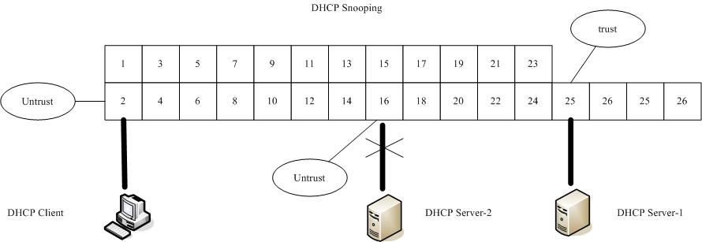

The DHCP server connected to an un-trusted port will be filtered.

Default Settings
The DHCP snooping on the Switch is disabled.
The DHCP snooping is enabled in VLAN(s): None.

Maximum Maximum
Port TrustedHost Count Port Trusted Host Count
---- ------- ----------- ---- ------- -----------
1 no 32 2 no 32
3 no 32 4 no 32
5 no 32 6 no 32
. . . . . . . . . . . . .

Notices
There are a global state and per VLAN states.
When the global state is disabled, the DHCP Snooping on the Switch is disabled even per VLAN states are enabled.
When the global state is enabled, user must enable per VLAN states to enable the DHCP Snooping on the specific VLAN.

VLAN 1 : port 1-10.
DHCP Client-1 : connect to port 3.
DHCP Server : connect to port 1.

Procedures:
- Default environments:
  - DHCP Client-1: ipconfig /release
  - DHCP Client-1: ipconfig /renew
DHCP Client-1 can get an IP address.

- Enable the global DHCP Snooping.
  - L2SWITCH(config)#dhcp-snooping
  - DHCP Client-1: ipconfig /release
  - DHCP Client-1: ipconfig /renew
DHCP Client-1 can get an IP address.

- Enable the global DHCP Snooping and VLAN 1 DHCP Snooping.
  - L2SWITCH(config)#dhcp-snooping
  - L2SWITCH(config)#dhcp-snooping vlan 1
  - DHCP Client-1: ipconfig /release
  - DHCP Client-1: ipconfig /renew
DHCP Client-1 cannot get an IP address.
; Because the DHCP server connects to a un-trust port.

- Enable the global DHCP Snooping and VLAN 1 DHCP Snooping.
  - L2SWITCH(config)#dhcp-snooping
  - L2SWITCH(config)#dhcp-snooping vlan 1
  - L2SWITCH(config)#interface gi1/0/1
  - L2SWITCH(config-if)#dhcp-snooping trust
  - DHCP Client-1: ipconfig /release
  - DHCP Client-1: ipconfig /renew
DHCP Client-1 can get an IP address.

- If you configure a static host entry in the DHCP snooping binding table, and then you want to change the host to DHCP client. The host will not get a new IP from DHCP server. You must delete the static host entry first.

CLI Configuration
Node | Command | Description
enable | show dhcp-snooping | This command displays the current DHCP snooping configurations.
configure | dhcp-snooping (disable|enable) | This command disables/enables the DHCP snooping on the switch.
configure | dhcp-snooping vlan VLANID | This command enables the DHCP snooping function on aVLAN or range of VLANs.
configure | no dhcp-snooping vlan VLANID | This command disables the DHCP snooping function on aVLAN or range of VLANs.
configure | dhcp-snooping server IPADDR | This command configures a valid DHCP server.
interface | dhcp-snooping host | This command configures the maximum host count for the specific port.
interface | no dhcp-snooping host | This command configures the maximum host count to default for the specific port.
interface | dhcp-snooping trust | This command configures the trust port for the specific port.
interface | no dhcp-snooping trust | This command configures the un-trust port for the specific port.
configure | interface range gigabitethernet1/0/PORTLISTS | This command enters the interface configure node.
if-range | dhcp-snooping host | This command configures the maximum host count for the specific ports.
if-range | no dhcp-snooping host | This command configures the maximum host count to default for the specific ports.
if-range | dhcp-snooping trust | This command configures the trust port for the specific ports.
if-range | no dhcp-snooping trust | This command configures the un-trust port for the specific ports.

Example:
L2SWITCH#configure terminal
L2SWITCH(config)#dhcp-snooping enable
L2SWITCH(config)#dhcp-snooping vlan 1
L2SWITCH(config)#interface 1/0/1
L2SWITCH(config-if)#dhcp-snooping trust

Web Configuration
DHCP Snooping
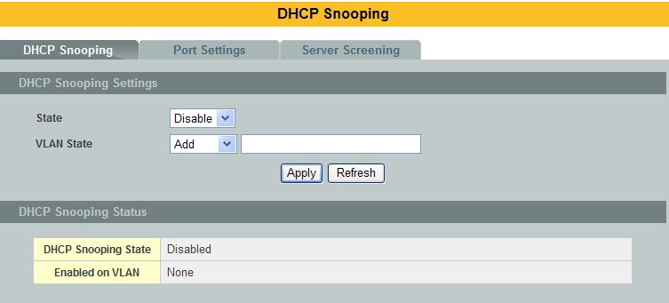

Parameter | Description
State | Select Enable to use DHCP snooping on the Switch. You still have to enable DHCP snooping on specific VLANs and specify trusted ports.  Note: The Switch will drop all DHCP requests if you enable DHCP snooping and there are no trusted ports.  Select Disable to not use DHCP snooping.
VLANState | Select Add and enter the VLAN IDs you want the Switch to enable DHCP snooping on. You can designate multiple VLANs individually by using a comma (,) and by range with a hyphen (-).  Select Delete and enter the VLAN IDs you no longer want the Switch to use DHCP snooping on.
Apply | Click Apply to take effect the settings.
Refresh | Click Refresh to begin configuring this screen afresh.
DHCP Snooping Status
DHCP Snooping State | This field displays the current status of the DHCP snoopingfeature, Enabled or Disabled.
Enabled on VLAN | This field displays the VLAN IDs that have DHCP snoopingenabled on them. This will display None if no VLANs have beenset.

Port Settings
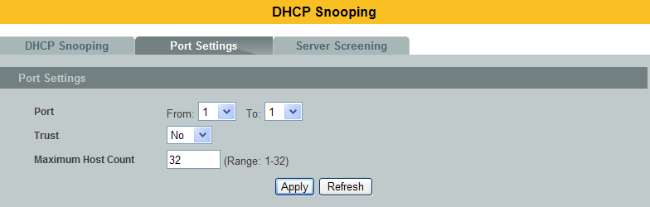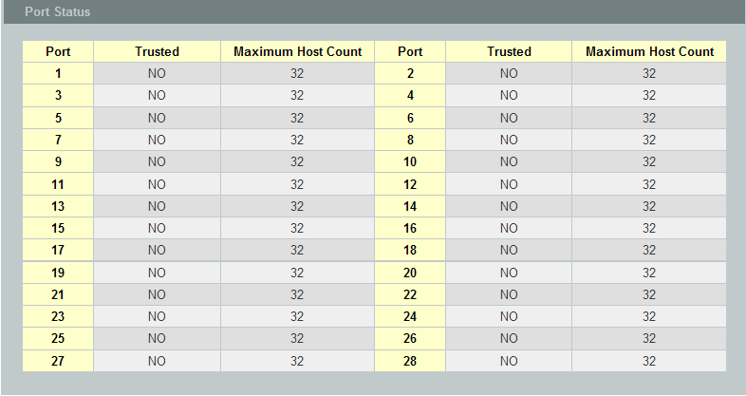

Parameter | Description
Port | Select a port number to modify its maximum host count.
Trust | Configures the specific port if it is a trust port.
Maximum Host Count | Enter the maximum number of hosts (1-32) that are permitted tosimultaneously connect to a port.
Apply | Click Apply to take effect the settings.
Refresh | Click Refresh to begin configuring this screen afresh.

DHCP Server Screening
The Switch supports DHCP Server Screening, a feature that denies access to rogue DHCP servers. That is, when one or more DHCP servers are present on the network and both provide DHCP services to different distinct groups of clients, the valid DHCP server’s packets will be passed to the client.

If you want to enable this feature, you must enable the DHCP Snooping function first. The Switch allows users to configure up to three valid DHCP servers.

If no DHCP servers are configured, it means all DHCP server are valid.

        - CLI Configuration
Node | Command | Description
enable | show dhcp-snooping server | This command displays the valid DHCP server IP.
configure | dhcp-snooping server IPADDR | This command configures a valid DHCP server’s IP.
configure | no dhcp-snooping server IPADDR | This command removes a valid DHCP server’s IP.

        - Web Configuration
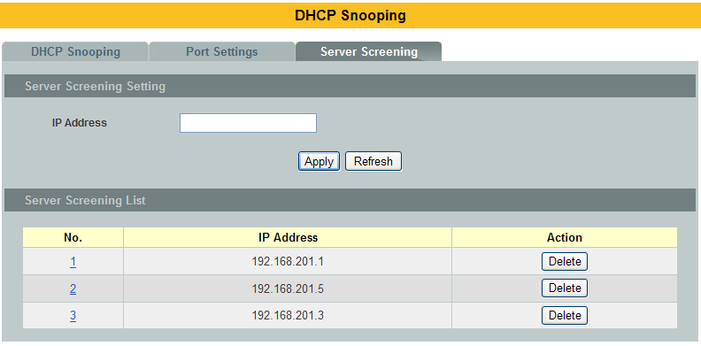

Parameter | Description
IP Address | This field configures the valid DHCP server’s IP address.
Apply |  | Click Apply to configure the settings.
Refresh |  | Click Refresh to begin configuring this screen afresh.
Server Screening List
No. |  | This field displays the index number of the DHCP server entry. Click thenumber to modify the entry.
IP Address |  | This field displays the IP address of the DHCP server.
Action |  | Click Delete to remove a configured DHCP server.

Binding Table
The DHCP Snooping binding table records the host information learned by DHCP snooping function (dynamic) or set by user (static). The ARP inspection will use this table to forward or drop the ARP packets. If the ARP packets sent by invalid host, they will be dropped. If the Lease time is expired, the entry will be removed from the table.

Static bindings are uniquely identified by the MAC address and VLAN ID. Each MACaddress and VLAN ID can only be in one static binding. If you try to create a staticbinding with the same MAC address and VLAN ID as an existing static binding, thenew static binding replaces the original one.

      - CLI Configuration
Node | Command | Description
enable | show dhcp-snooping binding | This command displays the current DHCP snooping binding table.
configure | dhcp-snooping binding mac MAC_ADDR ip IP_ADDR vlan VLANID port PORT_NO | This command configures a static host into the DHCP snooping binding table.
configure | no dhcp-snooping binding mac MACADDR | This command removes a static host from the DHCP snooping binding table.

Example:
L2SWITCH#configure terminal
L2SWITCH(config)#dhcp-snooping binding mac 00:11:22:33:44:55 ip 1.1.1.1 vlan 1 port2
L2SWITCH(config)#no dhcp-snooping binding mac 00:11:22:33:44:55
L2SWITCH#show dhcp-snooping binding

      - Web Configuration
Static Entry Settings
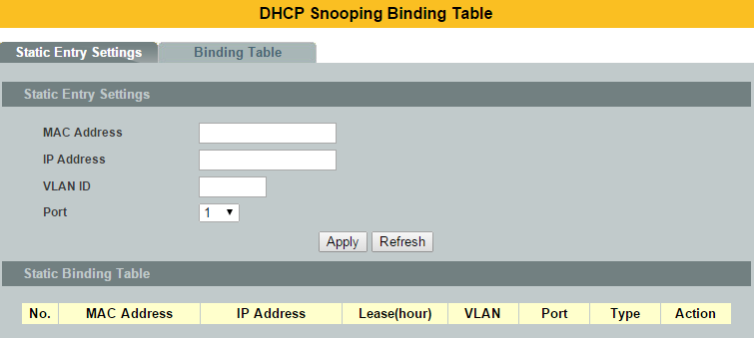

Parameter | Description
MAC Address | Enter the source MAC address in the binding.
IP Address | Enter the IP address assigned to the MAC address in the binding.
VLAN ID | Enter the source VLAN ID in the binding.
Port | Specify the port in the binding.
Static Binding Table
No. | This field displays a sequential number for each binding. Click it to updatean existing entry.
MAC Address | This field displays the source MAC address in the binding.
IP Address | This field displays the IP address assigned to the MAC address in thebinding.
Lease (Hour) | This field displays how long the binding is valid.
VLAN | This field displays the source VLAN ID in the binding.
Port | This field displays the port number in the binding.
Type | This field displays how the Switch learned the binding.  Static: This binding was learned from information provided manually byan administrator.  Dynamic: This binding was learned by snooping DHCP packets.
Action | Click Delete to remove the specified entry.

Binding Table
Bindings are used by DHCP snooping and ARP inspection to distinguish betweenauthorized and unauthorized packets in the network. The Switch learns thedynamic bindings by snooping DHCP packets and from information providedmanually in the Static Entry Settings screen.

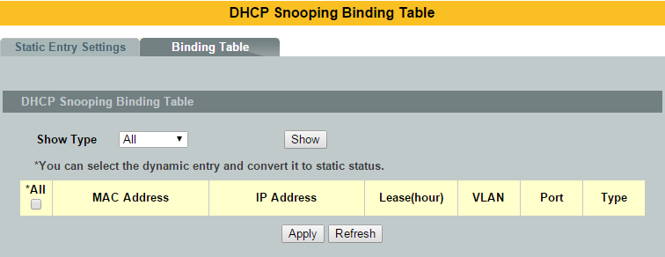

Parameter | Description
MAC Address | This field displays the source MAC address in the binding.
IP Address | This field displays the IP address assigned to the MAC address in the binding.
Lease | This field displays how long the binding is valid.
VLAN | This field displays the source VLAN ID in the binding.
Port | This field displays the port number in the binding. If this field is blank, thebinding applies to all ports.
Type | This field displays how the Switch learned the binding.  Static: This binding was learned from information provided manually byan administrator.  Dynamic: This binding was learned by snooping DHCP packets.

ARP Inspection

ARP Inspection
Dynamic ARP inspection is a security feature which validates ARP packet in a network. Dynamic ARP inspections validates the packet by performing IP to MAC address binding inspection stored in a trusted database (the DHCP snooping database) before forwarding the packet. Dynamic ARP intercepts, logs, and discards ARP packets with invalid IP-to-MAC address bindings. This capability protects the network from certain man-in-the-middle attacks.

Dynamic ARP inspection ensures that only valid ARP requests and responses are relayed.
The switch performs these activities:
- Intercepts all ARP requests and responses on un-trusted ports.
- Verifies that each of these intercepted packets has a valid IP-to-MAC address binding before it updates the local ARP cache or before it forwards the packet to the appropriate destination·

Trusted and un-trusted port
- This setting is independent of the trusted and un-trusted setting of the DHCP Snooping.
- The Switch does not discard ARP packets on trusted ports for any reasons.
- The Switch discards ARP packets on un-trusted ports if the sender’s information in the ARP packets does not match any of the current bindings.
- Normally, the trusted ports are the uplink port and the un-trusted ports are connected to subscribers.

Configurations:
Users can enable / disable the ARP Inspection on the Switch. Users also can enable / disable the ARP Inspection on a specific VLAN. If the ARP Inspection on the Switch is disabled, the ARP Inspection is disabled on all VLANs even some of the VLAN ARP Inspection are enabled.

Default Settings
The ARP Inspection on the Switch is disabled.
The age time for the MAC filter is 5 minutes.
ARP Inspection is enabled in VLAN(s): None.

Port Trusted Port Trusted
---- ------- ---- -------
1 no 2 no
3 no 4 no
5 no 6 no
7 no 8 no
9 no 10 no
11 no 12 no
13 no 14 no
15 no 16 no
17 no 18 no
19 no 20 no
21 no 22 no
23 no 24 no
25 no 26 no
27 no 28 no
Notices: There are a global state and per VLAN states.
- When the global state is disabled, the ARP Inspection on the Switch is disabled even per VLAN states are enabled.
- When the global state is enabled, user must enable per VLAN states to enable the ARP Inspection on the specific VLAN.

CLI Configuration
Node | Command | Description
enable | show arp-inspection | This command displays the current ARP Inspection configurations.
configure | arp-inspection (disable | enable) | This command disables/enables the ARP Inspection function on the switch.
configure | arp-inspection vlan VLANID | This command enables the ARP Inspection function on aVLAN or range of VLANs.
configure | no arp-inspection vlan VLANID | This command disables the ARP Inspection function on aVLAN or range of VLANs.
interface | arp-inspection trust | This command configures the trust port for the specific port.
interface | no arp-inspection trust | This command configures the un-trust port for the specific port.

Example:
L2SWITCH#configure terminal
L2SWITCH(config)#arp-inspection enable
L2SWITCH(config)#arp-inspection vlan 1
L2SWITCH(config)#interface 1/0/1
L2SWITCH(config-if)#arp-inspection trust

Web Configuration
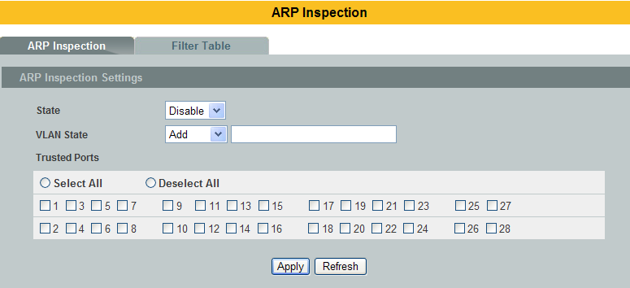
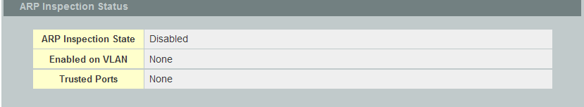

Parameter | Description
State | Use this to Enable or Disable ARP inspection on the Switch.
VLANState | Enter the VLAN IDs you want the Switch to enable ARP Inspectionfor. You can designate multiple VLANs individually by using acomma (,) and by range with a hyphen (-).
Trusted Ports | Select the ports which are trusted and deselect the ports whichare untrusted.The Switch does not discard ARP packets on trusted ports for anyreason.  The Switch discards ARP packets on untrusted ports in the  following situations:  • The sender’s information in the ARP packet does not matchany of the current bindings.  • The rate at which ARP packets arrive is too high. You canspecify the maximum rate at which ARP packets can arrive onuntrusted ports.
Select All | Click this to set all ports to trusted.
Deselect All | Click this to set all ports to untrusted.
Apply | Click Apply to add/modify the settings.
Refresh | Click Refresh to begin configuring this screen afresh.
ARP Inspection Status
ARPInspectionState | This field displays the current status of the ARP Inspectionfeature, Enabled or Disabled.
Enabled on VLAN | This field displays the VLAN IDs that have ARP Inspectionenabled on them. This will display None if no VLANs have beenset.
Trusted Ports | This field displays the ports which are trusted. This will display  None if no ports are trusted.

Filter Table
Dynamic ARP inspections validates the packet by performing IP to MAC address binding inspection stored in a trusted database (the DHCP snooping database) before forwarding the packet. When the Switch identifies an unauthorized ARP packet, it automatically creates a MAC addressfilter to block traffic from the source MAC address and source VLAN ID of theunauthorized ARP packet. The switch also periodically deletes entries if the age-time for the entry is expired.

- If the ARP Inspection is enabled and the system detects invalid hosts, the system will create a filtered entry in the MAC address table.
- When Port link down and ARP Inspection was disabled, Switch will remove the MAC-filter entries learned by this port.
- When Port link down and ARP Inspection was enabled, Switch will remove the MAC-filter entries learned by this port.
- The maximum entry of the MAC address filter table is 256.
- When MAC address filter table of ARP Inspection is full, the Switch receives unauthorized ARP packet, and it automatically creates a SYSLOG and drop this ARP packet. The SYSLOG event happens on the first time.

Default Settings
- The mac-filter age time : 5 minutes. (0 – No age)
- The maximum mac-filter entries : 256.

CLI Configuration
Node | Command | Description
enable | show arp-inspection mac-filter | This command displays the current ARP Inspection filtered MAC.
configure | arp-inspection mac-filter age VALUE | This command configures the age time for the ARP inspection MAC filter entry.
configure | clear arp-inspection mac-filter | This command clears all of entries in the filter table.
configure | no arp-inspection mac-filter mac MACADDR vlan VLANID | This command removes an entry from the ARP inspection MAC filter table.

Web Configuration
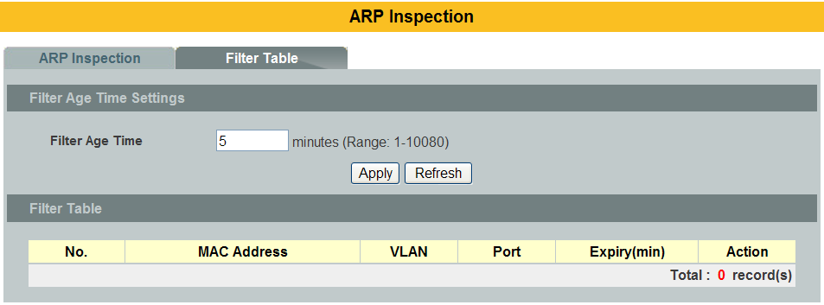

Parameter | Description
Filter Age Time | This setting has no effect on existing MAC address filters.  Enter how long (1-10080 minutes) the MAC address filter remains in the Switch after the Switch identifies an unauthorized ARP packet. The Switch automatically deletes the MAC address filter afterwards.
Apply | Click Apply to add/modify the settings.
Refresh | Click Refresh to begin configuring this screen afresh.
Filter Table
No. | This field displays a sequential number for each MAC addressfilter.
MAC Address | This field displays the source MAC address in the MAC addressfilter.
VLAN | This field displays the source VLAN ID in the MAC address filter.
Port | This field displays the source port of the discarded ARP packet.
Expiry (min) | This field displays how long (in minutes) the MAC address filterremains in the Switch.
Action | Click Delete to remove the record manually.
Total | This field displays the current number of MAC address filters thatwere created because the Switch identified unauthorized ARPpackets.

ACL
L2 Access control list (ACL) is a list of permissions attached to an object. The list specifies who or what is allowed to access the object and what operations are allowed to be performed on the object.

L2 ACL function allows user to configure a few rules to reject packets from the specific ingress ports or all ports. These rules will check the packets’ source MAC address and destination MAC address. If packets match these rules, the system will do the actions “deny”. “deny” means rejecting these packets.

The Action Resolution engine collects the information (action and metering results) from the hit entries: if more than one rulematches, the actions and meter/counters are taken from the policy associated with the matched rule with highest priority.

L2 ACL Support:
1. Filter a specific source MAC address.
Command: sourcemac host MACADDR
2. Filter a specific destination MAC address.
Command: destination mac host MACADDR
3. Filter a range of source MAC address.
Command: sourcemacMACADDR MACADDR
The second MACADDR is a mask, for example: ffff.ffff.0000
4. Filter a range of destination MAC address.
Command: destination macMACADDR MACADDR
The second MACADDR is a mask, for example: ffff.ffff.0000

L3 ACL Support:
1. Filter a specific source IP address.
Command: source ip host IPADDR
2. Filter a specific destination IP address.
Command: destinationiphost IPADDR
3. Filter a range of source IP address.
Command: source ip IPADDRIPADDR
The second IPADDR is a mask, for example: 255.255.0.0
4. Filter a range of destination IP address.
Command: destinationip IPADDRIPADDR

L4 ACL Support:
1. Filter a UDP/TCP source port.
2. Filter a UDP/TCP destination port.

Default Settings
- Maximum profile : 64.
- Maximum profile name length : 16.

Notice: The ACL name should be the combination of the digit or the alphabet.

CLI Configuration
Node | Command | Description
enable | show access-list | This command displays all of the access control profiles.
configure | access-list STRING ip-type (ipv4|ipv6) | This command creates a new access control profile.  Where the STRING is the profile name. And you can specify the type, ipv4 or ipv6.
configure | no access-list STRING | This command deletes an access control profile.
acl | show | This command displays the current access control profile.
acl | action (disable|drop|permit) | This command actives this profile.  disable– disable the profile.  drop– If packets match the profile, the packets will be dropped.  permit– If packets match the profile, the packets will be forwarded.
acl | action dscp remarking <0-63> | This command actives this profile and specify that it is for DSCP remark. And configures the new DSCP value which will be override to all packets matched this profile.
acl | action 802.1p remarking <0-7> | This command actives this profile and specify that it is for 802.1p remark. And configures the new 802.1p value which will be override to all packets matched this profile.
acl | 802.1p VALUE | This command configures the 802.1p value for the profile.
acl | dscp VALUE | This command configures the DSCP value for the profile.
acl | destination mac hostMACADDR | This command configures the destination MAC and mask for the profile.
acl | destination mac MACADDR MACADDR | This command configures the destination MAC and mask for the profile.
acl | destination mac MACADDR MACADDR | This command configures the destination MAC and mask for the profile. The second MACADDR parameter is the mask for the profile.
acl | no destination mac | This command removes the destination MAC from the profile.
acl | ethertype STRING | This command configures the ether type for the profile. Where the STRING is a hex-decimal value. e.g.: 08AA.
acl | no ethertype | This command removes the limitation of the ether type from the profile.
acl | source mac host MACADDR | This command configures the source MAC and mask for the profile.
acl | source mac MACADDR MACADDR | This command configures the source AMC and mask for the profile.
acl | no source mac | This command removes the source MAC and mask from the profile.
acl | source ip host IPADDR | This command configures the source IP address for the profile.
acl | source ip IPADDR IPMASK | This command configures the source IP address and mask for the profile.
acl | no source ip | This command removes the source IP address from the profile.
acl | destination ip host IPADDR | This command configures a specific destination IP address for the profile.
acl | destination ip IPADDR IPMASK | This command configures the destination IP address and mask for the profile.
acl | no destination ip | This command removes the destination IP address from the profile.
acl | l4-source-port IPADDR | This command configures UDP/TCP source port for the profile.
acl | no l4-source-port IPADDR | This command removes the UDP/TCP source port from the profile.
acl | L4-destination-port PORT | This command configures the UDP/TCP destination port for the profile.
acl | no l4-destination-port | This command removes the UDP/TCP destination port from the profile.
acl | vlan VLANID | This command configures the VLAN for the profile.
acl | no vlan | This command removes the limitation of the VLAN from the profile.
acl | source interface PORT_ID | This command configures the source interface for the profile.
acl | no source interface PORT_ID | This command removes the source interface from the profile.

Where the MAC mask allows users to filter a range of MAC in the packets’ source MAC or destination MAC.
For example: source mac 00:01:02:03:04:05 ff:ff:ff:ff:00

The command will filter source MAC range from 00:01:02:03:00:00 to 00:01:02:03:ff:ff

Where the IPMASK mask allows users to filter a range of IP in the packets’ source IP or destination IP.
For example:source ip 172.20.1.1 255.255.0.0

The command will filter source IP range from 172.20.0.0 to 172.20.255.255

Example:
L2SWITCH#configure terminal
L2SWITCH(config)#access-list 111
L2SWITCH(config-acl)#vlan 2
L2SWITCH(config-acl)#source interface 1
L2SWITCH(config-acl)#show
Profile Name: 111
Activate: disabled
VLAN: 2
Source Interface: 1
Destination MAC Address: any
Source MAC Address: any
Ethernet Type: any
Source IP Address: any
Destination IP Address: any
Source Application: any
Destination Application: any

Web Configuration
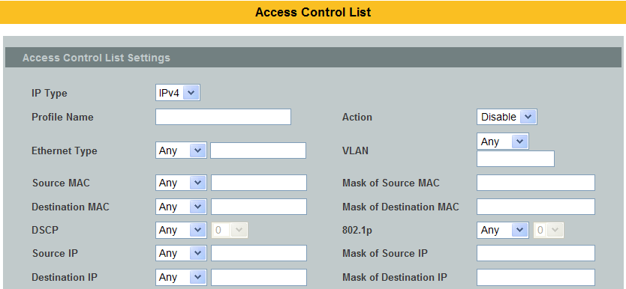
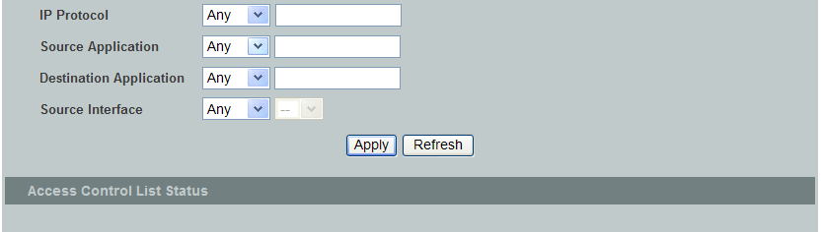

Parameter | Description
Profile Name | The access control profile name.
Action |  | Selects Disables / Drop / Permits/ DSCP action for the profile.
Ethernet Type | Configures the Ethernet type of the packets that you want to filter.
VLAN | Configures the VLAN of the packets that you want to filter.
Source MAC | Configures the source MAC of the packets that you want to filter.
Mask of Source MAC | Configures the bitmap mask of the source MAC of the packets that you want to filter.  If the Source MAC field has been configured and this field is empty, it means the profile will filter the one MAC configured in Source MAC field.
Destination MAC | Configures the destination MAC of the packets that you want to filter.
Mask of Destination MAC | Configures the bitmap mask of the destination MAC of the packets that you want to filter.  If the Destination MAC field has been configured and this field is empty, it means the profile will filter the one MAC configured in Destination MAC field.
DSCP | Configure the DSCP for the profile.
802.1p | Configures the 802.1p for the profile.
Source IP | Configures the source IP of the packets that you want to filter.
Mask of Source IP | Configures the bitmap mask of the source IP of the packets that you want to filter.  If the Source IP field has been configured and this field is empty, it means the profile will filter the one IP configured in Source IP field.
Destination IP | Configures the destination IP of the packets that you want to filter.
Mask of Destination IP | Configures the bitmap mask of the destination IP of the packets that you want to filter.  If the Destination IP field has been configured and this field is empty, it means the profile will filter the one IP configured in Destination IP field.
Source Application | Configures the source UDP/TCP ports of the packets that you want to filter.
Destination Application | Configures the destination UDP/TCP ports of the packets that you want to filter.
Source Interface(s) | Configures one or a rage of the source interfaces of the packets that you want to filter.
Apply | Click Apply to add/modify the settings.
Refresh | Click Refresh to begin configuring this screen afresh.

802.1x
IEEE 802.1X is an IEEE Standard for port-based Network Access Control ("port" meaning a single point of attachment to the LAN infrastructure). It is part of the IEEE 802.1 group of networking protocols. It provides an authentication mechanism to devices wishing to attach to a LAN, either establishing a point-to-point connection or preventing it if authentication fails. It is used for most wireless 802.11 access points and is based on the Extensible Authentication Protocol (EAP).

802.1X provides port-based authentication, which involves communications between a supplicant, authenticator, and authentication server. The supplicant is often software on a client device, such as a laptop, the authenticator is a wired Ethernet switch or wireless access point, and an authentication server is generally a RADIUS database. The authenticator acts like a security guard to a protected network. The supplicant (i.e., client device) is not allowed access through the authenticator to the protected side of the network until the supplicant’s identity is authorized. An analogy to this is providing a valid passport at an airport before being allowed to pass through security to the terminal. With 802.1X port-based authentication, the supplicant provides credentials, such as user name / password or digital certificate, to the authenticator, and the authenticator forwards the credentials to the authentication server for verification. If the credentials are valid (in the authentication server database), the supplicant (client device) is allowed to access resources located on the protected side of the network.

Upon detection of the new client (supplicant), the port on the switch (authenticator) is enabled and set to the "unauthorized" state. In this state, only 802.1X traffic is allowed; other traffic, such as DHCP and HTTP, is blocked at the network layer (Layer 3). The authenticator sends out the EAP-Request identity to the supplicant, the supplicant responds with the EAP-response packet that the authenticator forwards to the authenticating server. If the authenticating server accepts the request, the authenticator sets the port to the "authorized" mode and normal traffic is allowed. When the supplicant logs off, it sends an EAP-logoff message to the authenticator. The authenticator then sets the port to the "unauthorized" state, once again blocking all non-EAP traffic.

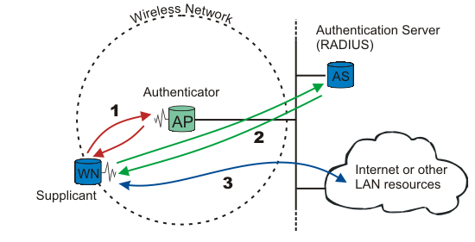

The following figure illustrates how a client connecting to an IEEE 802.1xauthentication enabled port goes through a validation process. The Switchprompts the client for login information in the form of a user name and password.

When the client provides the login credentials, the Switch sends an authenticationrequest to a RADIUS server. The RADIUS server validates whether this client isallowed access to the port.

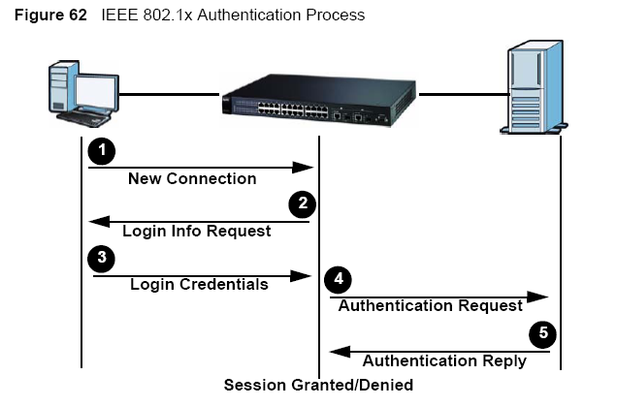
Local User Accounts
By storing user profiles locally on the Switch, your Switch is able to authenticateusers without interacting with a network authentication server. However, there is alimit on the number of users you may authenticate in this way.

Guest VLAN:
The Guest VLAN in IEEE 802.1x port authentication on the switch to provide limited services to clients, such as downloading the IEEE 802.1x client. These clients might be upgrading their system for IEEE 802.1x authentication.

When you enable a guest VLAN on an IEEE 802.1x port, the switch assigns clients to a guestVLAN when the switch does not receive a response to its EAP request/identityframe or when EAPOL packets are not sent by the client.

Port Parameters:

- Admin Control Direction:
both - drop incoming and outgoing packets on the port when auser has not
passed 802.1x port authentication.
in - drop only incoming packets on the port when a user has notpassed
802.1x port authentication.

- Re-authentication:
Specify if a subscriber has to periodically re-enter his or her usernameand password to stay connected to the port.

- Reauth-period:
Specify how often a client has to re-enter his or her username and password to stay connected to the port. The acceptable range for this field is 0 to 65535 seconds.

- Port Control Mode:
auto : Users can access network after authenticating.
force-authorized : Users can access network without authentication.
force-unauthorized: Users cannot access network.

- Quiet Period:
Specify a period of the time the client has to wait before the next re-authentication attempt. This will prevent the Switch from becoming overloaded with continuous re-authentication attempts from the client. The acceptable range for this field is 0 to 65535 seconds.

- Server Timeout:
The server-timeout value is used for timing out the Authentication Server.

- Supp-Timeout:
The supp-timeout value is the initialization value used for timing out a Supplicant.

- Max-req Time:
Specify the amount of times the Switch will try to connect to the authentication server before determining the server is down. The acceptable range for this field is 1 to 10 times.

Default Settings
The default global 802.1x state is disabled.
The default 802.1x Authentication Method is local.
The default port 802.1x state is disabled for all ports.
The default port Admin ControlDirection is both for all ports.
The default port Re-authentication is disabled for all ports.
The default port Control Mode is auto for all ports.
The default port Guest VLAN is 0 for all ports. (Guest VLAN is disabled).
The default port Max-req Time is 2 times for all ports.
The default port Reauth period is 3600 seconds for all ports.
The default port Quiet period is 20 seconds for all ports.
The default port Supp timeout is 30 seconds for all ports.
The default port Server timeout is 16 seconds for all ports.

CLI Configuration
Node | Command | Description
enable | show dot1x | This command displays the current 802.1x configurations.
enable | show dot1x username | This command displays the current user accounts for the local authentication.
enable | show dot1x accounting-record | This command displays the local accounting records.
configure | dot1xauthentication (disable|enable) | This command enables/disables the 802.1x authentication on the switch.
configure | dot1xauthentic-method (local|radius) | This command configures the authentic method of 802.1x.
configure | no dot1xauthentic-method | This command configures the authentic method of 802.1x to default.
configure | dot1x radius primary-server-ip <IP> port PORTID | This command configures the primary radius server.
configure | dot1x radius primary-server-ip <IP> port PORTID key KEY | This command configures the primary radius server.
configure | dot1x radius secondary-server-ip <IP> port PORTID | This command configures the secondary radius server.
configure | dot1x radius secondary-server-ip <IP> port PORTID key KEY | This command configures the secondary radius server.
configure | no dot1x radius secondary-server-ip | This command removes the secondary radius server.
configure | dot1x username <STRING> passwd <STRING> | This command configures the user account for local authentication.
configure | no dot1x username <STRING> | This command deletes the user account for local authentication.
configure | dot1x accounting (disable|enable) | This command enables/disables the dot1x local accounting records.
configure | dot1x guest-vlanVLANID | This command configures the guest vlan.
configure | no dot1x guest-vlan | This command removes the guest vlan.
interface | dot1x admin-control-direction (both|in) | This command configures the control direction for blocking packets.
interface | dot1x default | This command sets the port configuration to default settings.
interface | dot1x max-req<1-10> | This command sets the max-req times of a port. (1~10).
interface | dot1x port-control(auto|force-authorized|force-unauthorized) | This command configures the port control mode on the port.
interface | dot1x authentication (disable|enable) | This command enables/disables the 802.1x on the port.
interface | dot1x reauthentication (disable|enable) | This command enables/disables re-authentication onthe port.
interface | dot1x timeoutquiet-period | This command configures the quiet-period value on the port.
interface | dot1x timeoutserver-timeout | This command configures the server-timeout value on the port.
interface | dot1x timeoutreauth-period | This command configures the reauth-period value on the port.
interface | dot1x timeoutsupp-timeout | This command configures the supp-timeout value on the port.
interface | dot1x guest-vlan(disable|enable) | This command configures the 802.1x state on the port.

Web Configuration
Global Settings
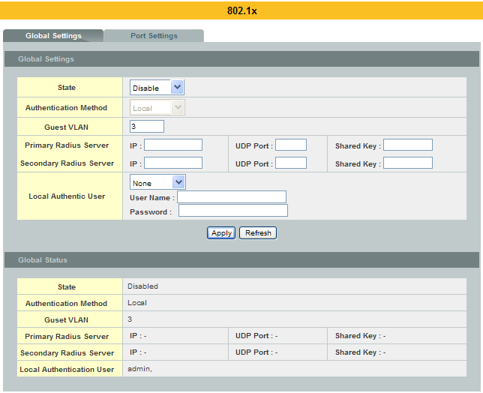

Parameter | Description
State | Select Enable to permit 802.1x authentication on the Switch.  Note: You must first enable 802.1x authentication on the Switch before configuring it on each port.
Authentication Method | Select whether to use Local or RADIUS as the authentication method.  The Local method of authentication uses the “guest” and “user” user groups of the user account database on the Switch itself to authenticate.  However, only a certain number of accounts can exist at one time.  RADIUS is a security protocol used to authenticate users by means of an external server instead of an internal device user database that is limited to the memory capacity of the device. In essence, RADIUS allows you to validate an unlimited number of users from a central location.
Guest VLAN | Configure the guest vlan.
Primary Radius Server | When RADIUS is selected as the 802.1x authentication method, the Primary Radius Server will be used for all authentication attempts.
IP Address | Enter the IP address of an external RADIUS server in dotted decimal notation.
UDPPort | The default port of a RADIUS server for authentication is 1812.
Share Key | Specify a password (up to 32 alphanumeric characters) as the key to be shared between the external RADIUS server and the Switch. This key is not sent over the network. This key must be the same on the external RADIUS server and the Switch.
Second Radius Server | This is the backup server used only when the Primary Radius Server is down.
Global Status
State | This field displays if 802.1x authentication is Enabled or Disabled.
Authentication Method | This field displays if the authentication method is Local or RADIUS.
Guest VLAN | The field displays the guest vlan.
Primary Radius Server | This field displays the IP address, UDP port and shared key for the Primary Radius Server. This will be blank if nothing has been set.
Secondary Radius Server | This is the backup server used only when the Primary Radius Server is down.
Apply | Click Apply to add/modify the settings.
Refresh | Click Refresh to begin configuring this screen afresh.

Port Settings
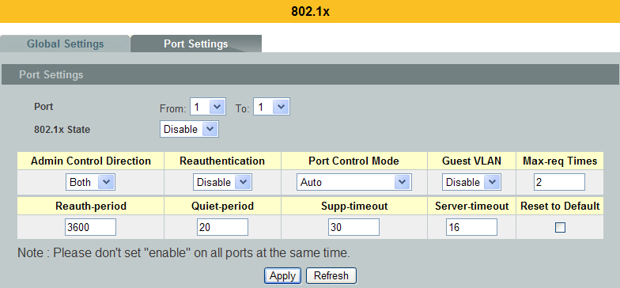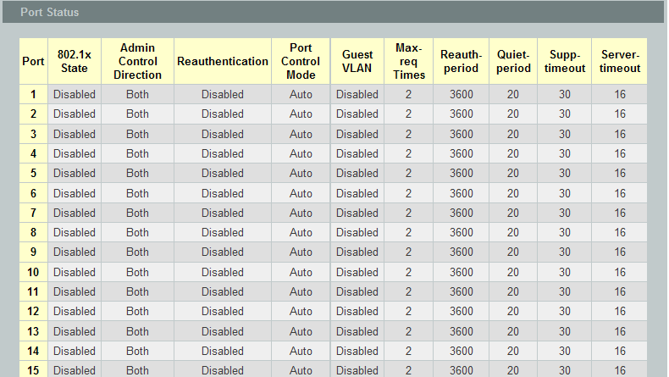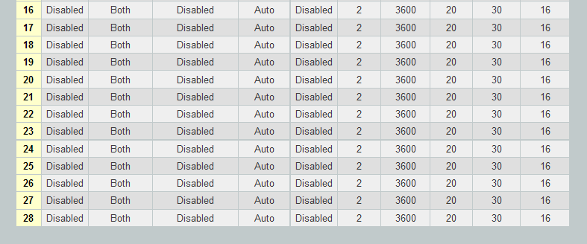

Parameter | Description
Port | Select a port number to configure.
802.1x State | Select Enable to permit 802.1x authentication on the port.  You must first enable 802.1x authentication on the Switch beforeconfiguring it on each port.
Admin Control  Direction | Select Both to drop incoming and outgoing packets on the port when auser has not passed 802.1x port authentication.  Select In to drop only incoming packets on the port when a user has notpassed 802.1x port authentication.
Re-authentication | Specify if a subscriber has to periodically re-enter his or her usernameand password to stay connected to the port.
Port Control Mode | Select Auto to require authentication on the port.  Select Force Authorized to always force this port to be authorized.  Select Force Unauthorized to always force this port to beunauthorized. No packets can pass through this port.
Guest VLAN | Select Disableto disable Guest VLAN on the port.  Select Enableto enable Guest VLAN on the port.
Max-req Time | Specify the amount of times the Switch will try to connect to the authentication server before determining the server is down. The acceptable range for this field is 1 to 10 times.
Reauth period | Specify how often a client has to re-enter his or her username and password to stay connected to the port. The acceptable range for this field is 0 to 65535 seconds.
Quiet period | Specify a period of the time the client has to wait before the next re-authentication attempt. This will prevent the Switch from becoming overloaded with continuous re-authentication attempts from the client. The acceptable range for this field is 0 to 65535 seconds.
Supp timeout | Specify how long the Switch will wait before communicating with the server. The acceptable range for this field is 0 to 65535 seconds.
Server timeout | Specify how long the Switch to time out the Authentication Server.The acceptable range for this field is 0 to 65535 seconds.
Reset to Default | Select this and click Apply to reset the custom 802.1x port authentication settings back to default.
Apply | Click Apply to add/modify the settings.
Refresh | Click Refresh to begin configuring this screen afresh.
Port Status
Port | This field displays the port number.
802.1x State | This field displays if 802.1x authentication is Enabled or Disabled onthe port.
Admin Control  Direction | This field displays the Admin Control Direction.  Both will drop incoming and outgoing packets on the port when a userhas not passed 802.1x port authentication.  In will drop only incoming packets on the port when a user has notpassed 802.1x port authentication.
Re-authentication | This field displays if the subscriber must periodically re-enter his or her username and password to stay connected to the port.
Port Control Mode | This field displays the port control mode.  Auto requires authentication on the port.  Force Authorized forces the port to be authorized.  Force Unauthorized forces the port to be unauthorized. No packets canPass through the port.
Guest VLAN | This field displays the Guest VLAN setting for hosts that have not passed authentication.
Max-req Time | This field displays the amount of times the Switch will try to connect to the authentication server before determining the server is down.
Reauth period | This field displays how often a client has to re-enter his or her username and password to stay connected to the port.
Quiet period | This field displays the period of the time the client has to wait before the next re-authentication attempt.
Supp timeout | This field displays how long the Switch will wait before communicating with the server.
Server timeout | This field displays how long the Switch will wait before communicating with the client.

Port Security

Port Security
The Switch will learn the MAC address of the device directly connected to a particular port and allow traffic through. We will ask the question: “How do we control who and how many can connect to a switch port?” This is where port security can assist us. The Switch allow us to control which devices can connect to a switch port or how many of them can connect to it (such as when a hub or another switch is connected to the port).
Let’s say we have only one switchport left free and we need to connect five hosts to it. What can we do? Connect a hub or switch to the free port! Connecting a switch or a hub to a port has implications. It means that the network will have more traffic. If a switch or a hub is connected by a user instead of an administrator, then there are chances that loops will be created. So, it is best that number of hosts allowed to connect is restricted at the switch level. This can be done using the “port-security limit” command. This command configures the maximum number of MAC addresses that can source traffic through a port.
Port securitycan sets maximum number of MAC addresses allowed per interface. When the limit is exceeded, incoming packets with new MAC addresses are dropped. It can be usedMAC table to check it.The static MAC addresses are included for the limit.
Notice:If you configure a port of the Switch from disabled to enabled, all of the MAC learned by this port will be clear.

Default Settings
  - The port security on the Switch is disabled.
  - The port state of the port security is disabled.
  - The Maximum MAC per port is 5.

CLI Configuration
Node | Command | Description
enable | show port-security | This command displays the current port security configurations.
configure | port-security (disable|enable) | This command enables / disables the global port security function.
interface | port-security (disable|enable) | This command enables / disables the port security function on the specific port.
interface | port-security limit VALUE | This command configures the maximum MAC entries on the specific port.
configure | interface range gigabitethernet1/0/PORTLISTS | This command enters the interface configure node.
if-range | port-security (disable|enable) | This command enables / disables the port security function for the specified ports
if-range | port-security limit VALUE | This command configures the maximum MAC entries for the specified ports.

Example:
L2SWITCH#configure terminal
L2SWITCH#port-security enable
L2SWITCH#interface 1/0/1
L2SWITCH#port-security limit 10
L2SWITCH#port-security enable

Web Configuration
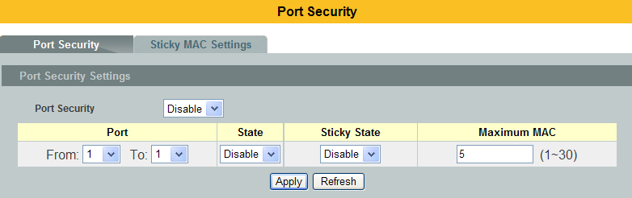
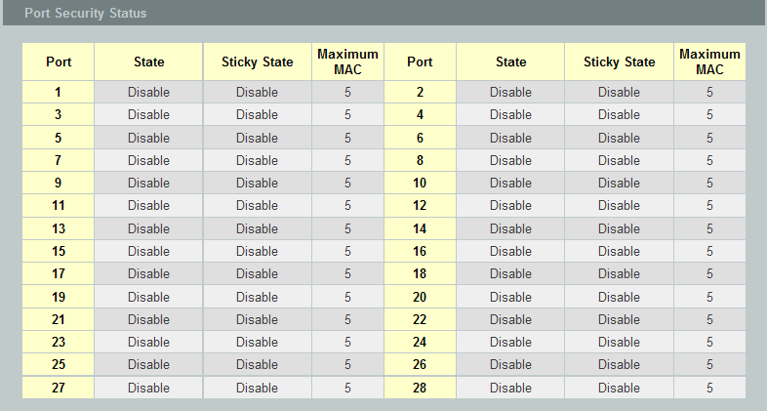

Parameter | Description
Port Security Settings
Port Security | Select Enable/Disableto permit Port Security on the Switch.
Port | Select a port number to configure.
State | Select Enable/Disableto permit Port Security on the port.
MaximumMAC | The maximum number of MAC addresses allowed per interface. The acceptable range is 1 to 30.
PortSecurity Status
Port | This field displays a port number.
State | This field displays if Port Security is Enabled or Disabled
Maximum MAC | This field displaysthe maximum number of MAC addresses

Sticky
Port security with sticky MAC addresses provides many of the same benefits as port security with staticMAC addresses, but sticky MAC addresses can be learned dynamically. Port security with sticky MACaddresses retains dynamically learned MAC addresses during a link-down condition.

If you enter a write memory or copy running-config startup-config command, then port security withsticky MAC addresses saves dynamically learned MAC addresses in the startup-config file and the portdoes not have to learn addresses from ingress traffic after bootup or a restart.

      - CLI Configurations
Node | Command | Description
enable | show port-security | This command displays the current port security configurations.
configure | port-security (disable|enable) | This command enables / disables the global port security function.
interface | port-security mac-address sticky | This command enables the stick function on the specific port.
interface | no port-security mac-address sticky | This command disables the stick function on the specific port.
interface | port-security mac-address stickyMACADDR vlan VLANID | This command configures a sticky MAC with a vlan on the specific port.
interface | no port-security mac-address stickyMACADDR | This command removes a sticky MAC with a vlan for the specific port from the MAC table.
configure | interface range gigabitethernet1/0/PORTLISTS | This command enters the interface configure node.
if-range | port-security mac-address sticky | This command enables the stick function on the specific ports.
if-range | no port-security mac-address sticky | This command disables the stick function on the specific ports.

The procedures to enable port security with sticky MAC addresses on a port:
- To enable the global Port-Security.
L2SWITCH(config)#port-security enable

- To select the port you want to configure.
L2SWITCH(config)#interface gigabitethernet1/0/10

- To enable the port Port-Security.
L2SWITCH(config-if)#port-security enable

- To enable the sticky on the port.
L2SWITCH(config-if)#port-security mac-address sticky

      - Web Configurations
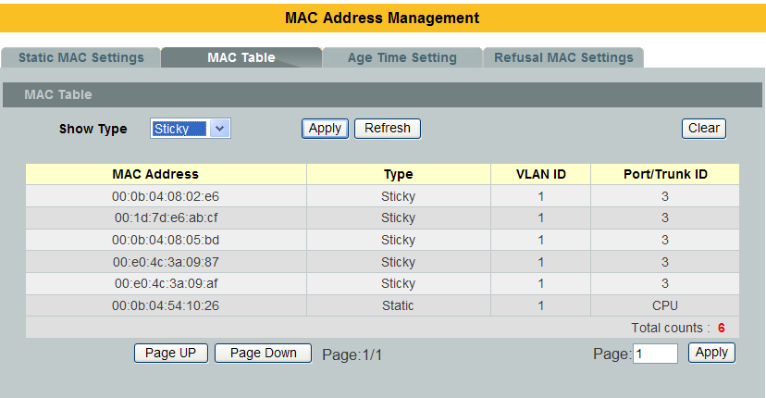

Parameter | Description
Port Security Settings
Port Security | Select Enable/Disableto permit the global Port Security on the Switch.
Port | Select a port or a range of ports to configure.
State | Select Enable/Disableto permit Port Security on the ports.
Sticky State | Select Enable/Disableto sticky on the ports.
MaximumMAC | The maximum number of MAC addresses allowed per interface. The acceptable range is 1 to 30.
PortSecurity Status
Port | This field displays a port number.
State | This field displays if the global Port Security is Enabled or Disabled
Sticky | This field displays if the sticky is Enabled or Disabled on the port.
Maximum MAC | This field displaysthe maximum number of MAC addresses on the port.

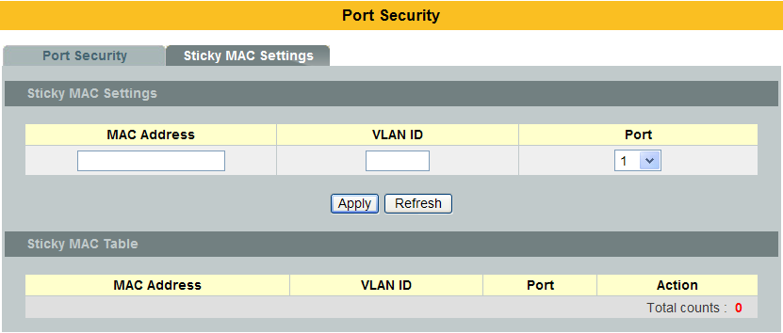

Parameter | Description
Sticky MAC Settings
MAC Address | Configures a Sticky MAC.
VLAN ID | Configures a VLAN for the Sticky MAC.
Port | Configures a port for the Sticky MAC.
Sticky MAC Table
MAC Address | The Sticky MAC.
VLAN ID | The VLAN for the Sticky MAC.
Port | The port for the Sticky MAC.
Action | Clicks the DELETE button to clear the sticky MAC.

Switch Lock
Roles:
  - Default: This is an invalid role, for initial configurations only.
If the Switch’s role is Default, normal user can configure their Switch to one of below roles. If the Switch’s role is one of below roles, user cannot change the Switch’s role.

  - Master: Can access slave’s authentications.
All ports are configured as users want.

  - Slave: Uplink ports are enabled. Downlink ports are disabled.
The Switch need authenticate with the master Switch to enable all of the downlink ports.

  - Master_Slave: Uplink ports are enabled. Downlink ports are enabled, but
blocked with port isolation.
The Switch can access slave’s authentication from downlink ports. The Switch need authenticate with a Master which connect to the uplink ports to normalize all of the downlink ports.

When the Switch is authenticating, the POST LED will be On/Off every seconds.

Notice: If the Slave has default vendor key and the Master don’t have, the Master will inform the Slave to change its vendor key when the Slave starts to authenticate.

Default Configurations:
Role = Default. (Invalid), must be changed.
Uplink Ports = None.
Vendor Key = 123456789012345678901234567890
State = disable.

CLI Configurations
Node | Command | Description
enable | show switch-lock | This command displays the current Switch Lock configurations.
configure | switch-lock state (disable|enable) | This command enables/disables the global state of the Switch Lock function.
configure | switch-lock clear counter | This command clears all of the ports’ authentication counters.
configure | switch-lock role (master|slave|master-slave) | This command configures the role for the Switch Lock function.
configure | switch-lock uplink-port PORTLIST | This command configures the uplink port list for the Switch Lock.
configure | switch-lock vendor-key STRING | This command configures the vendor key for the Switch Lock.(Up to 30 characters)

switch-lock role (master|slave|master-slave)
- If the current Role is Default, the Switch can be changed to one of the three roles: master, slave, master-slave.
- If the role has been changed, it cannot be changed to another role.

switch-lock (disable|enable)
- If the current state is disabled, the Switch can be enabled.
- If the state has been enabled, it cannot be disabled again.

switch-lock vendor-key STRING
- If the current Vendor Key is the default value, 123456789012345678901234567890, the Switch can be configured to any values.
- If the Vendor Key has been changed, it cannot be changed again.

switch-lock uplink-port PORTLIST
- User can configure any ports as uplink-port.
- If the Switch’s role is slave, the uplink port count cannot be 0.

Web Configurations
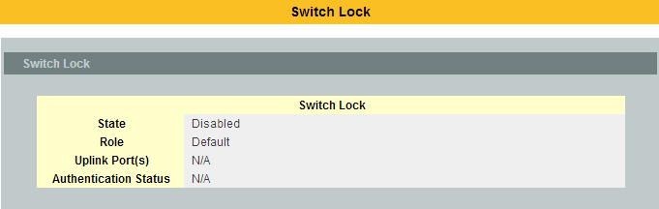

Parameter | Description
State | The current global state for the Switch Lock.
Role | The current role of the Switch for the Switch Lock.
Uplink Port | The uplink port list for the Switch Lock.
Authentication Status | The authentication status for the slave function. (Discovery, Authenticating or Authenticated).

TACACS+
The purpose of this enhancement is to support TACACS+ on the Switch platforms. Terminal Access Controller Access Control System Plus is a security application that provides centralized validation of users attempting to gain access to a router, network access server etc. In order for the TACACS+ feature on the VOLKTEK products to work it would need a TACACS+ server, which would typically be a daemon running on a centralized UNIX or windows NT authentication, authorization and accounting facilities for managing network access points from a single management service.

Product Features
The TACACS+ implementation will support the following features:

- The implementation will conform to version 1.78 of the TACACS+ draft RFC.
- Authentication, Authorization and Accounting can be run as well as disabled independently of each other.
- In case TACACS+ authentication fails on account of the server being unreachable the box can be made to default to a local authentication policy.
- TACACS+ packet body encryption will be supported.
- Single Tacacs+ server will be support.
- Multiple connect mode will be support.
- Syslog messages will be support.

Functional Description
The Tacacs+ implementation will provide the following services:

Authentication:
Complete control of authentication through login and password dialog, challenge and response, messaging support etc.

Authorization:
Control over user capabilities for the duration of the user session, like setting auto commands, enforcing restrictions on what configuration commands a user may execute, session duration etc.

Accounting :
Collecting and sending information used for billing, auditing, and reporting to the TACACS+ daemon.

Each of the above mentioned services can be configured and run independent of the others. The TACACS+ implementation will provide authentication and confidentiality between the router and the TACACS+ daemon. It runs on TCP port 49.
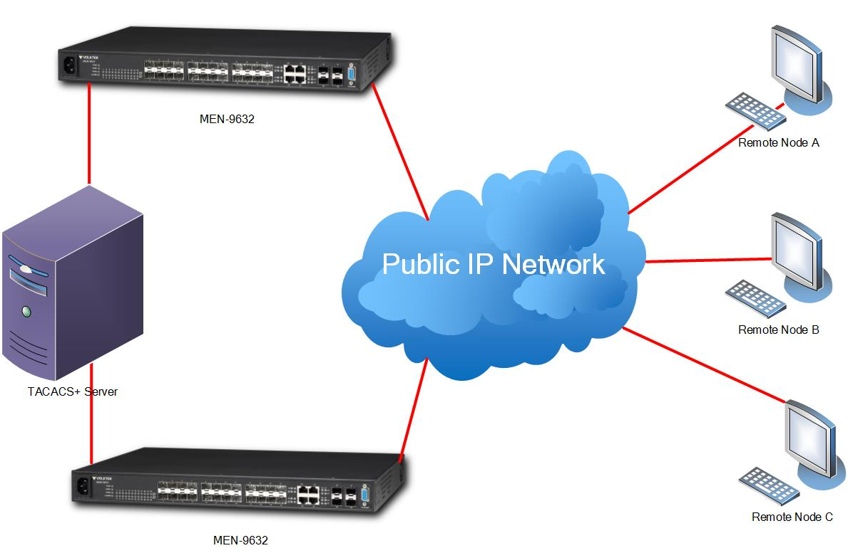

Application:
Remote network access is witnessing a major paradigm shift, that from terminal access to LAN access. Single users want to connect to the corporate network in the same way that they connect at work i.e. as a LAN user. This places increased emphasis on network access security. As a result of this network managers are concerned with 3 parameters: authentication, authorization and accounting. This is where TACACS+ enters into the picture. A typical deployment using TACACS+ could be as follow:

Notices
- Tacacs+ service must be enabled before configuring the authentication, authorization and accounting parameters, otherwise it will return error as Tacacs+ service is not enabled.
- Not allowed to disable the Authentication login mode when both enabled login-mode and login local.
- Not allowed to disable the Authentication enable mode when both enabled enable-mode and enable local.
- Not allowed to enable the login-mode local when login-mode is in disable.
- Not allowed to enable the enable-mode local when enable-mode is in disable.
- For input CLI, user must supply full command or partial command with TAB (command must be completed). The reason is only the command after user HIT the ENTER is only send to TACACSP server for authorization or accounting. So if this command is partial then subsequently authorization or accounting fails.

    - CLI Configuration
Mode | Command | Description
Enable | show tacacs-plus | To show the Tacacs+ Statistics.
configure | tacacs-plus server-host <ipaddr> | To set the Tacacs+ Server ip address
configure | no tacacs-plus server-host | To reset the Tacacs+ Server ip address as 0.0.0.0
configure | tacacs-plus server-key <key> | To set the Tacacs+ server key
configure | no tacacs-plus server-key | To reset the Tacacs+ server key as default key( NULL means no key)
configure | tacacs-plus enable | To enable the Tacacs+ service
configure | no tacacs-plus enable | To disable the Tacacs+ service
configure | tacacs-plus authentication login-mode enable | To enable the authentication login mode
configure | no tacacs-plus authentication login-mode enable | To disable the authentication login mode
configure | tacacs-plus authentication login-mode local enable | To enable the authentication login local mode
configure | no tacacs-plus authentication login-mode local enable | To disable the authentication login local mode
configure | tacacs-plus authentication enable-mode enable | To enable the authentication in enable mode.
configure | no tacacs-plus authentication enable-mode enable | To disable the authentication in enable mode.
configure | tacacs-plus authentication enable-mode local enable | To enable the authentication enable local mode
configure | no tacacs-plus authentication enable-mode local enable | To disable the authentication enable local mode
configure | tacacs-plus authorization commands enable | To enable the authorization show commands.
configure | no tacacs-plus authorization commands enable | To disable the authorization show commands.
configure | tacacs-plus authorization exec enable | To enable the authorization configuration commands.
configure | no tacacs-plus authorization exec enable | To disable the authorization configuration commands.
configure | tacacs-plus accounting commands enable | To enable the level 1 commands for accounting.
configure | no tacacs-plus accounting commands enable | To disable the level 1 commands for accounting.
configure | tacacs-plus accounting exec enable | To enable the level 15 commands for accounting.
configure | no tacacs-plus accounting exec enable | To disable the level15 commands for accounting
configure | tacacs-plus line-console enable | To enable TACACSP on the console port.
configure | no tacacs-plus line-console enable | To disable TACACSP on the console port.

Example:
L2SWITCH#show tacacs-plus
Tacacs+ Server Host :0.0.0.0
Tacacs+ State :disabled
Tacacs+ line-console mode :disabled
Authentication Login mode :disabled Local: disabled
Authentication Enable mode :disabled Local: disabled
Authorization :Command: disabled Exec : disabled
Accounting :Command:disabled Exec : disabled
Authentication Sessions :0
Authorization Sessions :0
Accounting Sessions :0

    - Web Configuration
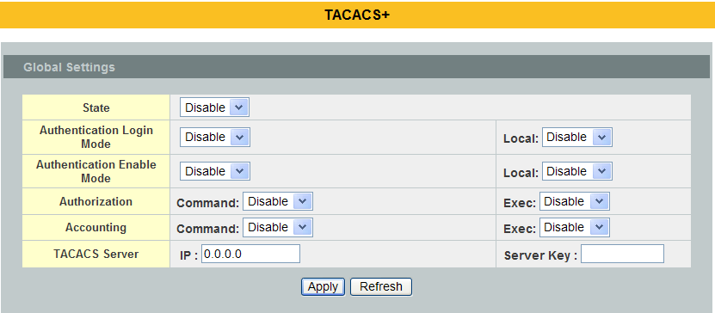
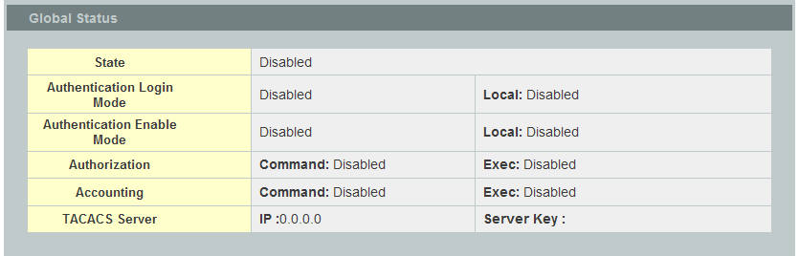

Parameter | Description
State | Enables / Disables the Tacacs+ service.
Authentication Login Mode | Enables / Disables the authentication in login mode.
Authentication Enable Mode | Enables / Disables the authentication in Enable mode.
Authorization Command | Enables / Disables the authorization with show commands.
Authorization Exec | Enables / Disables the authorization with configuration commands.
Accounting Command | Enables / Disables the level 1 command for the Accounting.
Accounting Exec | Enables / Disables the level 15 command for the Accounting.
TACACS Server IP | Configures the TACACS server’s IP.
TACACS Server Server Key | Configures the server key for the TACACS server.

Monitor

Alarm
The feature displays if there are any abnormal situation need process immediately.

    - CLI Configuration
Node | Command | Description
enable | show alarm-info | This command displaysalarm information.

    - Web Configuration
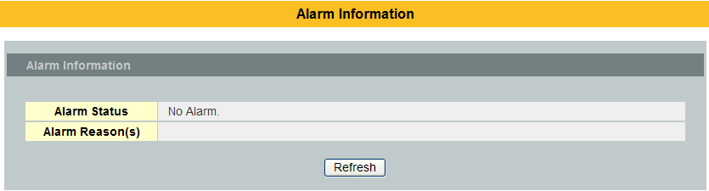

Parameter | Description
Alarm Information
Alarm Status | This field indicates if there is any alarm events.
Alarm Reason(s) | This field displays all of the detail alarm events.

  - Hardware Information
The feature displays some hardware information to monitor the system to guarantee the network correctly.
  - Displays the board’s and CPU’s and MAC chip’s temperature.
  - Displays the 1.0V and 2.5V and 3.3V input status.

    - CLI Configuration
Node | Command | Description
enable | show hardware-monitor (C|F) | This command displays hardware working information.

L2SWITCH#show hardware-monitor C
Hardware Working Information:
Temperature(C) Cent MAX MIN Threshold Status
-------------- ------- ------- -------- ------------- ---------
BOARD 44.0 44.2 24.0 80.0 Normal
CPU 49.2 49.2 26.5 80.0 Normal
PHY 57.5 57.5 30.0 80.0 Normal

Voltage(V) Current MAX MIN Threshold Status
-------------- --------- ------- -------- ------------ --------
1.0V IN 1.009 1.009 1.009 +/-5% Normal
1.8V IN 1.768 1.778 1.755 +/-5% Normal
3.3V IN 3.264 3.264 3.259 +/-5% Normal

Power Source: Power Source 1.

    - Web Configuration

Power Source 1 : Power from AC power.
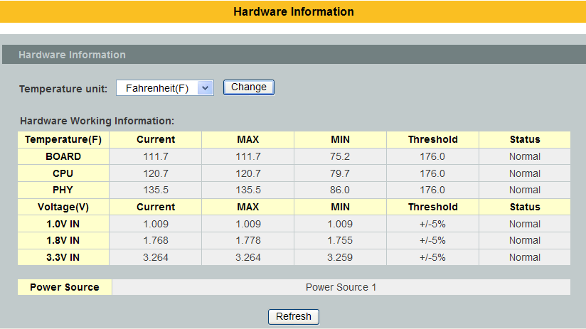

Port Statistics
This feature helps users to monitor the ports’ statistics, to display the link up ports’ traffic utilization only.

CLI Configuration
Node | Command | Description
enable | show port-statistics | This command displaysthe link up ports’ statistics.
Example:
L2SWITCH#show port-statistics

Packets Bytes Errors Drops
Port Rx Tx Rx Tx Rx Tx Rx Tx
---- -------- -------- ------- -------- -------- -------- -------- --------
7 1154 2 108519 1188 0 0 0 0

Web Configuration
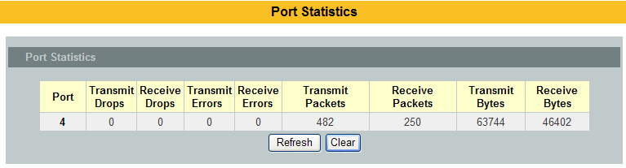

Parameter | Description
Port | Select a port or a range of ports to display their statistics.
Rx Packets | The field displays the received packet count.
Tx Packets | The field displays the transmitted packet count.
Rx Bytes | The field displays the received byte count.
Tx Bytes | The field displays the transmitted byte count.
Rx Errors | The field displays the received error count.
Tx Errors | The field displays the transmitted error count.
Rx Drops | The field displays the received drop count.
Tx Drops | The field displays the transmitted drop count.
Refresh | Click this button to refresh the screen quickly.

Port Utilization
This feature helps users to monitor the ports’ traffic utilization, to display the link up ports’ traffic utilization only.

CLI Configuration
Node | Command | Description
enable | show port-utilization | This command displaysthe link up ports’ traffic utilization.

Web Configuration
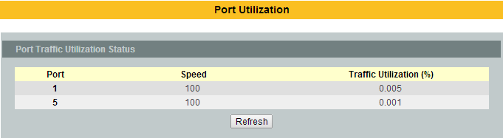

Parameter | Description
Port | Select a port or a range of ports to display their RMON statistics.
Speed | The current port speed.
Utilization | The port traffic utilization.
Refresh | Click this button to refresh the screen quickly.

RMON Statistics
This feature helps users to monitor or clear the port’s RMON statistics.

CLI Configuration
Node | Command | Description
enable | show rmon statistics | This command displaysthe RMON statistics.
configure | clear rmon statistics [IFNAME] | This command clears one port’s or all ports’ RMON statistics.

Web Configuration
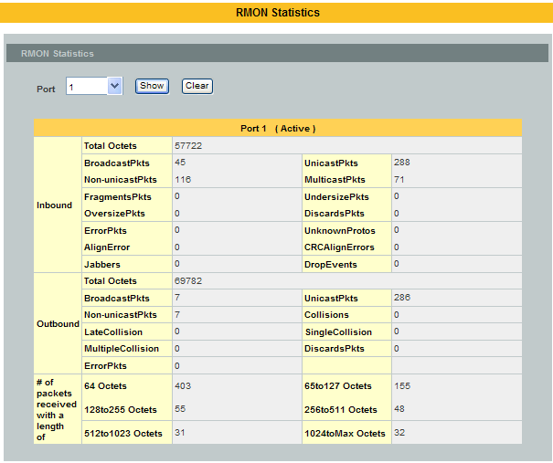

Parameter | Description
Port | Select a port or a range of ports to display their RMON statistics.
Show | Show them.
Clear | Clear the RMON statistics for the port or a range of ports.

SFP Information
The SFP information allows user to know the SFP module’s information, such as vendor name, connector type, revision, serial number, manufacture date. And to know the DDMI information if the SFP modules have supported the DDMI function.

CLI Configuration
Node | Command | Description
enable | show sfp info port PORT_ID | This command displaysthe SFP information.
enable | show sfp ddmi port PORT_ID | This command displaysthe SFP DDMI status.

Web Configuration
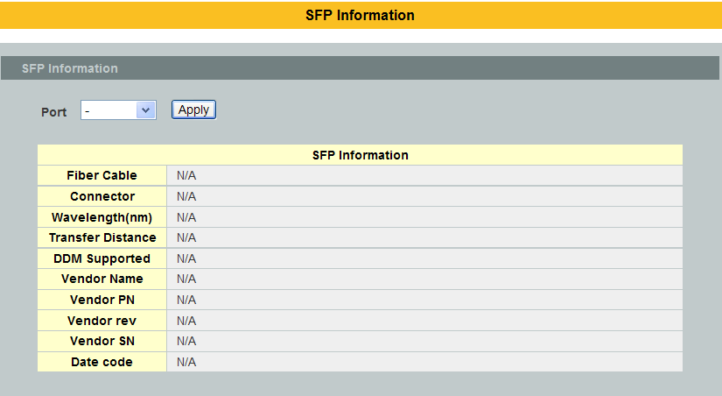

Parameter | Description
Port | Select a port number to configure.
Apply | Click Apply to display the SFP information.
Fiber Cable | To indicate if the fiber cable is connected.
Connector | Code of optical connector type.
Vendor Name | SFP vendor name.
Vendor PN | Part Number.
Vendor rev | Revision level for part number.
Vendor SN | Serial number (ASCII).
Date Code | Manufacturing date code.

Traffic Monitor
The function can be enabled / disabled on a specific port or globally be enabled disabled on the Switch.The function will monitor the broadcast / multicast / broadcast and multicast packets rate. If the packet rate is over the user’s specification, the port will be blocked. And if the recovery function is enabled, the port will be enabled after recovery time.

Default Settings
Packet Packet Recovery
Port State Status Type Rate(pps) State Time(min)
---- -------- ------- ----------- --------- -------- ---------
1 Disabled Normal Bcast 1000 Enabled 1
2 Disabled Normal Bcast 1000 Enabled 1
3 Disabled Normal Bcast 1000 Enabled 1
4 Disabled Normal Bcast 1000 Enabled 1
5 Disabled Normal Bcast 1000 Enabled 1
6 Disabled Normal Bcast 1000 Enabled 1
. . . . . . . . . . . . . . .

CLI Configuration
Node | Command | Description
enable | show traffic-monitor | This command displaysthe traffic monitor configurations and current status.
configure | traffic-monitor (disable|enable) | This command enables / disables the traffic monitor on the Switch.
interface | traffic-monitor (disable|enable) | This command enables / disables the traffic monitor on the port.
interface | traffic-monitor rateRATE_LIMIT type (bcast|mcast|bcast+mcast) | This command configures the packet rate and packet type for the traffic monitor on the port.  bcast – Broadcast packet.  mcast – Multicast packet.
interface | traffic-monitor recovery (disable|enable) | This command enables / disables the recovery function for the traffic monitor on the port.
interface | traffic-monitor recovery time VALUE | This command configures the recovery time for the traffic monitor on the port.
configure | interface range gigabitethernet1/0/PORTLISTS | This command enters the interface configure node.
if-range | traffic-monitor (disable|enable) | This command enables / disables the traffic monitor on the port.
if-range | traffic-monitor rateRATE_LIMIT type (bcast|mcast|bcast+mcast) | This command configures the packet rate and packet type for the traffic monitor on the port.  bcast – Broadcast packet.  mcast – Multicast packet.
if-range | traffic-monitor recovery (disable|enable) | This command enables / disables the recovery function for the traffic monitor on the port.
if-range | traffic-monitor recovery time VALUE | This command configures the recovery time for the traffic monitor on the port.

Web Configuration
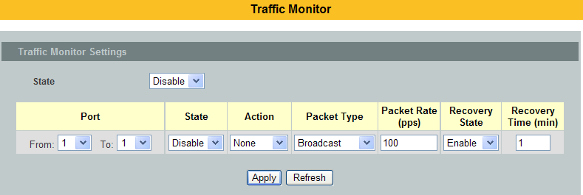
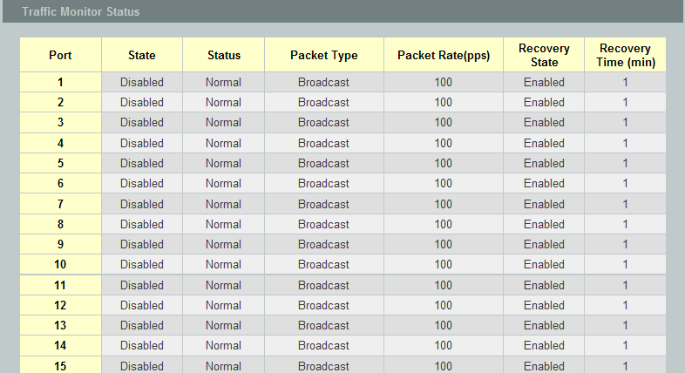
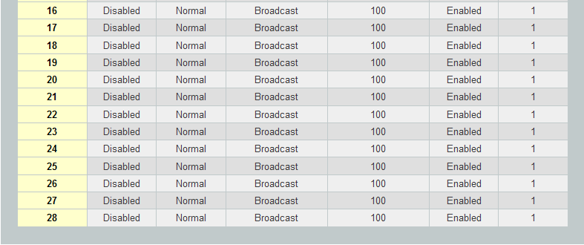

Parameter | Description
State | Globally enables / disables the traffic monitor function.
Port | The port range which you want to configure.
State | Enables / disables the traffic monitor function on these ports.
Action | Unblock these ports.
Packet Type | Specify the packet type which you want to monitor.
Packet Rate | Specify the packet rate which you want to monitor.
Recover State | Enables / disables the recovery function for the traffic monitor function on these ports.
Recovery Time | Configures the recovery time for the traffic monitor function on these ports.(Range: 1 – 60 minutes)

Management

SNMP

SNMP
Simple Network Management Protocol (SNMP) is used in network management systems to monitor network-attached devices for conditions that warrant administrative attention. SNMP is a component of the Internet Protocol Suite as defined by the Internet Engineering Task Force (IETF). It consists of a set of standards for network management, including an application layer protocol, a database schema, and a set of data objects.
SNMP exposes management data in the form of variables on the managed systems, which describe the system configuration. These variables can then be queried (and sometimes set) by managing applications.

Support below MIBs:
- RFC 1157 A Simple Network Management Protocol
- RFC 1213 MIB-II
- RFC 1493 Bridge MIB
- RFC 1643 Ethernet Interface MIB
- RFC 1757 RMON Group 1,2,3,9

SNMP community act like passwords and are used to define the security parameters of SNMP clients in an SNMP v1 and SNMP v2c environments. The default SNMP community is “public” for both SNMP v1 and SNMP v2c before SNMP v3 is enabled. Once SNMP v3 is enabled, the communities of SNMP v1 and v2c have to be unique and cannot be shared.

Network ID of Trusted Host:
The IP address is a combination of the Network ID and the Host ID.
Network ID = (Host IP & Mask).
User need only input the network ID and leave the host ID to 0. If user has input the host ID, such as 192.168.1.102, the system will reset the host ID, such as 192.168.1.0

Note: Allow user to configure the community string and rights only.
User configures the Community String and the Rights and the Network ID of Trusted Host=0.0.0.0, Subnet Mask=0.0.0.0. It means that all hosts with the community string can access the Switch.

Default Settings
- SNMP : disabled.
- System Location : L2SWITCH. (Maximum length 64 characters)
- System Contact : None. (Maximum length 64 characters)
- System Name : None. (Maximum length 64characters)
- Trap Receiver : None.
- Community Name : None.
- The maximum entry for community : 3.
- The maximum entry for trap receiver : 5.

      - CLI Configuration
Node | Command | Description
enable | show snmp | This command displays the SNMP configurations.
configure | snmp community STRING (ro|rw) trusted-host IPADDR | This command configures the SNMP community name.
configure | snmp (disable|enable) | This command disables/enables the SNMP on the switch.
configure | snmp system-contact STRING | This command configures contact information for the system.
configure | snmp system-location STRING | This command configures the location information for the system.
configure | snmp system-name STRING | This command configures a name for the system.  (The System Name is same as the host name)
configure | snmp trap-receiver IPADDR VERSION COMMUNITY | This command configures the trap receiver’s configurations, including the IP address, version (v1 or v2c) and community.

Example:
L2SWITCH#configure terminal
L2SWITCH(config)#snmp enable
L2SWITCH(config)#snmp community public rw trusted-host 192.168.200.106/24
L2SWITCH(config)#snmp trap-receiver 192.168.200.106 v2c public
L2SWITCH(config)#snmp system-contact IT engineer
L2SWITCH(config)#snmp system-location Branch-Office

      - Web Configuration
SNMP Setting:
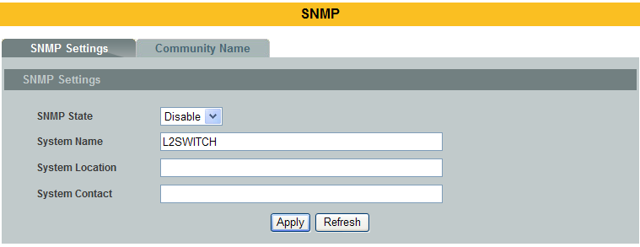

Parameter | Description
SNMPState | Select Enable to activate SNMP on the Switch.  Select Disable to not use SNMP on the Switch.
System Name | Type a System Name for the Switch.  (The System Name is same as the host name)
System Location | Type a System Location for the Switch.
System Contact | Type a System Contact for the Switch.
Apply | Click Apply to configure the settings.
Refresh | Click this button to reset the fields to the last setting.

Community Name:
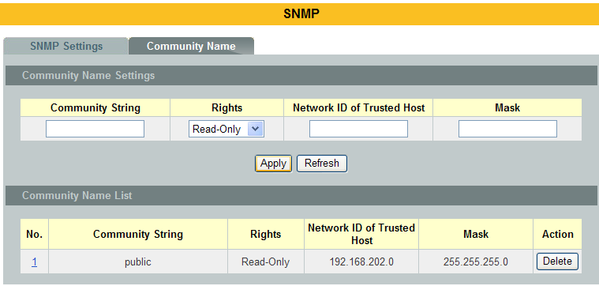

Parameter | Description
Community String | Enter a Community string, this will act as a password for requests fromthe management station.  An SNMP community string is a text string that acts as a password. It isused to authenticate messages that are sent between the managementstation (the SNMP manager) and the device (the SNMP agent). Thecommunity string is included in every packet that is transmitted betweenthe SNMP manager and the SNMP agent.
Rights | Select Read-Only to allow the SNMP manager using this string to collectinformation from the Switch.  Select Read-Write to allow the SNMP manager using this string to createor edit MIBs (configure settings on the Switch).
Network ID of Trusted Host | Type the IP address of the remote SNMP management station in dotteddecimal notation, for example 192.168.1.0.
Mask | Type the subnet mask for the IP address of the remote SNMP  management station in dotted decimal notation, for example  255.255.255.0.
Apply | Click Apply to configure the settings.
Refresh | Click Refresh to begin configuring this screen afresh.
Community Name List
No. | This field indicates the community number. It is used for identificationonly. Click on the individual community number to edit the communitysettings.
Community String | This field displays the SNMP community string. An SNMP communitystring is a text string that acts as a password.
Right | This field displays the community string’s rights. This will be Read Only or Read Write.
Network ID of  Trusted Host | This field displays the IP address of the remote SNMP managementstation after it has been modified by the subnet mask.
Subnet Mask | This field displays the subnet mask for the IP address of the remote SNMPmanagement station.
Action | Click Delete to remove a specific Community String.

SNMP Trap
      - SNMP Trap Receiver
Web Configurations
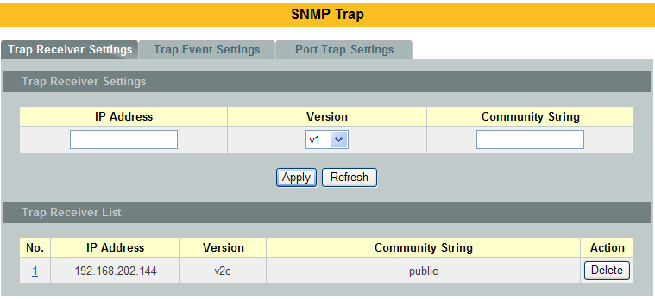

Parameter | Description
IP Address | Enter the IP address of the remote trap station in dotted decimalnotation.
Version | Select the version of the Simple Network Management Protocol to use. v1 or v2c.
Community String | Specify the community string used with this remote trap station.
Apply | Click Apply to configure the settings.
Refresh | Click Refresh to begin configuring this screen afresh.
Trap Receiver List
No. | This field displays the index number of the trap receiver entry. Click thenumber to modify the entry.
IP Address | This field displays the IP address of the remote trap station.
Version | This field displays the version of Simple Network Management Protocol inuse. v1 or v2c.
Community String | This field displays the community string used with this remote trapstation.
Action | Click Delete to remove a configured trap receiver station.

      - SNMP Trap Events
The features allow users to enable/disables individual trap notification.

alarm-over-heat - Trap when system’s temperature is too high.
alarm-over-load - Trap when system is over load.
alarm-power-fail - Trap when system power is over voltage/under voltage/
RPS over voltage/RPS under voltage.
bpdu - Trap when port is blocked by BPDU Guard/BDPU Root
Guard/BPDU port state changed.
dual-homing - Trap when port is blocked by Dual Homing.
dying-gasy - Trap when system is power off.
loop-detection - Trap when port is blocked by Loop Detection.
pd-alive - Trap when PD device has no responses.
port-admin-state-change - Trap when port is enabled/disable by administrator.
port-link-change - Trap when port is link up/down change.
power-source-change - Trap when the power source has been changed.
(AC to DC or DC to AC)
stp-topology-change - Trap when the STP topology change.
traffic-monitor - Trap when port is blocked by Traffic Monitor.
xpress-ring - Trap when port is blocked by Xpress Ring.

        - CLI Configurations
Node | Command | Description
enable | show snmp trap-event | This command displays the SNMP configurations.
configure | snmp trap-event alarm-over-heat (disable/enable) | This command enables/disables the alarm-over-heat trap.
configure | snmp trap-event alarm-over-load (disable/enable) | This command enables/disables the alarm-over-load trap.
configure | snmp trap-event alarm-power-fail (enable/enable) | This command enables/disables the alarm-power-fail trap.
configure | snmp trap-event bpdu (disable/enable) | This command enables/disables the BPDU port state change/BPDU Root Guard/BPDU Guard trap.
configure | snmp trap-event dual-homing (disable/enable) | This command enables/disables the dual-homing trap.
configure | snmp trap-event dying-gasp (disable/enable) | This command enables/disables the dying-gasp trap.
configure | snmp trap-event loop-detection (disable/enable) | This command enables/disables the loop-detection trap.
configure | snmp trap-event pd-alive (disable/enable) | This command enables/disables the pd-alive trap.
configure | snmp trap-event port-admin-state-change (disable/enable) | This command enables/disables the port-admin-state-change trap.
configure | snmp trap-event port-link-change (disable/enable) | This command enables/disables the port-link-change trap.
configure | snmp trap-event power-source-change (disable/enable) | This command enables/disables the power-source-change trap.
configure | snmp trap-event stp-topology-change (disable/enable) | This command enables/disables the stp-topology-change trap.
configure | snmp trap-event traffic-monitor (disable/enable) | This command enables/disables thetraffic-monitor trap.
configure | snmp trap-event xpress-ring (disable/enable) | This command enables/disables the xpress-ring trap.

        - Web Configurations
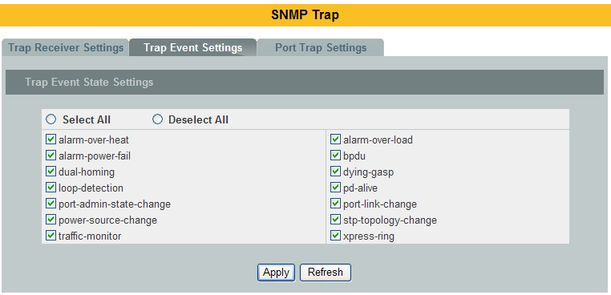

Parameter | Description
Trap Event State Settings
Select all | Enables all of trap events.
Deselect All | Disables all os trap events.
Apply | Click Apply to configure the settings.
Refresh | Click Refresh to begin configuring this screen afresh.

      - SNMP Port Trap
The features allow users to enable/disables port-link-change trap notification by individual port.

        - CLI Configurations
Node | Command | Description
enable | show snmp port-link-change-trap | This command displays the SNMP port link-change trap configurations.
interface | snmp port-link-change-trap | This command enables the link change trap on the specific port.
interface | no snmp port-link-change-trap | This command disables the link change trap on the specific port.
configure | interface range gigabitethernet1/0/PORTLISTS | This command enters the interface configure node.
if-range | snmp port-link-change-trap | This command enables the link change trap on the specific ports.
if-range | no snmp port-link-change-trap | This command disables the link change trap on the specific ports.

        - Web Configurations
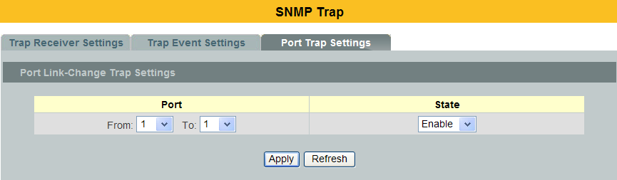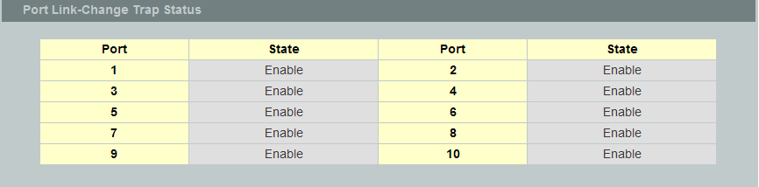

Parameter | Description
Trap Event State Settings
Port | Selects the range of ports.
State | Selects the state for the ports..
Apply | Click Apply to configure the settings.
Refresh | Click Refresh to begin configuring this screen afresh.

SNMPv3
      - CLI Configurations
Node | Command | Description
enable | show snmp user | This command displays all snmp v3 user.
enable | show snmp group | This command displays all snmp v3 group.
enable | show snmp view | This command displays all snmp v3 view.
configure | snmp user USERNAME GROUPNAME noauth | Configure v3 user of non- authentication.
configure | snmp user USERNAME GROUPNAME auth (MD5|SHA) STRINGS | Configure v3 user of authentication.
configure | snmp user USERNAME GROUPNAME priv (MD5|SHA) STRINGS (DES | AES) STRINGS | Configure v3 user of authentication and encryption.
configure | snmp group GROUPNAME noauth (read STRINGS write STRINGS notify STRINGS) | Configure v3 group of non- authentication.
configure | snmp group GROUPNAME auth (read STRINGS write STRINGS notify STRINGS) | Configure v3 group of authentication.
configure | snmp group GROUPNAME priv (read STRINGS write STRINGS notify STRINGS) | Configure v3 group of authentication and encryption.
configure | snmp view VIEWNAME STRINGS (included|excluded) | To identify the subtree.
configure | no snmp user USERNAME GROUPNAME | This command removes a v3 user from switch.
configure | no snmp group GROUPNAME | This command removes a v3 group from switch.
configure | no snmp view VIEWNAME STRINGS | This command removes a v3 view from switch.

      - Web Configurations
SNMPv3 User
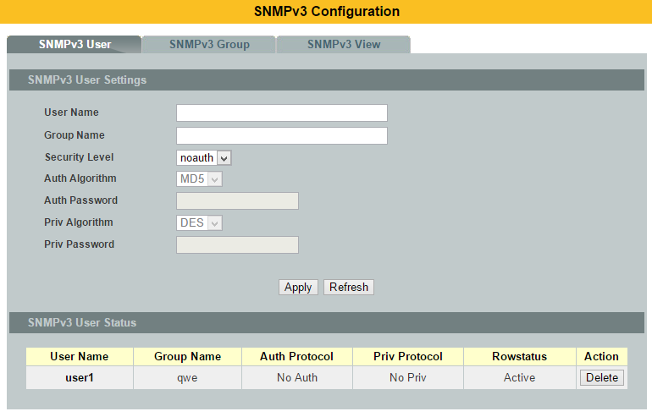

Parameter | Description
User Name | Enter the v3 user name.
Group Name | Map the v3 user name into a group name.
Security Level | Select the security level of the v3 user to use.  noauth means no authentication and no encryption.  auth means messages are authenticated but not encrypted.  priv means messages are authenticated and encrypted.
Auth Algorithm | Select MD5 or SHA Algorithm when security level is auth or priv.
Auth Password | Set the password for this user when security level is auth or priv. (pass phrases must be at least 8 characters long!)
Priv Algorithm | Select DESor AESencryption when security level is priv.
Priv Password | Set the password for this user when security level is priv. (pass phrases must be at least 8 characters long!)
Apply | Click Apply to configure the settings.
Refresh | Click Refresh to begin configuring this screen afresh.
SNMPv3 User Status
User Name | This field displays the v3 user name.
Group Name | This field displays the group name which the v3 user mapping.
Auth Protocol | These fields display the security level to this v3 user.
Priv Protocol | These fields display the security level to this v3 user.
Rowstatus | This field displays the v3 user rowstatus.
Action | Click Delete to remove a v3 user.

SNMPv3 Group
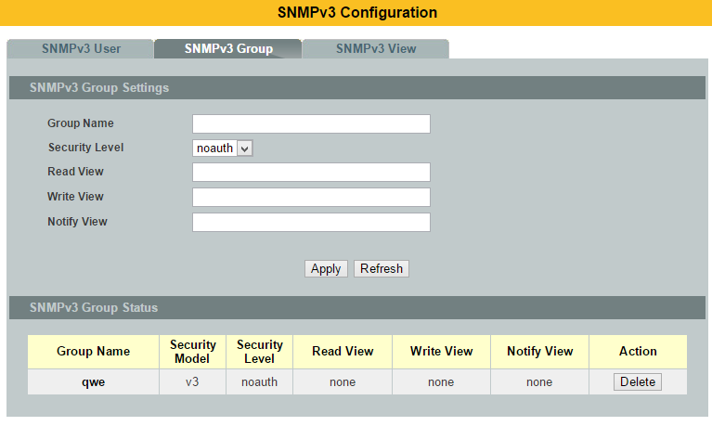

Parameter | Description
Group Name | Enter the v3 user name.
Security Level | Select the security level of the v3 group to use.
Read View | Note that if a group is defined without a read view than all objects are available to read. (default value is none.)
Write View | if no write or notify view is defined, no write access is granted and no objects can send notifications to members of the group. (default value is none.)
Notify View | By using a notify view, a group determines the list of notifications its users can receive.(default value is none.)
Apply | Click Apply to configure the settings.
Refresh | Click Refresh to begin configuring this screen afresh.
SNMPv3 Group Status
Group Name | This field displays the v3 user name.
Security Model | This field displays the security model of the group.  Always displayed v3: User-based Security Model (USM)
Security Level | This field displays the security level to this group.
Read View | These fields display the View list of this group.
Write View | These fields display the View list of this group.
Notify View | These fields display the View list of this group.
Action | Click Delete to remove a v3 group.

SNMPv3 View
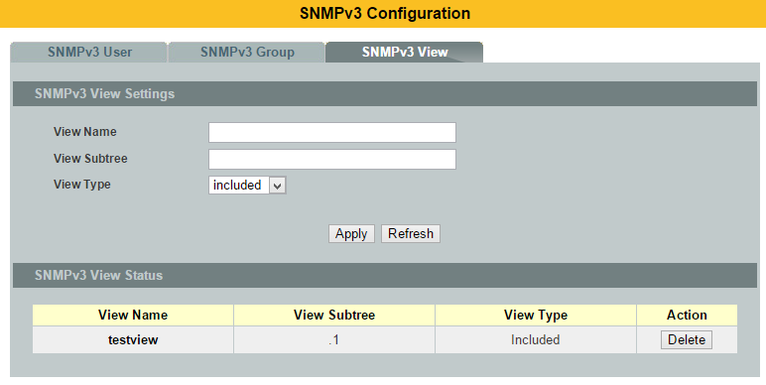

Parameter | Description
View Name | Enter the v3 view name for creating an entry in the SNMPv3 MIB view table.
View Subtree | The OID defining the root of the subtree to add to (or exclude from) the named view.
View Type | Select included or excluded todefine subtree adding to the view or not.
Apply | Click Apply to configure the settings.
Refresh | Click Refresh to begin configuring this screen afresh.
SNMPv3 View Status
View Name | This field displays the v3 view name.
View Subtree | This field displays the subtree.
View Type | This field displays the subtree adding to the view or not.
Action | Click Delete to remove a v3 view.

  - Auto Provision
Auto provision is a service that service provider can quickly, easily and automatically configure remote device or doing firmware upgrade at remote side.

- When the Auto Provision is enabled, the Switch will download the auto provision information file from the auto provision server first.

The file name is followed below naming rule:
Model_Name_Autoprovision.txt
For Example: MEN-5428_Autoprovision.txt

The contents of the file are listed below:
AUTO_PROVISION_VER=1
Firmware_Upgrade_State=1
Firmware_Version=5428-000-1.1.0.S0
Firmware_Image_File=5428-000-1.1.0.S0.fw
Firmware_Reboot=1
Global_Configuration_State=0
Global_Configuration_File=5428-000-1.1.0.S0.save
Global_Configuration_Reboot=0
Specific_Configuration_State=0
Specific_Configuration_Reboot=0

- If AUTO_PROVISION_VER is biggest than current auto provision version, do step 3; otherwise, wait 24 hours and go back to step 1.

- If the Firmware_Upgrade_State =1, do step 4; otherwise, do step 6.

- If the Firmware_Version is difference than current firmware version, download the Firmware_Image_File and upgrade firmware.

- If upgrade firmware succeeded and Firmware_Reboot=1, let reboot_flag=1.

- If the Global_Configuration_State =1, download the Global_Configuration_File and upgrade configuration; otherwise, do step 8.

- If upgrade configutation succeeded and Global_Configuration_Reboot =1, let reboot_flag=1.

- If the Specific_Configuration_State =1, download the specific configuration file and upgrade configuration; otherwise do step 10. The naming is “Model_Name _” with 12-bit MAC digits ,example for following is “MEN-5428_00e04c8196b9.txt”

- If upgrade configuration succeeded and Specific_Configuration_Reboot =1, let reboot_flag=1.

- If reboot_flag=1, save running configuration and reboot the switch; otherwise, wait 24 hours and go back to step 1.

Default Settings
Auto provision configuration profile:
Active : Disable
Version : 0
Protocol : FTP
FTP user/pwd : /
Folder :
Server address :

    - CLI Configuration
Node | Command | Description
enable | show auto-provision | This command displays the current auto provision configurations.
configure | auto-provision | This command enters the auto-provision node.
auto-provision | Show | This command displays the current auto provision configurations.
auto-provision | active (enable|disable) | This command enables/disables the auto provision function.
auto-provision | server-addressIPADDR | This command configures the auto provision server’s IP.
auto-provision | protocol (tftp|http|ftp) | The command configurations the upgrade protocol.
auto-provision | FTP-user username STRING password STRING | The command configurations the username and password for the FTP server.
auto-provision | folder STRING | The command configurations the folder for the auto provision server.
auto-provision | no folder | The command configurations the folder to default.
auto-provision | no FTP-user | The command configurations the username and password to default.

    - Web Configuration
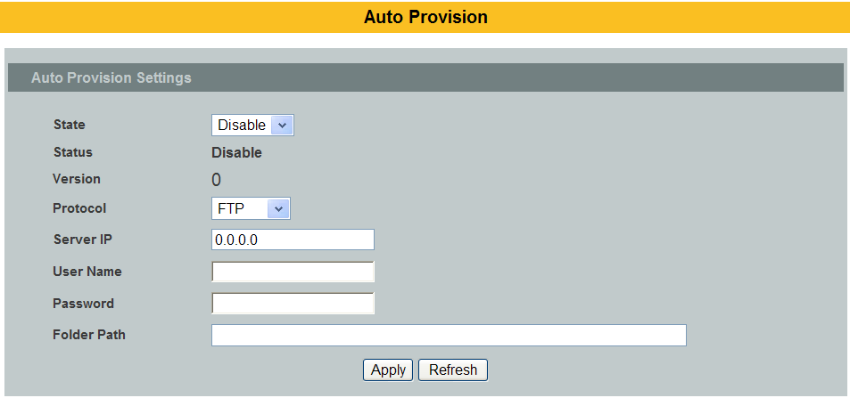

Mail Alarm
The feature sends an e-mail trap to a predefined administrator when some events occur. The events are listed below:
    - System Reboot : The system warn start or cold start.
    - Port Link Change : A port link up or down.
    - Configuration Change : The system configurations in the NV-RAM have
been updated.
    - Firmware Upgrade : The system firmware image has been updated.
    - User Login : A user login the system.
    - Port Blocked : A port is blocked by looping detection or BPDU
Guard.
Default Settings
Mail-Alarm Configuration:
-----------------------------------------------
State : Disabled.
Server IP : 0.0.0.0
Server Port : 25
Mail From :
Mail To :

Trap Event Status:
-----------------------------------------------
System Reboot : Disabled.
Port Link Change : Disabled.
Configuration Change : Disabled.
Firmware Upgrade : Disabled.
User Login : Disabled.
PortBlocked : Disabled.
Alarm : Disabled.

Reference
Default Ports |  | Server | Authentication | Port
SMTP Server (Outgoing Messages) |  | Non-Encrypted | AUTH | 25 (or 587)
 |  | Secure (TLS) | StartTLS | 587
 |  | Secure (SSL) | SSL | 465
POP3 Server (Incoming Messages) |  | Non-Encrypted | AUTH | 110
 |  | Secure (SSL) | SSL | 995
Googlemail – Gmail |  | Server: | Authentication: | Port:
SMTP Server (Outgoing Messages) |  | smtp.gmail.com | SSL | 465
 |  | smtp.gmail.com | StartTLS | 587
POP3 Server (Incoming Messages) |  | pop.gmail.com | SSL | 995
Outlook.com |  | Server: | Authentication: | Port:
SMTP Server (Outgoing Messages) |  | smtp.live.com | StartTLS | 587
POP3 Server (Incoming Messages) |  | pop3.live.com | SSL | 995
Yahoo Mail |  | Server: | Authentication: | Port:
SMTP Server (Outgoing Messages) |  | smtp.mail.yahoo.com | SSL | 465
POP3 Server (Incoming Messages) |  | pop.mail.yahoo.com | SSL | 995
Yahoo Mail Plus | Server: |  | Authentication: | Port:
SMTP Server (Outgoing Messages) | plus.smtp.mail.yahoo.com |  | SSL | 465
POP3 Server (Incoming Messages) | plus.pop.mail.yahoo.com |  | SSL | 995

CLI Configuration
Node | Command | Description
enable | show mail-alarm | This command displays the Mail Alarm configurations.
configure | mail-alarm (disable|enable) | This command disables / enables the Mail Alarm function.
configure | mail-alarm auth-account | This command configures the Mail server authentication account.
configure | mail-alarm mail-from | This command configures the mail sender.
configure | mail-alarm mail-to | This command configures the mail receiver.
configure | mail-alarm server-ip IPADDR server-port VALUE | This command configures the mail server IP address and the TCP port.
configure | mail-alarm server-ip IPADDR server-port Default | This command configures the mail server IP address and configures 25 as the server’s TCP port.
configure | mail-alarm trap-event (reboot|link-change|config.|firmware|login|port-blocked|alarm) (disable|enable) | This command disables / enables mail trap events.

Web Configuration
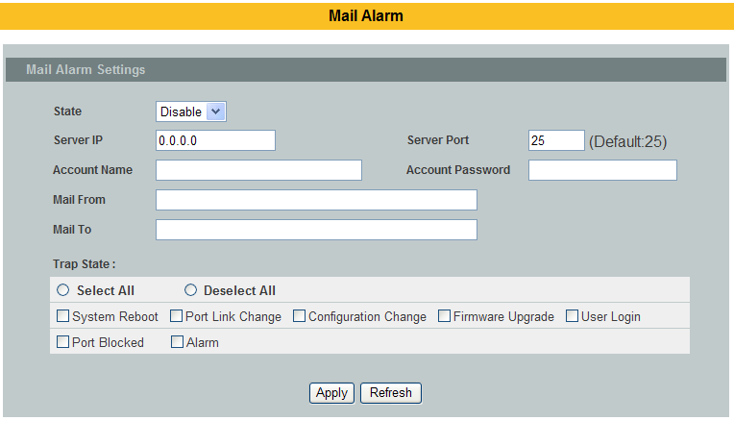

Parameter | Description
State | Enable / disable the Mail Alarm function.
Server IP | Specifies the mail server’s IP address.
Server Port | Specifies the TCP port for the SMTP.
Account Name | Specifies the mail account name.
Account Password | Specifies the mail account password.
Mail From | Specifies the mail sender.
Mail To | Specifies the mail receiver.
Trap State | Enables / disables the mail trap event states.

Maintenance

Configuration

CLI Configuration
Node | Command | Description
configure | Reboot | This command reboots the system.
configure | reload default-config | This command copies a default-config file to replace the current one.  Note: The system will reboot automatically to take effect the configurations.
configure | write memory | This command writescurrent operating configurations to the configuration file.
configure | archive download-config <URL PATH> | This command downloads a new copy of configuration file from TFTP server.  Where <URL PATH> can be:  ftp://user:pass@192.168.1.1/file  http://192.168.1.1/file  tftp://192.168.1.1/file
configure | archive upload-config <URL PATH> | This command uploadsthecurrent configurations file to a TFTP server.
configure | archive download-fw<URL PATH> | This command downloads a new copy of firmware file from TFTP / FTP / HTTP server.  Where <URL PATH> can be:  ftp://user:pass@192.168.1.1/file  http://192.168.1.1/file  tftp://192.168.1.1/file

Example:
L2SWITCH#configure terminal
L2SWITCH(config)#interface eth0
L2SWITCH(config-if)#ip address 172.20.1.101/24
L2SWITCH(config-if)#ip address default-gateway 172.20.1.1
L2SWITCH(config-if)#management vlan 1

Enable the DHCP client function for the switch.
- L2SWITCH#configure terminal
- L2SWITCH(config)#interface eth0
- L2SWITCH(config-if)#ip dhcp client enable

Web Configuration
Configuration
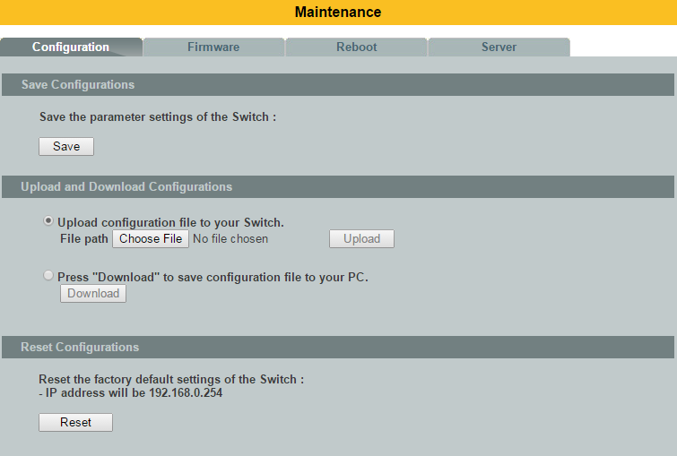

Save Configurations
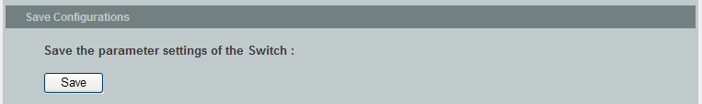
Press the Save button to save the current settings to the NV-RAM (flash).

Upload / Download Configurations to /from a your server
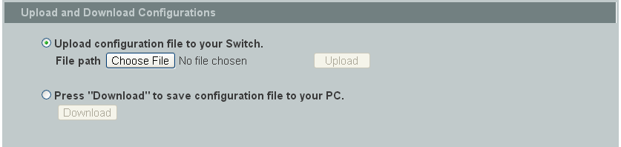

Follow the steps below to save the configuration file to a your PC.
- Select the “Press “Download” to save configurations file to your PC”.
- Click the “Download” button to start the process.

Follow the steps below to load the configuration file from your PC to the Switch.
- Select the “Upload configurations file to your Switch”.
- Select the full path to your configuration file.
- Click the Upload button to start the process.

Reset the factory default settings of the Switch
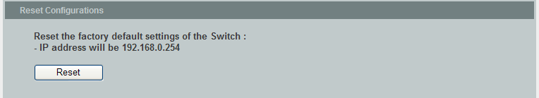
Press the Reset button to set the settings to factory default configurations.

Firmware
Type the path and file name of the firmware file you wish to upload to the Switchin the File path text box or click Browse to locate it. Click Upgrade to load thenew firmware.
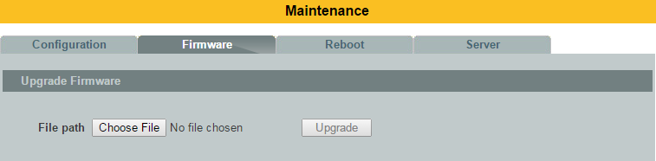

Reboot
Reboot allows you to restart the Switch without physically turning the power off.
Follow the steps below to reboot the Switch.
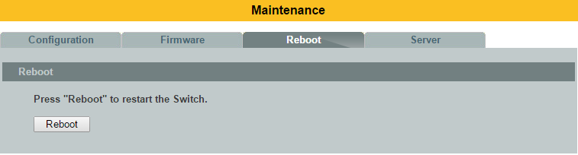
In the Reboot screen, click the Reboot button. The following screen displays.

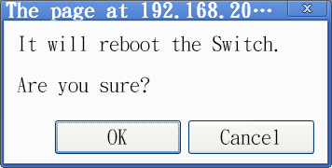
Click OK again and then wait for the Switch to restart. This takes up to two minutes. This does not affect the Switch’s configuration.

Server Control
The function allows users to enable or disable the SSH or Telnet or Web service individual using the CLI or GUI.

      - CLI Configuration
Node | Command | Description
enable | show server status | This command displays the current server status.
configure | ssh server | This command enables the ssh on the Switch.
configure | no ssh server | This command disables the ssh on the Switch.
configure | telnet server | This command enables the telnet on the Switch.
configure | no telnet server | This command disables the telnet on the Switch.
configure | web server | This command enables the web on the Switch.
configure | no web server | This command disables the web on the Switch.

      - Web Configuration
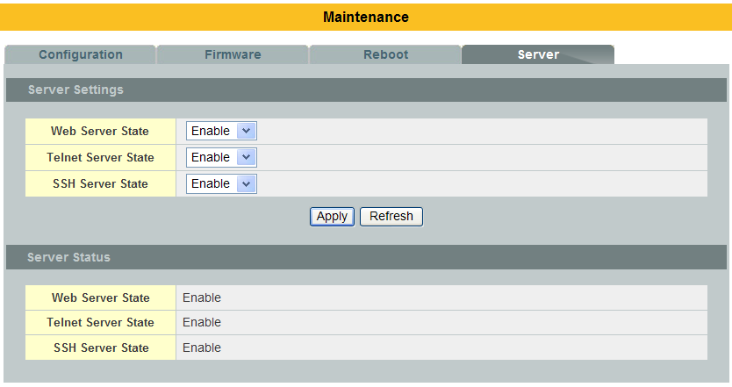

Parameter | Description
Server Settings
Web Server State | Selects Enable or Disable to enable or disable the Web service.
Telnet Server State | Selects Enable or Disable to enable or disable the Telnet service.
SSH Server State | Selects Enable or Disable to enable or disable the SSH service.
Apply | Click Apply to configure the settings.
Refresh | Click this button to reset the fields to the last setting.
Server Status
Web Server Status |  | Displays the current Web service status.
Telnet Server Status |  | Displays the current Telnet service status.
SSH Server Status |  | Displays the current SSH service status.

System log
The syslog function records some of system information for debugging purpose. Each log message recorded with one of these levels, Alert/Critical/Error/Warning/Notice/Information. The syslog function can be enabled or disabled. The default setting is disabled. The log message is recorded in the Switch file system. If the syslog server’s IP address has been configured, the Switch will send a copy to the syslog server.

The log message file is limited in 4KB size. If the file is full, the oldest one will be replaced.

CLI Configuration
Node | Command | Description
enable | show syslog | The command displays all of the log message recorded in the Switch.
enable | show syslog level LEVEL | The command displays the log message with the LEVEL recorded in the Switch.
enable | show syslog server | The command displays the syslog server configurations.
configure | clear syslog | The command clears the syslog message.
configure | syslog-server (disable|enable) | The command disables / enables the syslog server function.
configure | syslog-server ipv4-ip IPADDR | The command configures the syslog server’s IP address in IPv4 format.
configure | syslog-server ipv6-ip IPADDR | The command configures the syslog server’s IP address in IPv6 format.
configure | syslog-server facility | The command configures the syslog facility level.

Example:
L2SWITCH#configure terminal
L2SWITCH(config)#syslog-server ipv4-ip 192.168.200.106
L2SWITCH(config)#syslog-server enable

Web Configuration
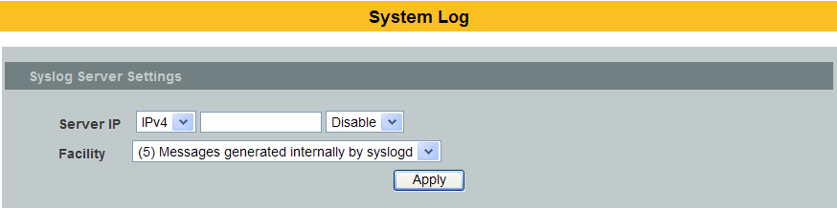
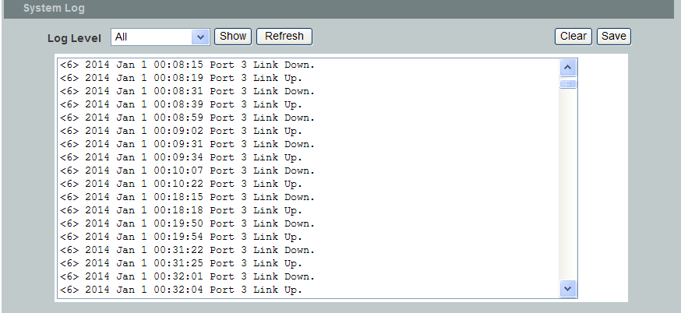

Parameter | Description
Server IP | Select IP type for the server’s IP.  Enter the Syslog server IP address.  Select Enableto activate switch sent log message to Syslog server when any new log message occurred.
Facility | Selects the facility level..
Apply | Click Apply to add/modify the settings.
Refresh | Click Refresh to begin configuring this screen afresh.
Log Level | Select Alert/Critical/Error/Warning/Notice/Informationto choose which log message to want to see.
Clear | Click Clear to clear all of log message.
Save | Click Save to save all of log message into NV-RAM.

User Account
The Switch allows users to create up to 6 user account. The user name and the password should be the combination of the digit or the alphabet. The last admin user account cannot be deleted. Users should input a valid user account to login the CLI or web management.

User Authority:The Switch supports two types of the user account, admin and normal. The default users account is username(admin) / password(admin).
- admin - read / write.

- normal - read only.
; Cannot enter the privileged mode in CLI.
; Cannot apply any configurations in web.

The Switch also supports backdoor user account. In case of that user forgot their user name or password, the Switch can generate a backdoor account with the system’s MAC. Users can use the new user account to enter the Switch and then create a new user account.

Default Settings
- Maximum user account : 6.
- Maximum user name length : 32.
- Maximum password length : 32.
- Default user account for privileged mode : admin / admin.

Notices
- The Switch allows users to create up to 6 user account.
- The user name and the password should be the combination of the digit or the alphabet.
- The last admin user account cannot be deleted.
- The maximum length of the username and password is 32 characters.

CLI Configuration
Node | Command | Description
enable | show user account | This command displays the current user accounts.
configure | add user USER_ACCOUNT PASSWORD (normal|admin) | This command adds a new user account.
configure | delete user USER_ACCOUNT | This command deletes a present user account.

Example:
L2SWITCH#configure terminal
L2SWITCH(config)#add user q q admin
L2SWITCH(config)#add user 1 1 normal

Web Configuration
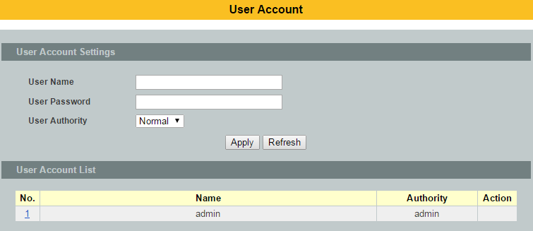

Parameter | Description
User Name | Type a new username or modify an existing one.
User Password | Type a new password or modify an existing one. Enter up to 32 alphanumeric or digit characters.
User Authority | Select with which group the user associates.admin (read and write) or normal (read only) for this user account.
Apply | Click Apply to add/modify the user account.
Refresh | Click Refresh to begin configuring this screen afresh.
User Account List
No. | This field displays the index number of an entry.
User Name | This field displays the name of a user account.
User  Password | This field displays the password.
User  Authority | This field displays the associated group.
Action | Click the Delete button to remove the user account.  Note: You cannot delete the last admin accounts.

Customer support

For all questions relate to the MEN-5428(D) or any other Volktek product, please contact Volktek customer support:

Address | Volktek Customer Support  4F, 192 Liancheng Road,  Zhonghe District,  New Taipei City 23553,  Taiwan
Phone | +886-2-8242-1000
Fax | +886-2-8242-3333
E-mail | support@volktek.com.tw
Website | www.volktek.com

ISO 9001 Certified

